Lecture 01
1. What is PHP?
- PHP (Hypertext Preprocessor) is a server-side scripting language used to create dynamic web pages and applications.

- Features:
  - Open source and free
  - Cross-platform
  - Embedded inside HTML
  - Works with databases like MySQL
Uses of PHP
- Generate dynamic content
- Handle forms and files
- Perform database operations
- Manage cookies and sessions
- Control user access and encrypt data

2. Basic PHP Code Example
The lecture slide shows a simple Hello World PHP program:
<!DOCTYPE HTML>
<html>
<head>
<title>Example</title>
</head>
<body>

<?php
echo "Hello World!";
?>

</body>
</html>
- PHP code runs inside <?php ... ?>.
- The echo statement prints output to the browser.

3. % of Websites Using Server-Side Programming Languages
Key Idea
The chart shows the popularity of different server-side programming languages used by websites.
Main Observations
- PHP – 78.9%
  - PHP is the most widely used server-side language on the web.
  - This proves PHP’s dominance in web development and why it is important to learn.
- ASP.NET – 11.7%
  - Second most used but far behind PHP.
- Java – 3.9%, Ruby – 2.4%, Static files – 2.1%
  - Used in smaller portions of websites.
- Scala – 1.2%, Python – 1.1%, JavaScript – 0.7%
  - Very low server-side usage in this dataset.
- ColdFusion – 0.5%, Perl – 0.3%, Erlang – 0.1%
  - Rarely used in modern websites.

4. Request–Response Cycle
Client vs Server
- Server: Service providers
Computer program or machine that provide services to (Web Services or FTP services) to other programs or users (machines).
- Client: Service requesters
Computer program or machine that request the services from servers
Flow
Client → Network → Server → Response → Client
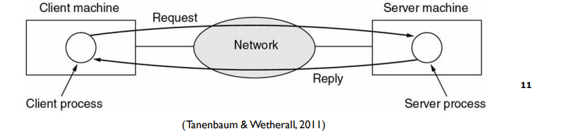
5. Client–Server Architecture Types
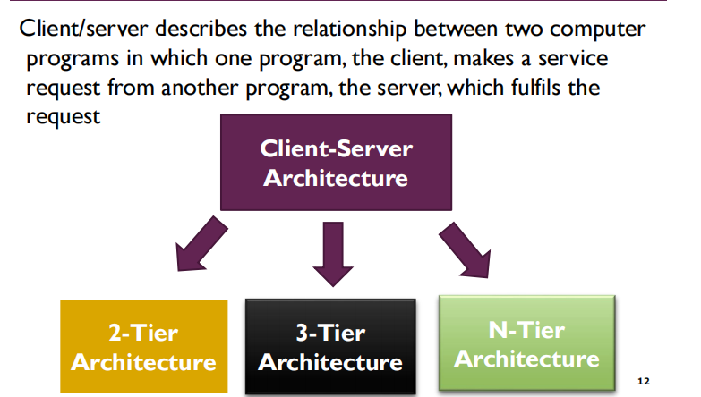

2-Tier Architecture
Definition:
A two-way interaction in a client–server environment where:
- The user interface (UI) is stored in the client.
- The data is stored in the server/database.
- The application logic can be in either the client or the server.
Working process:
Client → sends request → Server/DB processes → Result returned to client.
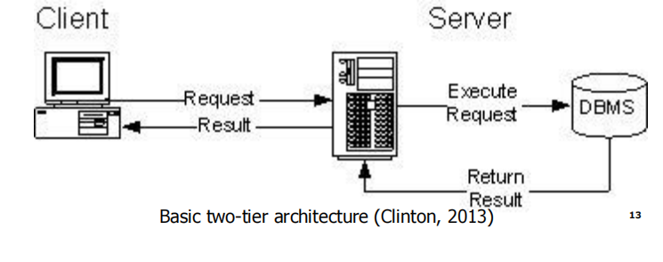
Key features:
- Simple structure
- Faster for small systems
- Less secure and less scalable

3-Tier Architecture
Definition:
A three-way interaction in a client–server environment where:
- Client layer: user interface
- Application server layer: business logic
- Database server layer: data storage
Working process:
Client → Application server → Database server → Result → back to client.
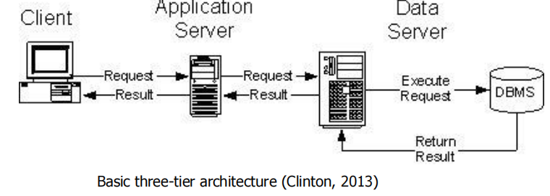
Key features:
- Better security
- High scalability
- Easier maintenance
- Used in modern web applications

Main Differences (Exam Point)
Feature | 2-Tier | 3-Tier
Layers | Client + Server | Client + App Server + DB
Logic location | Client or Server | Application server
Security | Low | High
Scalability | Limited | High
Usage | Small systems | Large web applications

ACTIVITY-TIME - Compare & Contrast
- 3-Tier vs Multi-Tier Architecture
3-Tier Architecture
- Contains three fixed layers:
  - Presentation (Client/UI)
  - Application/Business Logic
  - Database/Data Layer
- Common in typical web applications.
- Easier to design and manage.
Multi-Tier Architecture
- Has more than three layers (extension of 3-tier).
- May include:
  - Web servers
  - Multiple application services
  - Microservices
  - Multiple databases
- Used in large enterprise or cloud systems.
- Provides higher scalability, flexibility, and security.
Key Point:
➡ 3-tier = exactly 3 layers
➡ Multi-tier = many layers for complex systems

- Front-End vs Back-End
Front-End
- Visible part of the website users interacts with.
- Built using HTML, CSS, JavaScript.
- Runs in the web browser.
Back-End
- Server-side processing and logic.
- Uses PHP, Java, Python, .NET, databases, etc.
- Handles:
  - Authentication
  - Data processing
  - Business rules
Key Point:
➡ Front-end = User Interface
➡ Back-end = Server logic & database

- Logical vs Physical Architecture
Logical Architecture
- Shows functional layers and relationships.
- Focuses on how the system works conceptually.
- Example: presentation → business → data.
Physical Architecture
- Shows actual hardware, servers, and network setup.
- Focuses on where components are deployed.
Key Point:
➡ Logical = concept/design view
➡ Physical = real implementation view

- Client-Side vs Server-Side
Client-Side
- Code runs in the user’s browser.
- Technologies: HTML, CSS, JavaScript.
- Faster response but less secure.
Server-Side
- Code runs on the web server.
- Technologies: PHP, Python, Java, .NET.
- More secure and powerful (database access, authentication).
Key Point:
➡ Client-side = browser execution
➡ Server-side = server execution

6. PHP Development Environment (XAMPP)
- PHP and MySQL can be installed using XAMPP.
- The screenshot on page 17 shows:
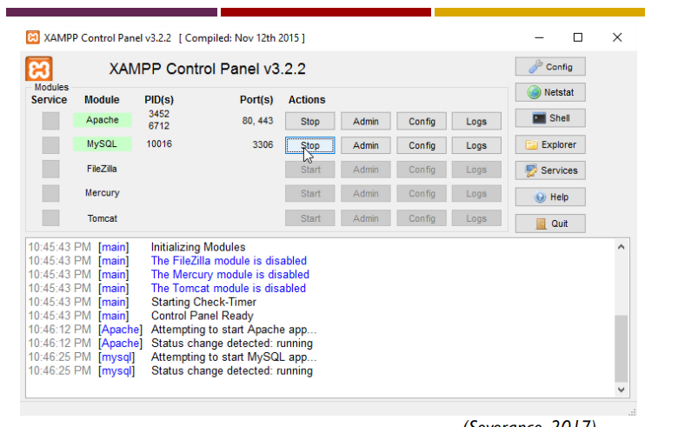
  - Apache server running
  - MySQL running
This allows local testing of web applications.
Websites Based on PHP
Examples of popular PHP-based websites
According to the lecture slide, several well-known global platforms are built using PHP technologies:
- Facebook – Large social networking platform originally developed with PHP.
- Wikipedia – Online encyclopedia powered by PHP-based MediaWiki software.
- Yahoo – Major web services provider that has used PHP in many systems.
- WordPress – Very popular content management system written in PHP.
- Pinterest – Image-sharing social media platform using PHP in its backend.
- Flickr – Photo hosting service that also relies on PHP.
These examples show that PHP is widely used for large-scale, real-world web applications, proving its importance in modern web development.

Lecture 02

1. HTML Basics
- HTML is a markup language used to describe web pages.
- It stands for HyperText Markup Language and uses tags to define content.

HTML Structure
- Only the content inside the <body> is displayed in the browser (shown in the page-structure diagram).
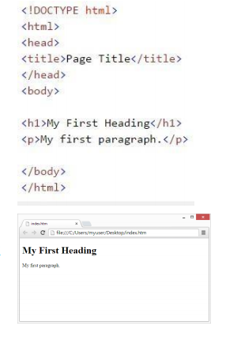
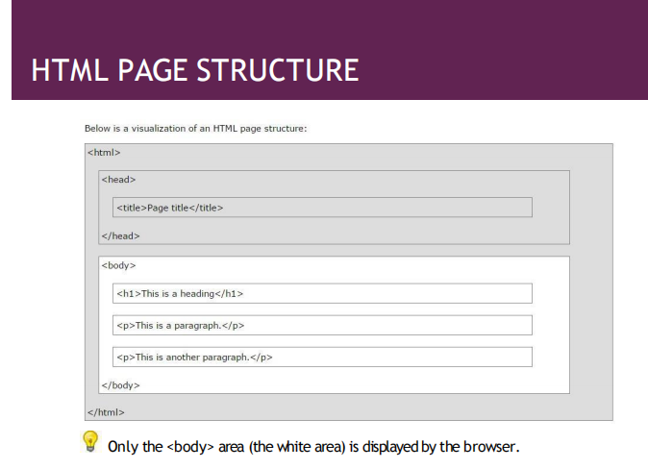

Common HTML Tags
<h1>Heading</h1>
<p>Paragraph</p>
<a href="url">Link</a>
<img src="image.jpg" alt="text">
- HTML elements use start tag + content + end tag.

HTML ATTRIBUTES
Attributes provide additional information about HTML elements.
◾ HTML elements can have attributes
◾ Attributes provide additional information about an element
◾ Attributes are always specified in the start tag
◾ Attributes come in name/value pairs like:name="value"
<!DOCTYPE html>
<html lang="en-US">
<body>
<h1>My First Heading</h1>
<p>My first paragraph.</p>
</body>
</html>

CSS – Introduction (Short Note)

1. What is CSS?
- CSS (Cascading Style Sheets) is a stylesheet language used to describe the presentation of HTML or XML documents.
- It controls how elements are displayed on screen, paper, or other media.
- CSS helps save time and work by controlling the layout of multiple web pages at once.
- External stylesheets are stored in separate .css files.

2. Basic CSS Example
body {
background-color: #d0e4fe;
}
h1 {
color: orange;
text-align: center;
}
p {
font-family: "Times New Roman";
font-size: 20px;
}
- This example shows how CSS changes background color, text color, alignment, font, and size

3. CSS Syntax
- A CSS rule-set contains:
  - Selector → identifies the HTML element to style.
  - Declaration block → contains one or more declarations separated by semicolons.
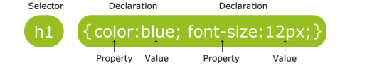
- Declarations:
  - Written as property: value;
  - End with semicolon (;)
  - Placed inside curly braces { }.

4. Element Selector
- Selects elements based on HTML tag name.
Example:
p {
text-align: center;
color: red;
}
- Applies the style to all <p> elements on the page.

5. ID Selector
- Uses the id attribute to style one unique element.
- Written with # before the id name.
Example:
#para1 {
text-align: center;
color: red;
}
- Applies only to the element with id="para1".

3. PHP Basics

Hello World
<!DOCTYPE HTML>
<html>
<head>
<title>Example</title>
</head>
<body>
<?php
echo “Hello World!";
?>
</body>
</html>

A PHP script can be placed anywhere in the document.

◾ A PHP script starts with <?php and ends with ?>:

<?php

// PHP code goes here

?>

◾The defaultfile extension for PHP files is ".php".

◾ A PHP file normally contains HTML tags,and some PHP scripting

code.

Comments in PHP
// single line
# single line
/* multi-line */
- Comments help explain or hide code.
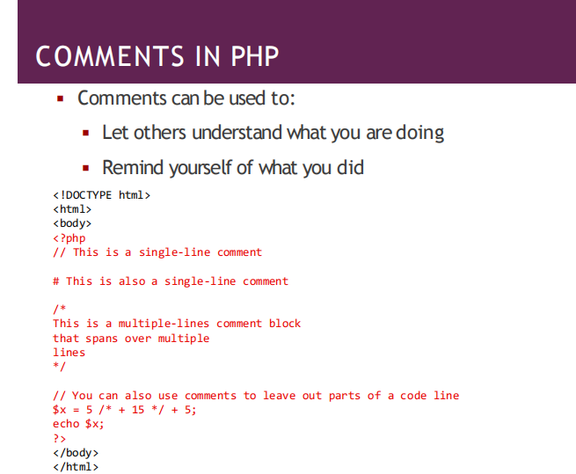

PHP Variables
- A variable in PHP starts with the $ sign and stores data values.
- No separate declaration is needed; the variable is created when first assigned.
- Variable names:
  - Must start with a letter or underscore
  - Cannot start with a number
  - Can contain letters, numbers, underscores
  - Are case-sensitive ($age ≠ $AGE).

Example

<?php

$txt = "Hello world!";

$x = 5;

$y = 10.5;

?>

◾ Output Examples
echo "I love $txt!";
echo $x + $y;
echo "I love " . $txt . "!";

2. Variable Scope in PHP
PHP has three scopes:
- Global Scope
A variable declared outside a function has a GLOBAL SCOPE and can only be accessed outside a function:
<?php
$x = 5; // global scope
function myTest() {
// using x inside this function will generate an error
echo "<p>Variable x inside function is: $x</p>";
}
myTest();
echo "<p>Variable x outside function is: $x</p>";
?>
- Local Scope

A variable declared within a function has a LOCAL SCOPE and can

only be accessed within thatfunction:

<?php

function myTest() {

$x = 5; // local scope

echo "<p>Variable x inside function is: $x</p>";

}

myTest();

// using x outside the function will generate an error

echo "<p>Variable x outside function is: $x</p>";

?>

- Static Scope
- Local variable that retains its value between function calls.
function test() {
static $x = 0;
echo $x;
$x++;
}

Global Keyword / $GLOBALS
- Used to access global variables inside functions.
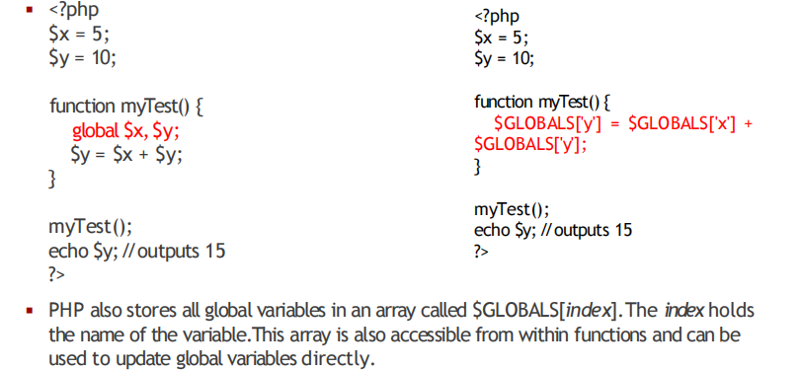
PHP THE STATIC KEYWORD
◾ Normally,when a function is completed/executed,all of its variables are deleted.However,
sometimes we want a local variable NOT to be deleted.We need it for a further job.
<?php
function myTest() {
static $x = 0;
echo $x;
$x++;
}
myTest();
myTest();
myTest();
?>
◾ Then,each time the function is called,that variable will still have the information it
contained from the lasttime the function was called.
◾ Note: The variable is still local to the function.

3. PHP Loops
Loops allow repeated execution of code.

While Loop
- loops through a block of code as long as the specified condition is true
while ($x <= 5) { echo $x; $x++; }

Do-While Loop
- loops through a block of code once, and then repeats the loop as long as the specified condition is true

do { echo $x; $x++; } while ($x <= 5);

For Loop
- loops through a block of code a specified number of times
for ($x = 0; $x <= 10; $x++) { echo $x; }

Foreach Loop
- Used to iterate through arrays.
foreach ($array as $value) { echo $value; }
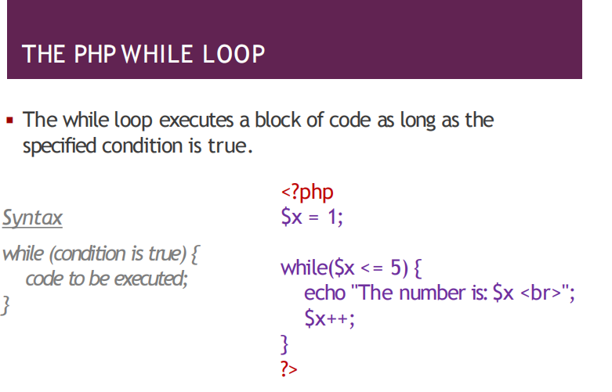

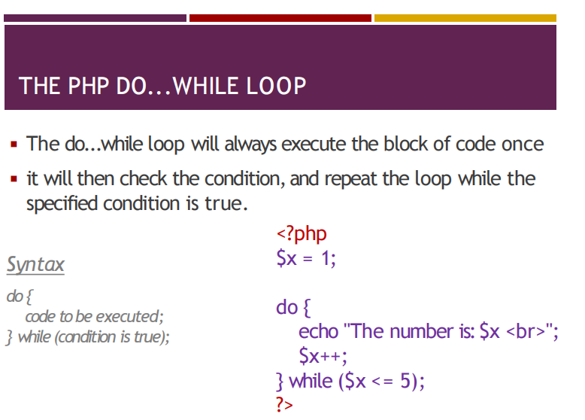
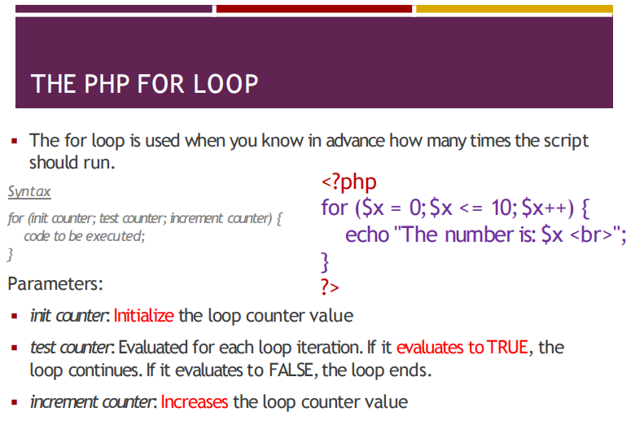

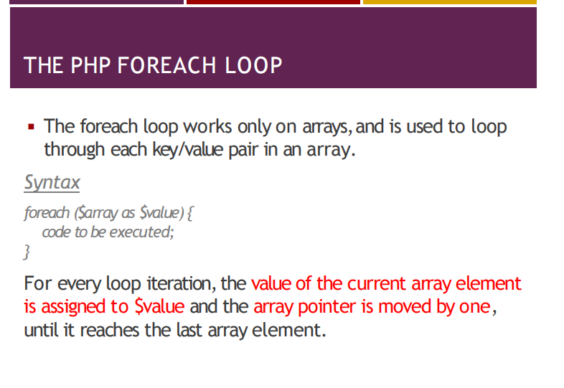

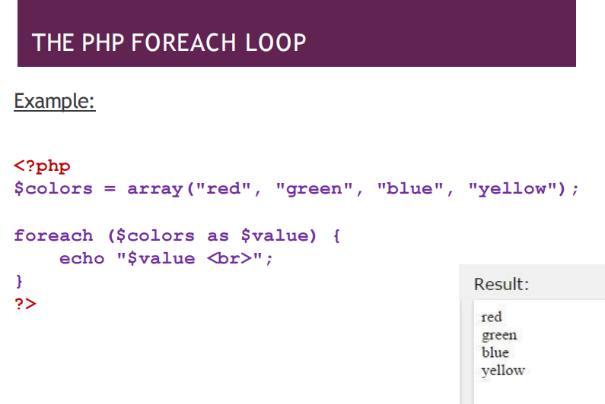

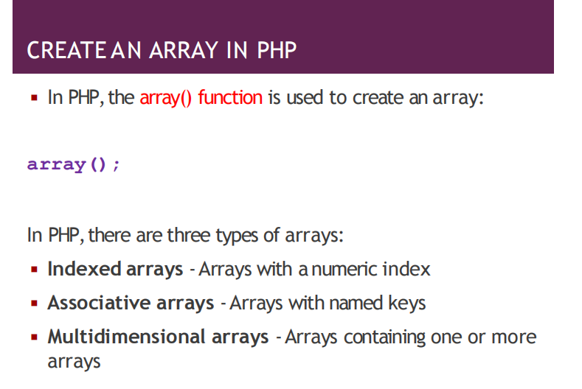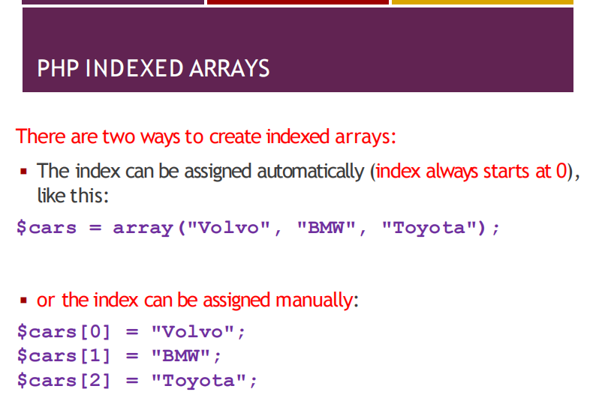

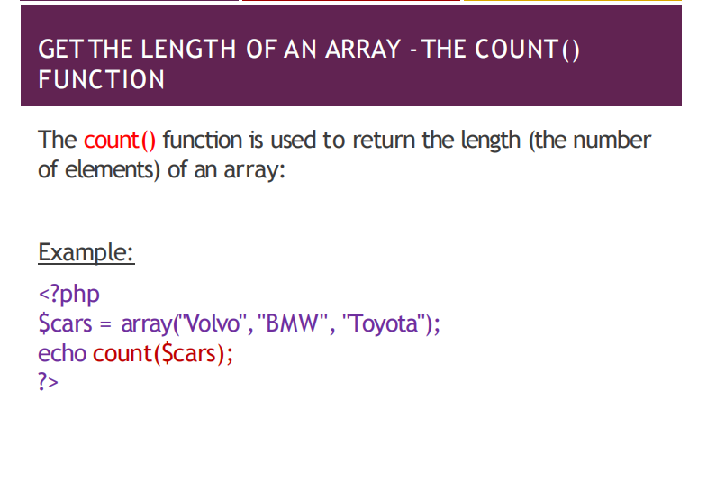

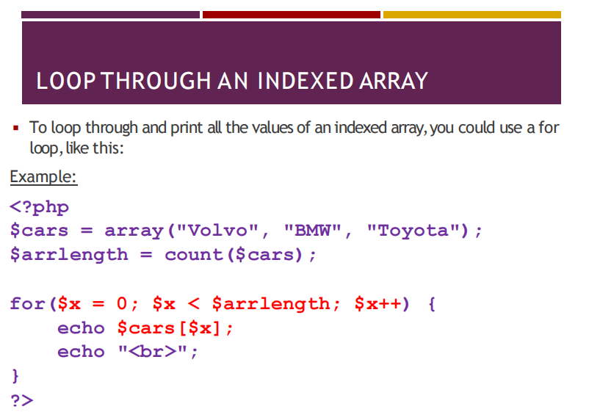

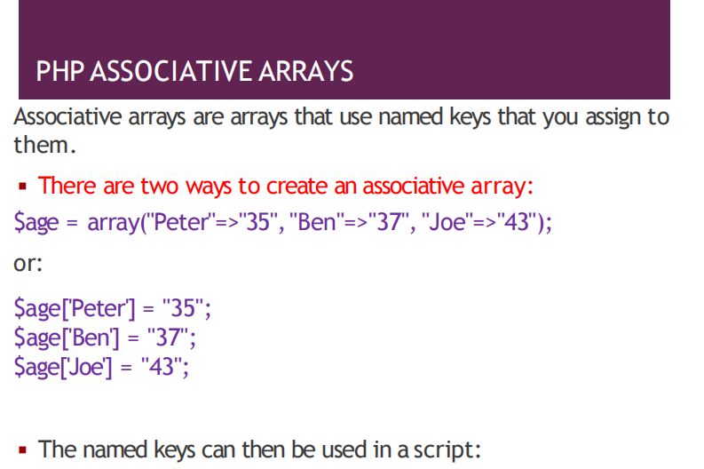

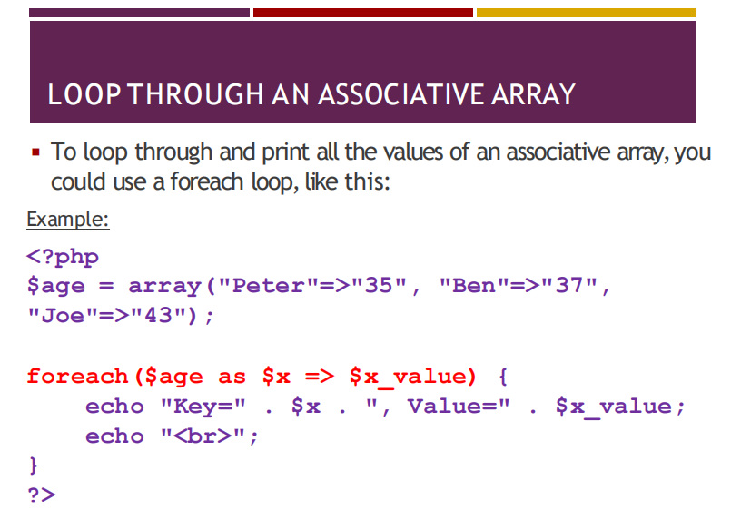

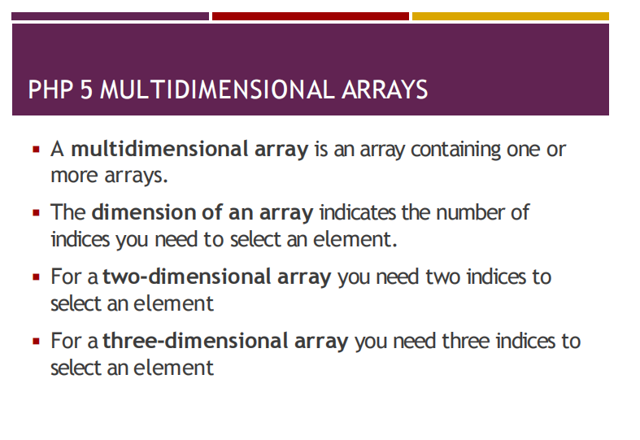

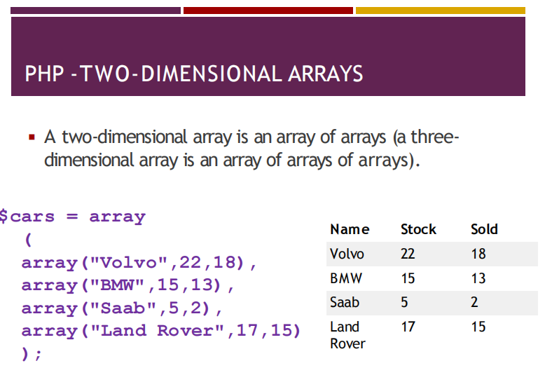

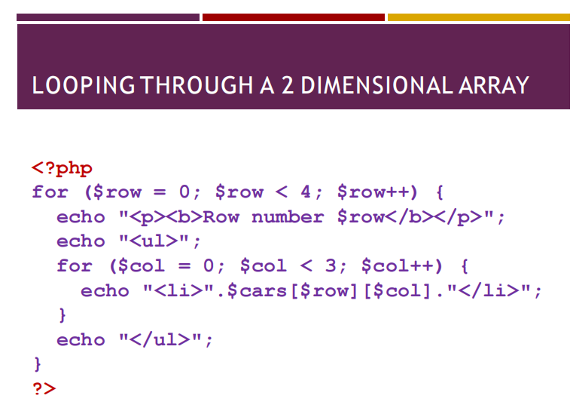

5. PHP + MySQL Database Connectivity

Connection Methods
- MySQLi
- PDO (PHP Data Objects)
(PDO supports multiple databases; both support prepared statements for security.)

MySQLi Connection Example
$conn = new mysqli("localhost","username","password");

PDO Connection Example
$conn = new PDO("mysql:host=localhost;dbname=myDB","username","password");

Select Data Example
$sql = "SELECT id, firstname, lastname FROM MyGuests";
$result = mysqli_query($conn, $sql);
- Used to retrieve and display database records.

