HCI Lecture 4 – Wireframing (Full Exam Note)
1. Introduction to Wireframing
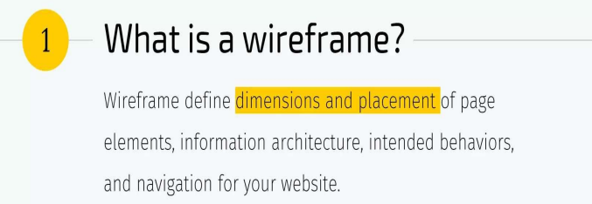
A wireframe is the skeleton blueprint of a website or application, and all designs should begin with it.
2. Benefits of Wireframes
Wireframes provide several important advantages:
- Help plan and structure a page’s basic layout quickly
- Cost-effective compared to full design
- Encourage team collaboration
- Fast to create and deliver
They also allow designers to explore multiple concepts, test ideas with users or clients, and choose the best solution efficiently.
3. Wireflows
What are Wireflows?
Wireflows are diagram designers use to document user interactions and show the directional flow within an application or website.
They:
- Show visual UI changes during interaction
- May include annotations explaining backend events or logic

Wireflow Creation Process
- Describe the user need or problem as a user story.
- Identify key interface screens (start and end points).
- Connect screens with arrows showing navigation and decision points.
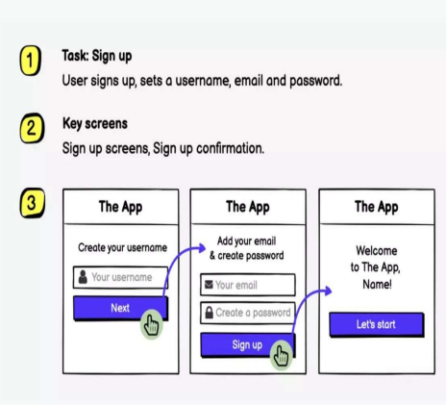
4. Wireframes & UX/UI Process
- Every product is unique, so the wireframing order depends on the project context.
- The best design process is not linear.
- Designers follow an iterative approach:
  - Share ideas early
  - Test rapidly
  - Validate continuously during development.
5. Role of Wireframing in Design Areas
(a) Interaction Design
At the wireframing stage, designers:
- Understand user needs
- Define interactions that satisfy those needs.
(b) Information Design
Wireframes help organize data and content by enabling:
- Planning content strategy
- Reviewing page copy
- Organizing and categorizing information
- Planning layouts for each unique page.
(c) Navigation Design
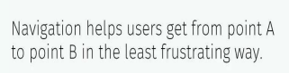
Wireframes assist in deciding:
- Logical and consistent placement of primary navigation links
- Placement of secondary navigation (submenus, breadcrumbs, search)
- Expected behavior of navigation elements.
(d) UI Design
Wireframes display main features, functions and content of a future user interface without visual styling, helping determine:
- Controls (links, buttons, text, icons)
- UI patterns (headers, grids, search, etc.)
- Design principles (contrast, hierarchy, alignment, proximity)
- Page templates (search results, category pages, checkout).
(e) Development Support
Wireframes enable early collaboration between designers and developers.
They help developers:
- Assess technical risks early
- Avoid features that are too complex or time-consuming.
6. Wireframing Best Practices
Designers should:
- Create a plan and define goals before wireframing
- Don’t skip the wireframing stage
- Set clear goals for each wireframe
- Minimize color usage
- Use basic UI components
- Maintain consistency
- Use real content in wireframe
- Add annotations for clarity
7.Digital Wireframing Tools (Most Common in UX/UI)
Beginner-Friendly
- Balsamiq – Simple, sketch-style wireframes.
- Canva Wireframe templates – Easy drag-and-drop layouts.
👉 Good for: students and quick low-fidelity wireframes.
Professional Industry Tools
- Figma – Most popular collaborative UI/UX design tool.
- Adobe XD – Wireframing, prototyping, and UI design.
- Sketch – Professional UI design (Mac only).
👉 Good for: high-fidelity wireframes, prototypes, teamwork.

HCI – Accessibility (Full Lecture Note)- Lec 05
1. What is Accessibility?
Accessibility is the degree to which a product, service, or environment is usable by as many people as possible.
It means equal access for everyone, including people with disabilities.
2. Web Accessibility
Web accessibility is the practice of designing and developing websites so that people with disabilities can perceive, understand, navigate, interact with, and contribute to the web.
It covers disabilities such as:
- Visual
- Auditory
- Cognitive
- Neurological
- Physical
- Speech impairments
3. Benefits of Accessibility for All Users
Accessibility improves usability even for people without disabilities:
1. Busy Environments
In crowded or noisy places, users may not be able to hear audio clearly.
How accessibility helps:
- Captions on videos
- Transcripts instead of audio
- Visual alternatives to sound alerts
Example:
A person in a noisy bus station can read captions instead of listening to a video.
➡ Accessibility improves usability in real-world environments.
2. Temporary Disabilities
People may experience short-term physical limitations.
Example:
- Broken arm
- Eye infection
- Temporary hearing problem
How accessibility helps:
- Keyboard navigation
- Voice commands
- Larger clickable buttons
➡ Accessible design supports users during temporary conditions.
3. Low Bandwidth Areas
Some users have slow internet connections.
How accessibility helps:
- Faster-loading websites
- Optimized images
- Lightweight design
- Clean structure
Accessible websites prioritize performance and efficiency, benefiting users in rural or low-speed internet areas.
➡ Accessibility improves performance for everyone.
4. Older Adults
Senior users may experience:
- Reduced vision
- Reduced motor skills
- Slower reaction time
How accessibility helps:
- Larger clickable areas
- Clear fonts and readable text
- Simple navigation
- High contrast design
➡ Accessibility improves usability for aging populations
4. Importance of Accessibility
- Accessibility is needed across desktop, mobile, and tablet devices.
- Over 1 billion people worldwide (≈15% of the population) experience disability, showing why inclusive design is essential.
5. WCAG – Web Content Accessibility Guidelines
Definition
- WCAG is created by the World Wide Web Consortium (W3C).
- It is the global benchmark for website accessibility, often required by law.
WCAG Versions
- WCAG 1.0 – 1999
- WCAG 2.0 – 2008
- WCAG 2.1 – 2018
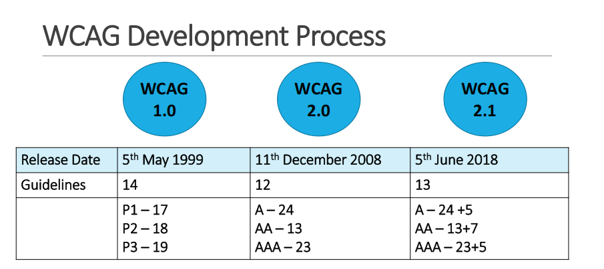
Structure of WCAG 2.1
- 4 Principles
- 13 Guidelines
- 78 Success Criteria
6. Four Principles of Accessibility (POUR) 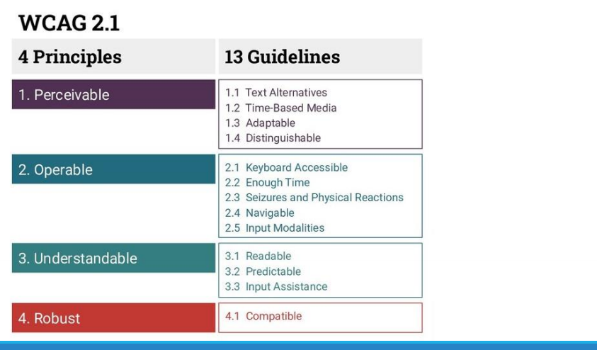
1. Perceivable
Information and UI components must be presented in ways users can perceive
(e.g., not invisible to all their senses).
2. Operable
Users must be able to operate navigation and interface components
(e.g., keyboard access, no impossible interactions).
3. Understandable
Content and interface operation must be easy to understand
(e.g., readable text, predictable behavior).
4. Robust
Content must work reliably with assistive technologies and future systems.
7. WCAG Conformance Levels
There are three accessibility levels:
- Level A → Minimum accessibility.
- Level AA → Level A plus additional requirements.
- Level AAA → Highest accessibility (level A and AA plus a few additional requirements).
8. Types of Disabilities
Accessibility must consider many disability categories:
- Visual impairments
- Hearing impairments
- Speech disabilities
- Mobility/physical disabilities
- Cognitive & learning disabilities
- Neurological disabilities
- Mental health conditions
- Chronic illnesses
- Multiple disabilities
Examples
- Speech disabilities → difficulty producing or organizing speech.
- Cognitive disabilities → reduced ability to learn, communicate, or live independently.

9 Image Accessibility & Types of Images

1. Why Image Accessibility is Important
According to WCAG 1.1.1 – Non-text Content (Level A),
all non-text content must have a text alternative that provides the same purpose as the image.

Benefits of Image Accessibility

1. Screen-reader users
- Alternative text can be read aloud or shown in Braille.
- Helps visually impaired users understand image content.

2. Speech-input users
- Users can focus or activate buttons/images using voice commands.

3. Speech-enabled browsing
- Text alternatives can be spoken automatically by assistive systems.

4. Mobile users
- Images may be disabled to save data, so alt text provides information.

5. Search Engine Optimization (SEO)
- Images with alt text become indexable by search engines, improving visibility.
➡ Therefore, image accessibility improves usability, accessibility, and discoverability.

2. Types of Images in Accessibility

2.1 Decorative Images

Definition
- Images that do not convey meaningful information.
- Used only for visual appearance or design.

Examples
- Background patterns or textures
- Icons that add no content meaning

Accessibility Rule
- Should have empty alt text (alt="")
OR
- Be implemented using CSS background images so screen readers ignore them.
➡ Prevents distraction for visually impaired users.
Week 5

2.2 Informative Images

Definition
- Images that provide important information not available in text.
- Require descriptive alternative text.

Examples
- Product images
- Maps
- Diagrams

Key Rule
- Alt text must convey the same information as the image.
- The alternative text must be meaningful and descriptive, not vague.
➡ Ensures full understanding for screen-reader users.

2.3 Actionable Images

Definition
- Images used to trigger an action (buttons, links, icons).

Accessibility Requirement
- Alt text must describe what action will happen, not just the image appearance.
➡ Helps users navigate and interact correctly.
10. Audio & Video Accessibility
To make media accessible:
- Captions → synchronized text for spoken audio.
- Transcripts → full text version of audio/video.
- Audio descriptions → narration of important visual events.
11. Landmark Accessibility & Structure
Landmarks
Landmarks are ARIA roles or HTML5 semantic regions that help users navigate pages easily.
Best Practices
- All page text should be inside landmark regions.
- Use proper heading structure, language specification, and titles.
- Apply ARIA labels to improve screen-reader understanding.
Week 6 – Software Engineering Process for UI Design & Requirement Gathering
1. Introduction
- Software engineering provides a structured way to develop software systems.
- UI design is a critical part of this process.
- Requirement gathering helps understand user needs, goals, and expectations before building the interface.
2. What is UI Design?
UI design focuses on:
- Visual layout
- Interaction flow
- Usability of software
It includes screens, buttons, icons, forms, menus, and layout.
Goal: create interfaces that are intuitive, accessible, and user-friendly.
3. Why UI Design Matters
UI design:
- Directly affects user satisfaction
- Influences usability and product adoption
- Reduces training time and improves task efficiency
- Strengthens brand identity and user trust
4. Software Engineering Process for Interface Design
The lecture diagram on page 5 shows a waterfall model flow from requirements → design → coding → testing → maintenance.
This represents the step-by-step UI development lifecycle.
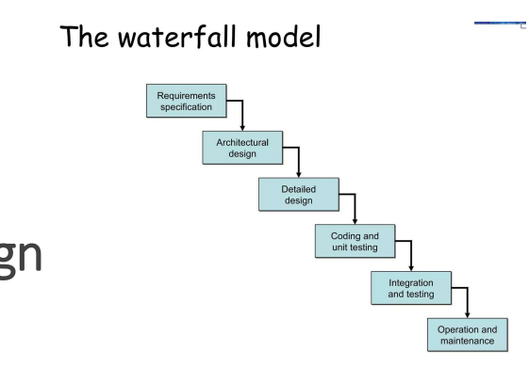
Step 1 – Requirement Analysis
- Identify functional and non-functional requirements.
- Understand users, tasks, workflows, and goals.
- Outputs: user stories, personas, use cases, scenarios.
Step 2 – Conceptual Design
- Create interaction models and information architecture.
- Decide:
  - Navigation structure
  - Content layout
  - User flow
- Tools: flowcharts, IA maps, UML diagrams.
Step 3 – Wireframing
- Low-fidelity sketches of interface structure.
- Focus on layout and functionality, not visuals.
- Tools: Figma, Balsamiq, Sketch.
Step 4 – Prototyping
- High-fidelity clickable models showing real interaction.
- Used for usability testing and stakeholder approval.
Step 5 – Visual Design
- Add typography, colors, icons, spacing.
- Build UI components and design systems.
- Ensure consistency and accessibility (WCAG).
Step 6 – Implementation
- Developers convert designs into working screens.
- Technologies: HTML, CSS, JavaScript, React, Flutter, Swift, etc.
- Connect to backend systems.
Step 7 – Testing & Refinement
Testing types:
- Usability testing
- A/B testing
- Accessibility testing
- Performance testing
Feedback is collected and design is iterated.
5. Requirement Gathering
Definition
Requirement gathering is the process of collecting information about:
- User needs
- System goals
- Business objectives
It ensures the UI is built on accurate and complete requirements.
Types of Requirements
- User requirements – what users want to achieve.
- Functional requirements – system features.
- Non-functional requirements – performance, usability, accessibility.
- Business requirements – organizational goals.
6. Requirement Gathering Techniques
1. User Interviews
- One-to-one discussions with users.
- Reveal pain points, expectations, workflows.
2. Surveys & Questionnaires
- Collect quantitative data from many users.
- Identify trends and preferences.
- Useful for large projects
3. Observation (Contextual Inquiry)
- Watch users perform real tasks.
- Discover actual behavior and hidden needs.
4. Focus Groups
- Group discussions with users, designers and stakeholders.
- Gather opinions, priorities, and ideas.
- Useful for brainstorming features.
5. Workshops
- Collaborative sessions including:
  - Story mapping
  - Task analysis
  - Interface sketching
- Aligns teams and goals.
6. Competitive Analysis
- Study competitor interfaces.
- Learn about industry standards and improvement areas.
7. Prototyping Feedback
- Show early prototypes to users.
- Gather feedback on layout, navigation, and features.
8. Use Cases & User Stories
- Describe user interactions with the system.
- Example:
“As a user, I want to filter products so I can find items faster.”
7. Benefits of Effective Requirement Gathering
- Reduces rework and development cost.
- Produces user-centered interfaces.
- Improves usability and satisfaction.
- Creates clear and measurable UI goals.

