**Question01**

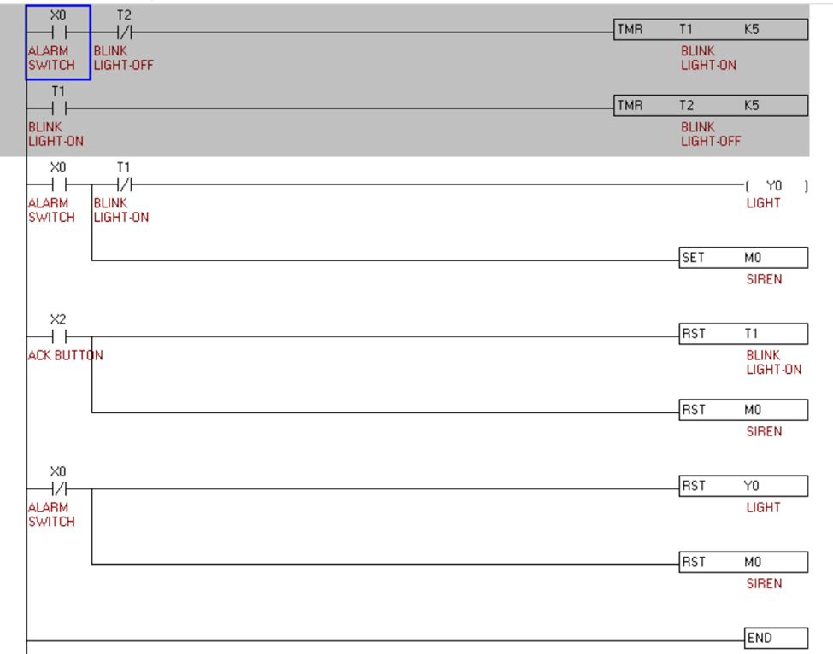1.A discrete input signal from an alarm

2. Write a program that will latch on a light 20 s after an input switch has been turned on. The timer will continue to cycle up to 20 s and reset itself until the input switch has been turned off. After the third time the timer has timed to 20s, the light will be unlatched.

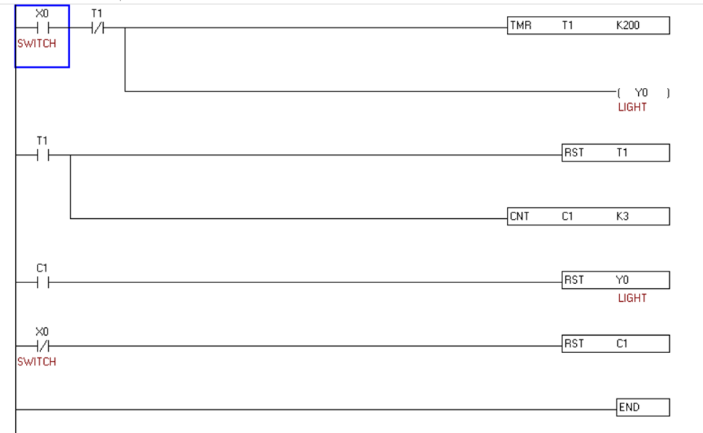

3.Write a program that will turn a light on when a count reaches 20. The light is then to go off when a count of 30 is reached.

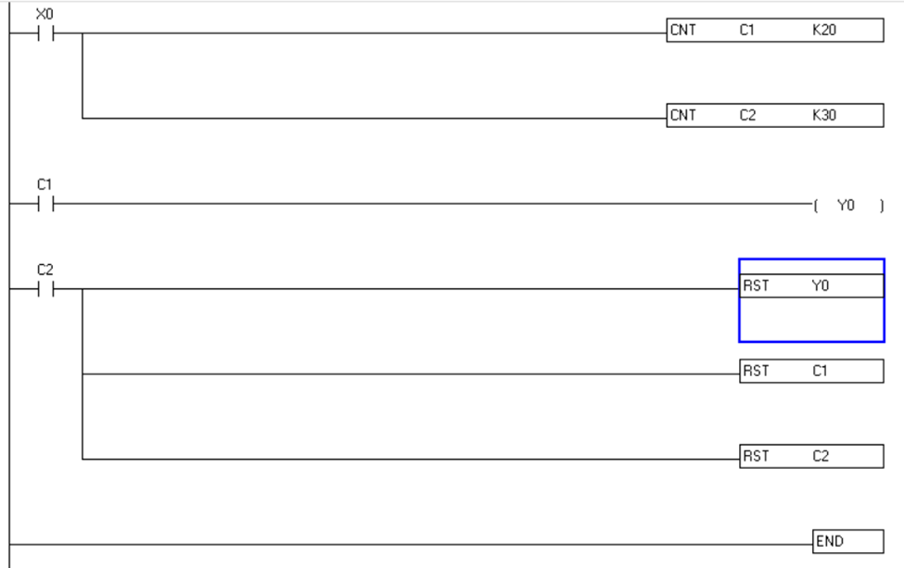

4.Write a program that will increment a counter's accumulated value 1 count every 60 s. A second counter's accumulated value will increment 1 count every time the first counter's accumulated value reaches 60. The first counter will reset when its accumulated value reaches 60, and the second counter will reset when its accumulated value reaches 12

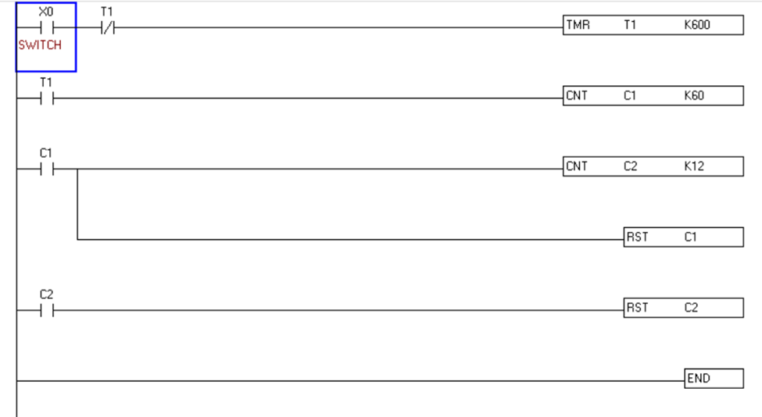

5. box-stacking

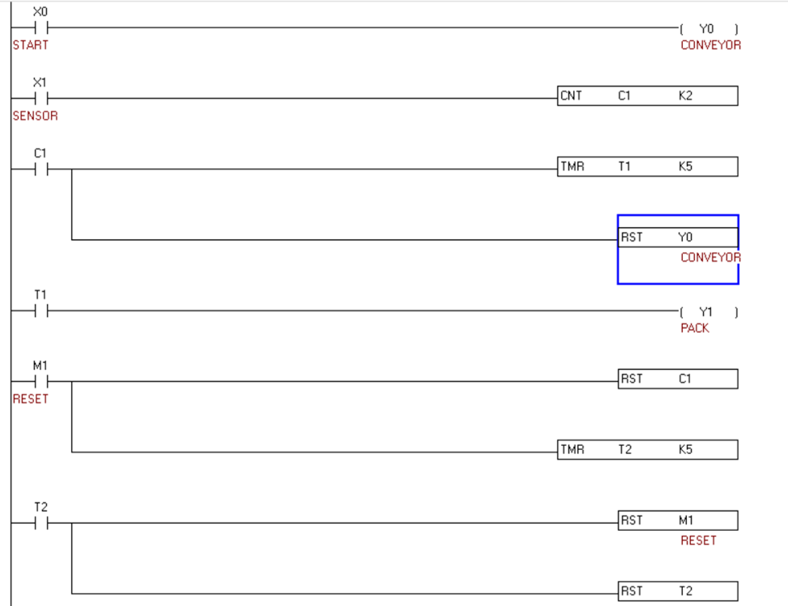

6.Detecting the standing bottles on the conveyor belt and pushing the fallen bottles.

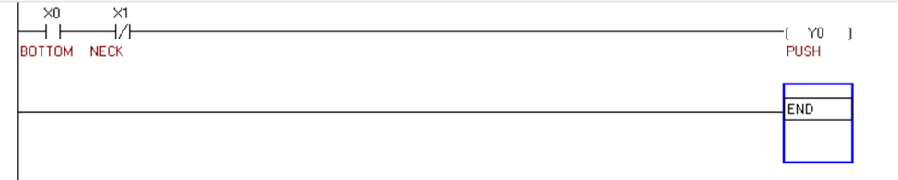

7. Fan by pressing two contacts for START and STOP

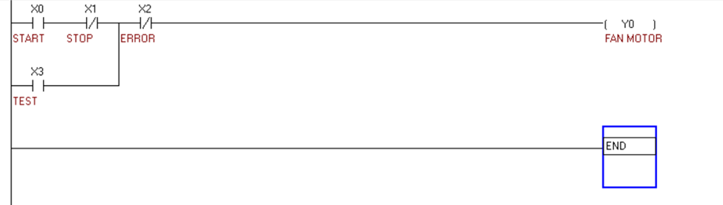

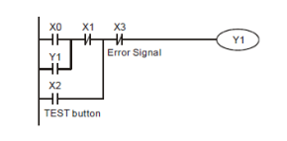

8. Two-way switch

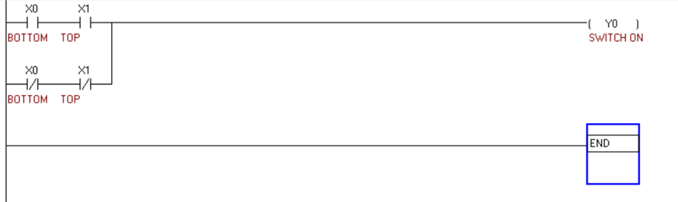

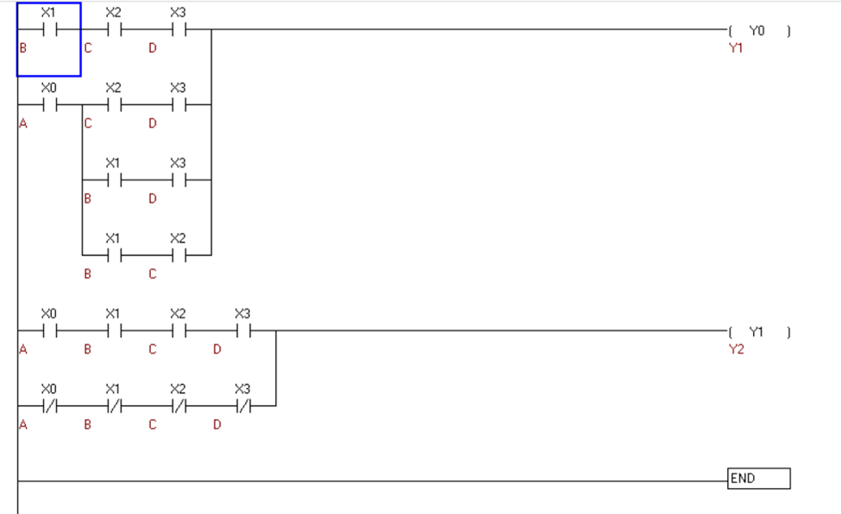9. A circuit has 4 inputs (A, B, C, and D) and 2 outputs (Y1, Y2). One of the outputs is high when majority of inputs are high. The second output is high when all inputs are of same type. Design the combinational circuit and implement it in PLC using Ladder Diagram programming language

10. The entry/exit of the parking lot is a single lane passage. By controlling the indicators, the program ensures that only one car can pass through the entry/exit so as to prevent car accident between entering and leaving cars

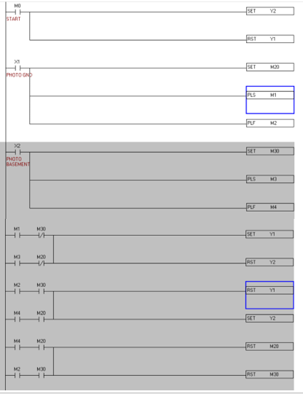

11.Turn on the switch, the light will be ON, turn off the switch, the light will be OFF. Construct using SET and RESET

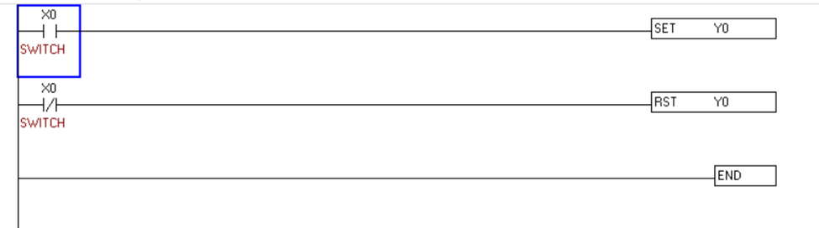

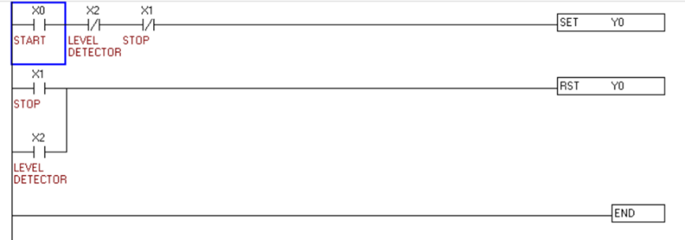12.Press START, the pump begins to pump out the water; press STOP or when the water is empty, the pump stops working

13.A PLC is to be used to control a floodlight. When a sensor with a normally open contact detects movement, the light is to switch on for 10 seconds and then switch off. Draw the necessary PLC wiring diagram and the ladder logic to operate the system as designed.

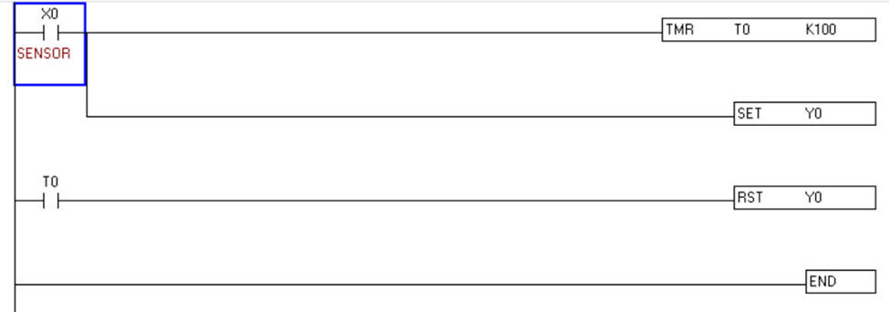

14.A PLC is to be used to control the drive for a car window. When a momentary contact switch is pressed the window starts to open. If the switch is closed for more than 1 second, the window continues opening until fully open. A second switch does the same thing to close the window. Limit switches are provided to detect the window’s fully open or fully closed positions. Draw the necessary PLC wiring diagram and the ladder logic to operate the system as designed.re

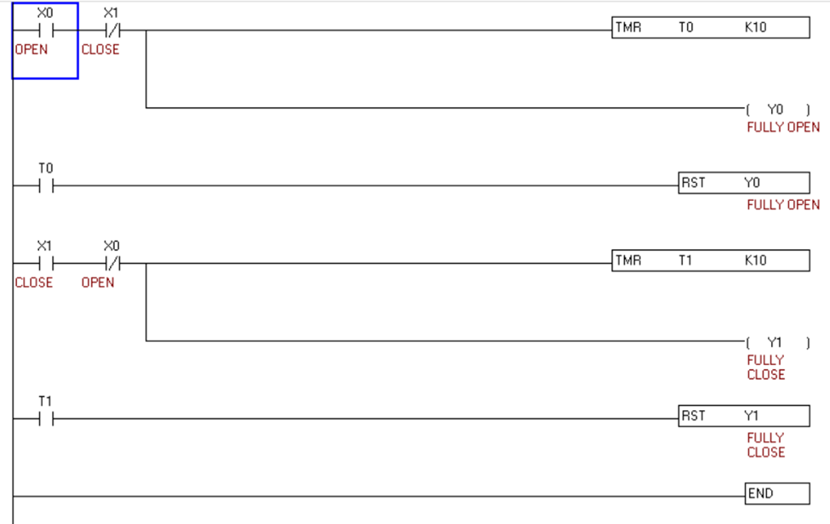

15.A PLC is used to control a conveyor system. A sensor with a normally open contact sees items passing on the conveyor. When 10 items have passed, the conveyor stops, a cylinder extends and retracts and the conveyor runs again until another 10 items have passed. Draw the necessary PLC wiring diagram and the ladder logic to operate the system as designed.

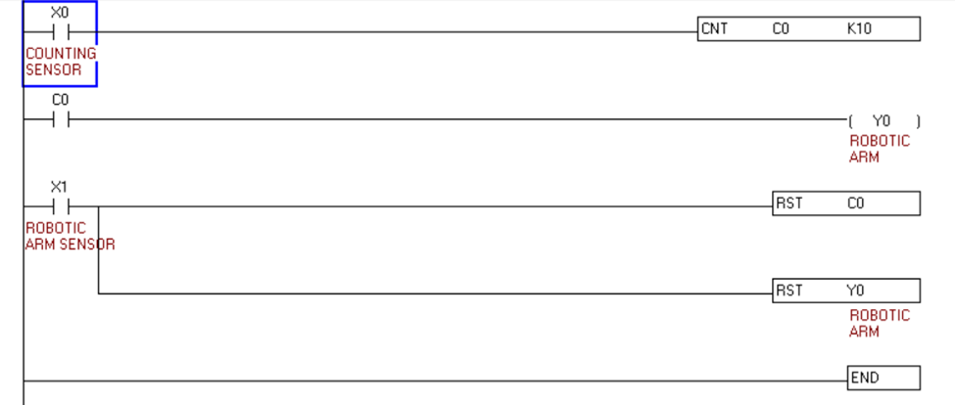

16.The motor is set to control for forward running when the Forward button is pressed and reverse running when the Reverse button is pressed. When the Stop button is pressed, the motor is set to stop its entire operation. Design the ladder program for the above control purpose

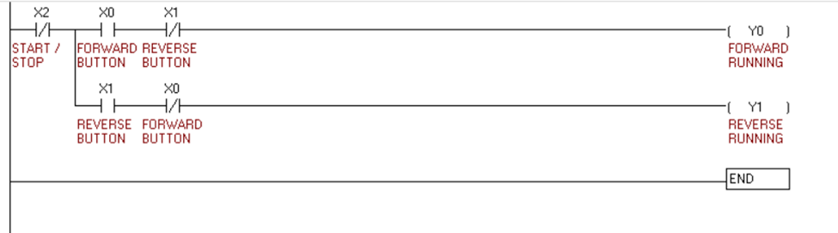

17. clock 24hours/3 conters

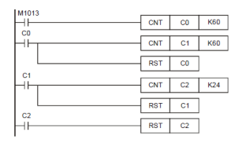

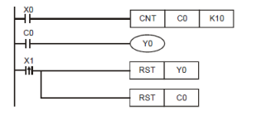18. box packaging robo arm/ackaging system with photo electronic sensor

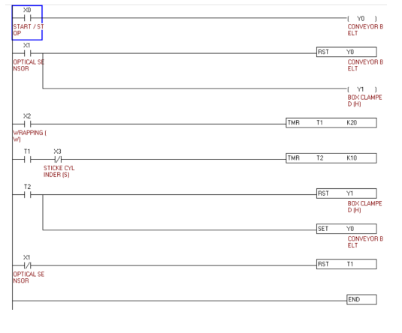19. chocolate box wrapping

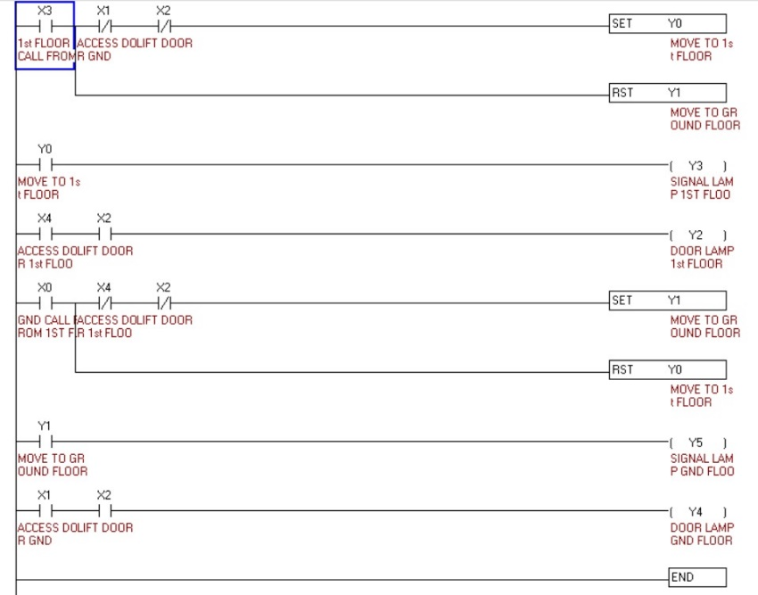20. Elevator