Keynote Outlook Add-In Guide

1. Download **MainModule.bas**
2. Open Outlook.
   1. Click on **File** -> **Options** -> **Customize Ribbon**
   2. 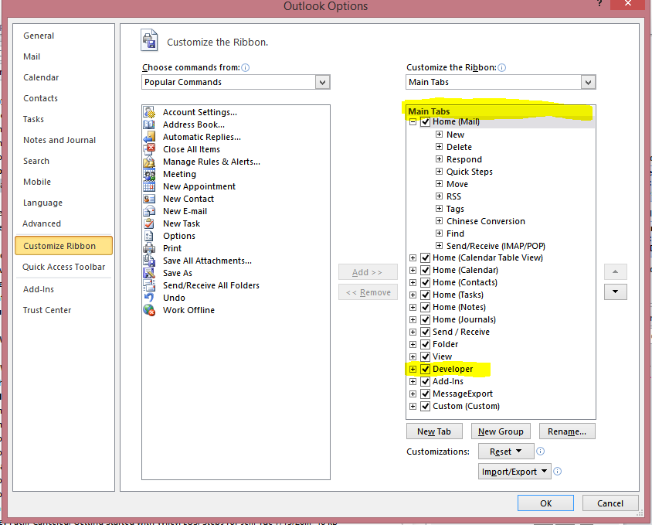On the **right list panel** (the box with “Main Tabs” at the top) **check off “Developer”**

1. Click **OK.** 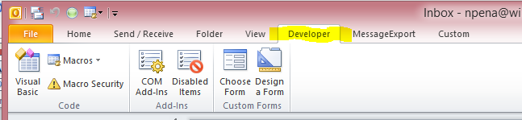The Developer Tab should now be visible.
2. On the top panel**, click on the** **Developer tab** 
   1. New Developer options will appear, click on the “**Visual Basic”** option.
   2. A new window will appear that looks as follows:

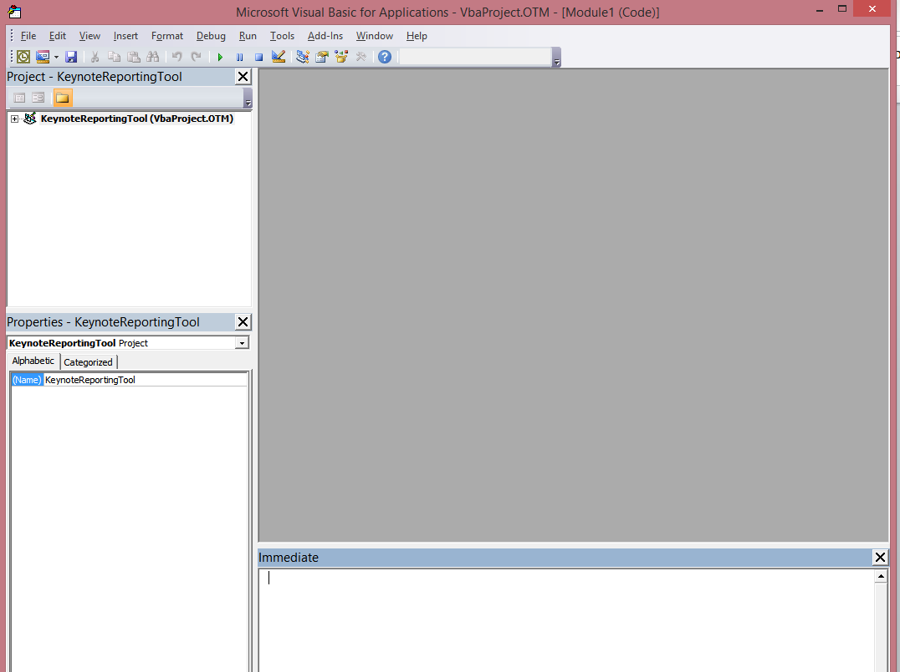

1. **Click on “File”** -> **Import File** -> **Select the MainModule.bas** file. This will bring the Keynote VBA module into your Outlook application. **Close the Developer window.**
2. To add the Keynote Tool button to the toolbar:
   1. **Click on the Quick Access Toolbar arrow** (see image)

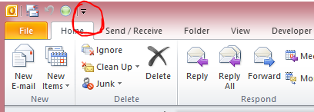

* 1. **Select the “More Commands…”** option.
  2. The following window will appear:
  3. 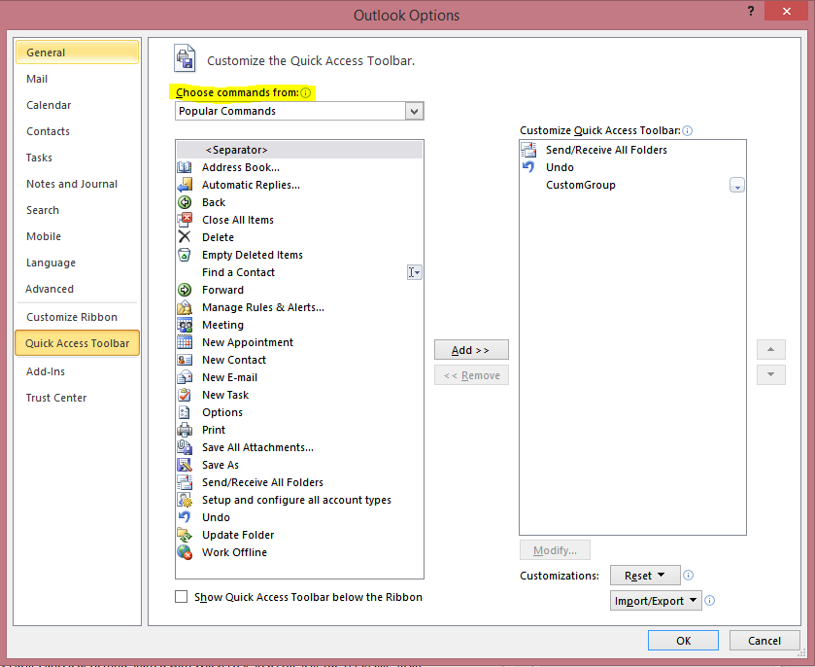**Click on the “Choose commands from:”** drop-down menu highlighted above.
  4. **Select “Macros”** from the drop-down list.

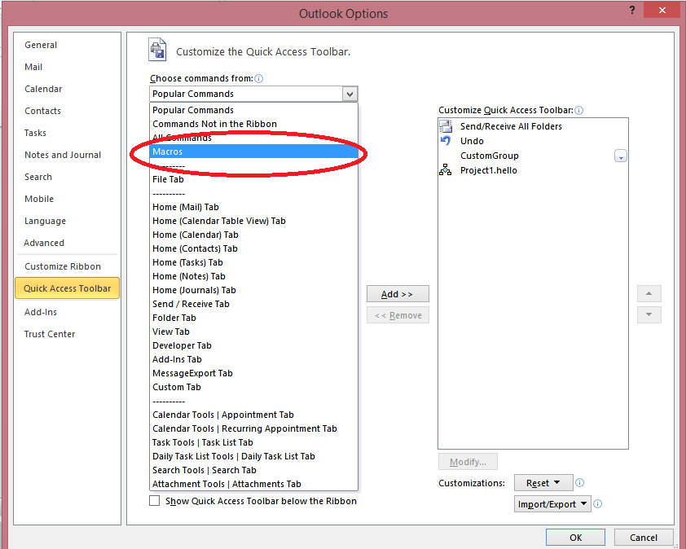

* 1. The following option should appear:
  2. 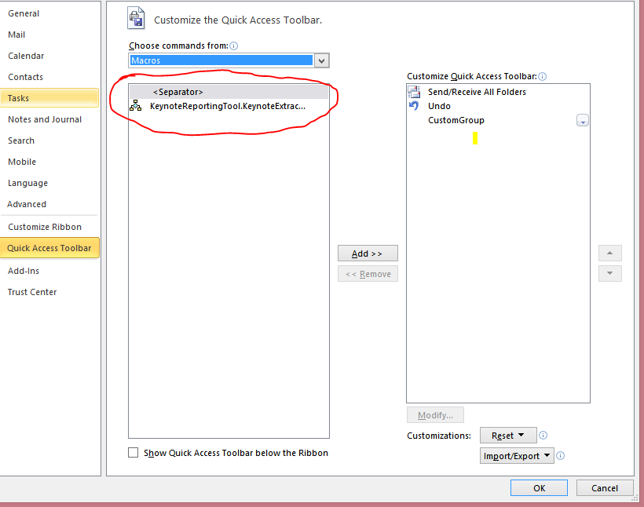**Select the KeynoteReportingTool…** option and **click the “Add>>”** button. It will cause it to appear on the right panel.
  3. **Click OK.**
  4. A new icon will appear on the quick access toolbar. This is the KeynoteTool button. Click on it to run the tool