

|  |  |  |  |  |
| --- | --- | --- | --- | --- |
| Future Program Batch 2.0 |  | Agitha Pramesti  Sembiring |  | Nadya Purbaningrum |

Software Requirements Spesification

[System Point of Sale for Book Store “ Jogmedia ”]

Table of Contents

1. Introduction
   1. Purpose
   2. Product Scope
   3. Definitions and Acronyms
      1. Definitions
      2. Acronyms
2. Overall Description Software
   1. Product Functionallity
      1. Transactions Module
      2. Administration Module
      3. Report Module
   2. End Users and Characteristic
   3. System Boundary
3. Spesific Requirements
   1. Functional Description
      1. Use Case Diagram
      2. Function 1: Order Book
         1. Scenario: Order Book
         2. Activity Diagram: Order Book
         3. Flowchart Diagram
      3. Function 2: Check Price Of Book
         1. Scenario: Check Price Of Book
         2. Activity Diagram: Check Price Of Book
      4. Function 3: Add Data Master
         1. Scenario: Add Data Master
         2. Activity Diagram: Add Data Master
      5. Function 4: Show Discount Book
         1. Scenario: Show Discount Book
         2. Activity Diagram: Show Discount Book
      6. Function 5: Show Out Of Stock Book
         1. Scenario: Show Out Of Stock Book
         2. Activity Diagram: Show Out Of Stock Book
      7. Function 6: Edit Data Master
         1. Scenario: Edit Data Master
         2. Activity Diagram: Edit Data Master
      8. Function 7: Show Income Store
         1. Scenario: Show Income Store
         2. Activity Diagram: Show Income Store
      9. Function 8: Show Detail Transaction
         1. Scenario: Show Detail Transaction
         2. Activity Diagram: Show Detail Transaction
   2. Non-Functional Requirements
   3. ERD and PDM
   4. UI
4. 1. Introduction 3

1.1 Purpose

1.2 Product Scope

1.3 Definitions and Acronyms

1. 2. Overall Description Software 4
2. 3. Spesific Requirements 5

# Introduction

* 1. Purpose

A point-of-sale (POS) transaction is what takes place between a merchant and a customer when a product or service is purchased, commonly using a point of sale system to complete the transaction. This document is meant to delineate the Software Requirement Spesification(SRS) of POS. So as to delineate the SRS, this document will provide an explaination of the software to be built in general and detail explanation.  Through the SRS document the software development  is expected to be more focused and does not cause ambiguity, especially for software system software developers. The Point of Sale for book store is intended to provide solution for vendors as well as customers through a single way using the system to manage the transaction and archiving the books.

* 1. Product Scope

Jogmedia POS  help the book store's owner by store the following information with every purchase made by customers: a unique transaction number assigned to every transaction, discounts applied to the book ( if any ), and the total price of all the items bought. For the database of transaction, the system will only store information about the date of transaction, total price, and book id offered in the book store. The system shall be able to store the unique product identification number, the product name, the selling price, for each item in the database. In generating reports, the system will display best selling books reports and the income by the manager’s role, the report( general ledger ) is divided into weekly, monthly,and yearly. And user can view the detail transaction any time he wishes, to do so, he or she must input a spesific date. And also this system will store the information about all of the books,categories, employees that user ( with manager’s role ) input.

* 1. Definitions and Acronyms
     1. Definitions
* Manager’s roles : Someone who has role as manager, this role is usually used by Jogmedia owners and certain people.
* Cashier’s roles: Someone who has role as cashier.
* Product: physical product.
* Use Case: a list of actions or event steps typically defining the interactions between a role and a system to achieve a goal.
  + 1. Acronyms
* POS – Point Of Sale
* SRS – Software Requirements Spesification
* ERD – Entity Relationship Diagram
* UI – User Interface
* PDM – Physical Data Model

# Overall Description Software

* 1. Product Functionallity
     1. Transactions Module

The Transactions Module provides facilities for the cashier to record and manage customer orders. Including Add order, Cancel order, Calculate total order and Print Invoice. Users that can access this module only users with role: Manager and Cashier.

* + 1. Administration Module

The Administration Module provides facilities for the user with manager’s role to manage books, categories, employees, and store details. Including Add item, Edit item, Soft delete item. This system doesn’t provide delete function for each item, but this system only perform soft delete function, this function will change the status of each item becomes non-active or active. Users that can access this module only users with role: Manager.

* + 1. Report Module

The reports module provides facilities for the manager to view general ledger weekly, monthly, and yearly. And also view detail transaction by input the spesific date.

* 1. End Users and Characteristic

There are only two types or roles available in the system, which are role for the cashier and manager. Each of these roles has different system usage, for the cashier will be able to perform transaction processing and print receipt. The manager's role is to manage data master whether adding data, updating data, and soft deleting data. Manager also play a role in managing employees or users who can access the system, updating information about the bookstore, and get reports from the system. Each user will have a different username and password to log in to the system. Here is a list of the functions available to users by role :

|  |  |  |  |
| --- | --- | --- | --- |
| **User Category** | **Task** | **Access rights** | **Capability** |
| Manager | * + Able to add new book data   + Able to update book data   + Able to activate book data   + Able to add new category   + Able to add update category   + Able to add new employee   + Able to activate employee   + Able to do transaction   + Able to displays income store   + Able to see detail transaction   + Able to create, update, and activate data master | All | Able to operate computer. |
| Cashier | * + Able to book order   + Able to check price book   + Able to do transaction | Feature transaction. | Able to operate computer. |

**Characteristic users**

* 1. System Boundary

Development of Information System Jogmedia has boundary:

1. Information System Jogmedia develop with Java.
2. Framework used is Spring boot.
3. Jogmedia is based on website application
4. Supporting software used is postgresql, bootstrap, and jQuery
5. The input that can be accepted by the system, in the form of text, number, some of the characters. (A-Z, a-z, 0-9, *whitespace*, *backspace*, *newline*, and characters other than letters in ASCII), and date/time.
6. Jogmedia used to operate in English Language.

# Spesific Requirements

* 1. Functional Description
     1. Use Case Diagram

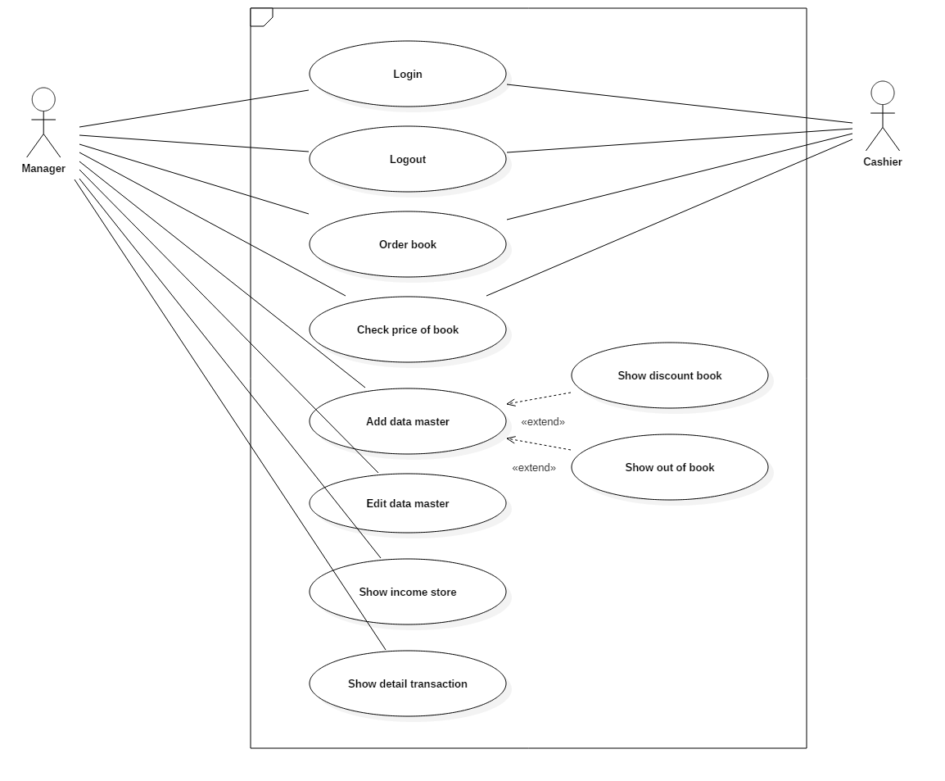

* + 1. Function 1: Order Book
       1. Scenario: Order Book

|  |  |
| --- | --- |
| **Use Case Name** | **Order Book** |
| Use Case Code | UC01 |
| Actor | Cashier |
| Description | Cashier add order by input some data needed. |
| Trigger | Cashier goes to transaction page. |
| Initial Condition | Cashier add order book yet. |
| Flow | Related information |
| 1. Cashier input isbn of book 2. System display table by the search of isbn 3. Cashier input quantity of book order 4. Cashier click buy 5. System show table cart 6. Cashier could continue or cancel order (by click ‘x’) 7. Cashier click button ‘pay’ 8. System show total payment order 9. Cashier input quantity of payment buyer 10. System show change by calculate total payment order – total quantity payment from buyer 11. Cashier klik button print | * + - 1. Menu available on system       2. Data available on system |
| Final Condition | Book ordered |

* + - 1. Activity Diagram

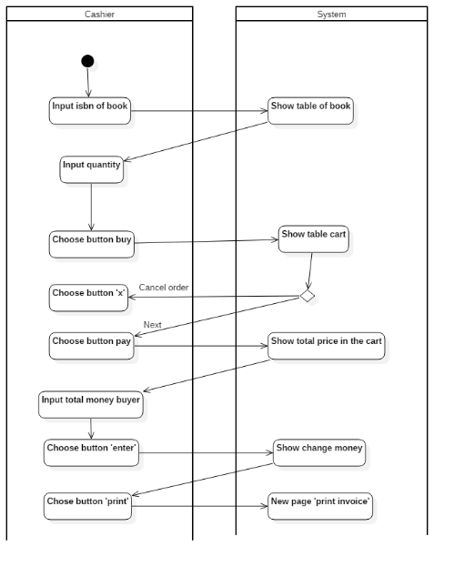

**Picture 2 Activity Diagram Order Book**

* + 1. Function 2: Check Price Of Book
       1. Scenario: Check Price Of Book

|  |  |
| --- | --- |
| **Use Case Name** | **Check price of book** |
| Use Case Code | UC02 |
| Actor | Cashier |
| Description | Cashier check the price of book |
| Trigger | Cashier goes to transaction page |
| Initial Condition | Cashier doing nothing |
| Flow | Related Information |
| 1. Cashier input isbn of book 2. System display table by the search of isbn 3. Cashier input quantity of book order 4. Cashier click buy 5. System show table cart | * 1. Menu available on system   2. Data available on system |
| Final Condition | Cashier get information price of book |

* + - 1. Activity Diagram: Check Price Of Book

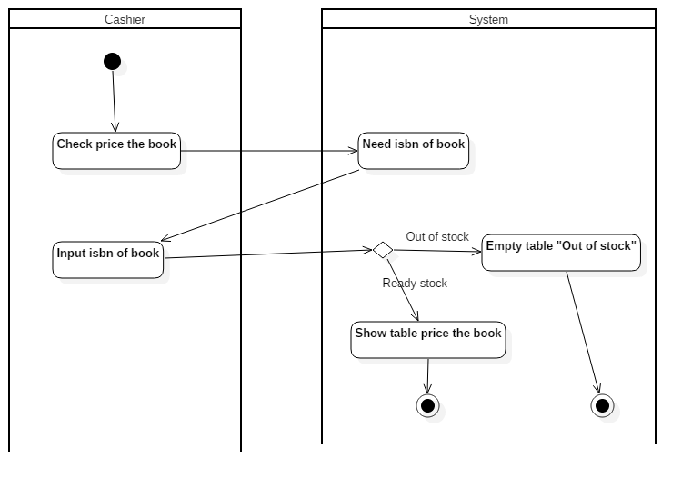

**Picture 3 Activity Diagram Check price of book**

* + 1. Function 3: Add Data Master
       1. Scenario: Add Data Master

|  |  |
| --- | --- |
| **Use Case Name** | **Add data master** |
| Use Case Code | UC03 |
| Actor | Manager |
| Description | Manager records the data master needed. There are 3 masters : book, category, employee. |
| Trigger | Manager goes to ‘master’ page. |
| Initial Condition | Manager doing nothing. |
| Flow | Related information |
| 1. Manager go to ‘master’ page 2. System show the page 3. Manager choose button ‘add new’ 4. System show page form of detail master needed. 5. Manager fill in the blank. 6. Manager choose button ‘save’. 7. System show master page if success. | * + 1. Form add data master     2. Menu available on system     3. Data available on system |
| Final Condition | Manager get new information for master data. |

* + - 1. Activity Diagram: Add Data Master

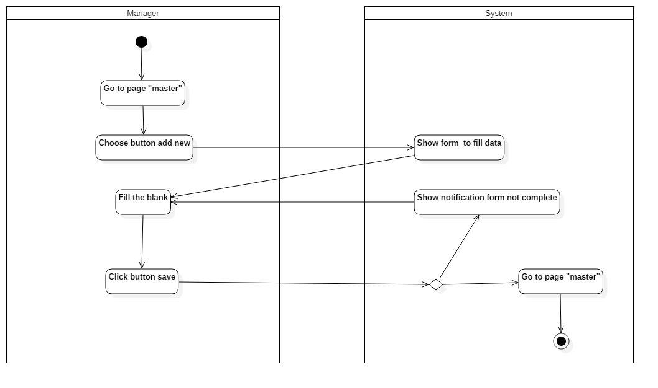

**Picture 4 Activity Diagram Add data master**

* + 1. Function 4: Show Discount Book
       1. Scenario: Show Discount Book

|  |  |
| --- | --- |
| **Use Case Name** | **Display discount book** |
| Use Case Code | UC04 |
| Actor | Manager |
| Description | Manager can show table discount book. |
| Trigger | Manager goes to book master page. |
| Initial condition | Manager know book discount book yet. |
| Flow   1. Manager goes to book page. 2. System show the book page. 3. Manager choose menu discount 4. System show the discount book page 5. Manager get information of discount book | Related information  1. Chosen menu  2. Book discount data |
| Final Condition | Manager get information of discount book |

* + - 1. Diagram Activity: Show Discount Book

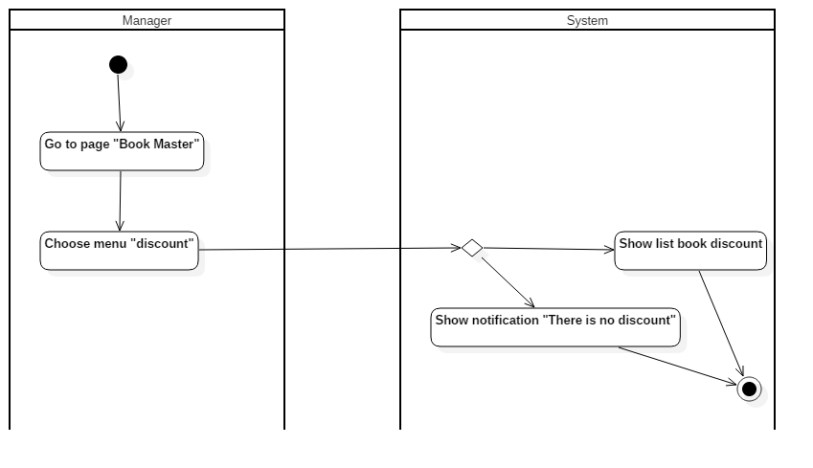

**Picture 5 Activity diagram Show discount book**

* + 1. Function 5: Show Out Of Stock Book
       1. Scenario: Show Out Of Stock Book

|  |  |
| --- | --- |
| **Use Case Name** | **Show out of stock book** |
| Use Case Code | UC05 |
| Actor | Manager |
| Description | Manager can show table out of stock book. |
| Trigger | Manager goes to book master page |
| Initial Condition | Manager know out of stock book yet. |
| Flow   1. Manager goes to book page. 2. System show the book page. 3. Manager choose menu discount 4. System show the discount book page   Manager get information of discount book | Related information  1. Chosen menu  2. Out of stock book data |
| Kondisi Akhir | Pengunjung berhasil mengisikan form kritik dan saran |

* + - 1. Diagram Activity: Show Out Of Stock Book

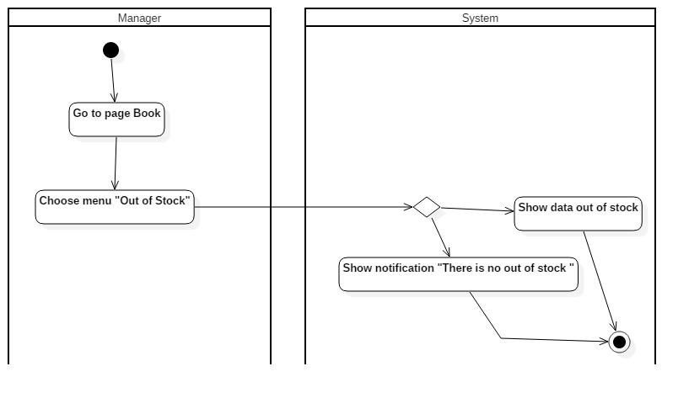

**Picture 6 Activity Diagram Show out of stock book**

* + 1. Function 6: Edit Data Master
       1. Scenario: Edit Data Master

|  |  |
| --- | --- |
| **Use Case Name** | **Edit data master** |
| Use Case Code | UC06 |
| Actor | Manager |
| Description | Manager can edit data of master |
| Trigger | Manager goes to master page |
| Initial Condition | Manager doing nothing |
| Flow   1. Manager goes to ‘master’ page 2. System show the page 3. Manager choose button ‘edit’ 4. System show page form of detail master needed. 5. Manager edit data in the form. 6. Manager choose button ‘save’. 7. System show master page if success. | Related information  1. Menu available on system  2. Data available on system  3. Form edit data master |
| Final Condition | Manager can update data of master |

* + - 1. Diagram Activity: Edit Data Master

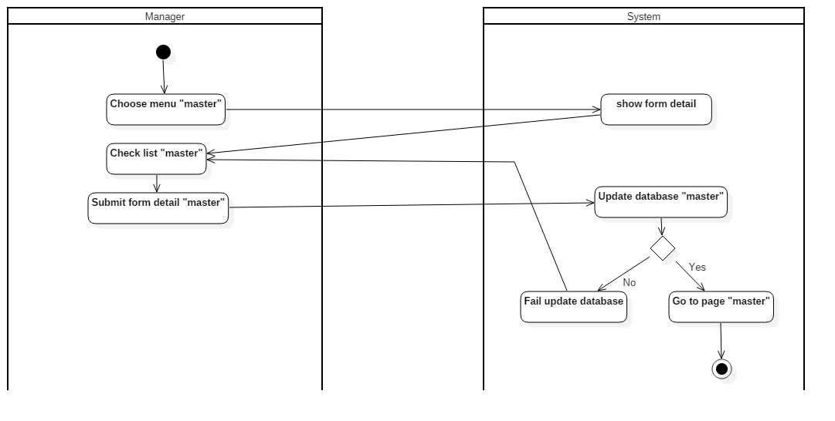

**Picture 7 Activity diagram Edit data master**

* + 1. Function 7: Show Income Store
       1. Scenario: Show Income Store

|  |  |
| --- | --- |
| **Use Case Name** | **Show income store** |
| Use Case Code | UC07 |
| Actor | Manager |
| Description | Manager displays income earned by time |
| Trigger | Manager goes to report page |
| Initial Condition | Incoming financial statement view has not yet appeared |
| Flow   1. Manager goes to report page. 2. System displays table containing the weekly income (default) 3. Manager can display report by time (week, month, year) | Informasi yang terkait   1. Menu chosen 2. Financial data 3. Financial data for week 4. Financial data for month 5. Financial data for year |
| Final Condition | Manager can already see financial income by time |

* + - 1. Activity Diagram: Show Income Store

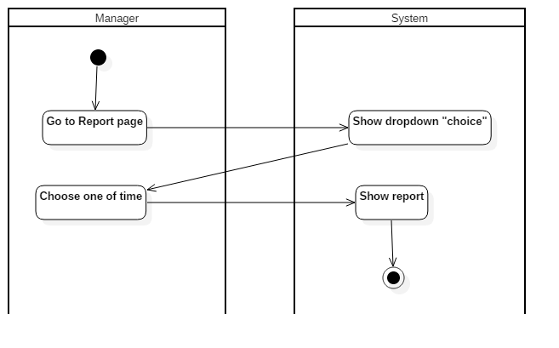

**Picture 8 Activity Diagram Show income store**

* + 1. Function 8: Show Detail Transaction
       1. Scenario: Show Detail Transaction

|  |  |
| --- | --- |
| **Use Case Name** | **Show detail transaction** |
| Use Case Code | UC08 |
| Actor | Manager |
| Description | Manager displays transactions that occur by datetime |
| Trigger | Manager goes to detail transaction page |
| Initial Condition | Report of detail transaction has not yet appeared |
| Flow   1. Manager goes to report page. 2. System displays table containing the weekly income (default) 3. Manager choose menu detail transaction 4. System displays a blank table preview with input pick date 5. Manager pick a date and choose button ’search’ 6. System displays table containing detail transaction by date | Related information   1. Menu yang dipilih 2. Data keuangan 3. Nama bulan 4. – 5. Data keuangan satu bulan |
| Final Condition | Manager can already see the detail transaction issued |

* + - 1. Activity Diagram: Show Detail Transaction

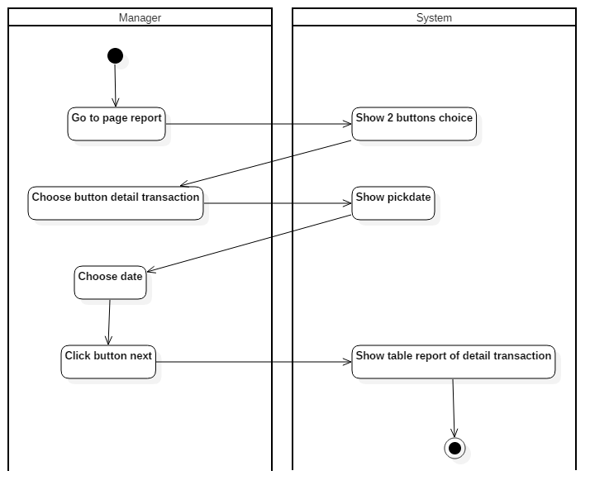

**Picture 15 Show detail transaction**

3.1.3 Flowchart Diagram

1. Cashier

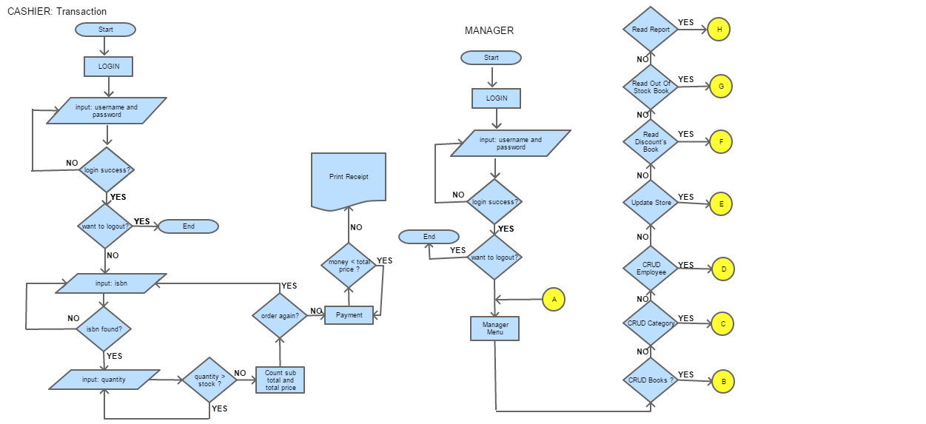

1. Manager



1. Book

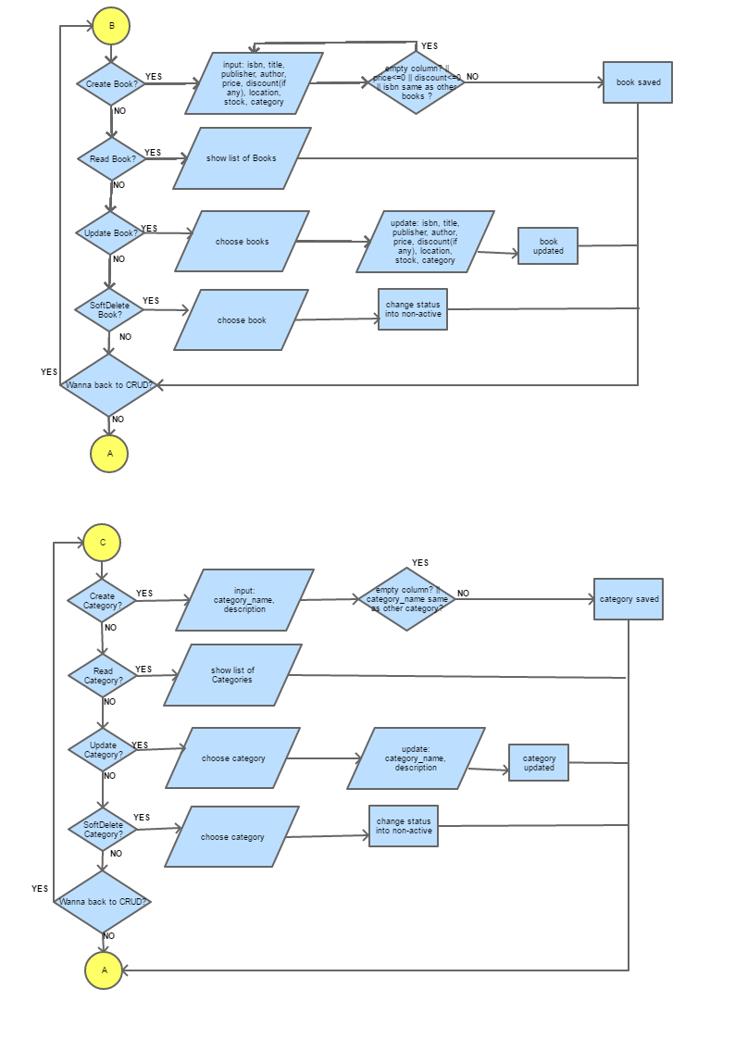

1. Category



1. Employee

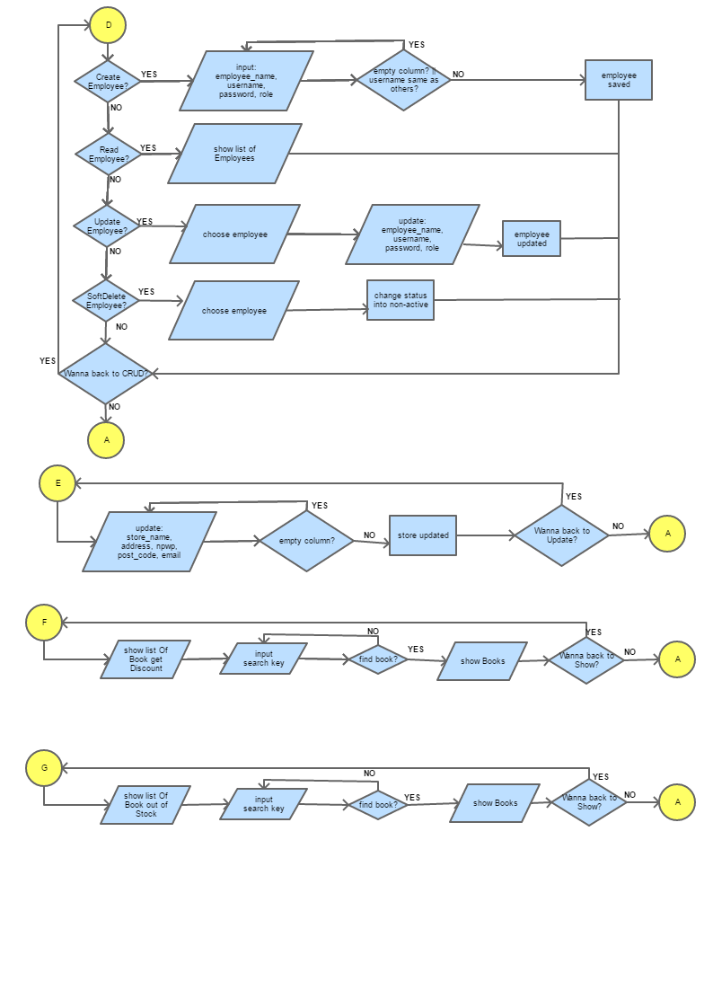

1. Store



1. General Ledger

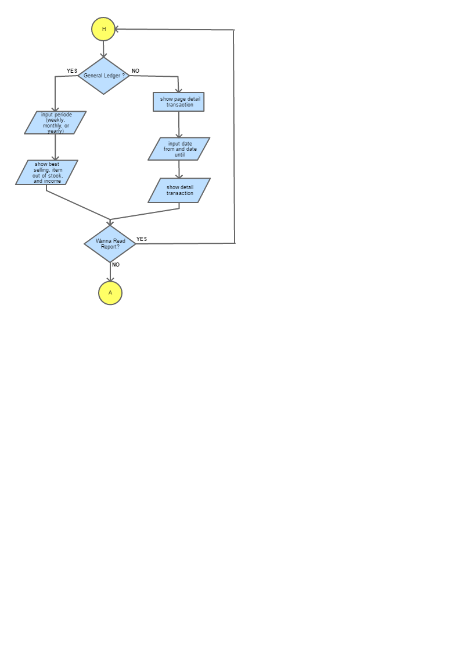

* 1. Non-Functional Requirements

Following Non-Functional Requirements:

* 24x7 availability
* Reliability
* Security : Unauthorized users are not allowed access to parts of system. All users of the system must be uniquely identified. This could be done by using a username and password.
  1. ERD and PDM
* ERD
* PDM



* 1. UI
     1. Opening Page: Login



This is the login page which is the opening page that will be showed when we run the project, every users shall to input the correct username and password.

* + 1. Menu



This is the available menu that user can access, for the manager’s role they can access both of the menu but for cashier’s role can only access the cashier’s menu.

* + 1. Manager – Book Management

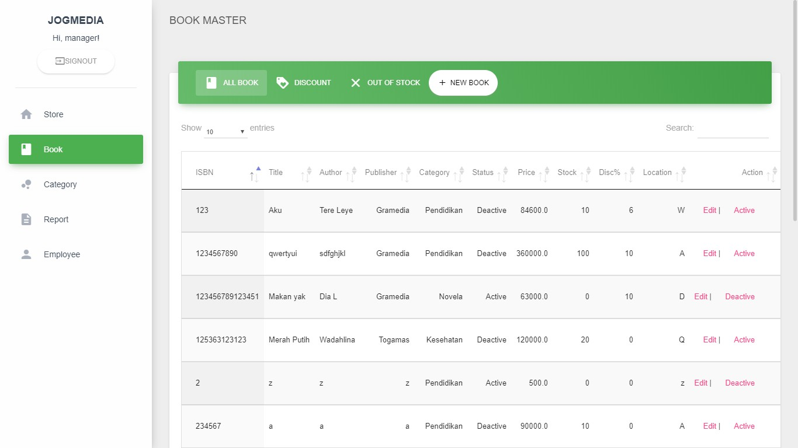

This is the first page that appears when user accesses the menu manager, this page will show all of the items or books that saved in the database with some columns like isbn, title, author, publisher, category, status, price, stock, discount,and location. The table data will displayed data as many as user's input in the top left corner. For every single of data rows has two actions which are edit and active( or deactive ) button. When the edit button is clicked then the system will display edit book page and when active button is clicked then automatically the status will change. In the top right corner there’s a search function, when user input a search key then system will display all books with isbn or title book contains the search key. At the top of this page there are several navbar menus such as discount, out of stock, new book. If the user accesses each of the menus then the system will display according to the title of the menu .At the top of this page there are several navbar menus such as discount, out of stock, new book. If the user accesses each of the menus then the system will display according to the title of the menu.

* + 1. Manager – Book Management: Add New Book

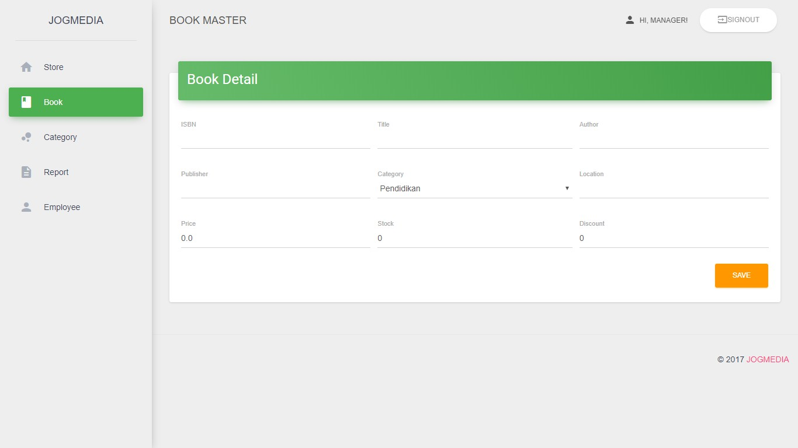

This page will be showed when user click button new book, in this page user can input the information about book such as isbn, title, author, publisher, category, location, price, stock, and discount ( if any ). Every book have a unique ISBN and the length is 13 for international standard. User click save and the book automatically saved in the database.

* + 1. Manager – Book Management: Edit Book

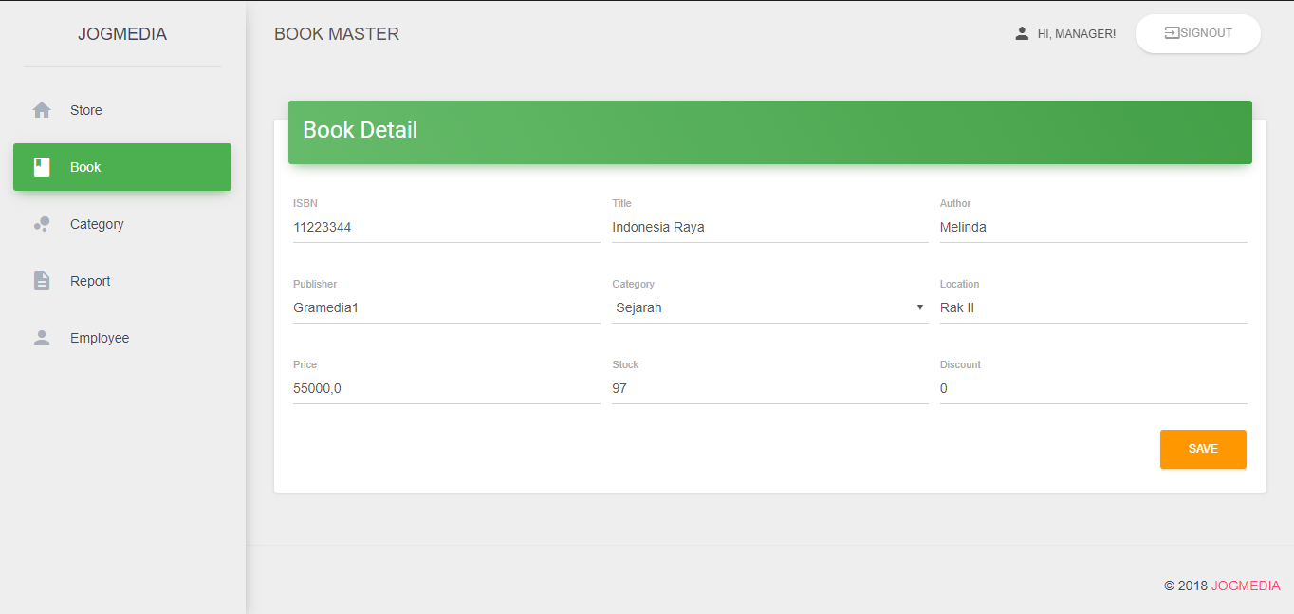

This page will be showed when user click button edit, in this page user can update the information about book such as title, author, publisher, category, location, price, stock, and discount ( if any ). User click save and the book automatically updated in the database.

* + 1. Manager – Category Management

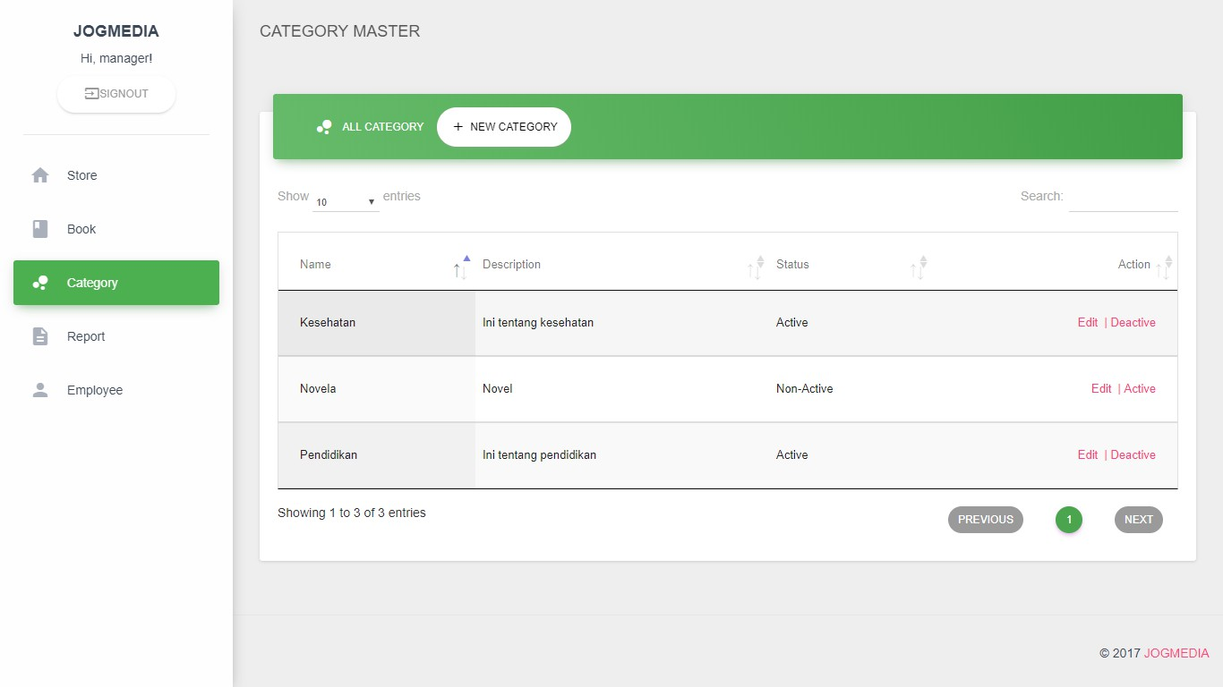

This page will be showed when users choose sub menu category, this page will display all category available from database, user can disable the category by click the deactive button and automatically the category won’t available in the drop down when user create book. User can search the category by input a search key in the top right corner.

* + 1. Manager – Category Management: Add Category

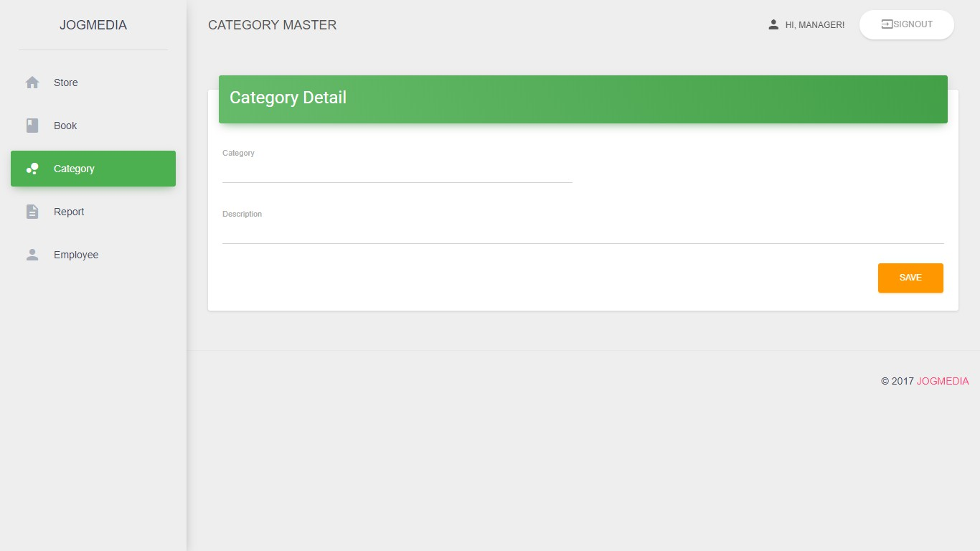

This page will be showed when user click button new category, in this page user can input the information about category such as category name and description. Every category name has an unique category name. User click save and the book automatically saved in the database.

* + 1. Manager – Category Management: Edit Category

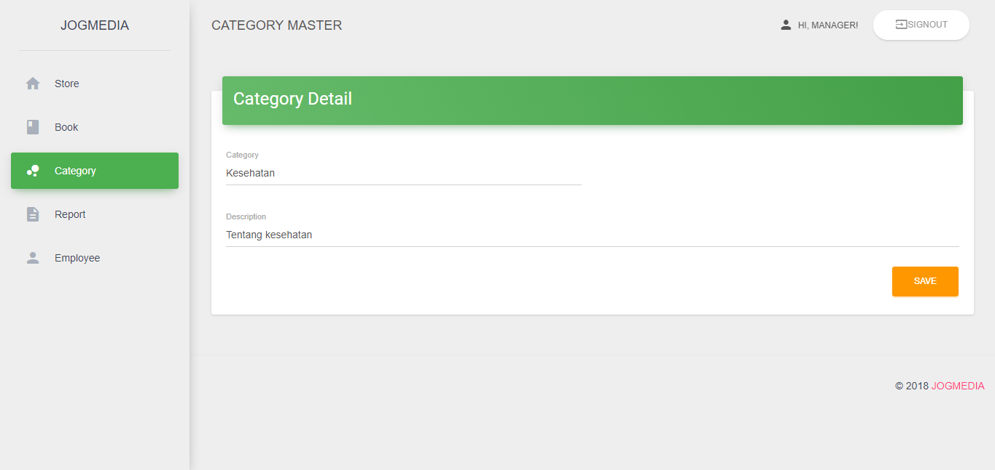

This page will be showed when user click button edit, in this page user can update the information about category such as category name and description. User click save and the category automatically updated in the database.

* + 1. Manager – Employee Management

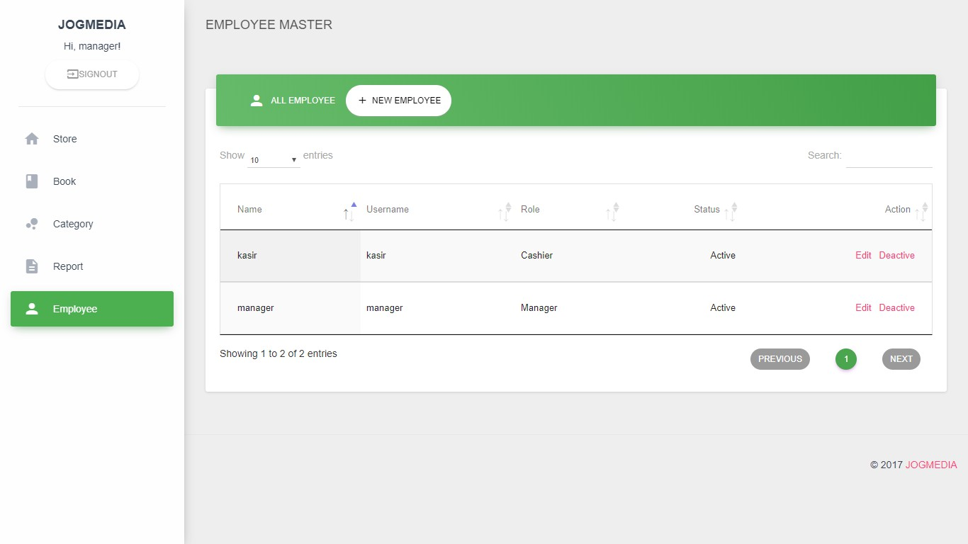

This page will be showed when users choose sub menu employee, this page will display all employees available from database, user can disable the employee by click the deactive button and automatically the status will change. User can search the employee by input a search key in the top right corner.

* + 1. Manager – Employee Management: Add New Employee

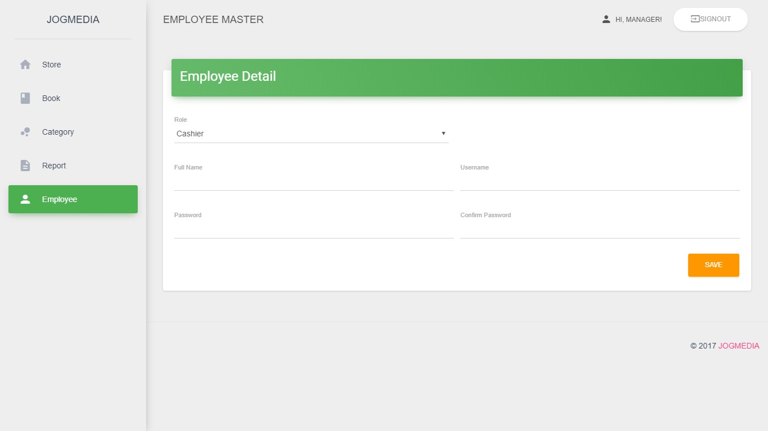

This page will be showed when user click button new employee, in this page user can input the information about employee such as role, name, username, password and confirm password. Every employee has an unique username. User click save and the employee automatically saved in the database.

* + 1. Manager – Employee Management: Edit Employee

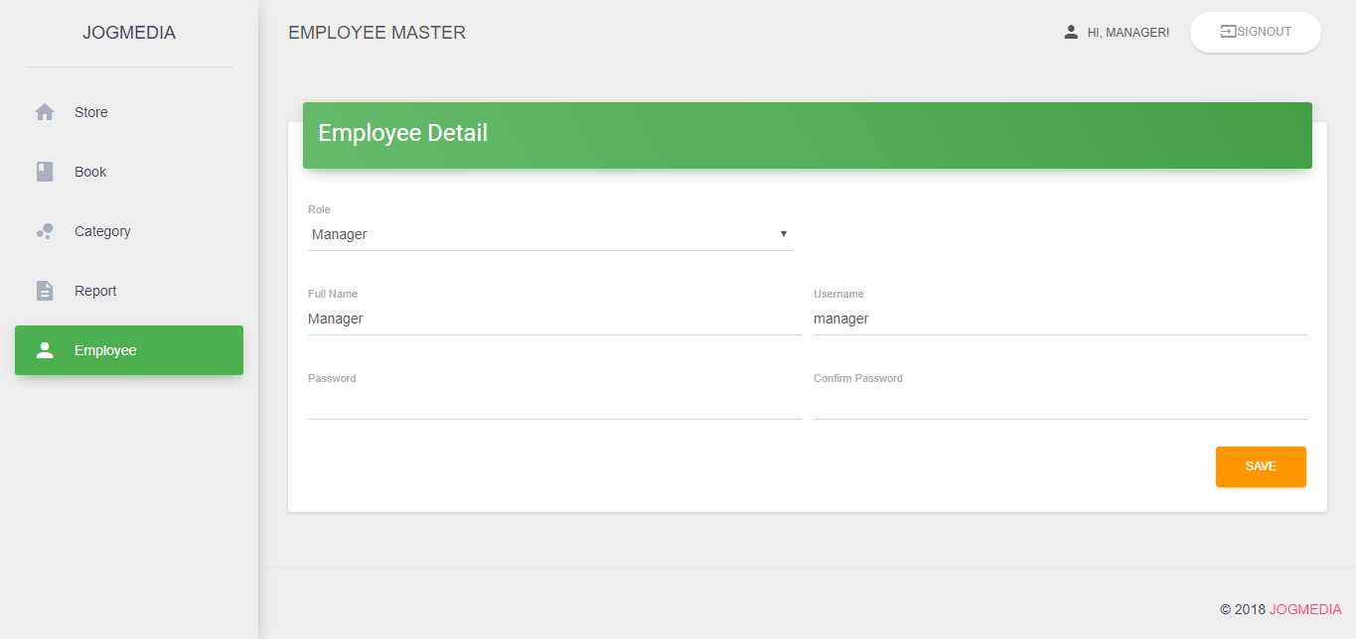

This page will be showed when user click button edit, in this page user can update the information about category such as category name and description. User click save and the category automatically updated in the database.

* + 1. Manager – Store Management

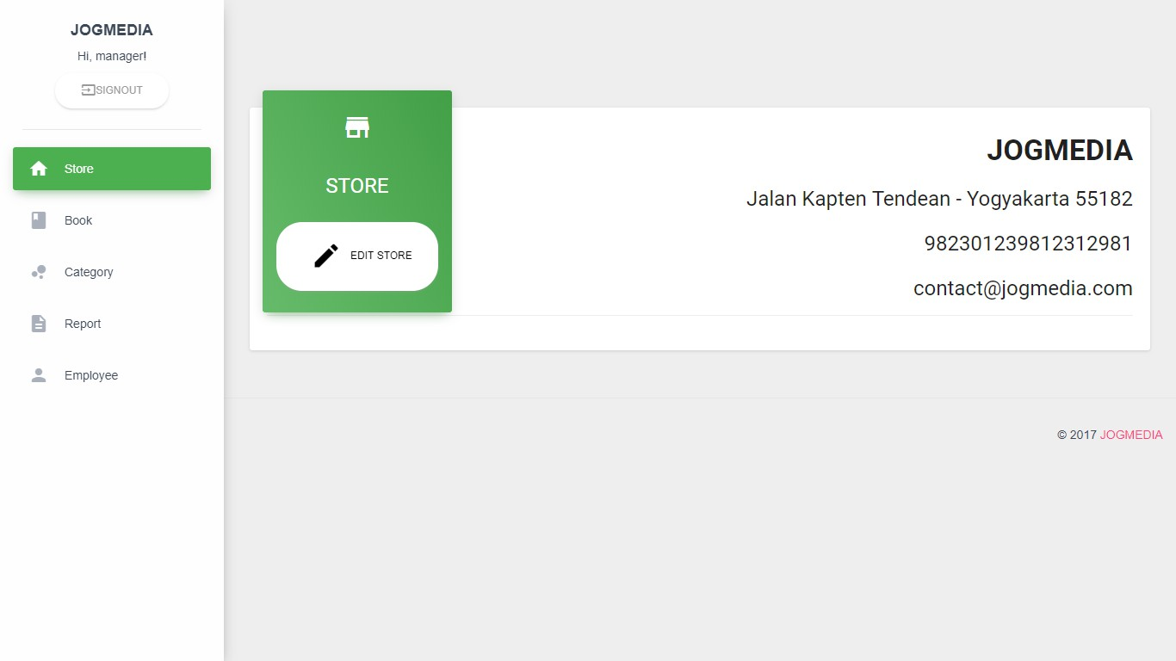

This page will show the information about store such as the name of the book store, address, post code, npwp, and email address of the book storre.

* + 1. Manager – Store Management: Edit Store

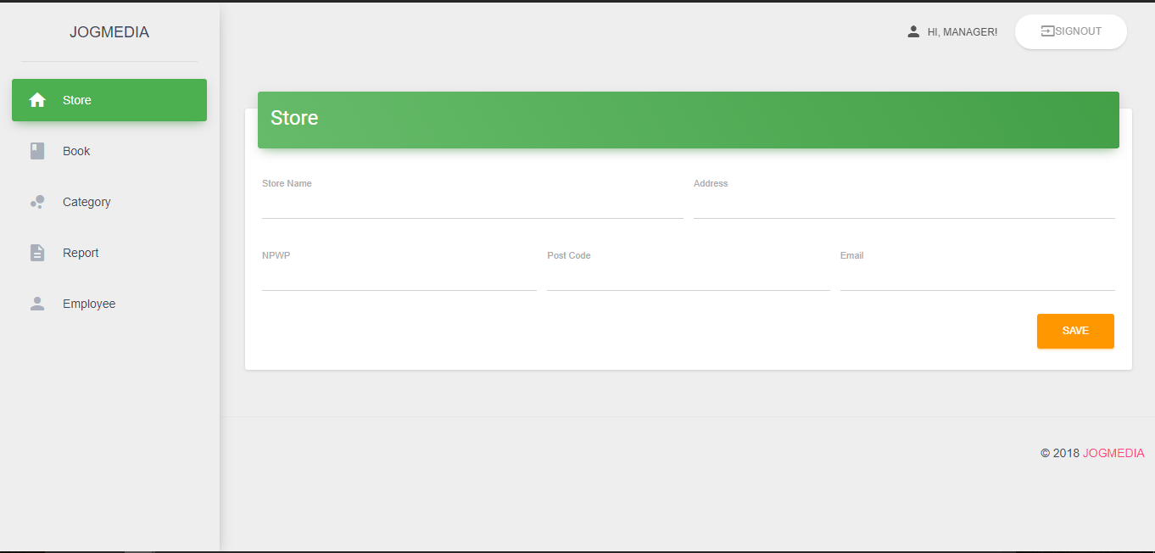

This page will be showed when user click button edit store, in this page user can update the information about store such as store name, address, npwp, post_code, and email address. User click save and the store automatically updated in the database.

* + 1. Manager – Report: General Ledger

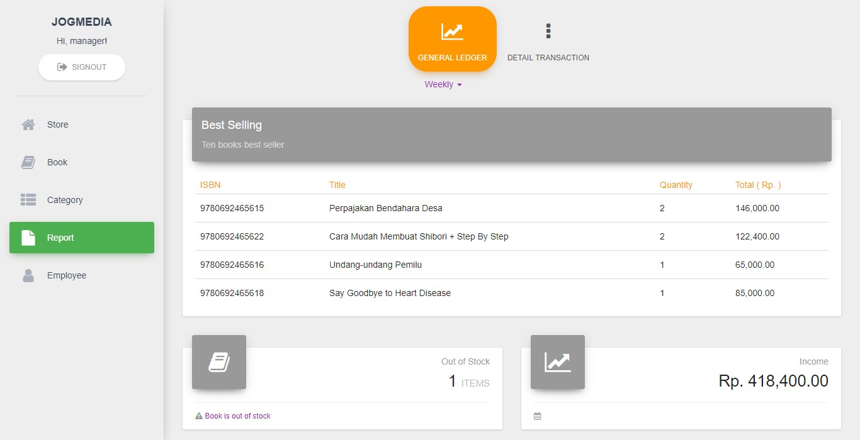

This page will display the general ledger by certain periode. User can choose the periode such as weekly, monthly, and yearly so system will display best selling book, item out of stock, and income in that periode.

* + 1. Manager – Report: Detail Transaction

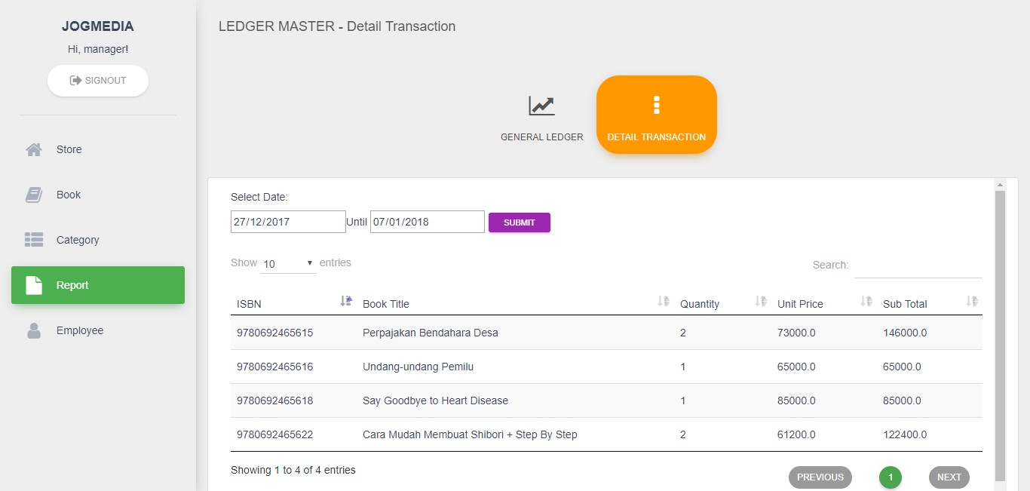

This is the detail transaction page, user need to input the spesific date and then system will show the detail transaction by the date that user had been entered.

* + 1. Cashier – Transaction Management

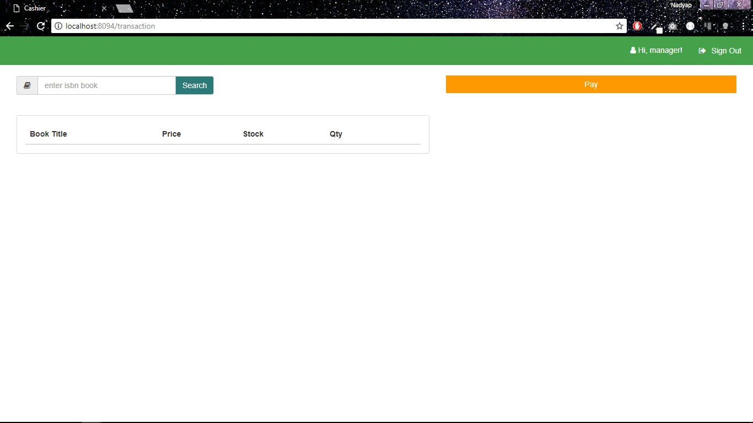

This is the first page when user access menu cashier, this page does not display anything if book order has not occurred yet. Search bar located at the top of the right function to search the book by entering isbn value, if isbn is found then it will be displayed.

* + 1. Cashier – Transaction Management: Add Book To Cart

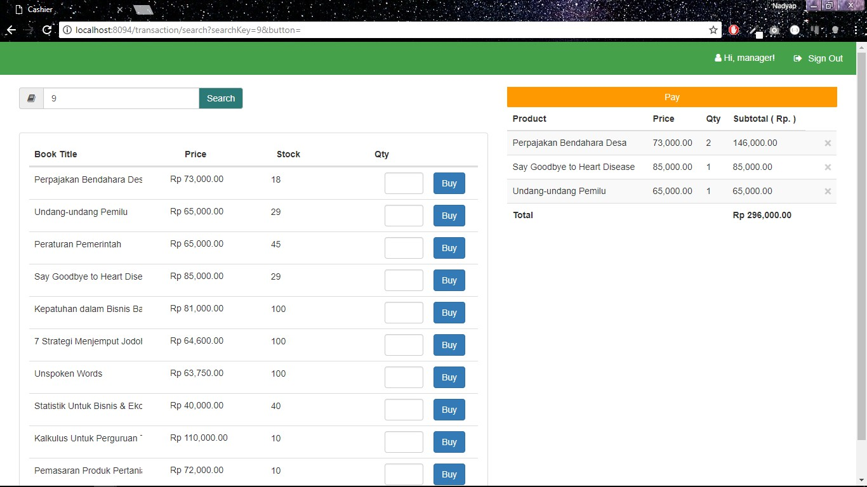

To add book to cart user need to input isbn of the book and system will display all book that have the same isbn. User need to input quantity, click button “buy”, and the book automatically move to the cart. To cancle the order user need to click button close ( x ).

* + 1. Cashier – Transaction Management: Payment

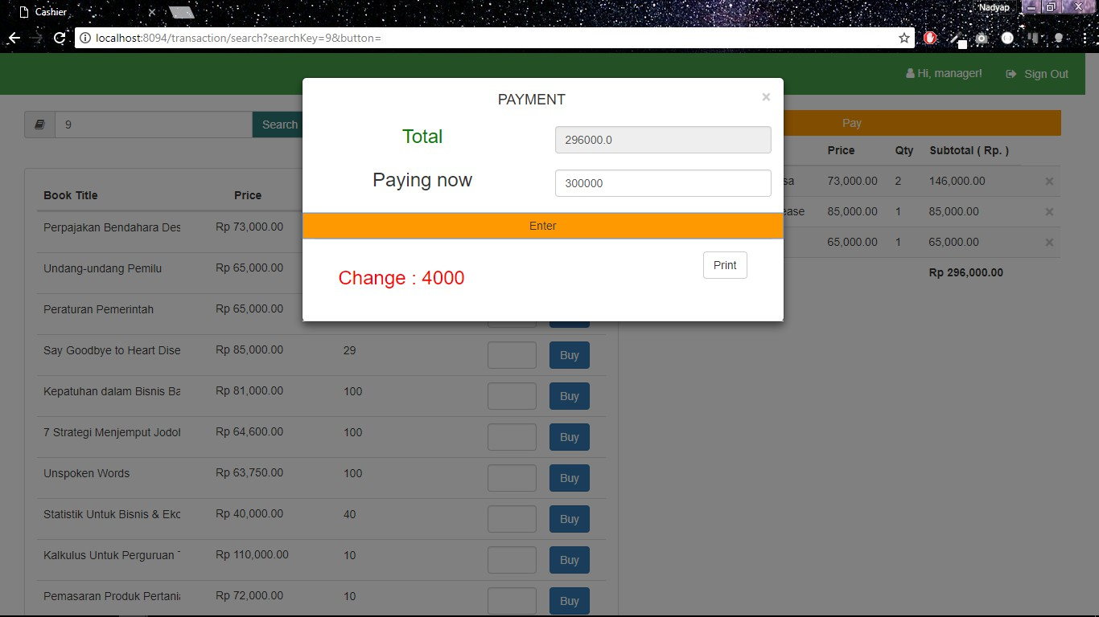

By clicking the button “pay” system will automatically shows total transaction and user need to input money. If money less than the total price, transaction won’t be proccessed and the invoice cann’t be printed. But if money equals or more than total price than the transaction can be proccessed by system and user can print the invoice.

* + 1. Cashier – Transaction Management: Print Invoice

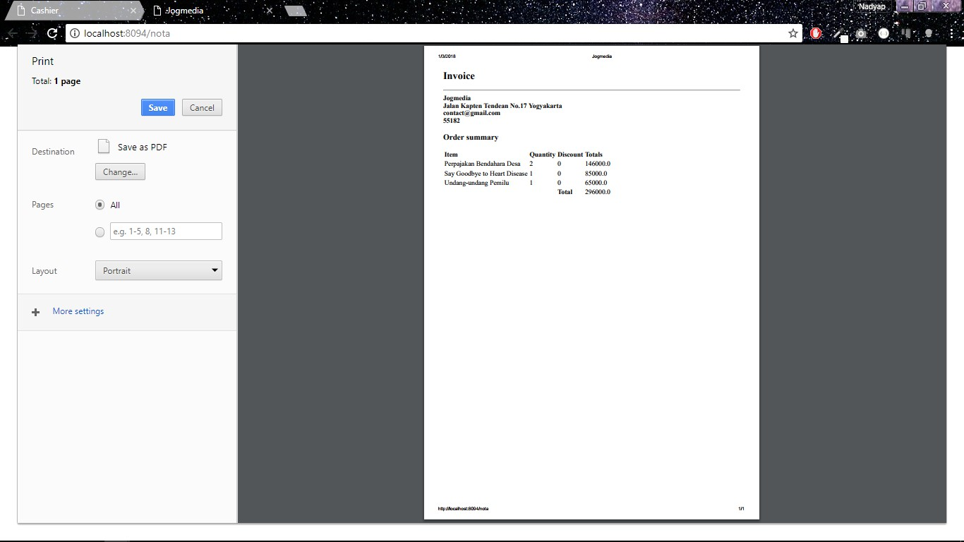

This is the print invoice page, user need to choose whether to print the invoice or not. If user choose to print the invoice then system will automatically save the invoice into pdf. But if choose not to print the invoice then the system only display the invormation about transaction.

* + 1. A
    2. a