In less than two weeks, I built a real-time AI Conversational Speech Avatar. The project is the prototype for the business that my TI:GER group and I built. I deviated a bit from using the Speech Avatar by Azure and decided to “roll my own”. The model that produces the real-time Avatar requires five H100 GPUs, enter the big cloud providers.

I have been trying to get capacity on AWS for the past five days. The perception (real/imagined) is that H100 capacity is in so high demand that capacity is limited and “hard” to come by. Ok, and unlike other instances p5.48xlarge instances are not readily available to the independent entrepreneur. That’s right! If you went to AWS and created an account today, you would not be able to spin up that instance class without begin granted permission first.

I have spent the last five days making support case after support case, appeal after appeal, email after email, phone call after phone call, to get the proper quota to be able to create an on-demand p5.48xlarge EC2 instance and still do not have the quota for each US availability zone. After three days they did finally approve me for us-east-1 and us-west-2. Now for the lay person this means that they have not approved me to use their computers across all of their US regions.
I got one message the other day that said… well, you read it.

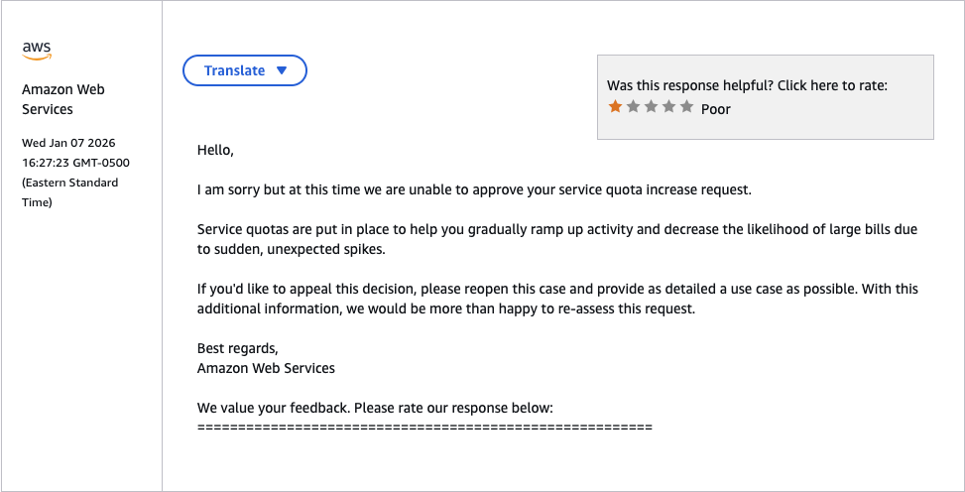

Like I need your help. There was even one instance where they approved me for a quota of 8 but the required quota for the instance that I need is 192. It makes no sense at all. That was one that I had to appeal. I started to include the following in the original quota request. We’ll see what that gets me.

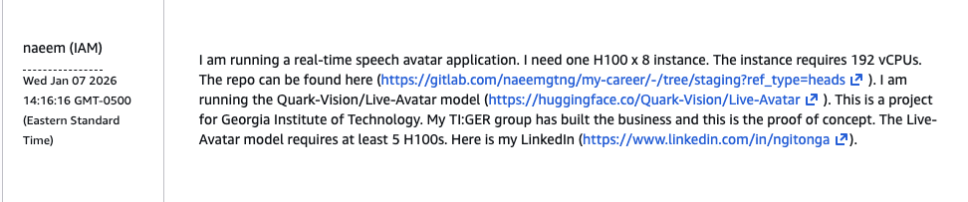

I am a credentialed user, and my account age will show that I have years using the platform. I can handle whatever I take on. But hey, this isn’t just about me or AWS. I experienced this type of gate keeping from all of the major cloud providers and some of the smaller ones. AWS was the most frustrating because I’ve used their services for almost a decade. For whatever reason it is done. The technology is not as democratized as one AWS executive preaches. And to get what I need, I got to continue learning (silver lining).

Compute is regulated. I had to get it from a smaller provider, and their process was more streamlined. I did not have to jump through so many hoops. I have the money to pay for what I use, and I use what I need. AWS, GCP, and Azure will not miss the few hundred dollars that I spend developing my application but for the engineers out there for some things we have to find better options and they are out there.

It helps to include in the request with the big names something like what I included above but that is still no guarantee that they will allow you to use their computers to do your work.

