Data Communication and Networking Lab

(CEL-222)

# Project Title

### Class

**BSCS 4A**

**Group Member**

**ALI GUHAR 02 134202 006**

**NAEEM UR REHMAN 02 134202 053**

### Hosted project Link:

### https://github.com/aligauhar/Cisco-software-house-

**Submitted To Sir Mirza Waqas**

**Table of Contents**

Table of Contents

Project Title 1

Class 1

Hosted project Link: 1

https://github.com/aligauhar/Cisco-software-house- 1

ABSTRACT 4

Introduction (Project Overview) 5

Literature Review 6

Description 6

MINIMUM HARDWARE REQUIREMENTS: 7

SOFTWARE REQUIREMENTS: 7

Components per branch 8

Designing And Implementing 8

Business Rules access & limitations 9

SREEN SHOTS 10

DEVELOPERS DEPARTMENT 10

PCs: 10

SWITCHES: 10

ROUTERS: 10

IOT DEVICES: 10

Light: 10

Fan: 10

Web Cam: 10

UX/UI DEVELOPER DEPARTMENTS 10

PCs: 10

SWITCHES: 10

ROUTERS: 10

IOT DEVICES: 10

Light: 10

Fan: 10

Web Cam: 10

QUALITY ASSURANCE DEPARTMENT 10

PCs: 11

SWITCHES: 11

ROUTERS: 11

IOT DEVICES: 11

Light: 11

Fan: 11

Web Cam: 11

MARKETING DEPARTMENT 11

PCs: 11

SWITCHES: 11

ROUTERS: 11

IOT DEVICES: 11

Light: 11

Fan: 11

Web Cam: 11

CUSTOMER CARE DEPARTMENT 11

PCs: 11

SWITCHES: 11

ROUTERS: 12

IOT DEVICES: 12

Light: 12

Fan: 12

Web Cam: 12

PROJECT MANAGER DEPARTMENT 12

PCs: 12

SWITCHES: 12

ROUTERS: 12

IOT DEVICES: 12

Light: 12

Fan: 12

Web Cam: 12

CEO DEPARTMENT 12

PCs: 12

SWITCHES: 12

ROUTERS: 12

IOT DEVICES: 12

Light: 13

Fan: 13

Web Cam: 13

PROJECT FINAL DIAGRAM 13

Conclusion 14

Reference 14

# ABSTRACT

With the advent of computer technology and the internet, consumers prefer to conduct their business electronically. These electronic transactions have to be monitored and carried out efficiently. This report focuses on the need and construction of software house networks and also provide distance services for any kind of software development and maintenance. Idea of creating a software house management system is to provide a secure connection between different department in which everyone is responsible for his part according to the company or business rules which are made, in case any security issue occurs, the system is designed in such a way that particular department facing the issue will be responsible for the issue faced. There has also been difficulty to maintain the company regular maintenance like opening the door, turning lights off and on and temperature maintenance, for that purpose we have used IOT, to manage them automatically the purpose of this project was to evaluate open source, free, intrusion detection systems and how easily they can integrate into an existing network. Data Communication and network have changed the way business and other daily affair works. Now, they rely on computer networks and internetwork. A set of devices often mentioned as nodes connected by media link is called a Network. A node can be a device which is capable of sending or receiving data generated by other nodes on the network like a computer, printer etc. These links connecting the devices are called Communication channels. Computer network is mainly de-rived from the ISO and OSI layers.

# Introduction (Project Overview)

A software house is a company that primarily provides software products. These companies may specialize in business or consumer software. The common definition is that the company is mainly invested in developing and distributing software products to be used for specific purposes like trade ecommerce etc. The goals and objectives of a software house vary, depending on the client base and a structure for software release. Some houses specialize in contractor jobs that are commissioned for specific corporate clients while others specialize in creating public out-of-the-box software to be sold on store shelves. Each specific approach requires its own design process, set of professional rules and distribution strategy, taking into account, for example, time zones, user system requirements and much more. This needs independent management of department and security; our system is made in such a way that only the departments that have concern with each other can contact. We have made a secure way of communication in the software house according to the business rules, access of the sensitive devices and departments and assigned to the responsible person only. Automatic system for daily maintenance has been applied. These services reduce operational costs and resource consumption in software house. Our system provides the ability to remotely monitor, manage and control devices.

# Literature Review



A comprehensive summary of the previous research on the topic we had to do includes the labs from our course CEL- 222 (Data Communication and Networking), help from our course teacher and their own website, scholarly articles, and other sources relevant to a particular area of research. The research enumerated, described, summarized, objectively evaluated and clarified what we needed to complete the project with ease. It gave us a guiding concept from multiple sources amalgamated to give us the resources to accumulate all our research to complete our project and face the minor difficulties/problems that came our way.

# Description

Our system is divided into 7 departments (CEO, Project Manager, ux/ui design, developer, Quality Assurance, Customer Care, Marketing team) each one of them has their own access and limitations. Each department is provided fan and light and a web cam to monitor the staff, they are connected automatically and can be controlled through the pc in CEO room while in CEO room there is a light and an Air Conditioner. All the devices are connected wirelessly through home bridge. The door of the software house is also automatic and can be controlled through CEO room.

Each department can access only the department that is concerned with it, and the employees within the departments can access each

Our Software house(HSF) is divided into 2 branches using dynamic routing each branch holds the same infrastructure, rules and connection limitations. This whole network provides all the basic requirements to run a software house.

## MINIMUM HARDWARE REQUIREMENTS:

Processor : Intel P-IV based system

Processor Speed : 2.0. GHz

RAM : 1GB

Hard Disk : 40GB to 80GB

## SOFTWARE REQUIREMENTS:

IDE : CISCO PACKET 7.1

## Components per branch

* 20 PCs
* 8 Router Of 4331
* 1 Router of 1841
* 1 home Gateway
* 8 2960-24TT switches
* 6 web cams
* 6 fans
* 7 lights
* 1 Air Conditioner
* 1 door

# Designing And Implementing

To implement software house management system Cisco packet tracer is used, IOT has also been implemented, these devices are like: smart light, smart fan, smart camera, smart door. However, home gateway provides controlling mechanisms. The system can be manipulated through the PC in CEO room

In software house some devices can be controlled by the staffs and some by higher authorities only. This makes the tasks easier, enjoyable and can be used as security means in any software house. However, IOT Gateway provides a connecting mechanism for the software house for automatic maintenance.

# Business Rules access & limitations



|  |  |  |  |
| --- | --- | --- | --- |
| **SNO** | **Departments** | **Access** | **IOT devices** |
| 1 | Developers Department | Developers have concern with the UX/Ui Department and Project Manager | Fan, Web-Cam, Light |
| 2 | Quality Assurance Department | They have concern with customer care, marketing team, UX/UI and project manager | Fan, Web-Cam, Light |
| 3 | Marketing Department | They have concern with customer care, project manager, UX/UI designers and quality assurance | Fan, Web-Cam, Light |
| 4 | Customer Care Department | They have concern with concern with project manager, quality assurance and marketing team | Fan, Web-Cam, Light |
| 5 | UX/UI Designer Department | They have concerned with developers, project managers and marketing team | Fan, Web-Cam, Light |
| 6 | Project Manager | They have concerned with every department | Fan, Web-Cam, Light |
| 7 | CEO | Only concerned to project manager and CEO of other branches | Air Conditioner, Light |

# SREEN SHOTS

## DEVELOPERS DEPARTMENT

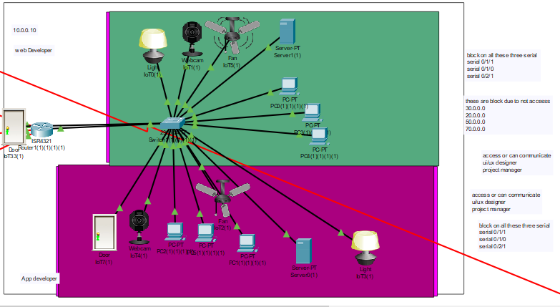

### 

### PCs:

### 

### SWITCHES:

### 

### ROUTERS:

### 

### 

### 

### 

### IOT DEVICES:

### 

### 

### Light:

### 

### 

### Fan:

### 

### 

### Web Cam:

### 

## UX/UI DEVELOPER DEPARTMENTS

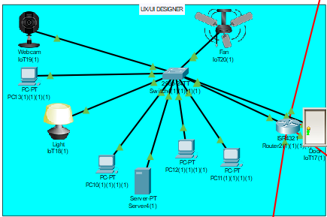

### 

### PCs:

### 

### SWITCHES:

### 

### ROUTERS:

### 

### 

### 

### IOT DEVICES:

### 

### Light:

### 

### 

### Fan:

### 

### 

### Web Cam:

### 

### 

## QUALITY ASSURANCE DEPARTMENT

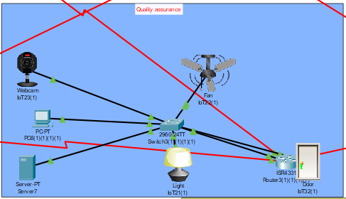

### 

### PCs:

### 

### SWITCHES:

### 

### ROUTERS:

### 

### 

### 

### 

### IOT DEVICES:

### 

### Light:

### 

### 

### Fan:

### 

### 

### Web Cam:

### 

### 

## MARKETING DEPARTMENT

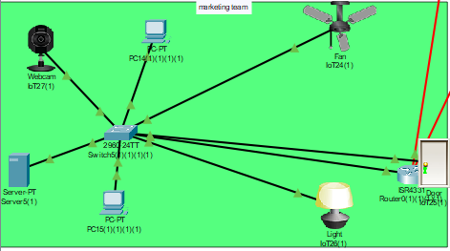

### 

### PCs:

### 

### SWITCHES:

### 

### ROUTERS:

### 

### 

### 

### IOT DEVICES:

### 

### Light:

### 

### Fan:

### 

### 

### Web Cam:

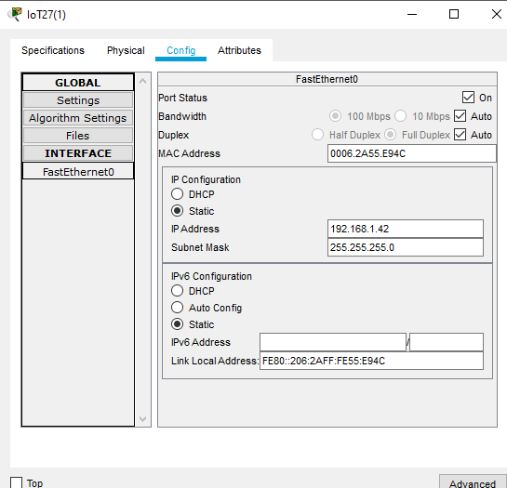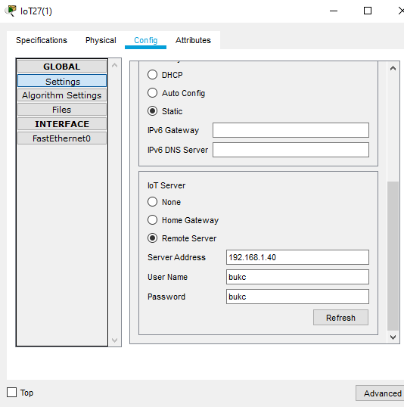

## CUSTOMER CARE DEPARTMENT

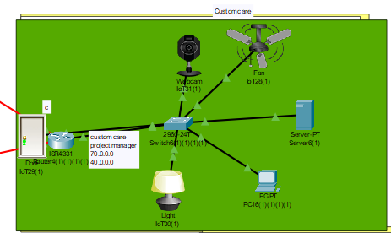

### PCs:

### 

### SWITCHES:

### 

### ROUTERS:

### 

### IOT DEVICES:

### 

### Light:

### 

### Fan:

### 

### Web Cam:

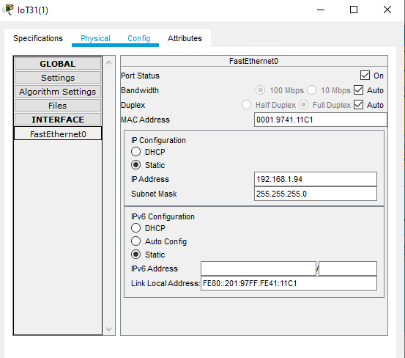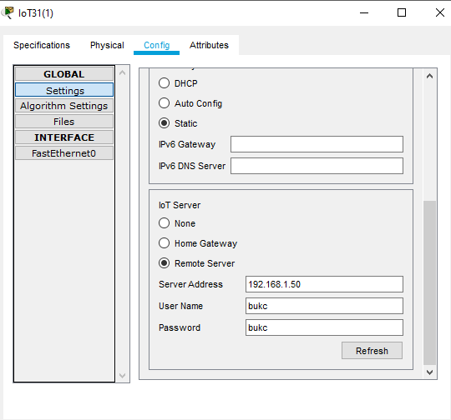

## PROJECT MANAGER DEPARTMENT

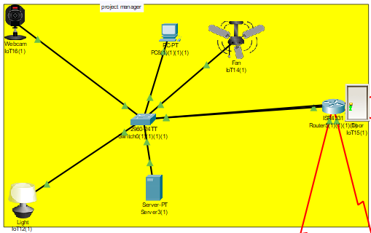

### PCs:

### 

### SWITCHES:

### 

### ROUTERS:

### 

### IOT DEVICES:

### 

### Light:

### 

### 

### Fan:

### 

### Web Cam:

### 

## CEO DEPARTMENT

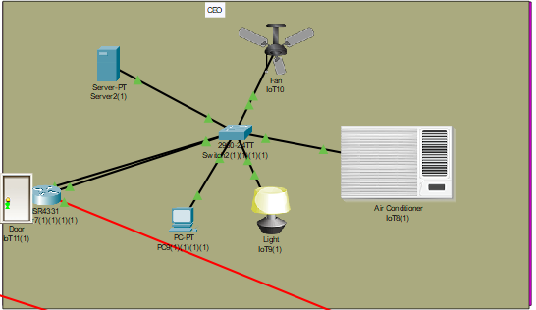

### PCs:

### 

### SWITCHES:

### 

### ROUTERS:

### 

### IOT DEVICES:

### 

### Light:

### 

### Fan:

### 

### Web Cam:

### 

## PROJECT FINAL DIAGRAM

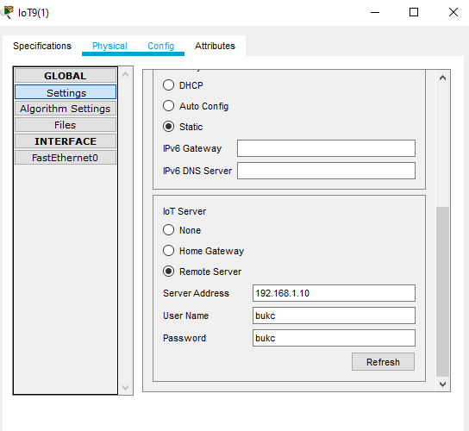

## 

## Campus one

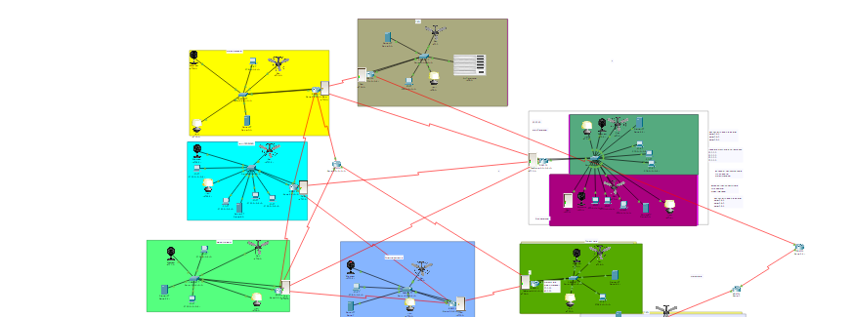

## Campus two

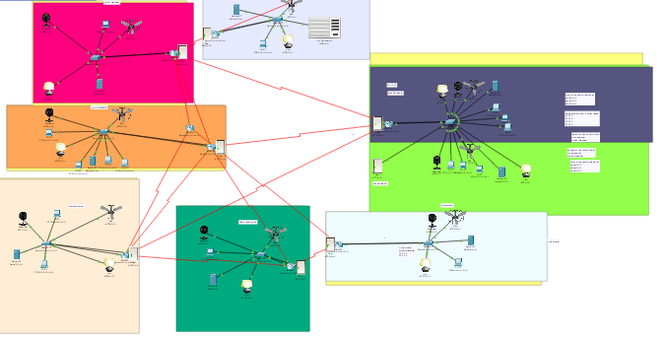

**Output:**

**Project manager to CEO**

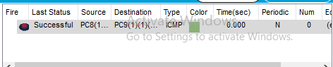

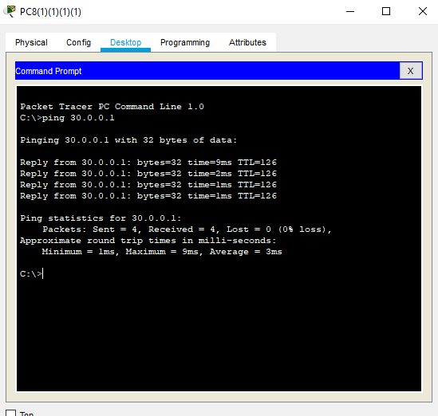

Ceo to other department

1.Ceo to developer

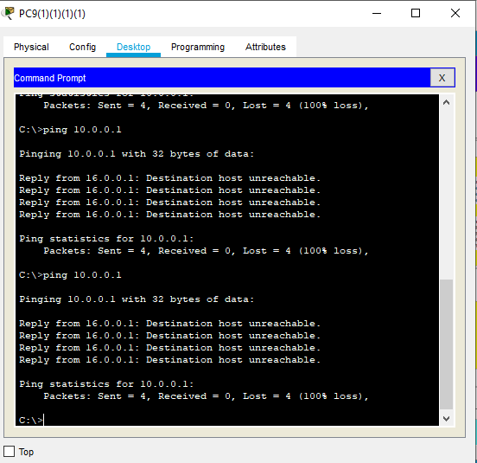

1. Ceo to custom care

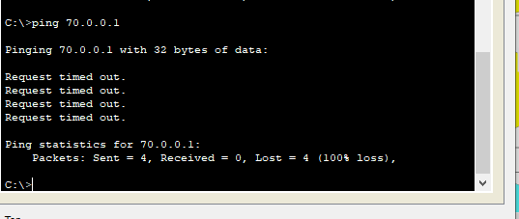

1. CEO to UX/UI

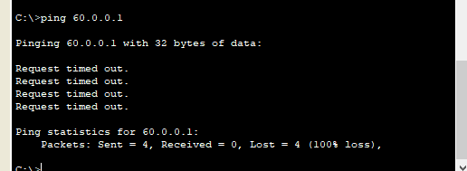

1. CEO to QUALITY ASSURANCE

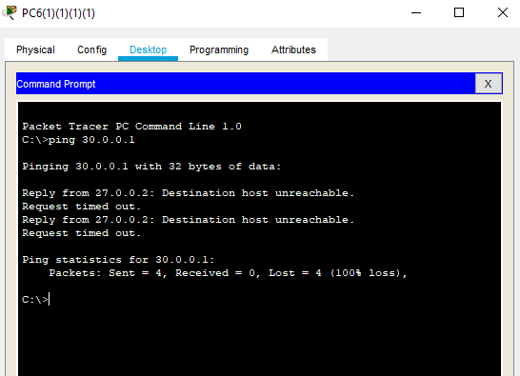

* **Quality to marketing team project manager custom care can access**

**Project manager to Quality**

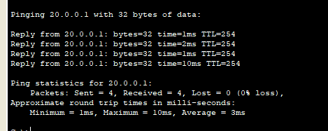

**Custom care to Quality**

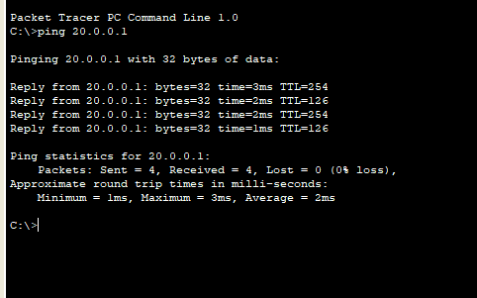

**Marketing to Quality**

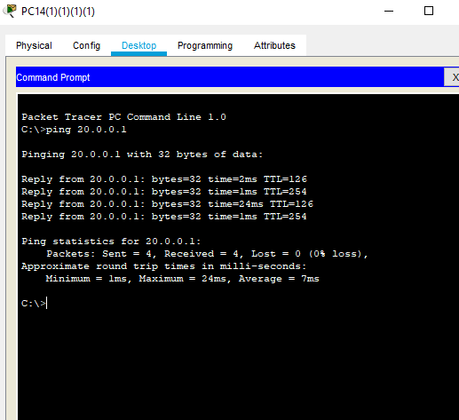

* **Quality to ceo and developer can not access**

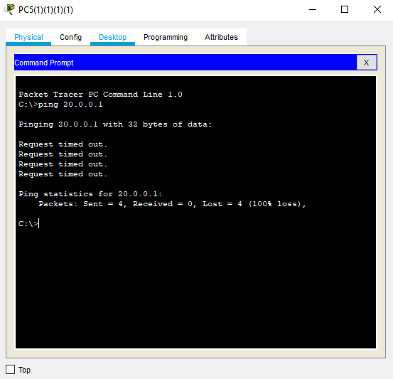

Q to ceo

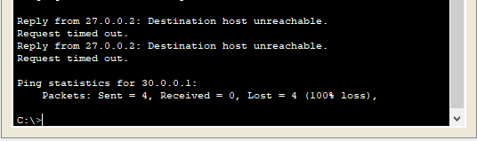

* **UX/UI to DEVELOPER PROJECT MANAGER AND MARKETING ACCESS**

1. Ux/ui TO PROJECT MANAGER

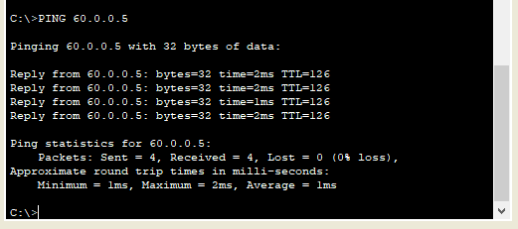

Ux/ui TO MARKEKTING

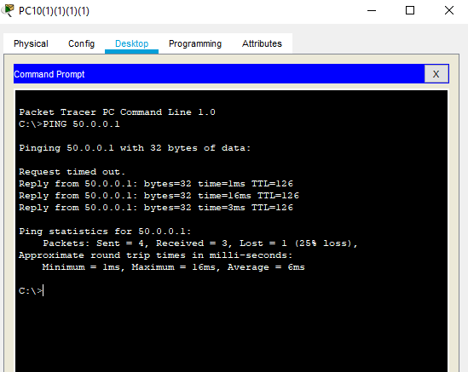

Ux/ui TO DEVELOPER

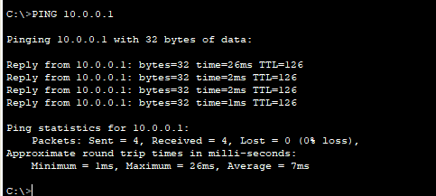

**No access to other dept**

**Ux/ui To ceo**

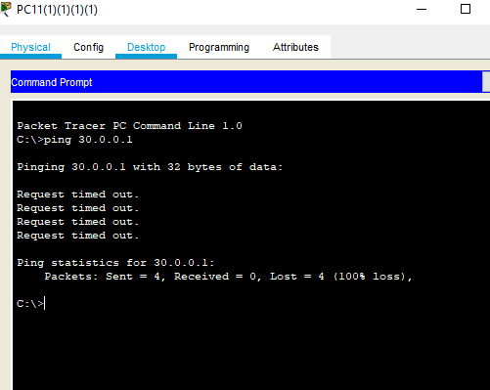

Ux/ui to quality

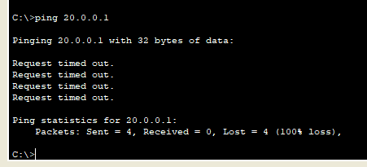

Ux/ui to custom care

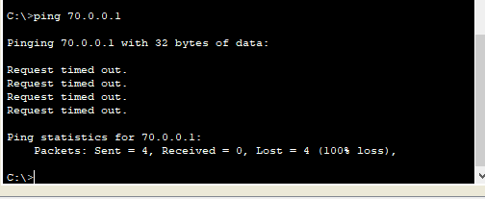

Project manager can access to all dept:

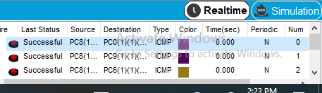

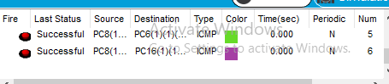

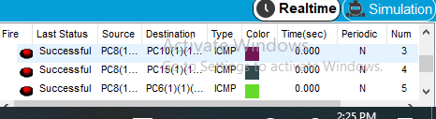

Develpoer to ux/ui and project manager access

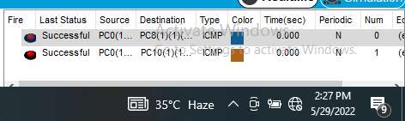

Developer to ux/ui

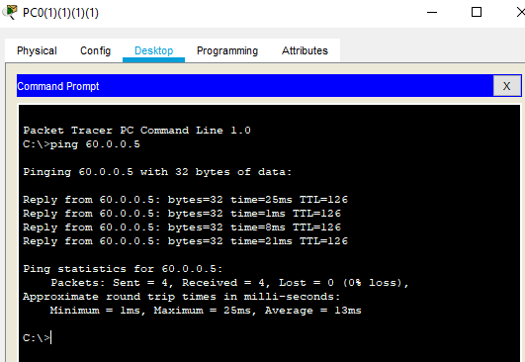

Developer to project manager

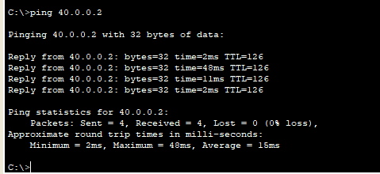

Block to rest of dept

Developer to quality

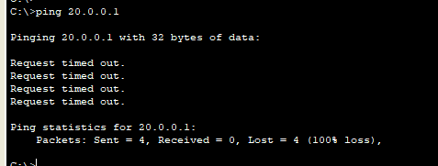

Developer to custom care

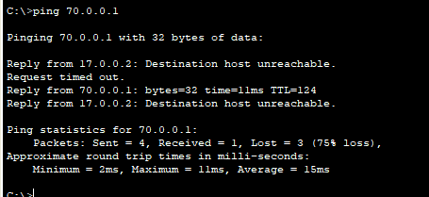

Developer to ceo

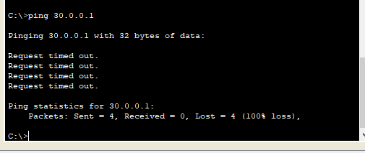

**Custom care to project manager and quality and marketing access rest dept block.**

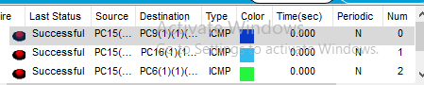

Block dept

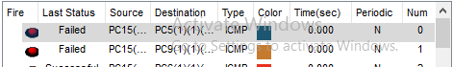

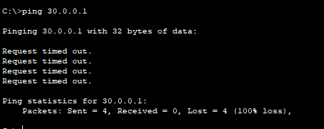

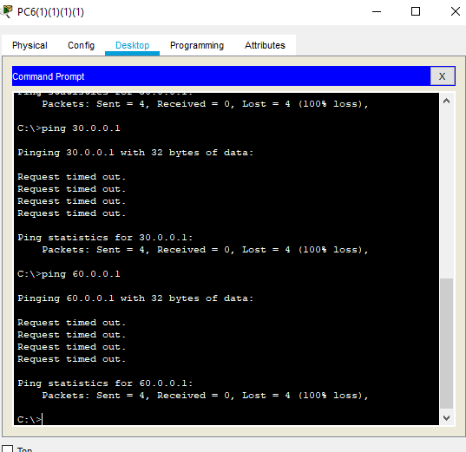

# Conclusion

This project holds all the necessary requirements to run networking of a software house having absolute security and good remote access, it ensures that data does not jumble up and successfully reaches its location due to its configuration. Each department has its own configuration following rules and regulations which makes the networking of this software house perfect. For automatic maintenance IOT devices are being used

# Reference

* <https://www.youtube.com/watch?v=vjPWanGskek>
* <https://www.youtube.com/watch?v=FOS1P4OdO8Y>
* <https://www.youtube.com/watch?v=1mQPH0LC2bM>
* <https://www.youtube.com/watch?v=zt3pyZIZhmU>
* <https://www.youtube.com/watch?v=fzhVwgf8FLw>











