APTECH COMPUTER EDUCATION
eProject Documentation Report

EventSphere
Management System
A Full-Stack MERN Application for Expo & Event Management

Student Information
Student ID | Name
Student 1536768 | Umaima
Student 1538786 | Maryam
Student 1547502 | Naeem Ullah
Student 1537741 | Eqaan Ahmed
Student 1538766 | Muhammad Rabiyan Samo
Student 1547427 | Yasir Ali

Table of Contents

1. Introduction
2. Project Overview & Objectives
3. Background & Problem Statement
4. Technology Stack
5. System Features & Functional Requirements
6. Application Screens
7. Non-Functional Requirements
8. Hardware & Software Requirements
9. Conclusion

1. Introduction
The thirst for learning, upgrading technical skills, and applying concepts in real-life environments is what the industry demands from IT professionals today. Busy work schedules, far-flung locations, and unavailability of convenient time-slots pose as major barriers when it comes to applying concepts into realism.

This eProject provides a live and synchronous learning environment that closely simulates classroom and lab-based learning into actual implementation. It is a project at your fingertips — an electronic, live juncture on the machine that allows students to:

- Practice step by step using a laddered approach
- Build a larger, more robust application
- Use utilities in applications designed by the user
- Move from single program to unified code leading to a complete application
- Learn implementation of concepts in a phased manner
- Enhance skills and add real-world value
- Work on real-life projects and create complicated, useful applications
- Receive mentoring and guidance through email support

Students at the centre are expected to complete this eProject and submit complete documentation with source code to the eProjects Team.

2. Project Overview & Objectives
The objective of this program is to provide students with a real-world project scenario and help them create applications using modern tools and frameworks. EventSphere is a complete, production-ready MERN stack application demonstrating the full integration of MongoDB, Express.js, React.js, and Node.js.

- Have a clear understanding of the subject before starting
- Revise all relevant concepts before beginning the project
- Contact the eProjects Team for any doubts regarding the application
- Submit complete source code along with this documentation

EventSphere addresses the real-world challenges in managing large-scale expos and trade events through a scalable, role-based web platform serving Admins, Exhibitors, and Attendees.

3. Background & Problem Statement
EventSphere Management is a leading event management firm specializing in organizing large-scale expos and trade shows across industries. The firm recognized challenges inherent in traditional expo management processes.

Organizers, exhibitors, and attendees faced numerous inefficiencies and hurdles including:

- Manual registration systems prone to errors and delays
- Disjointed communication channels between organizers, exhibitors, and attendees
- Limited access to real-time event information and schedule updates
- Lack of centralized booth management and floor plan visualization
- No unified platform for ticketing, analytics, and reporting

Driven by a commitment to revolutionize the expo experience, EventSphere sought to harness the power of the MERN stack to address these pain points and create a robust, efficient digital system.

4. Technology Stack
EventSphere is built on the MERN stack — a modern, JavaScript-based technology stack that enables full-stack web development from a single language ecosystem:

Frontend | Backend | Database | Auth | Tools
React.js | Node.js | MongoDB | JWT | VS Code
Tailwind CSS | Express.js | Mongoose | bcrypt | Postman
React Router | REST API | Atlas Cloud | Cookies | Git/GitHub

Additional libraries include Recharts for analytics visualizations, Socket.io for real-time communication, Cloudinary for image management, and Stripe for payment processing.

5. System Features & Functional Requirements

5.1 User Authentication
- Users (organizers, exhibitors, attendees) can create accounts and log in securely
- Role differentiation upon registration: Admin/Organizer, Exhibitor, Attendee
- Password reset / forgot-password functionality
- Password encryption using bcrypt for secure storage
- JWT-based session management with secure HTTP-only cookies

5.2 Admin / Organizer Dashboard
- Create, edit, and delete expo events with full detail management
- View exhibitor registrations and approve or reject applications
- Assign booth spaces and manage floor plan allocations
- Create and manage event schedules with time slots, sessions, and speakers
- Generate reports on attendee engagement, booth traffic, and session popularity
- Display real-time analytics on expo performance
- Manage payments and revenue tracking with detailed breakdowns

5.3 Exhibitor Portal
- Register for expos by providing company details, products/services, and documents
- Update exhibitor profiles including logos, descriptions, and contact information
- View available booth spaces on floor plans and reserve them
- Manage booth details including products/services showcased and staff info
- Communicate with organizers and neighboring exhibitors via in-app messaging

5.4 Attendee Interface
- Access event details including schedule, exhibitor list, and floor plans
- Register for events, sessions, or workshops
- Search and filter exhibitors by categories, products, or keywords
- Browse event schedules and bookmark sessions of interest
- Receive notifications and reminders for bookmarked sessions
- Join live sessions and interact with speakers

6. Application Screens
The following section presents all major screens of the EventSphere application with detailed descriptions of each page's purpose, features, and design.

6.1 Home Landing Page
The landing page serves as the main entry point of EventSphere. It features a bold hero section with the tagline "Where great Events begin." alongside a featured event card displaying live attendee and exhibitor counts. The page uses a sophisticated purple gradient design with glassmorphism effects throughout.

Key elements: prominent Call-to-Action buttons ("Start Free →" and "Browse Events"), a featured Global Tech Event card showing 2,400 attendees and 84 exhibitors, top navigation with Events, Pricing, About, Contact links, and a dark/light mode toggle.

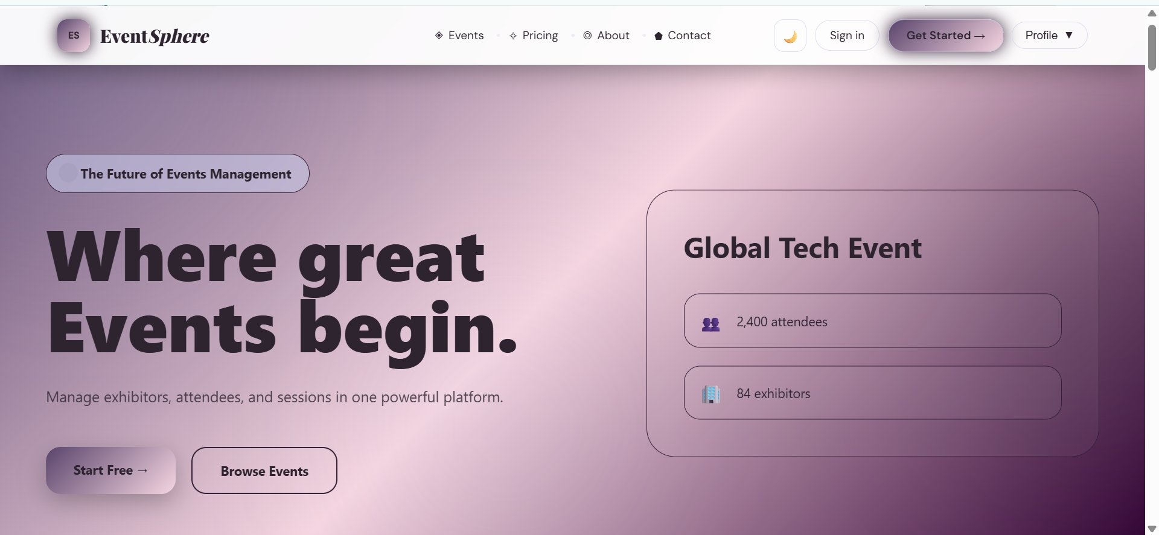

6.2 Login Page
The login page features a clean glassmorphic design on a purple gradient background. Users authenticate with their Email Address and Password through a frosted-glass card interface. The page links to account creation for new users and supports role-based redirection upon successful login.

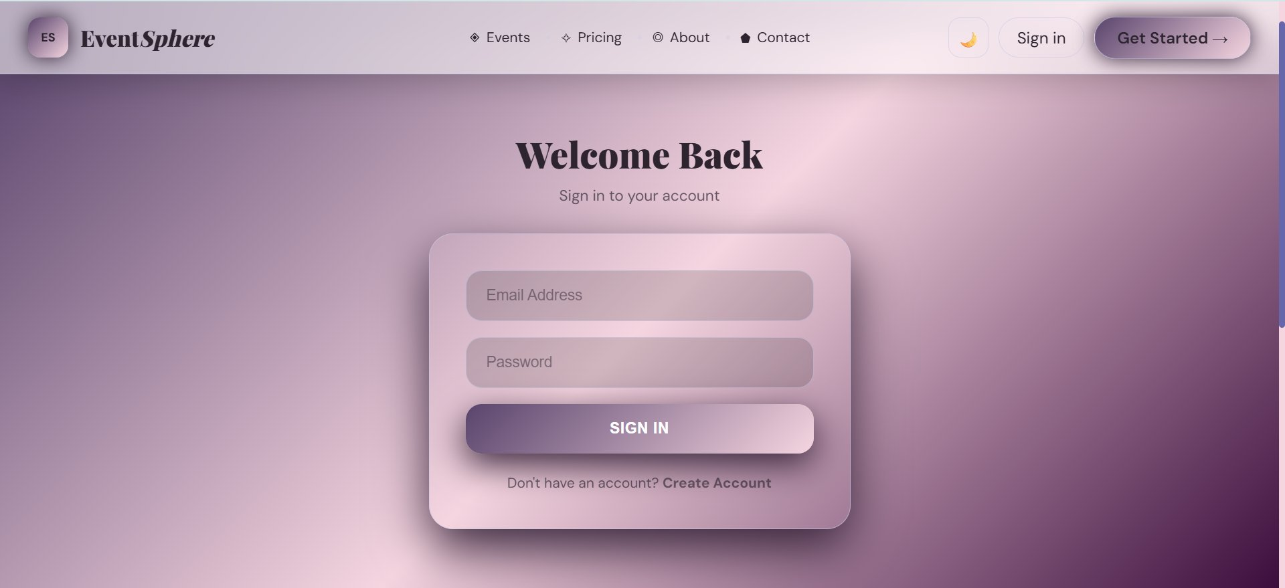

6.3 Register / Create Account Page
The registration page supports three distinct user roles via tab-based selection: Attendee, Exhibitor, and Admin. Each role unlocks different system capabilities. The registration form collects Full Name, Email Address, Phone Number, and Password, and routes the user to the appropriate dashboard upon account creation.

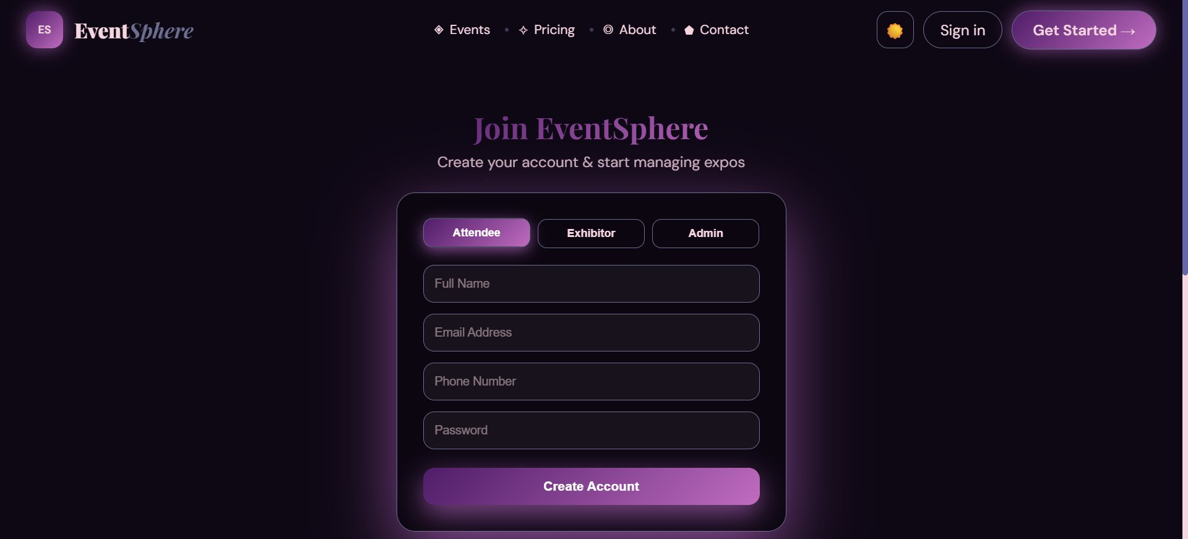

6.4 Event Directory
The Events page is the main discovery hub for all platform events. It features a dramatic dark-themed hero section headlined "Discover the world's most extraordinary events" with a live scrolling ticker showing current events across global cities (Mumbai, Seoul, London, NYC).

Users can search by title or location, filter by status (All Status / Live / Upcoming / Past), and filter by category chips: Technology, Fashion, Food, Art, Business, Science, and Other. Grid and list view toggles are available. A total of 18 events are shown in the demonstration.

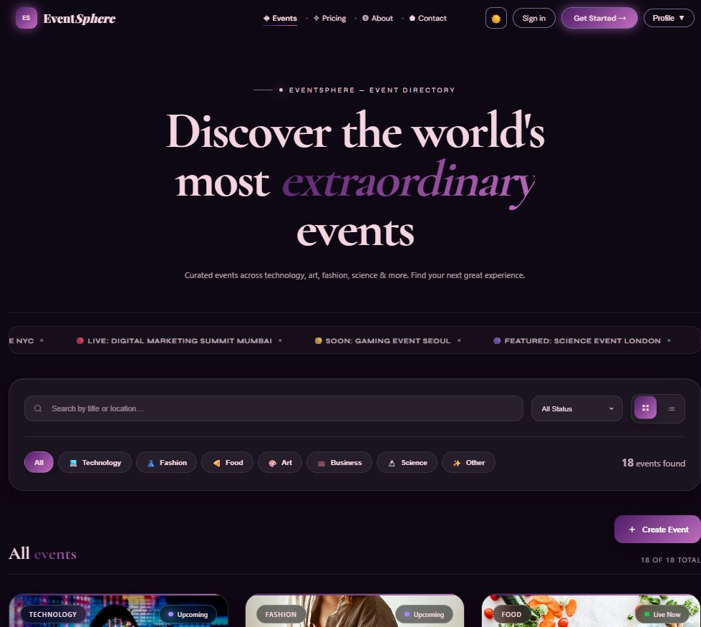

6.5 Event Detail Page
Each event has a dedicated detail page featuring a full-width banner image, status tags (LIVE NOW / BUSINESS), event title, location, date range, and current attendee count. A three-tab interface presents Overview, Details, and Schedule content sections.

The sidebar displays the ticket price ($799 per ticket), a "Register Now" CTA, attendee count (1,480), available spots (20) with a 99%-filled progress bar, and a location indicator. Event tags (#Creative, #Branding, #Design, #Leadership) aid discoverability.

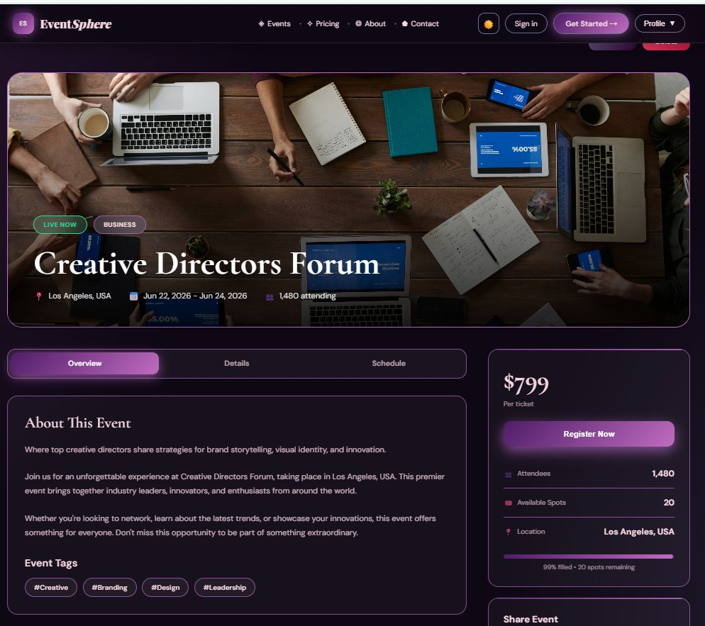

6.6 About Page
The About page uses a full dark-themed layout with a centered hero featuring "About EventSphere" and the tagline "A powerful event management platform for expos, conferences, and large-scale experiences." An animated typewriter effect cycles through platform capabilities on the sub-headline. A real conference image is displayed on the right for visual credibility.

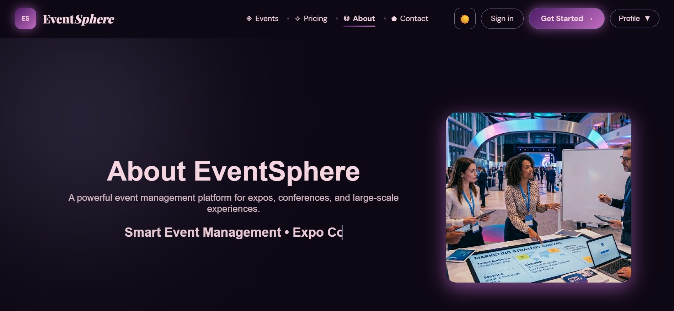

6.7 Contact Page
The Contact page includes a banner image of a live expo event at the top, followed by two panels: a "Send Message" form on the left (Name, Email, Message fields) and a Contact Info panel on the right showing the company's Karachi, Pakistan address, support email, phone number (+92 300 0000000), and a "We respond within 24 hours" note.

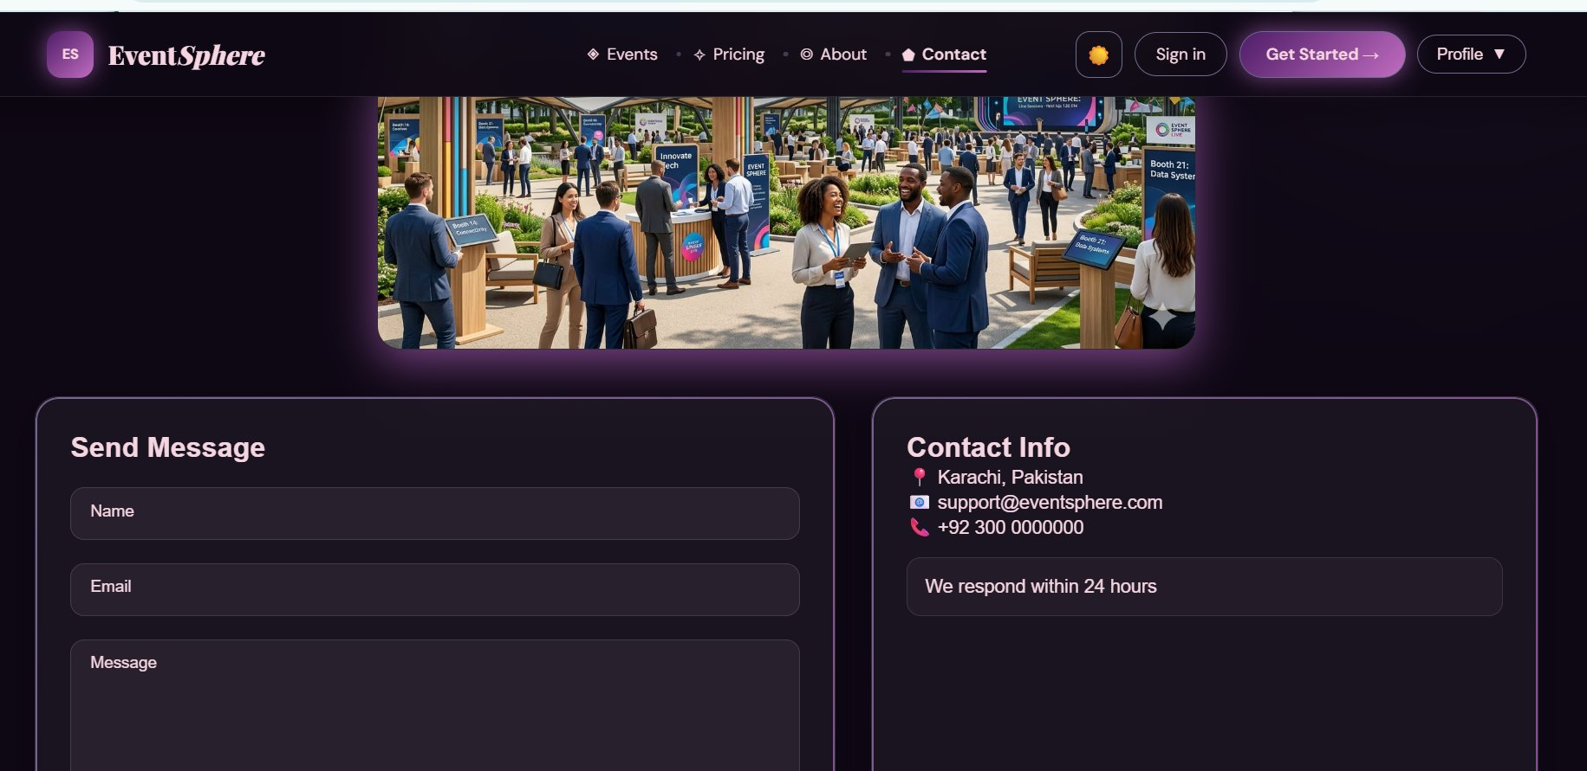

6.8 Admin Schedule Management
The Schedule section within the Admin Panel features an interactive calendar view (May 2026). Admins can navigate months using arrow controls. Event indicators appear on calendar dates. Clicking a date reveals events for that day in a sidebar: the demonstration shows 3 Events Today — Morning Yoga (06:30 AM), Team Standup (09:00 AM), and Lunch Meet (01:00 PM) with their respective dates. An "+ Add Event" button allows admins to create new schedule entries.

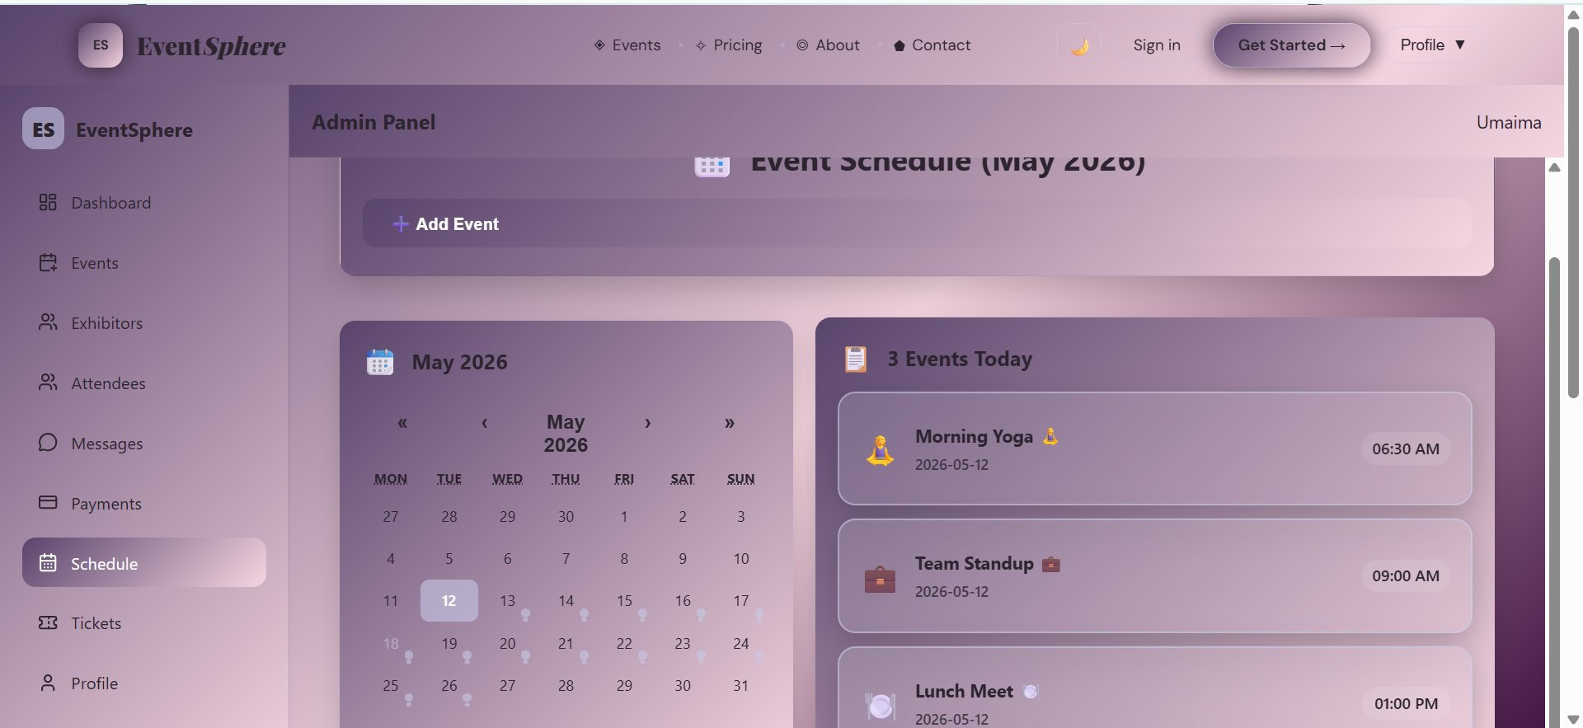

6.9 Attendee Panel — Today's Sessions
The Attendee Panel provides a personalized dashboard for event attendees. The main feature is the "Today's Sessions" view which lists all available live sessions with time, location, attendee count, and speaker name.

Three sessions are displayed: AI & Future Tech (10:00–11:30 AM, Hall A, 120 attendees, Dr. Ahmed Khan), Startup Growth Hacks (12:00–1:00 PM, Hall B, 85 attendees, Sara Ali), and Web3 & Blockchain (2:00–3:30 PM, Hall C, 150 attendees, John Smith). A "Join Session" button is available for each.

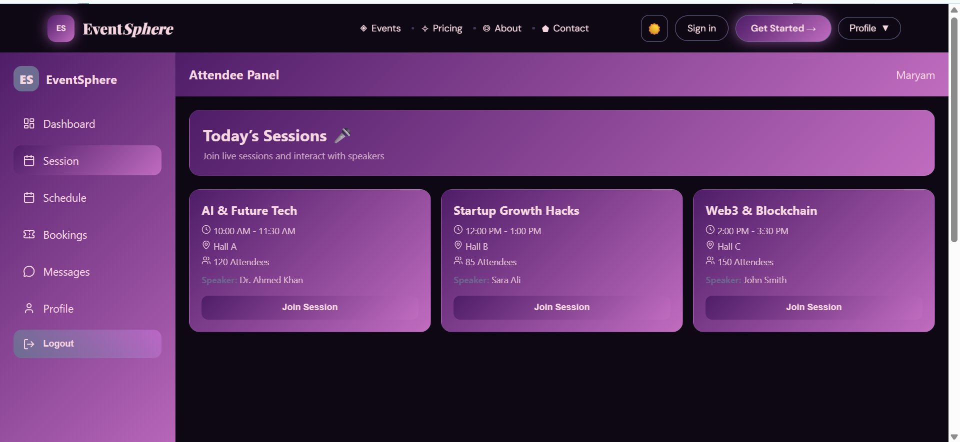

6.10 Exhibitor Dashboard
The Exhibitor Dashboard gives exhibitors a high-level analytics view of their platform presence. Three stat cards display: Events (12), Booths (4), and Attendees (1,240). Two charts are shown below:

- Events Growth — a line chart tracking event count from January to May 2026, showing growth from 4 to 12 events
- Weekly Attendee — a bar chart showing Mon–Fri daily attendance peaking on Thursday (~300 attendees)

The sidebar provides navigation to Dashboard, Events, Create Booth, My Booth, Messages, Profile, and Logout. The logged-in user is shown as "Maryam" in the top-right.

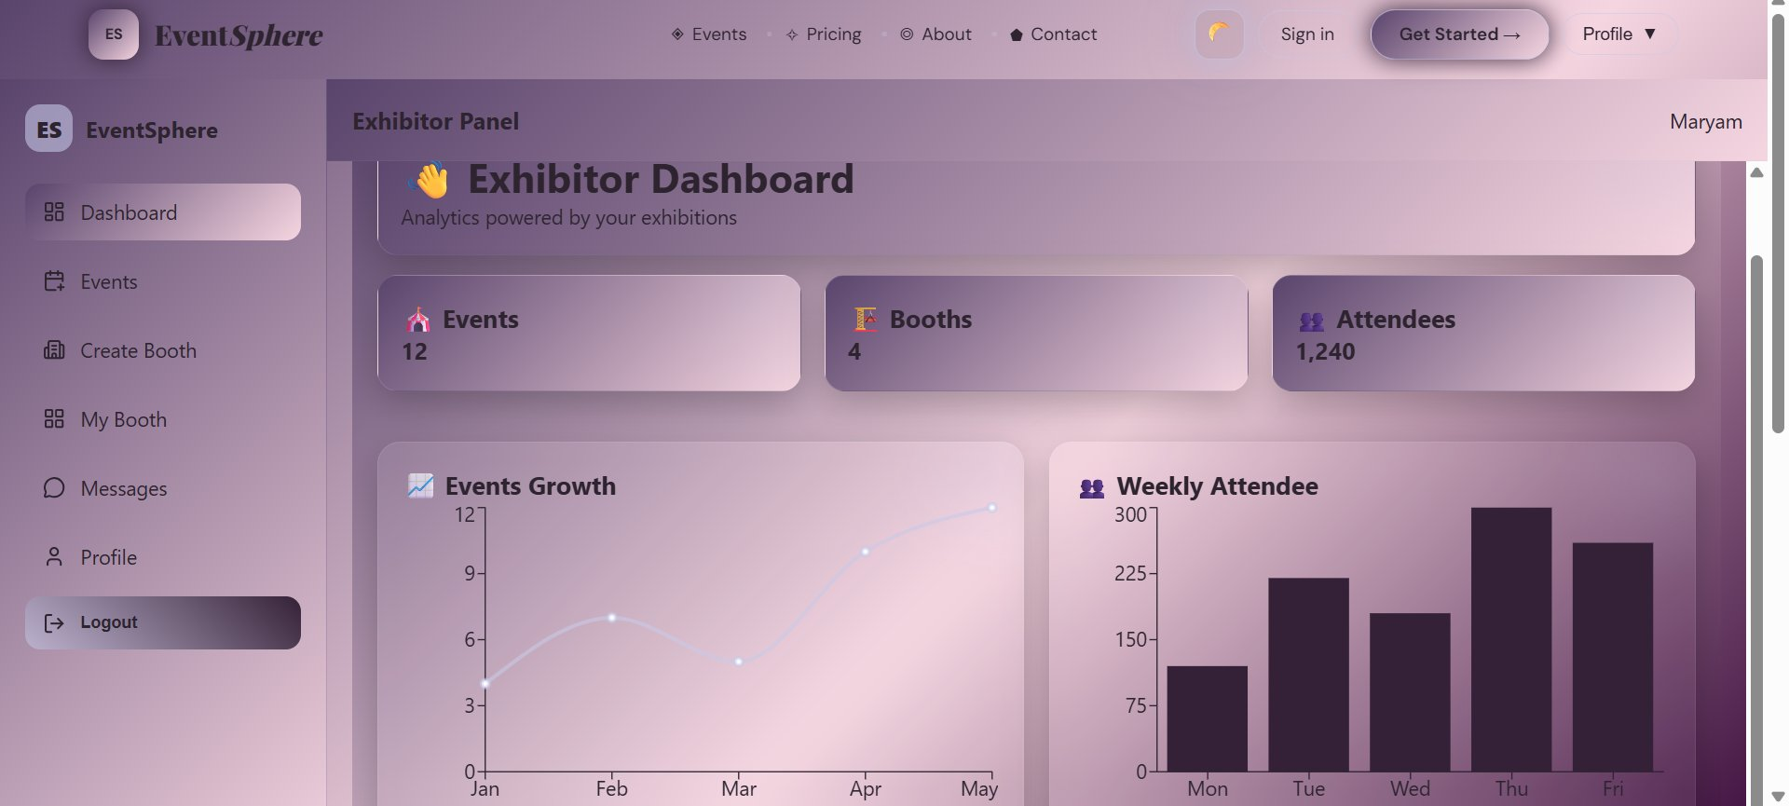

6.11 Create Booth Page
The Create Booth page allows exhibitors to configure their expo presence. The dark-themed form on the left includes fields for Booth Name, Category (dropdown defaulting to "Technology"), Description (textarea), Location ("Hall A"), and Contact Email.

A live preview panel on the right updates in real time as the exhibitor fills in the form, showing exactly how the booth will appear in the EventSphere expo system. This allows exhibitors to verify their booth presentation before submitting.

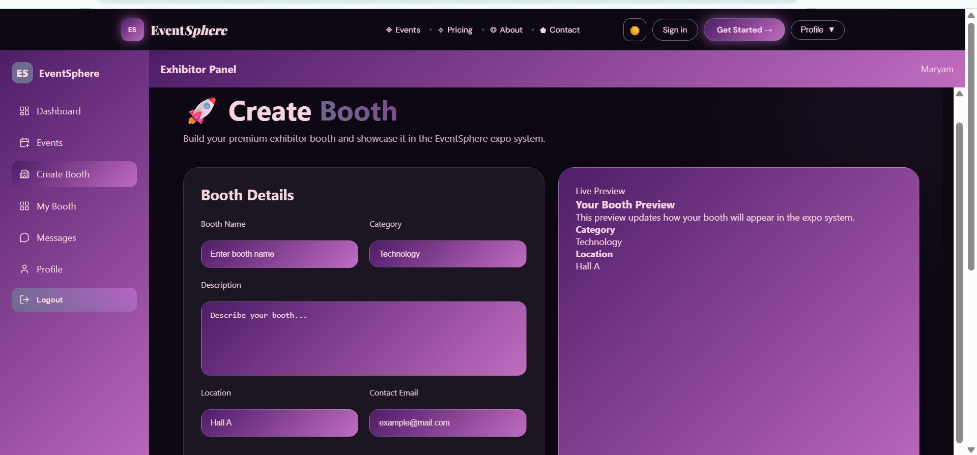

6.12 Call-to-Action Section & Footer
The platform's footer area features a prominent CTA banner "Ready to create your next big event?" with a "Start Free Trial" button and social proof text citing 340K+ platform users. Below the CTA, the footer is organized into four columns: Quick Links (Home, Events, Pricing, About Us, Contact), Platform (Browse Events, Create Expo, Analytics), Legal & Support (Privacy Policy, Terms of Service, Help Center, Cookie Policy, Security), and a newsletter subscription form with X, LinkedIn, Facebook, and email social links.

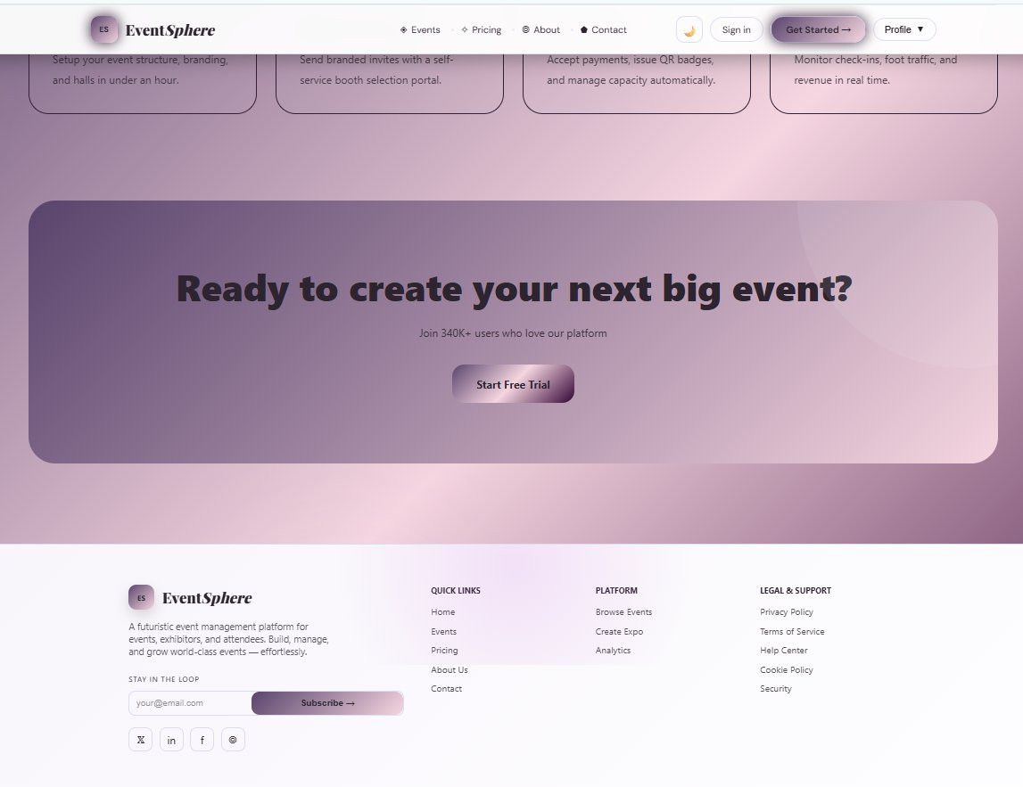

7. Non-Functional Requirements

7.1 Performance
Requirement | Detail
Response Time | Application responds to user interactions within 1–2 seconds for most operations
Scalability | System handles growing users and data without significant performance degradation
Concurrent Users | Supports hundreds of concurrent users without performance bottlenecks

7.2 Security
Requirement | Detail
Data Encryption | All sensitive user data including passwords and personal info are securely encrypted during storage and transmission
Authentication | User authentication uses industry-standard practices (JWT + bcrypt) to prevent unauthorized access
Authorization | Access control ensures users can only access their own data or permitted public data

7.3 Privacy & Reliability
Requirement | Detail
Data Privacy | Application complies with GDPR data privacy regulations
User Consent | Users have control over data they share and provide informed consent for processing
Uptime | Application targets a minimum of 99% uptime with scheduled maintenance communicated in advance
Data Backup | Regular automated data backups prevent data loss in case of system failures

7.4 Usability & Compatibility
Requirement | Detail
UI Design | Intuitive, user-friendly interface with consistent navigation and responsive design across all devices
Accessibility | Adheres to WCAG accessibility standards to ensure usability for individuals with disabilities
Cross-Browser | Functions correctly on Chrome, Firefox, Safari, and Microsoft Edge
Mobile Support | Fully responsive and works well on various mobile devices and screen sizes

8. Hardware & Software Requirements

8.1 Hardware Requirements
Requirement | Detail
Processor | Pentium 166 or better; Intel Core i3/i5 recommended for development
RAM | 128 MB minimum; 8 GB or higher recommended for MERN stack development
Storage | 20 GB+ free disk space for Node.js packages, MongoDB, and project files
Operating System | Windows 2000 Server or higher; Windows 10/11 or macOS recommended
Internet | Stable broadband connection for MongoDB Atlas, npm packages, and deployment

8.2 Software Requirements
Requirement | Detail
Runtime | Node.js v18+ with npm package manager
Frontend | React.js v18+ with Vite or Create React App scaffolding
Backend | Express.js v4+ framework
Database | MongoDB v6+ (local) or MongoDB Atlas (cloud-hosted)
Code Editor | Visual Studio Code with ESLint and Prettier extensions
Version Control | Git with GitHub for source code management and collaboration
API Testing | Postman for REST API testing and endpoint documentation
Browser | Google Chrome / Mozilla Firefox / Microsoft Edge

9. Conclusion
EventSphere Management System is a comprehensive, production-grade MERN stack application that demonstrates the full potential of modern JavaScript web development technologies. The project successfully addresses real-world challenges in managing large-scale expos and trade events through a unified, role-based digital platform.

Through this eProject, the following key learnings and implementations were achieved:

- Full-stack JavaScript development using the complete MERN stack (MongoDB, Express, React, Node.js)
- Role-based access control system with three distinct user types: Admin, Exhibitor, and Attendee
- Real-time data management and interactive analytics dashboards
- Modern UI/UX design with glassmorphism effects, dark/light mode, and fully responsive layouts
- RESTful API design and implementation with proper authentication and authorization flows
- Integration of payment processing, image management, and real-time messaging features

EventSphere demonstrates the student's ability to conceptualize, design, and implement a complex, multi-role web application from scratch. The system is scalable, secure, and ready for real-world deployment.

This project was developed and submitted as part of the Aptech Computer Education MERN Stack eProject curriculum, representing the culmination of knowledge and skills developed throughout the program.

— End of Documentation —

