Spring-Kafka to develop Kafka-based messaging solutions

Apache Kafka is a messaging solution that features:
- Publish and subscribe to streams of records.
- Store streams of records in a fault-tolerant durable way.
- Process streams of records as they occur.
Kafka allows an application to send messages, stores them on a central cluster, and allows these messages to be received by applications that process them. The Kafka cluster stores messages in categories called topics.
Spring-Kafka makes programming easier and quicker. It provides a "template" as a high-level abstraction for sending messages. It also provides support for Message-driven POJOs with @KafkaListener annotations.
This article will show us how to publish/ consume messages to/ from an Apache Kafka topic using a Spring boot java application.
Here are the steps:
- Install Kafka
- Create a Kafka topic to publish messages.
- Create a Spring Boot Project.
- Configure application with application.yml
- Create a Producer to publish messages.
- Create a Consumer to consume messages.
- Create a Rest Controller to invoke kafka producer.

Install Kafka
Follow the steps on https://kafka.apache.org/quickstart to run Kafka server.

Apache Kafka requires a running ZooKeeper instance, which is used for reliable distributed coordination.

For Windows environment: -
- Download and extract ZooKeeper from http://zookeeper.apache.org/releases.html
- Download and extract Kafka from http://kafka.apache.org/downloads.html
- Open command prompt. Set JAVA_HOME to your java installation directory. For example set JAVA_HOME = c:\Java
- Change the directory to the Zookeeper folder. Start zookeeper using the command: .\bin\zkserver
- Open another command prompt. Set JAVA_HOME to your java installation directory.
- Change the directory to the Kafka folder. Start Kafka using the command: .\bin\windows\kafka-server-start.bat .\config\server.properties
Create a Kafka topic to publish messages
Follow steps on https://kafka.apache.org/quickstart to create a topic named ‘test’ in Kafka to publish messages.
For Windows: Open another command prompt. Set JAVA_HOME to your java installation directory. Change the directory to the Kafka folder. Create topic using command: -
.\bin\windows\kafka-topics.bat --create --topic quickstart-events --bootstrap-server localhost:9092
Create a Spring Boot Project
Create a Spring Starter Project with web and kafka dependencies.
<dependency>
<groupId>org.springframework.boot</groupId>
<artifactId>spring-boot-starter-web</artifactId>
</dependency>
<dependency>
<groupId>org.springframework.kafka</groupId>
<artifactId>spring-kafka</artifactId>
</dependency>

Configure application with application.yml
server:
port: 9000
spring:
kafka:
consumer:
bootstrap-servers: localhost:9092
group-id: group_id
auto-offset-reset: earliest
key-deserializer: org.apache.kafka.common.serialization.StringDeserializer
value-deserializer: org.apache.kafka.common.serialization.StringDeserializer
producer:
bootstrap-servers: localhost:9092
key-serializer: org.apache.kafka.common.serialization.StringSerializer
value-serializer: org.apache.kafka.common.serialization.StringSerializer

app:
consumer:
topic:
subscribed-to: test

logging:
level:
root: ERROR
org.springframework.web: ERROR
com.example: INFO
Create a Producer to generate messages
package com.example.event.producer;

import org.slf4j.Logger;
import org.slf4j.LoggerFactory;
import org.springframework.beans.factory.annotation.Autowired;
import org.springframework.kafka.core.KafkaTemplate;
import org.springframework.stereotype.Service;
@Service
public class EventProducer {

@Autowired
private KafkaTemplate<Object, Object> kafkaTemplate;

private final Logger logger = LoggerFactory.getLogger(EventProducer.class);

public void sendEventMessage(String topic, String eventMessage) {
logger.info(String.format("Producing message: %s", eventMessage));
kafkaTemplate.send(topic,eventMessage);
}
}

Create a Consumer to consume messages
package com.example.event.consumer;

import org.slf4j.Logger;
import org.slf4j.LoggerFactory;
import org.springframework.kafka.annotation.KafkaListener;
import org.springframework.stereotype.Service;

@Service
public class EventConsumer {
private final Logger logger = LoggerFactory.getLogger(EventConsumer.class);
@KafkaListener(topics = "${app.consumer.topic.subscribed-to}", groupId = "group.id")
public void consume(String eventMessage) throws Exception {
logger.info(String.format("Consumed Message: %s", eventMessage));
}

}

Create a Rest Controller to send messages
Create a rest resource that enables sending messages to the Kafka topic.
package com.example.controller;

import org.springframework.beans.factory.annotation.Autowired;
import org.springframework.beans.factory.annotation.Value;
import org.springframework.web.bind.annotation.PathVariable;
import org.springframework.web.bind.annotation.PostMapping;
import org.springframework.web.bind.annotation.RequestMapping;
import org.springframework.web.bind.annotation.RestController;

import com.example.event.producer.EventProducer;

@RestController
@RequestMapping(value = "/kafka")
public class EventMessageController {
@Value("${app.consumer.topic.subscribed-to}")
private String topicToPublish;

private final EventProducer eventProducer;

@Autowired
EventMessageController(EventProducer eventProducer) {
this.eventProducer = eventProducer;
}

@PostMapping(path = "/send/message/{event}")
public String sendEventMessage(@PathVariable String event) {
try{
this.eventProducer.sendEventMessage(topicToPublish, event);
}catch(Exception e) {
return "Failed sending message: " + e.getMessage();
}
return "Message sent successfully";
}
}
Now, if we run our Spring Boot application, we can invoke rest resource http://localhost:9000/ kafka/send/message/{event} using the Post method. 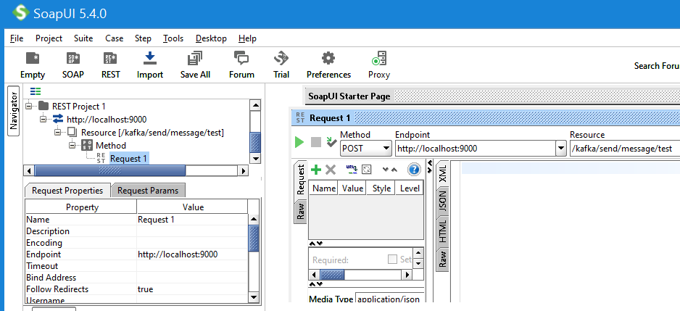

This will trigger our Producer to publish the message to the Kafka topic.
Our Consumer will receive the message and it will be logged in the application console.

