Spring-Kafka to develop Kafka-based messaging solutions

Apache Kafka is a messaging solution that features:
- Publish and subscribe to streams of records.
- Store streams of records in a fault-tolerant durable way.
- Process streams of records as they occur.
Kafka allows an application to send messages, stores them on a central cluster, and allows these messages to be received by applications that process them. The Kafka cluster stores messages in categories called topics.
Spring-Kafka makes programming easier and quicker. It provides a "template" as a high-level abstraction for sending messages. It also provides support for Message-driven POJOs with @KafkaListener annotations.
This article will show us how to publish/ consume messages to/ from an Apache Kafka topic using a Spring boot application.
Here are the steps:
- Install Kafka
- Create a Kafka topic to publish messages.
- Create a Spring Boot Project.
- Configure application with application.yml
- Create a Producer to publish messages.
- Create a Consumer to consume messages.
- Create a Rest Controller to invoke kafka producer.

Install Kafka
Follow the steps on https://kafka.apache.org/quickstart to start the Kafka environment.

Apache Kafka requires a running ZooKeeper instance, which is used for reliable distributed coordination.

For Windows environment: -
- Download and extract ZooKeeper from http://zookeeper.apache.org/releases.html
- Download and extract Kafka from http://kafka.apache.org/downloads.html
- Open command prompt. Set JAVA_HOME to your java installation directory. For example set JAVA_HOME = c:\Java
- Change the directory to the Zookeeper folder. Start zookeeper using the command: .\bin\zkserver
- Open another command prompt. Set JAVA_HOME to your java installation directory.
- Change the directory to the Kafka folder. Start Kafka using the command: .\bin\windows\kafka-server-start.bat .\config\server.properties
Create a Kafka topic to publish messages
Follow steps on https://kafka.apache.org/quickstart to create a topic named ‘test’ in Kafka to publish messages.
For Windows: Open another command prompt. Set JAVA_HOME to your java installation directory. Change the directory to the Kafka folder. Create topic using command: -
.\bin\windows\kafka-topics.bat --create --topic quickstart-events --bootstrap-server localhost:9092
Publish some messages to your topic:
.\bin\windows\kafka-console-producer.bat --broker-list localhost:9092 --topic test
>Message one
>Message two
By default, each line you enter will result in a separate message being written to the topic. You can stop the producer client with Ctrl-C at any time.
Read the messages: Open another command prompt. Set JAVA_HOME to your java installation directory. Change the directory to the Kafka folder.
.\bin\windows\kafka-console-consumer.bat --bootstrap-server localhost:9092 --topic test --from-beginning
Message one
Message two
You can stop the consumer client with Ctrl-C at any time.
Create a Spring Boot Project
Create a Spring Starter Project with Kafka and Web dependencies. You can also Bootstrap your application with Spring Initializr, and then open it in your favorite IDE.
<dependency>
<groupId>org.springframework.boot</groupId>
<artifactId>spring-boot-starter-web</artifactId>
</dependency>
<dependency>
<groupId>org.springframework.kafka</groupId>
<artifactId>spring-kafka</artifactId>
</dependency>

Configure application with application.yml
server:
port: 9000
spring:
kafka:
consumer:
bootstrap-servers: localhost:9092
group-id: group_id
auto-offset-reset: earliest
key-deserializer: org.apache.kafka.common.serialization.StringDeserializer
value-deserializer: org.apache.kafka.common.serialization.StringDeserializer
producer:
bootstrap-servers: localhost:9092
key-serializer: org.apache.kafka.common.serialization.StringSerializer
value-serializer: org.apache.kafka.common.serialization.StringSerializer

app:
consumer:
topic:
subscribed-to: test

logging:
level:
root: ERROR
org.springframework.web: ERROR
com.example: INFO
Create a Producer to publish messages
package com.example.event.producer;

import org.slf4j.Logger;
import org.slf4j.LoggerFactory;
import org.springframework.beans.factory.annotation.Autowired;
import org.springframework.kafka.core.KafkaTemplate;
import org.springframework.stereotype.Service;
@Service
public class EventProducer {

@Autowired
private KafkaTemplate<Object, Object> kafkaTemplate;

private final Logger logger = LoggerFactory.getLogger(EventProducer.class);

public void sendEventMessage(String topic, String eventMessage) {
logger.info(String.format("Producing message: %s", eventMessage));
kafkaTemplate.send(topic,eventMessage);
}
}

Create a Consumer to consume messages
package com.example.event.consumer;

import org.slf4j.Logger;
import org.slf4j.LoggerFactory;
import org.springframework.kafka.annotation.KafkaListener;
import org.springframework.stereotype.Service;

@Service
public class EventConsumer {
private final Logger logger = LoggerFactory.getLogger(EventConsumer.class);
@KafkaListener(topics = "${app.consumer.topic.subscribed-to}", groupId = "group.id")
public void consume(String eventMessage) throws Exception {
logger.info(String.format("Consumed Message: %s", eventMessage));
}

}

Create a Rest Controller to invoke Kafka Producer
Create a rest resource that enables sending messages to the Kafka topic.
package com.example.controller;

import org.springframework.beans.factory.annotation.Autowired;
import org.springframework.beans.factory.annotation.Value;
import org.springframework.web.bind.annotation.PathVariable;
import org.springframework.web.bind.annotation.PostMapping;
import org.springframework.web.bind.annotation.RequestMapping;
import org.springframework.web.bind.annotation.RestController;

import com.example.event.producer.EventProducer;

@RestController
@RequestMapping(value = "/kafka")
public class EventMessageController {
@Value("${app.consumer.topic.subscribed-to}")
private String topicToPublish;

private final EventProducer eventProducer;

@Autowired
EventMessageController(EventProducer eventProducer) {
this.eventProducer = eventProducer;
}

@PostMapping(path = "/send/message/{event}")
public String sendEventMessage(@PathVariable String event) {
try{
this.eventProducer.sendEventMessage(topicToPublish, event);
}catch(Exception e) {
return "Failed sending message: " + e.getMessage();
}
return "Message sent successfully";
}
}
Now, if we run our Spring Boot application, we can invoke rest resource http://localhost:9000/ kafka/send/message/{event} using the Post method.
Curl -X POST localhost:9000/kafka/send/message/test
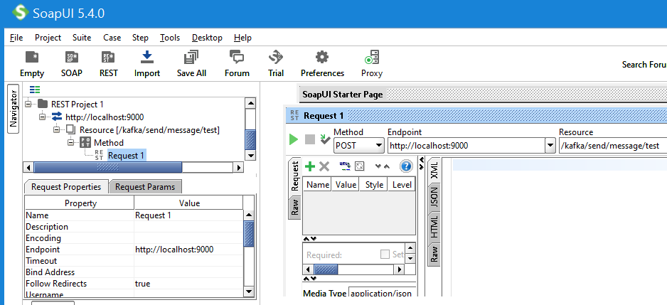

This will trigger our Producer to publish the message to the Kafka topic.
Our Consumer will receive the message and it will be logged in the application console.

