# **Programming Assignment 2 Report**

|  |  |
| --- | --- |
| Student(s): | Naeem Jan  Nabeel Abdulla |

### **Project Idea:**

For this assignment we have created a system which helps students, parents and teachers use to keep better track of their work. Students and parents are able to access grades and teachers are able to add grades to students. This system would help digitalize school.

**Data Schema:**

Our project has 3 different tables. The first table is the table which stores the students in classes. Every student has a parent and a unique id. Another table is the table which stores the grades of the students. This table is editable because teachers are allowed to add grades to any student. The third table stores teachers, their id, and the subject they teach.

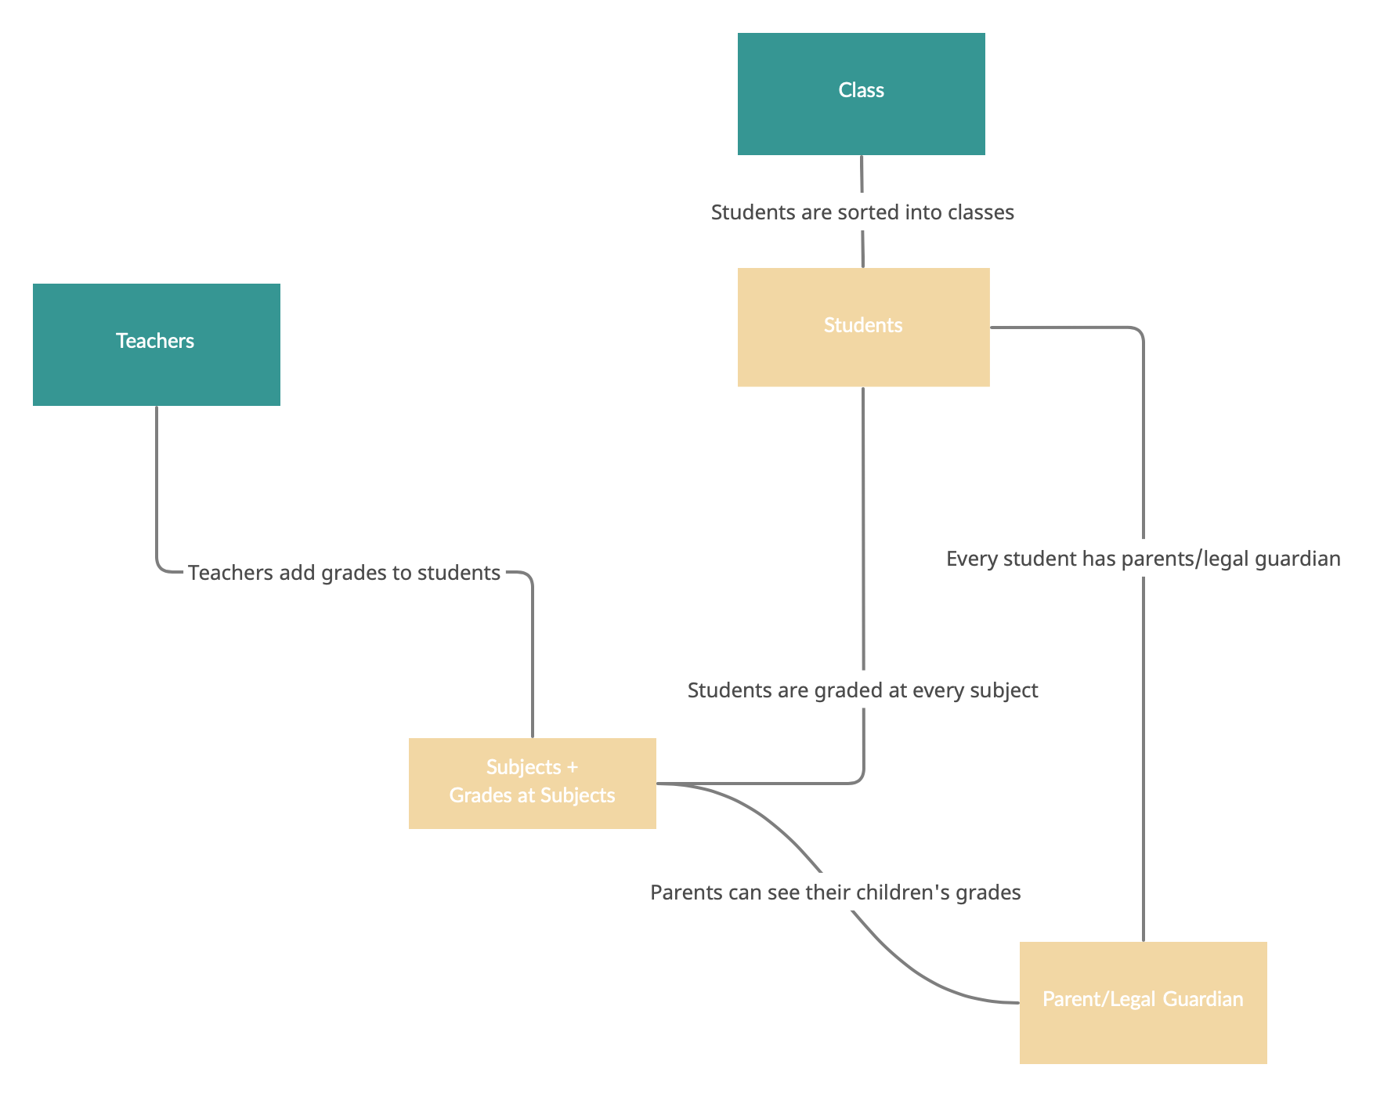

## **SQL Queries:**

We used lots of interesting queries within our project. One of the most important is the query which reads from the database necessary information for the continuation of the task given by the user. We have created joins between Student Grades and Student Data because it creates a more simple structure so any user would understand.

—---------------------------------------------------------------------------------------------------------------------

We decided to store grades in percentages like (100, 89, 67) because it would be easier to calculate the average grade. We also decided to use the JOIN statement in order to create a simpler, more intuitive data structure.

Source Code:

Video Demonstration: