Analysis (Question 1)
Our analysis (see the Table 1) backs up the accusation in which out 73.5% female were rejected. The Table 2 (left column) gives an impression of a 'grave' gap between admittance of male vs. female students (44% vs. 35%).
Table 1: Evidence in favor of accusation on graduate school
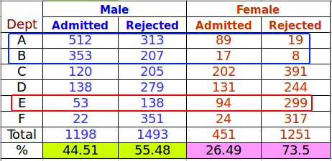

Table 2: Data Transition (left column to right column)
 | Admitted (Male) = 512 / (512 + 313) = 62.6 %  Rejected (Male) = 313 / (512 + 313) = 37.94 %  This transition table is displayed in figure on next page
  Admit | Gender | Dept | Freq
  Admitted | Male | A | 512
  Rejected | Male | A | 313
  Admitted | Female | A | 89
  Rejected | Female | A | 19
  Admitted | Male | B | 353
  Rejected | Male | B | 207
  Admitted | Female | B | 17
  Rejected | Female | B | 8
  Admitted | Male | C | 120
  Rejected | Male | C | 205
  Admitted | Female | C | 202
  Rejected | Female | C | 391
  Admitted | Male | D | 138
  Rejected | Male | D | 279
  Admitted | Female | D | 131
  Rejected | Female | D | 244
  Admitted | Male | E | 53
  Rejected | Male | E | 138
  Admitted | Female | E | 94
  Rejected | Female | E | 299
  Admitted | Male | F | 22
  Rejected | Male | F | 351
  Admitted | Female | F | 24
  Rejected | Female | F | 317
  Dept | Gender | Admitted | Rejected
  A | Male | 62,06 | 37,94
  A | Female | 82,41 | 17,59
  B | Male | 63,04 | 36,96
  B | Female | 68,00 | 32,00
  C | Male | 36,92 | 63,08
  C | Female | 34,06 | 65,94
  D | Male | 33,09 | 66,91
  D | Female | 34,93 | 65,07
  E | Male | 27,75 | 72,25
  E | Female | 23,92 | 76,08
  F | Male | 5,90 | 94,10
  F | Female | 7,04 | 92,96

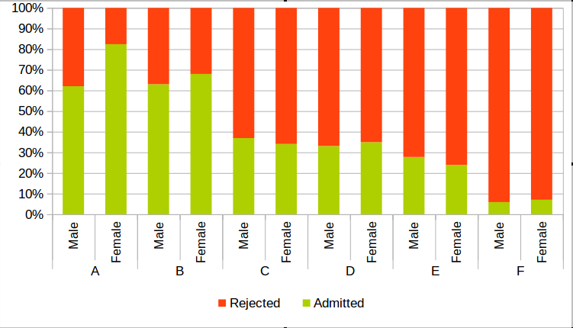

Fig. 1: Percent Stacked chart for gender wise distribution in each department
However, I shall reject the accusation regarding gender discrimination. We have established a question: “How many female candidates have knocked at the door of graduate school and what percentage was turned down or welcomed ?”. We have plotted the stacked bar chart (Fig. 1) based on this “fair enough” principle. We have concluded following findings:
- More female were accepted in departments A, B, D and F. Specially two departments A and B have shown high inclination towards selection of female candidates where more than 82% and 68% female potential candidates were accepted. This is not true for male potential candidates in either of the departments.
- Department C and E are showing that more male candidates were accepted, but the difference is marginal. In fact the percentage is almost close in both of the departments where 36.9% male and 34.1% female were admitted. This is true for department E as well ( 27.8% male vs. 23.9% female) were accepted.
- Department A accepts higher number of applicants for both genders. There were 825 male versus 108 female candidates for this department. Although department A accepts 82% female (vs. 62% male) but higher number of male applicants gives the false sense of bias on overall admissions to all departments.
- The phenomenon in (3) repeated itself for department B in almost same fashion.
- Department E has higher rejection rate for both male and female candidates. There were significantly more female candidates than opposite gender. Although on individual gender bases, there was no imbalance as almost same percentage for each gender was accepted. But a higher rate of rejection leads to misleading accusation of gender discrimination.

Regards
Muhammad.Naeem@univ-lyon2.fr
******************************* End *********** *******************

