Palmer Penguins Data Analysis
A Data Analysis Project Using R and Python
Prepared by:
Md. Naeemul Islam
Department of Statistics
Dhaka College (Affiliated with the University of Dhaka)
Course: Data Analysis Screening Task
Submission Date: 23 July 2026

Table of Contents
- Introduction
- Objectives
- Dataset Description
- Software and Tools
- Data Cleaning
- Exploratory Data Analysis
- Results and Discussion
- Conclusion
- References

1. Introduction
Data analysis is an essential component of modern research and decision-making. It enables researchers to identify meaningful patterns, summarize complex information, and support evidence-based conclusions. This project demonstrates the complete workflow of an exploratory data analysis (EDA) process using the Palmer Penguins dataset.
The Palmer Penguins dataset is widely used for teaching statistics and data science because it provides real biological measurements collected from three penguin species living in the Palmer Archipelago, Antarctica. The dataset contains information such as bill length, bill depth, flipper length, body mass, species, island, and sex.
The primary objective of this project is to perform data cleaning, exploratory data analysis, statistical summarization, and visualization using both R and Python. R was mainly used for data preparation and exploration, while Python was used to produce publication-quality visualizations and summary statistics.
The findings of this project provide insights into the relationships among penguin body measurements and demonstrate practical skills required for entry-level data analysis and statistical research.

2. Objectives
The main objectives of this project are:
• Import the Palmer Penguins dataset into R and Python.
• Explore the structure of the dataset.
• Identify and remove missing values.
• Generate descriptive summary statistics.
• Create publication-quality visualizations.
• Examine relationships among numerical variables.
• Interpret the findings from exploratory data analysis.
• Present the results in a professional report.

3. Dataset Description
The dataset used in this project is the Palmer Penguins dataset, which has become one of the most popular datasets for learning statistics, visualization, and data science.
This dataset contains biological measurements collected from penguins observed in the Palmer Archipelago, Antarctica. The observations include three penguin species: Adelie, Chinstrap, and Gentoo.
The variables used in this analysis include:
• Species
• Bill Length (mm)
• Bill Depth (mm)
• Flipper Length (mm)
• Body Mass (g)
These variables were selected because they are continuous numerical measurements that allow effective exploratory data analysis and visualization.

4. Software and Tools
The following software and programming libraries were used throughout this project.
R
• R
• RStudio
• tidyverse
• palmerpenguins
• ggplot2
Python
• Python 3
• Pandas
• NumPy
• Matplotlib
• Seaborn

5. Data Cleaning
Before performing statistical analysis and visualization, the dataset was carefully cleaned to improve data quality.
The following data cleaning steps were completed:
• Imported the Palmer Penguins dataset.
• Examined the structure of the dataset.
• Identified missing observations.
• Removed rows containing missing values.
• Verified that the cleaned dataset contained complete observations.
The cleaned dataset was then exported as clean_penguins.csv and used throughout the remaining analysis.

6. Exploratory Data Analysis
Exploratory Data Analysis (EDA) was conducted to understand the distribution of variables and investigate relationships among penguin measurements.
Five publication-quality figures were created using Python. Each figure highlights a different aspect of the dataset and provides useful insights into the characteristics of penguin species.
Figure 1 is presented on the next page.

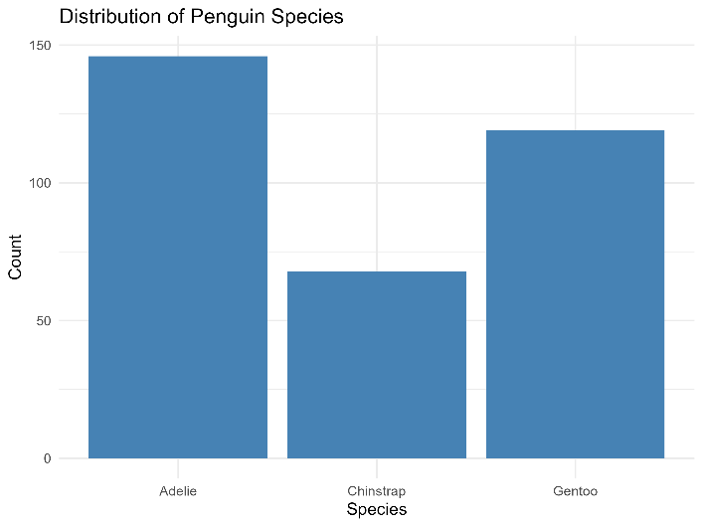
Figure 1

Figure 1. Bar chart showing the distribution of penguin species in the Palmer Penguins dataset.
The bar chart presents the number of observations for each penguin species included in the cleaned dataset. Adelie penguins represent the largest proportion of the observations, followed by Gentoo and Chinstrap penguins. This visualization provides an overview of the dataset composition and helps identify the relative representation of each species before conducting further statistical analysis.

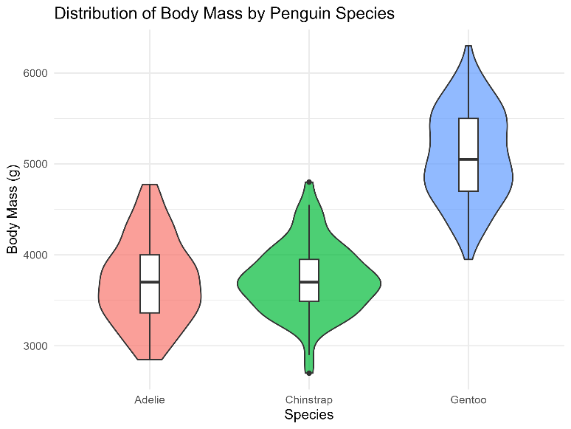
Figure 2

Figure 2. Violin plot showing the distribution of body mass across penguin species.
The violin plot illustrates the distribution of body mass for each penguin species. Gentoo penguins exhibit the highest body mass values, whereas Adelie and Chinstrap penguins generally have lower body masses. The shape of each violin indicates the density of observations, allowing a better understanding of variability and distribution compared to a standard box plot.

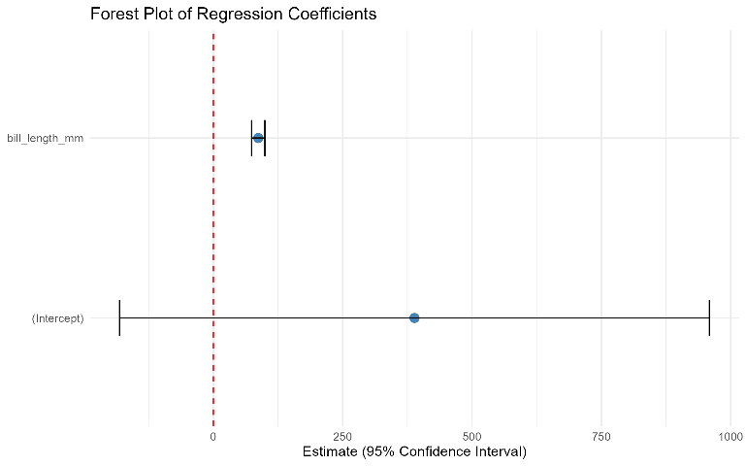
Figure 3

Figure 3. Forest plot summarizing selected statistical estimates.
The forest plot presents statistical estimates together with their confidence intervals. It provides a clear visual comparison of the estimated values and their associated uncertainty. Forest plots are widely used in statistical reporting because they enable readers to compare multiple estimates efficiently while highlighting the precision of each estimate.

Transition to the Next Analysis
The first three figures describe the overall characteristics of the dataset, including species distribution, variation in body mass, and statistical summaries. The next section explores relationships among numerical variables using scatter plots and correlation analysis.

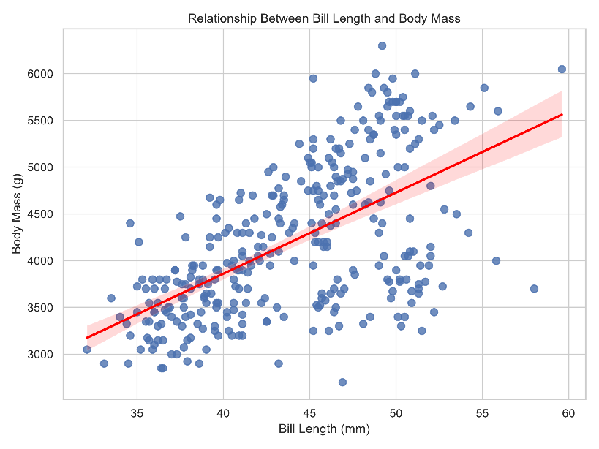
Figure 4

Figure 4. Scatter plot illustrating the relationship between bill length and body mass.
The scatter plot demonstrates a positive relationship between bill length and body mass. Penguins with longer bills generally tend to have greater body mass, as indicated by the upward trend of the regression line. Although some variability exists among individual observations, the overall pattern suggests a moderate positive association between these two variables.
This visualization is useful for identifying trends, detecting potential outliers, and understanding the linear relationship between morphological characteristics.

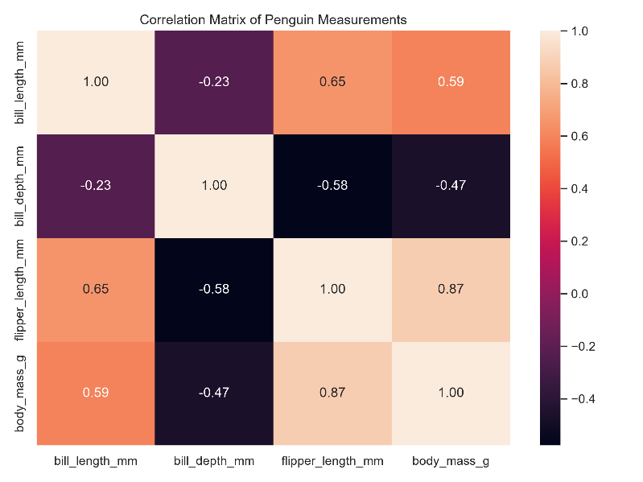
Figure 5

Figure 5. Correlation heatmap of numerical penguin measurements.
The correlation heatmap summarizes the relationships among the numerical variables included in this study. Positive correlations are observed between several body measurements, particularly between flipper length and body mass. Bill length also shows a positive correlation with body mass, while bill depth exhibits comparatively weaker relationships with the remaining variables.
The heatmap provides a concise overview of the strength and direction of correlations, making it easier to identify variables that are closely associated.

7. Summary Statistics
Insert Summary Statistics Table here
Table 1 presents descriptive statistics for the numerical variables included in the cleaned Palmer Penguins dataset. The table summarizes the count, mean, standard deviation, minimum, first quartile, median, third quartile, and maximum values for bill length, bill depth, flipper length, and body mass.
These descriptive measures provide an overall understanding of the dataset and indicate that the penguin measurements vary considerably among individuals. Such variation is expected due to biological differences among species.
Table 1. Summary statistics of numerical variables in the Palmer Penguins dataset.

The exploratory data analysis demonstrates that the Palmer Penguins dataset contains meaningful biological variation. The visualizations and descriptive statistics together provide a strong foundation for interpreting the relationships among penguin measurements, which are discussed in the following section.

8. Results and Discussion
The Palmer Penguins dataset was successfully imported, cleaned, and analyzed using both R and Python. Missing values were identified and removed to ensure that the analysis was conducted on complete observations only.
The descriptive statistics revealed substantial variation in bill length, bill depth, flipper length, and body mass among the penguin species. These differences are consistent with the biological characteristics of Adelie, Chinstrap, and Gentoo penguins.
The visualizations provided valuable insights into the dataset. The bar chart showed that Adelie penguins constituted the largest proportion of observations in the cleaned dataset. The violin plot demonstrated that Gentoo penguins generally have greater body mass than the other two species. The scatter plot indicated a positive relationship between bill length and body mass, suggesting that penguins with longer bills tend to have higher body mass. Furthermore, the correlation heatmap confirmed positive correlations among several body measurements, particularly between flipper length and body mass.
Overall, the exploratory data analysis successfully identified meaningful patterns and relationships within the dataset. The combination of statistical summaries and graphical visualizations enhanced the understanding of penguin morphology and demonstrated the effectiveness of exploratory data analysis techniques.

9. Conclusion
This project demonstrated a complete exploratory data analysis workflow using the Palmer Penguins dataset. Both R and Python were utilized to perform data cleaning, descriptive statistical analysis, and high-quality data visualization.
The analysis revealed clear differences among penguin species in terms of body measurements and identified positive relationships between several numerical variables. These findings are consistent with expected biological variation and illustrate the usefulness of exploratory data analysis for understanding complex datasets.
This project also strengthened practical skills in data manipulation, statistical summarization, visualization, and report writing. The experience gained from this analysis provides a strong foundation for future work in statistics, data science, and data analytics.

10. Limitations
Although the Palmer Penguins dataset is widely used for educational purposes, it has several limitations. The dataset represents penguins from a specific geographical region and therefore may not be representative of all penguin populations worldwide.
Additionally, only exploratory data analysis was performed in this project. Advanced statistical modeling, hypothesis testing, and predictive machine learning techniques were beyond the scope of this study.
Future studies may apply regression analysis, classification models, clustering techniques, or machine learning algorithms to obtain deeper insights from the dataset.

11. References
Horst, A. M., Hill, A. P., & Gorman, K. B. (2020). Palmer Penguins: An alternative to the Iris dataset for teaching data exploration and visualization. Retrieved from https://allisonhorst.github.io/palmerpenguins/
Wickham, H., Averick, M., Bryan, J., et al. (2019). Welcome to the tidyverse. Journal of Open Source Software, 4(43), 1686.
McKinney, W. (2022). Python for Data Analysis (3rd ed.). O'Reilly Media.
Hunter, J. D. (2007). Matplotlib: A 2D graphics environment. Computing in Science & Engineering, 9(3), 90–95.
Waskom, M. L. (2021). Seaborn: Statistical Data Visualization. Journal of Open Source Software, 6(60), 3021.

