Student teams will submit a detailed report on the project’s aims, significance and novelty, technical approaches used, outcomes derived and how it addresses the problem statement identified earlier. It should include the work done in all phases of the NLP pipeline starting from data acquisition to delivering the end outcomes. Group members should make sure that everyone contributes to the report equally. The report should include the elements below, as appropriate:

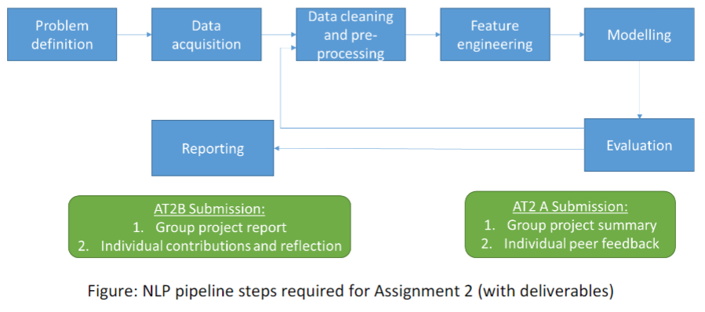

## Project objectives and scope

## Data description

## NLP methods and techniques (including models, justification for usage, trials conducted, and ethical implications)

## Findings – insights from the data, model and evaluation

## Project delivery outcomes and value added

## Challenges faced and solutions

## Limitations and future steps

## Project progress timeline with milestones achieved

## References

## Appendix (for data sets, code, visualizations, and additional material requiring an extended number of pages)