**Dara**

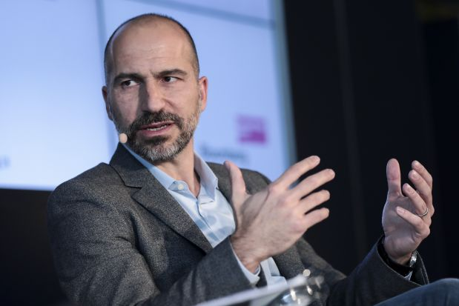

Uber CEO

49 years old

From RTP, NC

Dara is the CEO of Uber but recently he has taken interest in the moderator role at fashionxproject. During his free time he manages the Uber company and ensures that his company is up and running. He recently campaigned the phrase, ‘Moving Forward,’ in light of the recent issues his company had faced in the past. As part of his ‘Moving Forward’ campaign, he is improving Uber’s customer relations to ensure that customers have the best possible driving experience.

Dara loves to manage and one way he wants to do that is by approving posts and moderating influencers at fashionxproject. By taking other roles besides that of CEO, Dara ensures that he develops his skills as a manager. Recently Dara has been interested in the realm of fashion so the act of moderating influencer posts would be a hobby for him. By approving posts made by influencers, Dara can stay up to date with current trends in fashion.