**DUCTILE MATERIALS:** (Yield Criteria)

* Maximum Shear Stress (MSS)
* Distortion Energy (DE)
* Ductile Coulomb-Mohr (DCM)

**BRITTLE MATERIALS:** (Fracture Criteria)

* Maximum Normal Stress (MNS)
* Brittle Coulomb-Mohr (BCM)
* Modified Mohr (MM)

**Maximum Shear Stress (MSS)**

Tmax = =

Maximum Shear Stress

σx: Normal stress in X direction  
σy: Normal stress in Y direction  
τxy: Shear stress perpendicular to X axis and in Y direction.  
σ1/2: Principal Stresses 1/2:   
Sy: Yield Strength

Equation for maximum shear stress angle in plane stress situation**Maximum Shear Angle:**

It should be able to calculate the factory of safety or tmax (Vice versa)

User should be able to enter σ1/2 or σx/y .

When calculating T max if it is equal or greater then the material it is a failure. (It should state failure)

**Distortion Energy Theory or the von Mises Stress:**

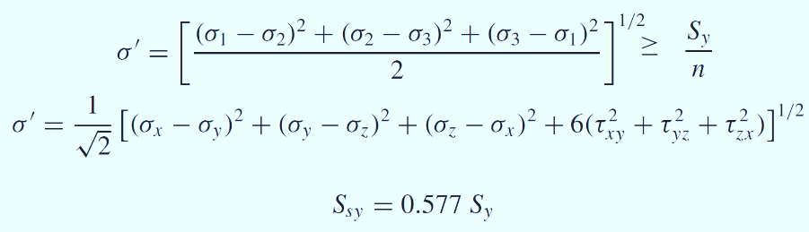

σ1/2/3: Principal Stresses 1,2,3   
Sy: Yield Strength  
Ssy: Shear Yield Strength

Plane stress σ3 = 0 :

σ' = [σ12 – σ1 σ2 + σ22 ]0.5 = Sy/n

User should be able to enter σ1/2 or σx/y or Stress 1 /2. (Using any two formulas above)

User should also be able to enter Ssy or Sy

Calculator should be able to calculate σ' / n

When calculating σ' if it is equal or greater then the material it is a failure. (It should state failure)

**Ductile-Coulomb-Mohr Theory Equation:**



*Syt* = yield tensile strength  
*Syc* = yield compressive strength  
*n*  = factor of safety   
*σ1 / σ2* = Principal stresses

It should state the material has failed or not. If yes state Fail if not say material is considered safe (within limits)

Failure Based on following:

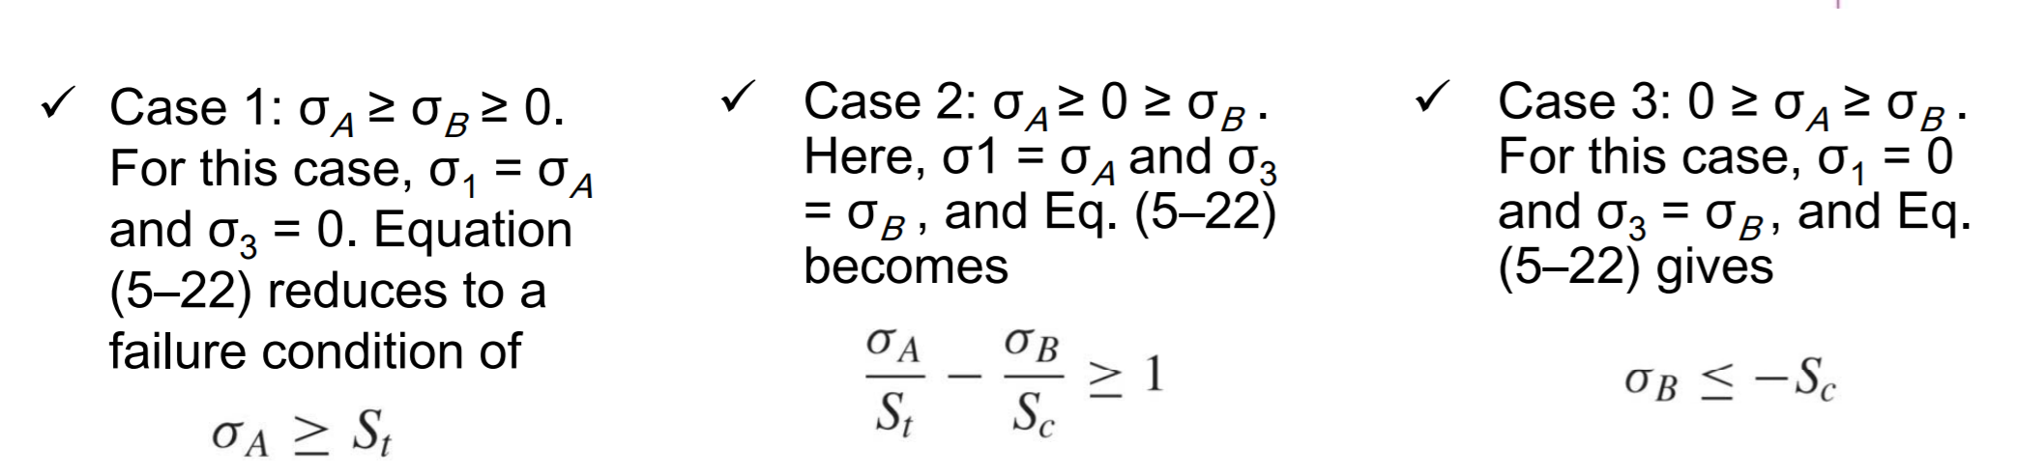

**Brittle-Coulomb-Mohr Theory Equation:**



*Sut* = ultimate tensile strength  
*Suc* = ultimate compressive strength  
*n*  = factor of safety   
*σA / σB* = nonzero principal stresses

It should state the material has failed or not. If yes state Fail if not say material is considered safe (within limits)

**Modified Mohr Theory Equation:**

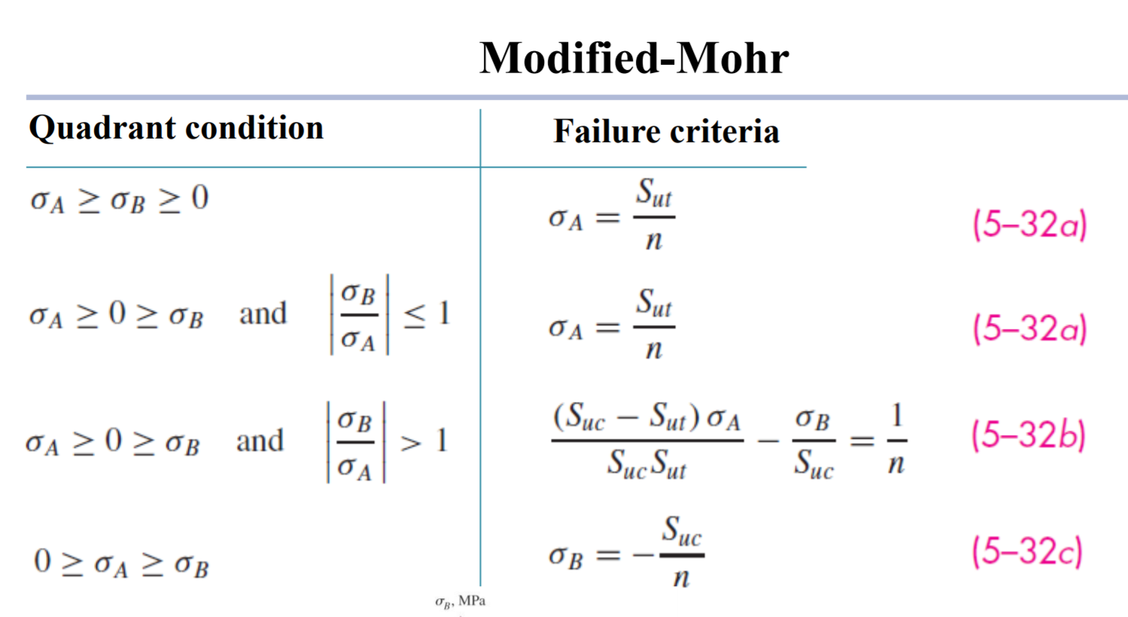

*Sut* = ultimate tensile strength  
*Suc* = ultimate compressive strength  
*n*  = factor of safety   
*σA / σB* = nonzero principal stresses

It should state the material has failed or not. If yes state Fail if not say material is considered safe (within limits)