Approximating uncertainty around indices from stratified-random trawl surveys using the Gamma distribution

Paul M. Regular, Mariano Koen-Alonso, Semra Yalcin, Andrea M.J. Perreault, Laura J. Wheeland

Northwest Atlantic Fisheries Center, Fisheries and Oceans Canada, P.O.Box 5667, St. John’s, NL, A1C 5X1, Canada   
  
2022-06-20

# Abstract

Many data-limited stock assessments rely on survey indices for the provision of science advice. Design-based estimators of stock size are often applied, however, the quantification of uncertainty around these estimates remains a challenge. Standard practice has been to use quantiles from a Student’s t distribution even though this method sometimes produces negative intervals. As an alternate method, we propose the use of the Gamma distribution, which cannot take negative values, to approximate uncertainty around survey indices. This involves the translation of unbiased design-based mean and variance estimators to shape and scale parameters for the Gamma distribution. Via simulation testing, we show that densities derived from the Gamma distribution closely match densities derived from bootstraped samples of simulated survey data. We also highlight an application of this method to Redfish in NAFO Division 3O. We argue that this approach offers a reasonable approximation of uncertainty that can be used to quantify stock status and inform risk-based management decisions.

# Introduction

A primary objective of fisheries-independent trawl surveys is to obtain indices of stock size and quantify the uncertainty around these indices. Such information plays a critical role in the assessment and management of fish stocks around the world as they often serve as a leading indicator to evaluate stock status and trend (Kimura and Somerton, 2006; Pennington and Strømme, 1998).

Fisheries management increasingly relies on the quantification of uncertainty about stock status and trend to characterize the risk associated with alternative management options. Whenever possible, this quantification of uncertainty is done using stock assessment models which are often calibrated using survey-based indices as a primary indicator of stock level and trajectory. However, data limitations, complex stock dynamics, and operational capacity constraints often preclude the implementation of complex stock assessment models. In these cases, the assessment of the stock tend to be based on the survey indices themselves, together with any additional biological and ecological information that may be available. Therefore, when assessments are survey-based, the quantification of uncertainty of the survey indices becomes a primary source for informing risk.

While model-based indices derived from geostatistical approaches (e.g., Anderson et al., 2022; Thorson et al., 2015) are growing in popularity, traditional design-based estimators continue to be the standard for the estimation of survey biomass and abundance. Among these the most common design for fisheries surveys is the random-stratified sampling with stratification mostly driven by depth.

In the Northwest Atlantic, major bottom trawl surveys follow a stratified-random sampling design with proportional allocation (e.g., González-Troncoso et al., 2022; Rideout et al., 2022), and the biomass and abundance indices are calculated accordingly (e.g., S. Smith and Somerton, 1981). Unfortunately, the quantification of uncertainty around these estimates remains a challenge. Quantiles from a Student’s t distribution are the standard to approximate the uncertainty around stratified estimates (Cochran, 1977, Seber 1982); however, the lower limits of this approximation can result in unrealistic negative values (Cadigan, 2011). Here we propose an alternate approximation to the uncertainty using the Gamma distribution which accounts for the positive and skewed nature of survey indices.

# Methods

*Rationale*

The derivation of the standard mean and variance estimators from a random-stratified sampling design is constructed using the general properties of the mean and variance, building these estimators from the straightforward concept that the overall mean represents a weighted average of the strata means, and where the weights applied are constants derived from the stratification scheme (e.g. Cochran 1977).

One important feature of this derivation is that it does not depend on any assumed distribution; the estimators of the mean and variance are valid ones irrespective of the underlying distribution. Furthermore, once the mean and variance are estimated, it is the approximation to the confidence intervals under the assumption of a normal distribution what leads to the use of normal quantiles to approximate the confidence intervals when sample sizes are large, or the use of the Student's t distribution when sample sizes are small (i.e. few degrees of freedom per stratum) and which allows for considering the sampling errors (Cochran 1977).

Therefore, the issue of negative values for the confidence interval of strictly positive quantities like biomass and abundance is not linked to the random-stratified estimators themselves, but to the subsequent assumption of normality used in the approximation of the confidence intervals. This is the reason that justifies the application of resampling techniques like bootstrap to derive more realistic confidence intervals for random-stratified estimators.

While resampling techniques can be an effective tool to generate confidence intervals, depending on the case in hand, they could require additional computing power and programming efforts. These additional steps should not be a deterrent to implementing them when required but having a simpler alternative that addresses the issues linked to the normal approximation can also be useful.

A cursory examination of biomass and abundance indices from research surveys not only shows that there are no negative values (thankfully), but that the distributions are seldom symmetrical; long positive tails are often observed. Given these features, a logical choice for describing these data is the Gamma distribution. This distribution is always positive, and depending on the parametrization, it can be fairly symmetrical (i.e. normal-like) or have a long right tail.

Given that the standard approach to approximate confidence intervals relies on the assumption of a normal distribution, here we propose that by simply changing the assumed distribution we can provide a better approximation to the confidence intervals which does not suffer from undesired features (e.g. negative lower values), while better resembling observed distributions (e.g. asymmetrical distribution with longer positive tails).

*Calculation*

Provided data from a bottom trawl stratified-random survey, average biomass or abundance ($\hat{μ}$) and sampling variance (${\hat{σ}}^{2}$) over the stock area can be estimated using the standard random-stratified design calculations (Cochran, 1977; S. J. Smith, 1990; S. Smith and Somerton, 1981). These estimates can then be used to calculate the scale ($\hat{θ}$) and shape ($\hat{κ}$) parameters of the corresponding Gamma distribution as:

$$\hat{θ}=\frac{{\hat{σ}}^{2}}{\hat{μ}}, \text{and} \hat{κ}=\frac{\hat{μ}}{\hat{θ}}$$

The resulting Gamma distribution is then assumed to describe the data and its quantiles used to define the confidence intervals in the same way the Normal or Student's t distributions are used in the standard approach.

*Simulation testing*

While the proposed approach only involves a change in the assumption made about the distribution of the estimated mean, establishing if it actually performs better than the customary normal/Student’s t distribution assumption requires additional analysis. To address this issue, we examined the performance of the change in the assumed distribution through simulation testing.

The simulation testing focused on two different scenarios where confidence intervals, or estimations of probabilities more generally, are often used in the context of indices from bottom trawl surveys. The first scenario is the straightforward confidence interval of a single survey index.

The second scenario is based on a commonly occurring case in index-driven stocks assessments where we want to estimate the probability of the stock to be above or below some reference point. In these cases, a typical situation involves the need to calculate the probability that the current index is above or below an average level of the index ${\hat{μ}}_{r}$ from a reference period *R*.

Since the reference point ${\hat{μ}}_{r}$ is an average of the index itself, its value cannot be perfectly known and the uncertainty around it should also be taken into account in the estimation of the probability. Given that each individual index value included in the average has its own variance, a full consideration of the uncertainty around the average should also consider this variability. Therefore, to fully account for the uncertainty around ${\hat{μ}}_{r}$ we need to combine the variances across the individual indices. This combined variance ${\hat{σ}}_{r}^{2}$ can be obtained by simply applying the general properties of the variance. Since ${\hat{μ}}_{r}$ is effectively a linear combination of the individual indices (i.e. the sum of random variables multiplied by a constant -the inverse of sample size-) the properties of the variance for a linear combination provides a way for estimating ${\hat{σ}}_{r}^{2}$. Furthermore, if we assume that the survey variances across years are independent, we can dismiss the covariances between years and ${\hat{μ}}_{r}$ and ${\hat{σ}}_{r}^{2}$ can be estimated as:

$${\hat{μ}}_{r}=\frac{\sum_{y=1}^{\left|R\right|}{\hat{μ_{y}}}}{\left|R\right|}, \text{and} {\hat{σ}}_{r}^{2}=\frac{\sum_{y=1}^{\left|R\right|}{{\hat{σ}}_{y}^{2}}}{{\left|R\right|}^{2}}$$

where $\hat{μ_{y}}$ and ${\hat{σ}}_{y}^{2}$ are the estimated annual mean and variance for the index in each year *y* within the reference period *R*, and where $\left|R\right|$ is the size of the period (i.e. the number of years used to compute the average). As above, ${\hat{μ}}_{r}$ and ${\hat{σ}}_{r}^{2}$ can be converted to $\hat{θ}$ and $\hat{κ}$ parameters to characterize the uncertainty assuming a Gamma distribution.

We explored these two scenarios by simulating a redfish-like population using the R package SimSurvey (Regular et al., 2020). The simulated population was based on the exponential decay cohort model where parameter settings for mortality, recruitment, and growth were based on assessments of redfish on the Grand Bank (see Appendix A for details). The simulated population was distributed through an area according to the age-year-space covariance with a parabolic relationship with depth. This survey area was 300 x 300 km with 10 km2 cell size and had 30 depth-based strata. We simulated stratified random sampling with a 2 m wide trawl hauled for a distance of 1.5 km. The population and survey were simulated over 20 years. The number of sets in a stratum was proportional to its area (approximately 1 set per 1000 km2) and the minimum set per stratum was 2. The survey simulation was replicated five times over the same population.

A single simulation run consisted in a twenty year time series where average trawlable abundance ($\hat{μ}$) and sampling variance (${\hat{σ}}^{2}$) were calculated by year using standard design-based estimators (S. J. Smith, 1990; S. Smith and Somerton, 1981), and these estimates were then used to calculate the scale ($\hat{θ}$) and shape ($\hat{κ}$) parameters of the Gamma distribution. We conducted five replicates of this simulation run.

To compare probability densities obtained from the Gamma distribution with densities based on an empirical approach, we applied a non-parametric bootstrap to resample the observations (sets) independently within each stratum with replacement. The resampling and calculation of the mean bootstrap estimator were repeated 1000 times with the R package boot (Canty and Ripley, 2021). Densities from these bootstrap samples were computed for each year and survey replicate for comparison to the Gamma approximation.

The entire simulation, including the simulated surveys and the bootstrap estimation, can be replicated using code in Appendix A.

The direct comparisons between the gamma approximated distributions for each survey year and run replicate provides a way to evaluate the first scenario described above, while the results from the entire simulation 1 were used to evaluate the second scenario.

We used the results from simulation 1 to estimate the average abundance and the associated variance was constructed by combining the annual variances as described above. These estimates were used to calculate the corresponding gamma distribution parameters to characterize the average abundance distribution. This distribution was then used to calculate the probability that the abundance in the terminal year, also assumed following a gamma distribution, to be below the average. This calculation was done by simulation using these two gamma distributions.

These results were then compared to an equivalent analysis where the corresponding empirical distribution were constructed using non-parametric bootstrapping.

## Application

During the 2022 assessment of Redfish in NAFO Division 3O, candidate biomass reference points were examined using indices derived from the Canadian spring and fall surveys of Div. 3O (years  
?). Given relative stability in catches through the history of the fishery, and trends in survey indices, the (full?) survey time series is considered to represent normal conditions for this stock (i.e. no apparent prolonged period of collapse). The average of the survey time series was therefore considered a reasonable proxy for BMSY [REF?] and, following the NAFO precautionary approach framework (NAFO, 2004), 30% of BMSY would be considered the limit reference point (LRP).

To combine indices from the spring and fall surveys, and account for uncertainty associated with estimates from both surveys, annual stratified means and variances from each survey were combined using the properties of the variance and translated to shape and scale parameters for use in the gamma distribution following the abovementioned equations. In years when a survey index is missing, the available survey is used in place of the mean and variance estimate. This same approach was applied to account for the uncertainty in the BMSY proxy by applying the Gamma distribution informed by averaged point estimates of mean and variance.

# Results and Discussion

The Gamma probability density distribution showed high variability among survey simulations, as did the bootstrap samples (Figure 1). Nevertheless, the shape of both the Gamma density and the bootstrap samples were similar across all years and survey replicates, indicating that the Gamma distribution provides a reasonable approximation of the uncertainty around the stratified estimates. This indicates that, at the very least, confidence intervals derived from assuming a Gamma distribution represent an improvement over the ones obtained by assuming a Student’s t distribution, which sometimes renders unrealistic confidence intervals.

The similarity holds when survey indices are aggregated (Figure 2). Though further quantitative analysis is required to assess the performance of these methods for calculating the confidence intervals, these results indicate that confidence intervals from the Gamma approach would be similar to those obtained using bootstrap samples.

The BMSY proxy and associated limit reference point (30% BMSY proxy) proposed for redfish in Div. 3O was accepted as an interim reference point, as was the Gamma-based method for quantifying uncertainty. Neither the value for MSY or for the LRP is considered perfectly known, therefore estimates were aggregated to account for uncertainty in these indices. Determining status relative to the LRP considering uncertainty in both the proxy-BMSY and the terminal biomass index provides the most fulsome formulation of uncertainty in stock status and is considered to provide the most precautionary approach to advice.

Wrap-up paragraph? This preliminary work suggests that the Gamma distribution provides a reasonable approach to quantifying uncertainty for redfish. Although work needs further simulation studies, could be a valuable tool for future work etc etc etc

# References

Anderson, S. C., Ward, E. J., English, P. A., and Barnett, L. A. (2022). sdmTMB: An R package for fast, flexible, and user-friendly generalized linear mixed effects models with spatial and spatiotemporal random fields. *bioRxiv*.

Cadigan, N. G. (2011). Confidence intervals for trawlable abundance from stratified-random bottom trawl surveys. *Canadian Journal of Fisheries and Aquatic Sciences*, *68*(5), 781–794.

Canty, A., and Ripley, B. D. (2021). *Boot: Bootstrap r (s-plus) functions*.

Cochran, W. G. (1977). *Sampling techniques*. John Wiley & Sons.

González-Troncoso, D., Garrido, I., Rábade, S., Fabeiro, M., Román, E., Tarrío, C., Sánchez, J. M. C., and Alpoim, R. (2022). Results from Bottom Trawl Survey on Flemish Cap of June-July 2021. *NAFO SCR Doc*, *22/004*.

Kimura, D. K., and Somerton, D. A. (2006). Review of statistical aspects of survey sampling for marine fisheries. *Reviews in Fisheries Science*, *14*(3), 245–283.

NAFO. (2004). NAFO Precautionary Approach Framework. *NAFO/FC Doc*, *04/18*.

Pennington, M., and Strømme, T. (1998). Surveys as a research tool for managing dynamic stocks. *Fisheries Research*, *37*(1-3), 97–106.

Regular, P. M., Robertson, G. J., Lewis, K. P., Babyn, J., Healey, B., and Mowbray, F. (2020). SimSurvey: An R package for comparing the design and analysis of surveys by simulating spatially-correlated populations [Journal]. *PLOS ONE*, *15*(5), 1–28. <https://doi.org/10.1371/journal.pone.0232822>

Rideout, R. M., Rogers, B., Wheeland, L., and Koen-Alonso, M. (2022). Temporal And Spatial Coverage Of Canadian (Newfoundland And Labrador Region) Spring And Autumn Multi-Species RV Bottom Trawl Surveys, With An Emphasis On Surveys Conducted In 2021. *NAFO SCR Doc*, *22/007*.

Smith, S. J. (1990). Use of statistical models for the estimation of abundance from groundfish trawl survey data. *Canadian Journal of Fisheries and Aquatic Sciences*, *47*(5), 894–903.

Smith, S., and Somerton, G. (1981). *STRAP: A User-Oriented Computer Analysis System for Groundfish Research Trawl Survey Data* (p. 66). Canadian Technical Report of Fisheries; Aquatic Sciences No. 1030.

Thorson, J. T., Shelton, A. O., Ward, E. J., and Skaug, H. J. (2015). Geostatistical delta-generalized linear mixed models improve precision for estimated abundance indices for West Coast groundfishes. *ICES Journal of Marine Science*, *72*(5), 1297–1310.

# Figures

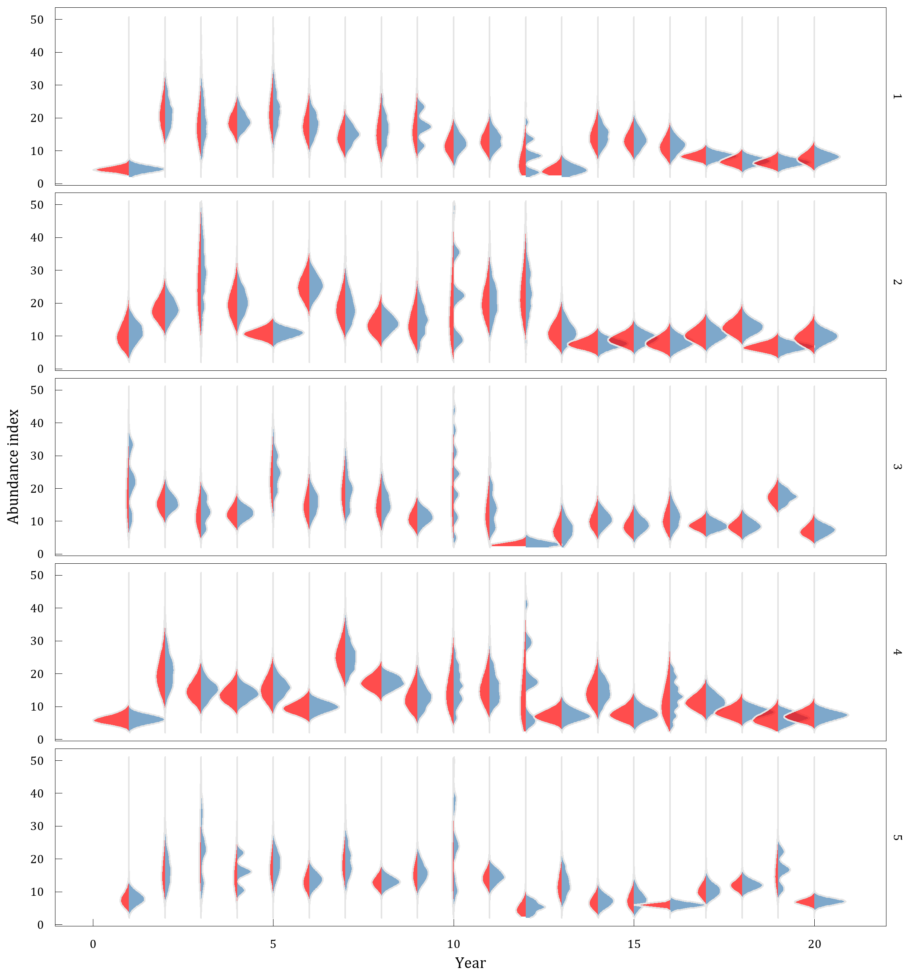

Fig 1: The bootstrap and gamma distributions estimated using simulated data from five independent surveys conducted over the same population across 20 years. The red area shows the density distribution from 1000 bootstrapped samples from each year and survey replicate. The blue area shows the gamma probability distribution from each year and survey replicate based on the mean and standard deviation of the design-based index.

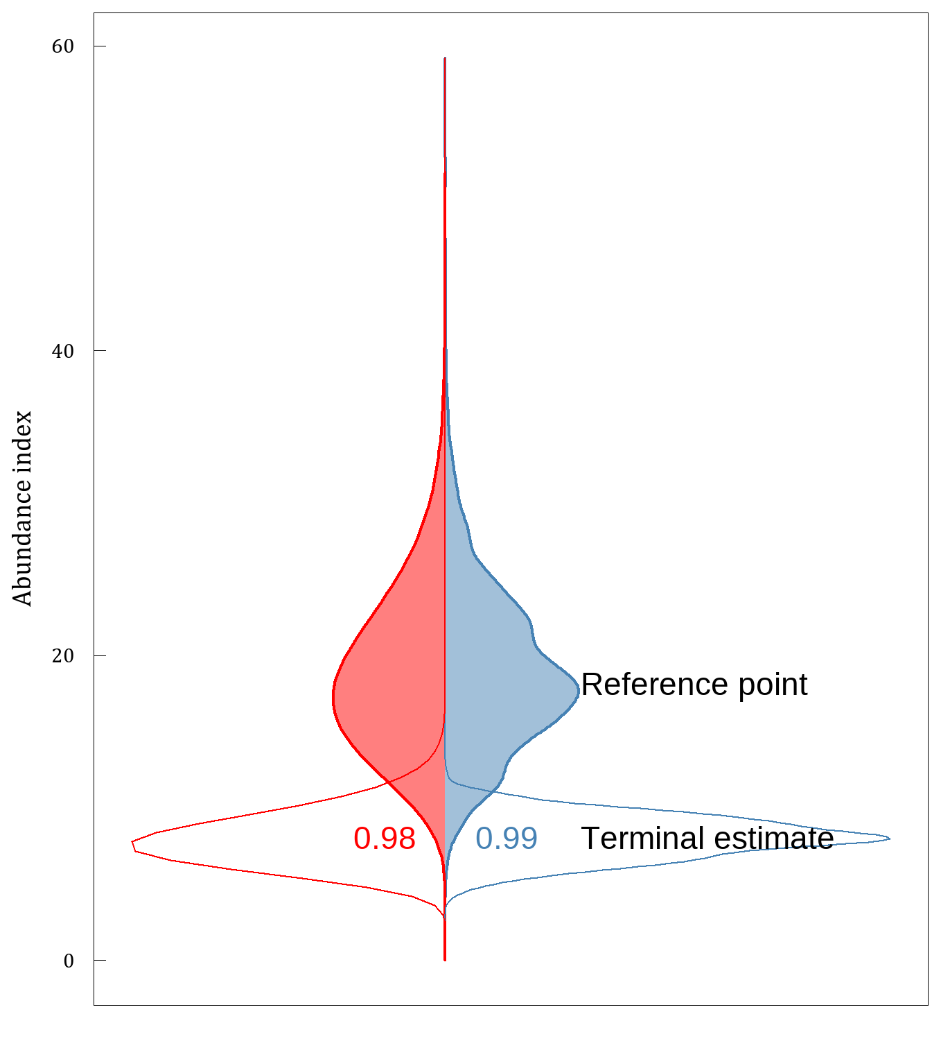

Fig 2: Bootstrap (blue) and gamma (red) distributions estimated from simulation 1 of a redfish-like population, where terminal estimates (year 20; open area) are compared to a reference period (aggregate estimates from years 2-9; shaded area). Densities for the reference period were obtained by combining the bootstrap samples and by aggregate parameters across the reference period (see Methods section). Probability that the terminal value is below the reference point is indicated.

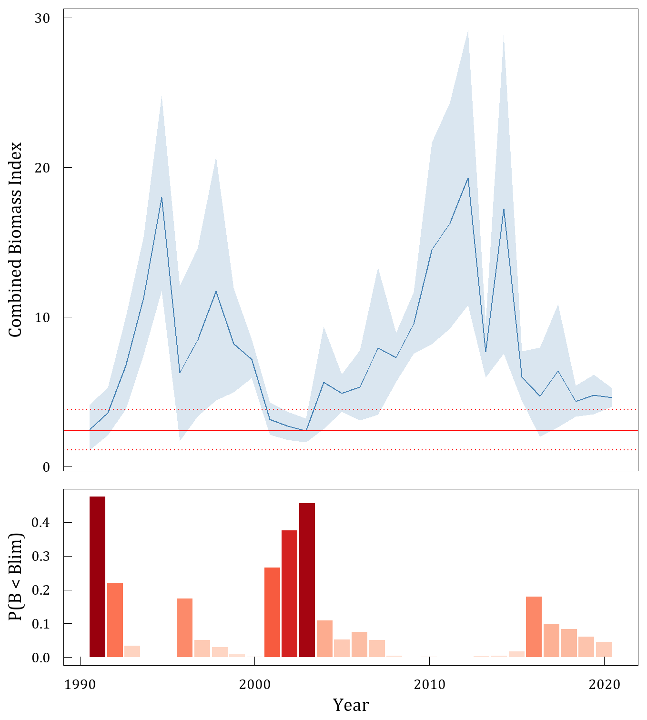

Fig 3: Combined CAN-Spring and CAN-Autumn biomass index (top; blue line) with 80% confidence intervals (blue shaded area) calculated using a Gamma distribution. Horizontal line (red) indicates interim Blim = 0.3 Bmsy-proxy with 80% confidence intervals (red dashed lines). Probability of By < Blim is presented below.

# Appendix A

Simulation results can be replicated using the below code.

library(SimSurvey)  
library(tidyr)  
library(future)  
library(tictoc)  
library(ggplot2)  
library(ggridges)  
library(dplyr)  
library(purrr)  
library(data.table)  
library(NAFOdown)  
  
plan(multisession, workers = floor(availableCores()/2))  
  
n_sims <- 5  
n_boot <- 1000  
  
  
## Simulation ----------  
  
set.seed(794)  
population <- sim_abundance(ages = 1:50,  
 years = 1:20,  
 R = sim_R(log_mean = log(600000000),  
 log_sd = 0.6,  
 random_walk = F),  
 Z = sim_Z(log_mean = log(0.2),  
 log_sd = 0.2,  
 phi_age = 0.4,  
 phi_year = 0.4),  
 N0 = sim_N0(N0 = "exp", plot = FALSE),  
 growth = sim_vonB(Linf = 30, L0 = 0,   
 K = 0.1, log_sd = 0.13,  
 length_group = 1,   
 digits = 0)) |>  
 sim_distribution(grid = make_grid(x_range = c(-150, 150),  
 y_range = c(-150, 150),  
 res = c(10, 10),  
 shelf_depth = 60,  
 shelf_width = 170,  
 depth_range = c(0, 1600),  
 n_div = 2,  
 strat_breaks = seq(0, 1600,   
 by = 65),  
 strat_splits = 4,  
 method = "bezier"),  
 ays_covar = sim_ays_covar(sd = 2,  
 range = 200,  
 phi_age = 0.5,  
 phi_year = 0.9),  
 depth_par = sim_parabola(mu = log(190),  
 sigma = 0.3,  
 log_space = TRUE))  
  
  
survey <- sim_survey(population,  
 n_sims = n_sims,  
 q = sim_logistic(k = 1, x0 = 6.5),  
 trawl_dim = c(1.5, 0.02),  
 resample_cells = FALSE,  
 binom_error = TRUE,  
 min_sets = 2,  
 set_den = 1/1000,  
 lengths_cap = 250,  
 ages_cap = 20,  
 age_sampling = "stratified",  
 age_length_group = 1,  
 age_space_group = "division") |>  
 run_strat()  
  
  
## Density from the Gamma distribution ----------  
  
total_strat <- survey$total_strat |>  
 mutate(sigma = sampling_units * sd,  
 scale = sigma ^ 2 / total,  
 shape = total / scale)  
  
## Use gamma to generate density by sim and year  
rng <- c(0.001, max(total_strat$total) * 2)  
x <- seq(rng[1], rng[2], length.out = 100)  
total_strat_den <- lapply(seq.int(nrow(total_strat)),   
 function(i) {  
 data.frame(sim = total_strat$sim[i],  
 year = total_strat$year[i],  
 total = x,  
 den = dgamma(x, shape = total_strat$shape[i],  
 scale = total_strat$scale[i]))  
}) |> dplyr::bind_rows()  
  
  
### Density from bootstrapping ----------  
  
setdet <- survey$setdet  
  
split_setdet <- split(setdet, paste0(setdet$year, "-", setdet$sim))  
  
sumYst <- function(data, i = seq_len(nrow(data))) {  
 data[i, ] |>  
 ### stratum level  
 group_by(year, strat, strat_area) |>  
 summarise(meanYh = mean(n), tow_area = mean(tow_area),   
 .groups = "drop_last") |>  
 mutate(Nh = strat_area/(tow_area)) |>  
 group_by(year) |>  
 mutate(N = sum(Nh), Wh = Nh/N, WhmeanYh = Wh * meanYh)|>  
 ### year level  
 summarise(sumYst= mean(N) * sum(WhmeanYh),   
 .groups = "drop_last") |>  
 pull(sumYst)  
}  
  
boot_one_year <- function(data, reps) {  
 b <- boot::boot(data, statistic = sumYst,   
 strata = data$strat, R = reps)  
 boot <- data.table(b$t) |> dplyr::rename(total = V1) |>  
 mutate(sim = mean(data$sim), year = mean(data$year))  
 return(boot)  
}  
  
tic()  
boot_index <- furrr::future_map_dfr(split_setdet, boot_one_year,   
 reps = n_boot,  
 .options = furrr::furrr_options(seed = TRUE))  
toc()  
  
quantile(boot_index$total, prob = c(0.001, 0.999))  
  
den_plot <- ggplot() +  
 geom_density_ridges(aes(x = total, y = as.numeric(year),   
 group = factor(year)),  
 color = "grey90", fill = "steelblue",   
 alpha = 0.7,  
 data = boot_index, scale = 1) +  
 geom_density_ridges(aes(x = total, y = year, height = den,   
 group = factor(year)),  
 stat = "identity", color = "grey90", fill = "red",   
 alpha = 0.7,  
 data = total_strat_den, scale = -1) +  
 coord_flip() + guides(fill = "none") +  
 scale_x_continuous(labels = scales::label_number(suffix = "",  
 scale = 1e-8),  
 limits = c(194587641, 5116017391)) +  
 ylab("Year") + xlab("Abundance index") +  
 facet_grid(rows = "sim") +  
 theme_nafo()  
  
  
## Relative status ----------  
  
  
sub_total_strat <- total_strat |>  
 filter(sim == 1)  
  
ref_est <- total_strat |>  
 filter(sim == 1, year %in% 2:9) |>  
 summarise(total = mean(total),  
 sigma = sqrt(mean(sigma ^ 2)),  
 scale = sigma ^ 2 / total,  
 shape = total / scale)  
  
ref_boot <- boot_index |>  
 filter(sim == 1, year %in% 2:9)  
  
x <- seq(min(ref_boot), max(ref_boot), length.out = 100)  
ref_den <- data.frame(total = x, den = dgamma(x, shape = ref_est$shape,   
 scale = ref_est$scale))  
  
t_est <- total_strat |>  
 filter(sim == 1, year == 20)  
  
t_den <- total_strat_den |>  
 filter(sim == 1, year == 20)  
  
t_boot <- boot_index |>  
 filter(sim == 1, year == 20)  
  
boot_prob <- mean((t_boot$total - ref_boot$total) < 0)  
n_samp <- 100000  
ref_samp <- rgamma(n_samp, shape = ref_est$shape, scale = ref_est$scale)  
t_samp <- rgamma(n_samp, shape = t_est$shape, scale = t_est$scale)  
gamma_prob <- mean((t_samp - ref_samp) < 0)  
  
ggplot() +  
 geom_density(aes(x = total), data = ref_boot, fill = "steelblue",   
 color = "steelblue", alpha = 0.5) +  
 geom_area(aes(x = total, y = -den), data = ref_den, fill = "red",   
 color = "red", alpha = 0.5) +  
 geom_density(aes(x = total), data = t_boot, fill = NA,   
 color = "steelblue", size = .nafo_lwd) +  
 geom_area(aes(x = total, y = -den), data = t_den, fill = NA,   
 color = "red", size = .nafo_lwd) +  
 geom_text(aes(x = t_est$total, y = max(ref_den$den) * 1.2,   
 label = "Terminal estimate"), hjust = 0, vjust = 0.5) +  
 geom_text(aes(x = ref_est$total, y = max(ref_den$den) * 1.2,   
 label = "Reference point"), hjust = 0, vjust = 1) +  
 geom_text(aes(x = t_est$total, y = 0, label = round(boot_prob, 2)),   
 hjust = -0.5, color = "steelblue") +  
 geom_text(aes(x = t_est$total, y = 0, label = round(gamma_prob, 2)),   
 hjust = 1.5, color = "red") +  
 theme_nafo() +  
 coord_flip() +  
 scale_x_continuous(labels = scales::label_number(suffix = "",   
 scale = 1e-8)) +  
 ylab("") + xlab("Abundance index") +  
 theme(axis.ticks.x = element_blank(),  
 axis.text.x = element_blank())

# Colophon

This version of the document was generated on 2022-06-20 14:58:11 using the R markdown template for SCR documents from [NAFOdown](https://github.com/nafc-assess/NAFOdown).

The computational environment that was used to generate this version is as follows:

#> - Session info ---------------------------------------------------------------  
#> setting value  
#> version R version 4.1.2 (2021-11-01)  
#> os Windows 10 x64 (build 19042)  
#> system x86_64, mingw32  
#> ui RTerm  
#> language (EN)  
#> collate English_United States.1252  
#> ctype English_United States.1252  
#> tz America/St_Johns  
#> date 2022-06-20  
#> pandoc 2.14.0.3 @ C:/Program Files/RStudio/bin/pandoc/ (via rmarkdown)  
#>   
#> - Packages -------------------------------------------------------------------  
#> package * version date (UTC) lib source  
#> assertthat 0.2.1 2019-03-21 [1] CRAN (R 4.1.2)  
#> base64enc 0.1-3 2015-07-28 [1] CRAN (R 4.1.0)  
#> bookdown 0.24 2021-09-02 [1] CRAN (R 4.1.1)  
#> cachem 1.0.6 2021-08-19 [1] CRAN (R 4.1.1)  
#> callr 3.7.0 2021-04-20 [1] CRAN (R 4.1.1)  
#> cli 3.1.0 2021-10-27 [1] CRAN (R 4.1.2)  
#> colorspace 2.0-2 2021-06-24 [1] CRAN (R 4.1.1)  
#> cowplot 1.1.1 2020-12-30 [1] CRAN (R 4.1.3)  
#> crayon 1.4.1 2021-02-08 [1] CRAN (R 4.1.1)  
#> data.table 1.14.0 2021-02-21 [1] CRAN (R 4.1.1)  
#> DBI 1.1.1 2021-01-15 [1] CRAN (R 4.1.1)  
#> desc 1.3.0 2021-03-05 [1] CRAN (R 4.1.1)  
#> devtools 2.4.3 2021-11-30 [1] CRAN (R 4.1.2)  
#> digest 0.6.29 2021-12-01 [1] CRAN (R 4.1.2)  
#> dplyr 1.0.7 2021-06-18 [1] CRAN (R 4.1.1)  
#> ellipsis 0.3.2 2021-04-29 [1] CRAN (R 4.1.1)  
#> evaluate 0.14 2019-05-28 [1] CRAN (R 4.1.1)  
#> fansi 0.5.0 2021-05-25 [1] CRAN (R 4.1.1)  
#> farver 2.1.0 2021-02-28 [1] CRAN (R 4.1.1)  
#> fastmap 1.1.0 2021-01-25 [1] CRAN (R 4.1.1)  
#> flextable * 0.6.9 2021-10-07 [1] CRAN (R 4.1.0)  
#> fs 1.5.2 2021-12-08 [1] CRAN (R 4.1.2)  
#> gdtools 0.2.3 2021-01-06 [1] CRAN (R 4.1.1)  
#> generics 0.1.1 2021-10-25 [1] CRAN (R 4.1.2)  
#> ggplot2 * 3.3.5 2021-06-25 [1] CRAN (R 4.1.1)  
#> ggridges 0.5.3 2021-01-08 [1] CRAN (R 4.1.3)  
#> ggthemes 4.2.4 2021-01-20 [1] CRAN (R 4.1.3)  
#> glue 1.4.2 2020-08-27 [1] CRAN (R 4.1.1)  
#> gtable 0.3.0 2019-03-25 [1] CRAN (R 4.1.1)  
#> here * 1.0.1 2020-12-13 [1] CRAN (R 4.1.1)  
#> highr 0.9 2021-04-16 [1] CRAN (R 4.1.1)  
#> htmltools 0.5.2 2021-08-25 [1] CRAN (R 4.1.1)  
#> knitr 1.34 2021-09-09 [1] CRAN (R 4.1.1)  
#> labeling 0.4.2 2020-10-20 [1] CRAN (R 4.1.0)  
#> lifecycle 1.0.1 2021-09-24 [1] CRAN (R 4.1.3)  
#> magrittr 2.0.1 2020-11-17 [1] CRAN (R 4.1.1)  
#> memoise 2.0.1 2021-11-26 [1] CRAN (R 4.1.2)  
#> munsell 0.5.0 2018-06-12 [1] CRAN (R 4.1.1)  
#> NAFOdown * 0.0.1.9000 2022-06-13 [1] local  
#> officer 0.4.0 2021-09-06 [1] CRAN (R 4.1.1)  
#> pillar 1.6.2 2021-07-29 [1] CRAN (R 4.1.1)  
#> pkgbuild 1.2.0 2020-12-15 [1] CRAN (R 4.1.1)  
#> pkgconfig 2.0.3 2019-09-22 [1] CRAN (R 4.1.1)  
#> pkgload 1.2.2 2021-09-11 [1] CRAN (R 4.1.0)  
#> plyr 1.8.6 2020-03-03 [1] CRAN (R 4.1.1)  
#> prettyunits 1.1.1 2020-01-24 [1] CRAN (R 4.1.1)  
#> processx 3.5.2 2021-04-30 [1] CRAN (R 4.1.1)  
#> ps 1.6.0 2021-02-28 [1] CRAN (R 4.1.1)  
#> purrr 0.3.4 2020-04-17 [1] CRAN (R 4.1.1)  
#> R6 2.5.1 2021-08-19 [1] CRAN (R 4.1.1)  
#> Rcpp 1.0.7 2021-07-07 [1] CRAN (R 4.1.1)  
#> remotes 2.4.0 2021-06-02 [1] CRAN (R 4.1.1)  
#> rlang 1.0.2 2022-03-04 [1] CRAN (R 4.1.3)  
#> rmarkdown 2.11 2021-09-14 [1] CRAN (R 4.1.1)  
#> rprojroot 2.0.2 2020-11-15 [1] CRAN (R 4.1.1)  
#> rstudioapi 0.13 2020-11-12 [1] CRAN (R 4.1.1)  
#> scales 1.1.1 2020-05-11 [1] CRAN (R 4.1.1)  
#> sessioninfo 1.2.2 2021-12-06 [1] CRAN (R 4.1.2)  
#> showtext 0.9-4 2021-08-14 [1] CRAN (R 4.1.1)  
#> showtextdb 3.0 2020-06-04 [1] CRAN (R 4.1.1)  
#> stringi 1.7.4 2021-08-25 [1] CRAN (R 4.1.1)  
#> stringr 1.4.0 2019-02-10 [1] CRAN (R 4.1.1)  
#> sysfonts 0.8.5 2021-08-09 [1] CRAN (R 4.1.1)  
#> systemfonts 1.0.3 2021-10-13 [1] CRAN (R 4.1.2)  
#> testthat 3.1.1 2021-12-03 [1] CRAN (R 4.1.2)  
#> tibble 3.1.4 2021-08-25 [1] CRAN (R 4.1.1)  
#> tidyselect 1.1.1 2021-04-30 [1] CRAN (R 4.1.1)  
#> usethis 2.0.1 2021-02-10 [1] CRAN (R 4.1.1)  
#> utf8 1.2.2 2021-07-24 [1] CRAN (R 4.1.1)  
#> uuid 0.1-4 2020-02-26 [1] CRAN (R 4.1.1)  
#> vctrs 0.3.8 2021-04-29 [1] CRAN (R 4.1.1)  
#> withr 2.4.3 2021-11-30 [1] CRAN (R 4.1.2)  
#> xfun 0.26 2021-09-14 [1] CRAN (R 4.1.0)  
#> xml2 1.3.2 2020-04-23 [1] CRAN (R 4.1.1)  
#> yaml 2.2.1 2020-02-01 [1] CRAN (R 4.1.0)  
#> zip 2.2.0 2021-05-31 [1] CRAN (R 4.1.1)  
#>   
#> [1] C:/Users/RegularP/Documents/R/win-library/4.1  
#> [2] C:/Program Files/R/R-4.1.2/library  
#>   
#> ------------------------------------------------------------------------------