Approximating uncertainty around indices from stratified-random trawl surveys using the Gamma distribution

Paul M. Regular, Mariano Koen-Alonso, Semra Yalcin, Andrea M.J. Perreault, Laura J. Wheeland

Northwest Atlantic Fisheries Center, Fisheries and Oceans Canada, P.O.Box 5667, St. John’s, NL, A1C 5X1, Canada   
  
2022-06-20

# Abstract

Many data-limited stock assessments rely on survey indices for the provision of science advice. Design-based estimators of stock size are often applied, however, the quantification of uncertainty around these estimates remains a challenge. Standard practice has been to use quantiles from a Student’s t distribution even though this method sometimes produces negative intervals. As an alternate method, we propose the use of the Gamma distribution, which cannot take negative values, to approximate uncertainty around survey indices. This involves the translation of unbiased design-based mean and variance estimators to shape and scale parameters for the Gamma distribution. Via simulation testing, we show that densities derived from the Gamma distribution closely match densities derived from bootstraped samples of simulated survey data. We also highlight an application of this method to Redfish in NAFO Division 3O. We argue that this approach offers a reasonable approximation of uncertainty that can be used to quantify stock status and inform risk-based management decisions.

# Introduction

A primary objective of fisheries-independent trawl surveys is to obtain indices of stock size and quantify the uncertainty around these indices. Such information plays a critical role in the assessment and management of fish stocks around the world as they often serve as a leading indicator of change (Kimura and Somerton, 2006; Pennington and Strømme, 1998). Surveys also influence risk-based decision making; however, such information is typically provided indirectly via estimates of uncertainty from stock assessment models that are calibrated using point estimates of trawlable abundance or biomass. Data limitations often preclude the use of complex assessment models and, as such, many stocks are assessed using survey-based indices of abundance or biomass. While model-based indices produced using geostatistical approaches (e.g., Anderson et al., 2022; Thorson et al., 2015) are growing in popularity, design-based estimators continue to be widely used. In the Northwest Atlantic, surveys typically follow a stratified-random sampling design with proportional allocation (e.g., González-Troncoso et al., 2022; Rideout et al., 2022), and indices are obtained using stratified analyses (e.g., S. Smith and Somerton, 1981). Unfortunately, the quantification of uncertainty around these estimates remains a challenge. Quantiles from a Student’s t distribution are often used to approximate the uncertainty around stratified estimates; however, the lower limits of this approximation can result in unrealistic negative values (Cadigan, 2011). We propose an alternate approximation of uncertainty using the Gamma distribution which accounts for the positive and skewed nature of survey indices.

# Methods

Provided data from a stratified-random survey, average trawlable abundance or biomass ($\hat{μ}$) and sampling variance (${\hat{σ}}^{2}$) over the stock area can be estimated using standard design-based formula (Cochran, 1977; S. J. Smith, 1990; S. Smith and Somerton, 1981). Instead of using a Student’s t distribution to describe uncertainty, we apply the Gamma distribution by translating $\hat{μ}$ and ${\hat{σ}}^{2}$ to scale ($\hat{θ}$) and shape ($\hat{κ}$) parameters as follows:

$$\hat{θ}=\frac{{\hat{σ}}^{2}}{\hat{μ}}, \text{and} \hat{κ}=\frac{{\hat{μ}}^{2}}{\hat{θ}}.$$

Provided these values, density, quantile, and random functions for the Gamma distribution can be used to calculate probabilities. For instance, the probability that the index increased from one year to the next can be quantified. For some cases there might also be a need to calculate the probability that the current index is above or below an average level from a reference period, ${\hat{μ}}_{r}$. If the reference period is based on the index, then the level cannot be perfectly known. To account for uncertainty around this reference, ${\hat{σ}}_{r}^{2}$, it is necessary to combine the variances across the indices. This is accomplished by averaging the means and summing equally weighted variances across a reference period of years $R$, where $\left|R\right|$ is the size of the period,

$${\hat{μ}}_{r}=\frac{\sum_{y=1}^{\left|R\right|}{\hat{μ_{y}}}}{\left|R\right|}, \text{and} {\hat{σ}}_{r}^{2}=\frac{\sum_{y=1}^{\left|R\right|}{{\hat{σ}}_{y}^{2}}}{\left|R\right|}.$$

This assumes that the estimates being averaged are independent. As above, ${\hat{μ}}_{r}$ and ${\hat{σ}}_{r}^{2}$ can be converted to $\hat{θ}$ and $\hat{κ}$ parameters to approximate uncertainty.

## Simulation

We simulated a redfish-like population using the R package SimSurvey (Regular et al., 2020). The simulated population was based on the exponential decay cohort model where parameter settings for mortality, recruitment, and growth were based on assessments of redfish on the Grand Bank (see Appendix A for details). The simulated population was distributed through an area according to the age-year-space covariance with a parabolic relationship with depth. This survey area was 300 x 300 km with 10 km2 cell size and had 30 depth-based strata. We simulated stratified random sampling with a 2 m wide trawl hauled for a distance of 1.5 km. The population and survey were simulated over 20 years. The number of sets in a stratum was proportional to its area (approximately 1 set per 1000 km2) and the minimum set per stratum was 2. The survey simulation was replicated five times over the same population.

Average trawlable abundance ($\hat{μ}$) and sampling variance (${\hat{σ}}^{2}$) was calculated by year and replicated (20 years across 5 surveys) using standard design-based estimators (S. J. Smith, 1990; S. Smith and Somerton, 1981), and these estimates were translated to scale ($\hat{θ}$) and shape ($\hat{κ}$) parameters as described above. To compare densities obtained from the Gamma distribution with densities based on an empirical approach, we applied a non-parametric bootstrap to resample the observations (sets) independently within each stratum with replacement. The resampling and calculation of the mean bootstrap estimator were repeated 1000 times with the R package boot (Canty and Ripley, 2021). Densities from these boostrap samples were computed for each year and survey replicated for comparison to the Gamma approximation.

This simulation can be replicated using code in Appendix A.

## Application

During the 2022 assessment of Redfish in NAFO Division 3O, candidate biomass reference points were examined using indices derived from the Canadian spring and fall surveys of Div. 3O (years  
?). Given relative stability in catches through the history of the fishery, and trends in survey indices, the (full?) survey time series is considered to represent normal conditions for this stock (i.e. no apparent prolonged period of collapse). The average of the survey time series was therefore considered a reasonable proxy for BMSY [REF?] and, following the NAFO precautionary approach framework (NAFO, 2004), 30% of BMSY would be considered the limit reference point (LRP).

To combine indices from the spring and fall surveys, and account for uncertainty associated with estimates from both surveys, annual stratified means and variances from each survey were integrated using the properties of the variance and translated to shape and scale parameters for use in the gamma distribution following the abovementioned equations. In years when a survey index is missing, the available survey is used in place of the mean and variance estimate. This same approach was applied to account for the uncertainty in the BMSY proxy by applying the Gamma distribution informed by averaged point estimates of mean and variance.

# Results and Discussion

The Gamma probability density distribution showed high variability among survey simulations, as did the bootstrap samples (Figure 1). Nevertheless, the shape of both the Gamma density and the bootstrap samples were similar across all years and survey replicates, indicating that the Gamma distribution provides a reasonable approximation of the uncertainty around the stratified estimates. The similarity holds when survey indices are aggregated (Figure 2). Though further quantitative analysis is required to assess the performance of these methods for calculating the confidence intervals, these results indicate that confidence intervals from the Gamma approach would be similar to those obtained using bootstrap samples. At the very least, confidence intervals from the Gamma distribution represents an improvement over the sometimes negative intervals derived from the t-distribution.

The BMSY proxy and associated limit reference point (30% BMSY proxy) proposed for redfish in Div. 3O was accepted as an interim reference point, as was the Gamma-based method for quantifying uncertainty. Neither the value for MSY or for the LRP is considered perfectly known, therefore estimates were aggregated to account for uncertainty in these indices. Determining status relative to the LRP considering uncertainty in both the proxy-BMSY and the terminal biomass index provides the most fulsome formulation of uncertainty in stock status and is considered to provide the most precautionary approach to advice.

Wrap-up paragraph? This preliminary work suggests that the Gamma distribution provides a reasonable approach to quantifying uncertainty for redfish. Although work needs further simulation studies, could be a valuable tool for future work etc etc etc

# References

Anderson, S. C., Ward, E. J., English, P. A., and Barnett, L. A. (2022). sdmTMB: An R package for fast, flexible, and user-friendly generalized linear mixed effects models with spatial and spatiotemporal random fields. *bioRxiv*.

Cadigan, N. G. (2011). Confidence intervals for trawlable abundance from stratified-random bottom trawl surveys. *Canadian Journal of Fisheries and Aquatic Sciences*, *68*(5), 781–794.

Canty, A., and Ripley, B. D. (2021). *Boot: Bootstrap r (s-plus) functions*.

Cochran, W. G. (1977). *Sampling techniques*. John Wiley & Sons.

González-Troncoso, D., Garrido, I., Rábade, S., Fabeiro, M., Román, E., Tarrío, C., Sánchez, J. M. C., and Alpoim, R. (2022). Results from Bottom Trawl Survey on Flemish Cap of June-July 2021. *NAFO SCR Doc*, *22/004*.

Kimura, D. K., and Somerton, D. A. (2006). Review of statistical aspects of survey sampling for marine fisheries. *Reviews in Fisheries Science*, *14*(3), 245–283.

NAFO. (2004). NAFO Precautionary Approach Framework. *NAFO/FC Doc*, *04/18*.

Pennington, M., and Strømme, T. (1998). Surveys as a research tool for managing dynamic stocks. *Fisheries Research*, *37*(1-3), 97–106.

Regular, P. M., Robertson, G. J., Lewis, K. P., Babyn, J., Healey, B., and Mowbray, F. (2020). SimSurvey: An R package for comparing the design and analysis of surveys by simulating spatially-correlated populations [Journal]. *PLOS ONE*, *15*(5), 1–28. <https://doi.org/10.1371/journal.pone.0232822>

Rideout, R. M., Rogers, B., Wheeland, L., and Koen-Alonso, M. (2022). Temporal And Spatial Coverage Of Canadian (Newfoundland And Labrador Region) Spring And Autumn Multi-Species RV Bottom Trawl Surveys, With An Emphasis On Surveys Conducted In 2021. *NAFO SCR Doc*, *22/007*.

Smith, S. J. (1990). Use of statistical models for the estimation of abundance from groundfish trawl survey data. *Canadian Journal of Fisheries and Aquatic Sciences*, *47*(5), 894–903.

Smith, S., and Somerton, G. (1981). *STRAP: A User-Oriented Computer Analysis System for Groundfish Research Trawl Survey Data* (p. 66). Canadian Technical Report of Fisheries; Aquatic Sciences No. 1030.

Thorson, J. T., Shelton, A. O., Ward, E. J., and Skaug, H. J. (2015). Geostatistical delta-generalized linear mixed models improve precision for estimated abundance indices for West Coast groundfishes. *ICES Journal of Marine Science*, *72*(5), 1297–1310.

# Figures

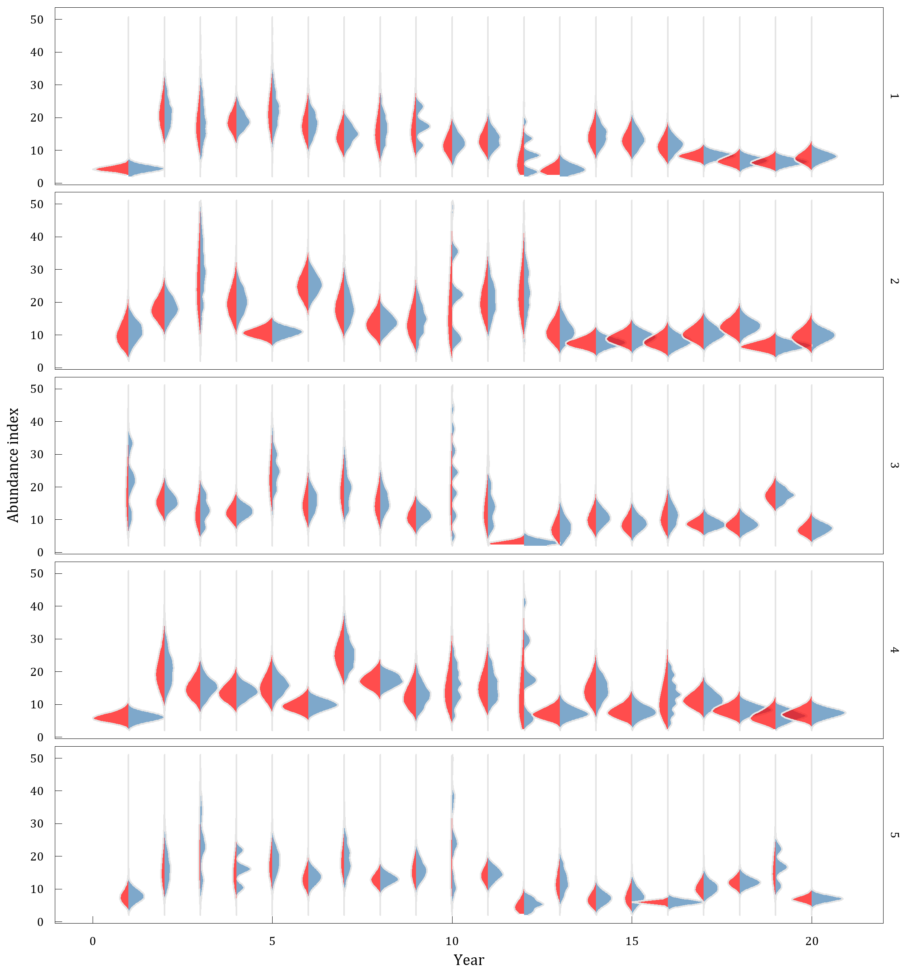

Fig 1: The bootstrap and gamma distributions estimated using simulated data from five independent surveys conducted over the same population across 20 years. The red area shows the density distribution from 1000 bootstrapped samples from each year and survey replicate. The blue area shows the gamma probability distribution from each year and survey replicate based on the mean and standard deviation of the design-based index.

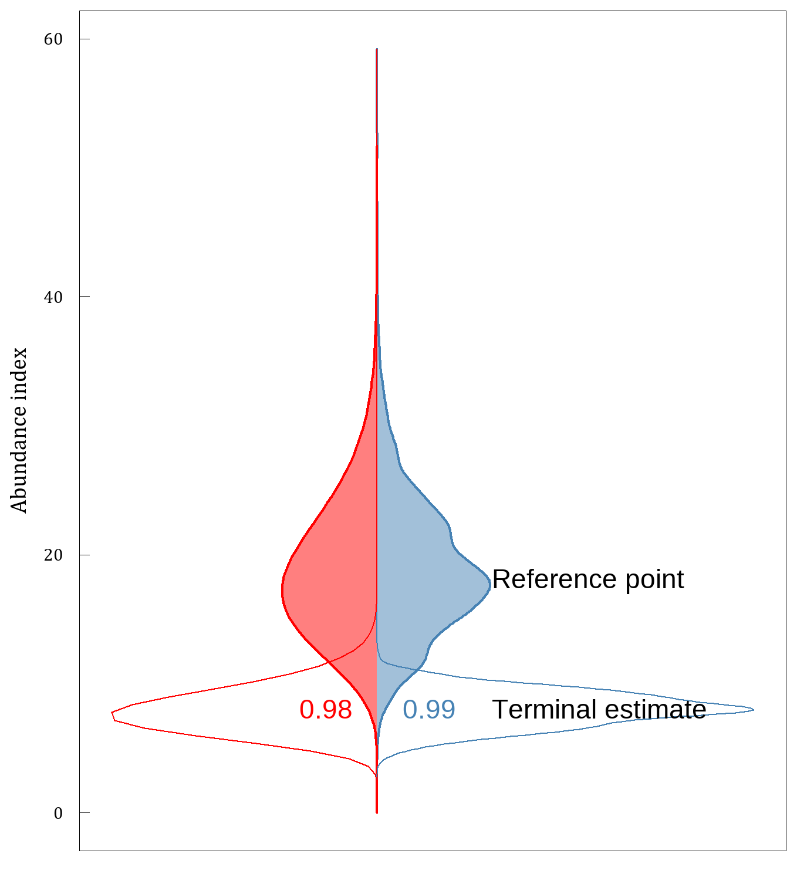

Fig 2: Bootstrap (blue) and gamma (red) distributions estimated from simulation 1 of a redfish-like population, where terminal estimates (year 20; open area) are compared to a reference period (aggregate estimates from years 2-9; shaded area). Densities for the reference period were obtained by combining the bootstrap samples and by aggregate parameters across the reference period (see Methods section). Probability that the terminal value is below the reference point is indicated.

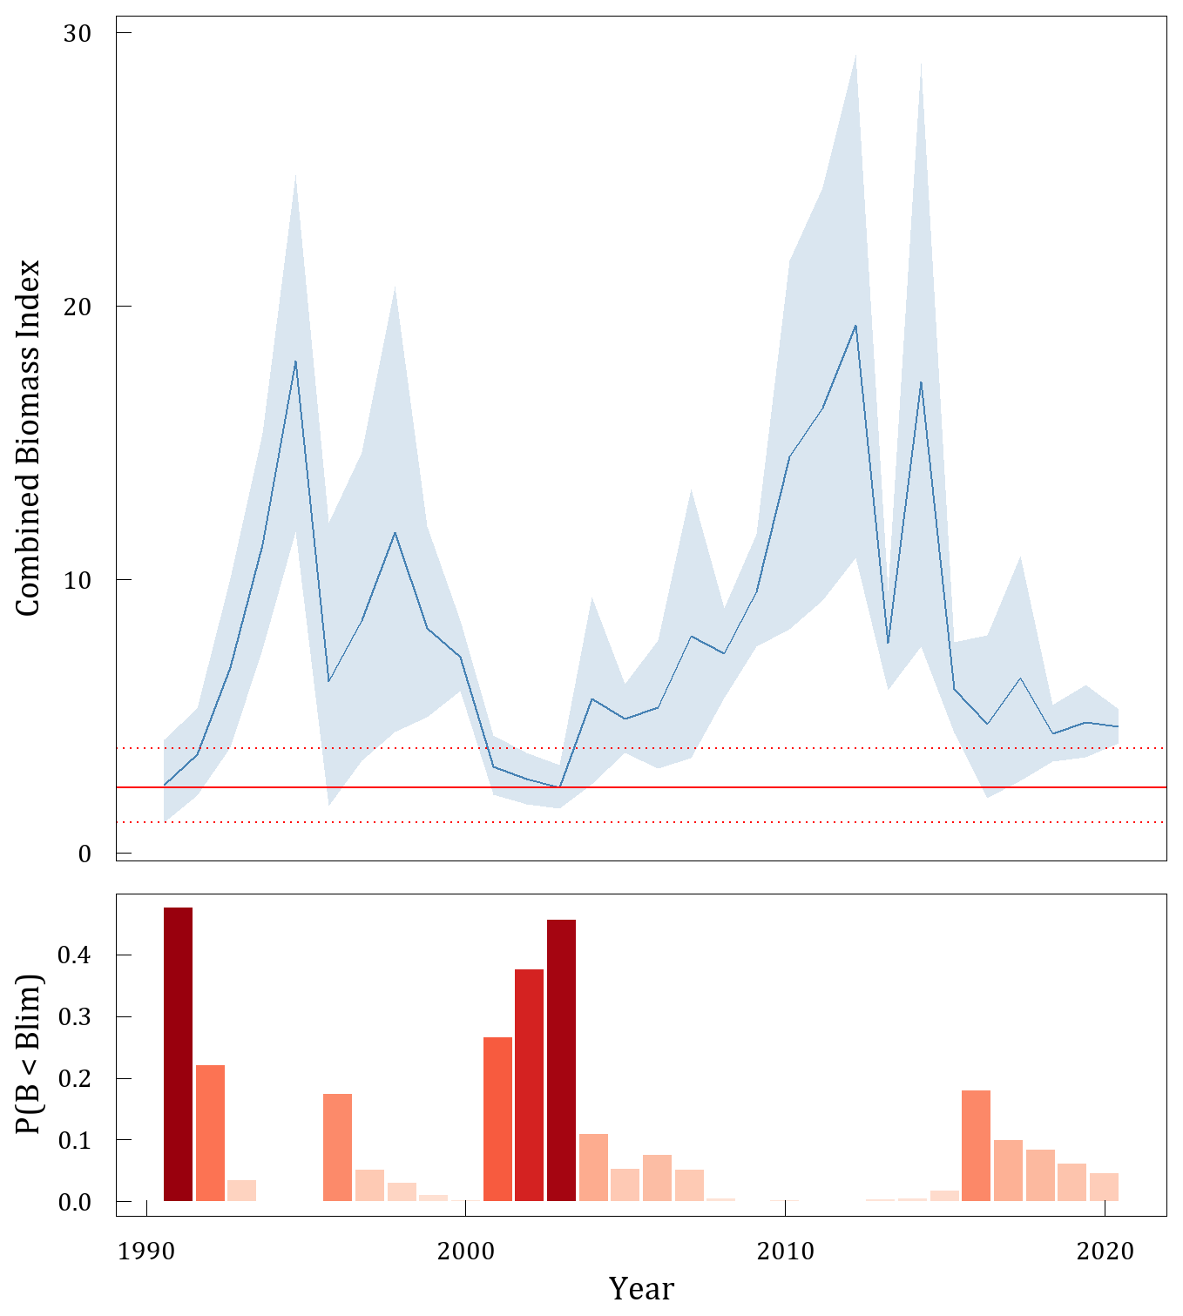

Fig 3: Combined CAN-Spring and CAN-Autumn biomass index (top; blue line) with 80% confidence intervals (blue shaded area) calculated using a Gamma distribution. Horizontal line (red) indicates interim Blim = 0.3 Bmsy-proxy with 80% confidence intervals (red dashed lines). Probability of By < Blim is presented below.

# Appendix A

Simulation results can be replicated using the below code.

library(SimSurvey)  
library(tidyr)  
library(future)  
library(tictoc)  
library(ggplot2)  
library(ggridges)  
library(dplyr)  
library(purrr)  
library(data.table)  
library(NAFOdown)  
  
plan(multisession, workers = floor(availableCores()/2))  
  
n_sims <- 5  
n_boot <- 1000  
  
  
## Simulation ----------  
  
set.seed(794)  
population <- sim_abundance(ages = 1:50,  
 years = 1:20,  
 R = sim_R(log_mean = log(600000000),  
 log_sd = 0.6,  
 random_walk = F),  
 Z = sim_Z(log_mean = log(0.2),  
 log_sd = 0.2,  
 phi_age = 0.4,  
 phi_year = 0.4),  
 N0 = sim_N0(N0 = "exp", plot = FALSE),  
 growth = sim_vonB(Linf = 30, L0 = 0,   
 K = 0.1, log_sd = 0.13,  
 length_group = 1,   
 digits = 0)) |>  
 sim_distribution(grid = make_grid(x_range = c(-150, 150),  
 y_range = c(-150, 150),  
 res = c(10, 10),  
 shelf_depth = 60,  
 shelf_width = 170,  
 depth_range = c(0, 1600),  
 n_div = 2,  
 strat_breaks = seq(0, 1600,   
 by = 65),  
 strat_splits = 4,  
 method = "bezier"),  
 ays_covar = sim_ays_covar(sd = 2,  
 range = 200,  
 phi_age = 0.5,  
 phi_year = 0.9),  
 depth_par = sim_parabola(mu = log(190),  
 sigma = 0.3,  
 log_space = TRUE))  
  
  
survey <- sim_survey(population,  
 n_sims = n_sims,  
 q = sim_logistic(k = 1, x0 = 6.5),  
 trawl_dim = c(1.5, 0.02),  
 resample_cells = FALSE,  
 binom_error = TRUE,  
 min_sets = 2,  
 set_den = 1/1000,  
 lengths_cap = 250,  
 ages_cap = 20,  
 age_sampling = "stratified",  
 age_length_group = 1,  
 age_space_group = "division") |>  
 run_strat()  
  
  
## Density from the Gamma distribution ----------  
  
total_strat <- survey$total_strat |>  
 mutate(sigma = sampling_units * sd,  
 scale = sigma ^ 2 / total,  
 shape = total / scale)  
  
## Use gamma to generate density by sim and year  
rng <- c(0.001, max(total_strat$total) * 2)  
x <- seq(rng[1], rng[2], length.out = 100)  
total_strat_den <- lapply(seq.int(nrow(total_strat)),   
 function(i) {  
 data.frame(sim = total_strat$sim[i],  
 year = total_strat$year[i],  
 total = x,  
 den = dgamma(x, shape = total_strat$shape[i],  
 scale = total_strat$scale[i]))  
}) |> dplyr::bind_rows()  
  
  
### Density from bootstrapping ----------  
  
setdet <- survey$setdet  
  
split_setdet <- split(setdet, paste0(setdet$year, "-", setdet$sim))  
  
sumYst <- function(data, i = seq_len(nrow(data))) {  
 data[i, ] |>  
 ### stratum level  
 group_by(year, strat, strat_area) |>  
 summarise(meanYh = mean(n), tow_area = mean(tow_area),   
 .groups = "drop_last") |>  
 mutate(Nh = strat_area/(tow_area)) |>  
 group_by(year) |>  
 mutate(N = sum(Nh), Wh = Nh/N, WhmeanYh = Wh * meanYh)|>  
 ### year level  
 summarise(sumYst= mean(N) * sum(WhmeanYh),   
 .groups = "drop_last") |>  
 pull(sumYst)  
}  
  
boot_one_year <- function(data, reps) {  
 b <- boot::boot(data, statistic = sumYst,   
 strata = data$strat, R = reps)  
 boot <- data.table(b$t) |> dplyr::rename(total = V1) |>  
 mutate(sim = mean(data$sim), year = mean(data$year))  
 return(boot)  
}  
  
tic()  
boot_index <- furrr::future_map_dfr(split_setdet, boot_one_year,   
 reps = n_boot,  
 .options = furrr::furrr_options(seed = TRUE))  
toc()  
  
quantile(boot_index$total, prob = c(0.001, 0.999))  
  
den_plot <- ggplot() +  
 geom_density_ridges(aes(x = total, y = as.numeric(year),   
 group = factor(year)),  
 color = "grey90", fill = "steelblue",   
 alpha = 0.7,  
 data = boot_index, scale = 1) +  
 geom_density_ridges(aes(x = total, y = year, height = den,   
 group = factor(year)),  
 stat = "identity", color = "grey90", fill = "red",   
 alpha = 0.7,  
 data = total_strat_den, scale = -1) +  
 coord_flip() + guides(fill = "none") +  
 scale_x_continuous(labels = scales::label_number(suffix = "",  
 scale = 1e-8),  
 limits = c(194587641, 5116017391)) +  
 ylab("Year") + xlab("Abundance index") +  
 facet_grid(rows = "sim") +  
 theme_nafo()  
  
  
## Relative status ----------  
  
  
sub_total_strat <- total_strat |>  
 filter(sim == 1)  
  
ref_est <- total_strat |>  
 filter(sim == 1, year %in% 2:9) |>  
 summarise(total = mean(total),  
 sigma = sqrt(mean(sigma ^ 2)),  
 scale = sigma ^ 2 / total,  
 shape = total / scale)  
  
ref_boot <- boot_index |>  
 filter(sim == 1, year %in% 2:9)  
  
x <- seq(min(ref_boot), max(ref_boot), length.out = 100)  
ref_den <- data.frame(total = x, den = dgamma(x, shape = ref_est$shape,   
 scale = ref_est$scale))  
  
t_est <- total_strat |>  
 filter(sim == 1, year == 20)  
  
t_den <- total_strat_den |>  
 filter(sim == 1, year == 20)  
  
t_boot <- boot_index |>  
 filter(sim == 1, year == 20)  
  
boot_prob <- mean((t_boot$total - ref_boot$total) < 0)  
n_samp <- 100000  
ref_samp <- rgamma(n_samp, shape = ref_est$shape, scale = ref_est$scale)  
t_samp <- rgamma(n_samp, shape = t_est$shape, scale = t_est$scale)  
gamma_prob <- mean((t_samp - ref_samp) < 0)  
  
ggplot() +  
 geom_density(aes(x = total), data = ref_boot, fill = "steelblue",   
 color = "steelblue", alpha = 0.5) +  
 geom_area(aes(x = total, y = -den), data = ref_den, fill = "red",   
 color = "red", alpha = 0.5) +  
 geom_density(aes(x = total), data = t_boot, fill = NA,   
 color = "steelblue", size = .nafo_lwd) +  
 geom_area(aes(x = total, y = -den), data = t_den, fill = NA,   
 color = "red", size = .nafo_lwd) +  
 geom_text(aes(x = t_est$total, y = max(ref_den$den) * 1.2,   
 label = "Terminal estimate"), hjust = 0, vjust = 0.5) +  
 geom_text(aes(x = ref_est$total, y = max(ref_den$den) * 1.2,   
 label = "Reference point"), hjust = 0, vjust = 1) +  
 geom_text(aes(x = t_est$total, y = 0, label = round(boot_prob, 2)),   
 hjust = -0.5, color = "steelblue") +  
 geom_text(aes(x = t_est$total, y = 0, label = round(gamma_prob, 2)),   
 hjust = 1.5, color = "red") +  
 theme_nafo() +  
 coord_flip() +  
 scale_x_continuous(labels = scales::label_number(suffix = "",   
 scale = 1e-8)) +  
 ylab("") + xlab("Abundance index") +  
 theme(axis.ticks.x = element_blank(),  
 axis.text.x = element_blank())

# Colophon

This version of the document was generated on 2022-06-20 14:58:11 using the R markdown template for SCR documents from [NAFOdown](https://github.com/nafc-assess/NAFOdown).

The computational environment that was used to generate this version is as follows:

#> - Session info ---------------------------------------------------------------  
#> setting value  
#> version R version 4.1.2 (2021-11-01)  
#> os Windows 10 x64 (build 19042)  
#> system x86_64, mingw32  
#> ui RTerm  
#> language (EN)  
#> collate English_United States.1252  
#> ctype English_United States.1252  
#> tz America/St_Johns  
#> date 2022-06-20  
#> pandoc 2.14.0.3 @ C:/Program Files/RStudio/bin/pandoc/ (via rmarkdown)  
#>   
#> - Packages -------------------------------------------------------------------  
#> package * version date (UTC) lib source  
#> assertthat 0.2.1 2019-03-21 [1] CRAN (R 4.1.2)  
#> base64enc 0.1-3 2015-07-28 [1] CRAN (R 4.1.0)  
#> bookdown 0.24 2021-09-02 [1] CRAN (R 4.1.1)  
#> cachem 1.0.6 2021-08-19 [1] CRAN (R 4.1.1)  
#> callr 3.7.0 2021-04-20 [1] CRAN (R 4.1.1)  
#> cli 3.1.0 2021-10-27 [1] CRAN (R 4.1.2)  
#> colorspace 2.0-2 2021-06-24 [1] CRAN (R 4.1.1)  
#> cowplot 1.1.1 2020-12-30 [1] CRAN (R 4.1.3)  
#> crayon 1.4.1 2021-02-08 [1] CRAN (R 4.1.1)  
#> data.table 1.14.0 2021-02-21 [1] CRAN (R 4.1.1)  
#> DBI 1.1.1 2021-01-15 [1] CRAN (R 4.1.1)  
#> desc 1.3.0 2021-03-05 [1] CRAN (R 4.1.1)  
#> devtools 2.4.3 2021-11-30 [1] CRAN (R 4.1.2)  
#> digest 0.6.29 2021-12-01 [1] CRAN (R 4.1.2)  
#> dplyr 1.0.7 2021-06-18 [1] CRAN (R 4.1.1)  
#> ellipsis 0.3.2 2021-04-29 [1] CRAN (R 4.1.1)  
#> evaluate 0.14 2019-05-28 [1] CRAN (R 4.1.1)  
#> fansi 0.5.0 2021-05-25 [1] CRAN (R 4.1.1)  
#> farver 2.1.0 2021-02-28 [1] CRAN (R 4.1.1)  
#> fastmap 1.1.0 2021-01-25 [1] CRAN (R 4.1.1)  
#> flextable * 0.6.9 2021-10-07 [1] CRAN (R 4.1.0)  
#> fs 1.5.2 2021-12-08 [1] CRAN (R 4.1.2)  
#> gdtools 0.2.3 2021-01-06 [1] CRAN (R 4.1.1)  
#> generics 0.1.1 2021-10-25 [1] CRAN (R 4.1.2)  
#> ggplot2 * 3.3.5 2021-06-25 [1] CRAN (R 4.1.1)  
#> ggridges 0.5.3 2021-01-08 [1] CRAN (R 4.1.3)  
#> ggthemes 4.2.4 2021-01-20 [1] CRAN (R 4.1.3)  
#> glue 1.4.2 2020-08-27 [1] CRAN (R 4.1.1)  
#> gtable 0.3.0 2019-03-25 [1] CRAN (R 4.1.1)  
#> here * 1.0.1 2020-12-13 [1] CRAN (R 4.1.1)  
#> highr 0.9 2021-04-16 [1] CRAN (R 4.1.1)  
#> htmltools 0.5.2 2021-08-25 [1] CRAN (R 4.1.1)  
#> knitr 1.34 2021-09-09 [1] CRAN (R 4.1.1)  
#> labeling 0.4.2 2020-10-20 [1] CRAN (R 4.1.0)  
#> lifecycle 1.0.1 2021-09-24 [1] CRAN (R 4.1.3)  
#> magrittr 2.0.1 2020-11-17 [1] CRAN (R 4.1.1)  
#> memoise 2.0.1 2021-11-26 [1] CRAN (R 4.1.2)  
#> munsell 0.5.0 2018-06-12 [1] CRAN (R 4.1.1)  
#> NAFOdown * 0.0.1.9000 2022-06-13 [1] local  
#> officer 0.4.0 2021-09-06 [1] CRAN (R 4.1.1)  
#> pillar 1.6.2 2021-07-29 [1] CRAN (R 4.1.1)  
#> pkgbuild 1.2.0 2020-12-15 [1] CRAN (R 4.1.1)  
#> pkgconfig 2.0.3 2019-09-22 [1] CRAN (R 4.1.1)  
#> pkgload 1.2.2 2021-09-11 [1] CRAN (R 4.1.0)  
#> plyr 1.8.6 2020-03-03 [1] CRAN (R 4.1.1)  
#> prettyunits 1.1.1 2020-01-24 [1] CRAN (R 4.1.1)  
#> processx 3.5.2 2021-04-30 [1] CRAN (R 4.1.1)  
#> ps 1.6.0 2021-02-28 [1] CRAN (R 4.1.1)  
#> purrr 0.3.4 2020-04-17 [1] CRAN (R 4.1.1)  
#> R6 2.5.1 2021-08-19 [1] CRAN (R 4.1.1)  
#> Rcpp 1.0.7 2021-07-07 [1] CRAN (R 4.1.1)  
#> remotes 2.4.0 2021-06-02 [1] CRAN (R 4.1.1)  
#> rlang 1.0.2 2022-03-04 [1] CRAN (R 4.1.3)  
#> rmarkdown 2.11 2021-09-14 [1] CRAN (R 4.1.1)  
#> rprojroot 2.0.2 2020-11-15 [1] CRAN (R 4.1.1)  
#> rstudioapi 0.13 2020-11-12 [1] CRAN (R 4.1.1)  
#> scales 1.1.1 2020-05-11 [1] CRAN (R 4.1.1)  
#> sessioninfo 1.2.2 2021-12-06 [1] CRAN (R 4.1.2)  
#> showtext 0.9-4 2021-08-14 [1] CRAN (R 4.1.1)  
#> showtextdb 3.0 2020-06-04 [1] CRAN (R 4.1.1)  
#> stringi 1.7.4 2021-08-25 [1] CRAN (R 4.1.1)  
#> stringr 1.4.0 2019-02-10 [1] CRAN (R 4.1.1)  
#> sysfonts 0.8.5 2021-08-09 [1] CRAN (R 4.1.1)  
#> systemfonts 1.0.3 2021-10-13 [1] CRAN (R 4.1.2)  
#> testthat 3.1.1 2021-12-03 [1] CRAN (R 4.1.2)  
#> tibble 3.1.4 2021-08-25 [1] CRAN (R 4.1.1)  
#> tidyselect 1.1.1 2021-04-30 [1] CRAN (R 4.1.1)  
#> usethis 2.0.1 2021-02-10 [1] CRAN (R 4.1.1)  
#> utf8 1.2.2 2021-07-24 [1] CRAN (R 4.1.1)  
#> uuid 0.1-4 2020-02-26 [1] CRAN (R 4.1.1)  
#> vctrs 0.3.8 2021-04-29 [1] CRAN (R 4.1.1)  
#> withr 2.4.3 2021-11-30 [1] CRAN (R 4.1.2)  
#> xfun 0.26 2021-09-14 [1] CRAN (R 4.1.0)  
#> xml2 1.3.2 2020-04-23 [1] CRAN (R 4.1.1)  
#> yaml 2.2.1 2020-02-01 [1] CRAN (R 4.1.0)  
#> zip 2.2.0 2021-05-31 [1] CRAN (R 4.1.1)  
#>   
#> [1] C:/Users/RegularP/Documents/R/win-library/4.1  
#> [2] C:/Program Files/R/R-4.1.2/library  
#>   
#> ------------------------------------------------------------------------------