STOCK FORECAST

CLASSIFICATION :- Predict whether the stock price will go Up or Down tomorrow

REGRESSION :- Predict the next day’s closing price

CLASSIFICATION

🔷 Theory : Stock Price Direction Prediction using Classification

1. Objective
The primary objective of this project is to build a classification model that predicts whether a stock’s closing price will go Up (1) or Down (0) the next day based on historical data and technical indicators.

2. Data Source
Historical stock data is retrieved using the Yahoo Finance API (yfinance) for a selected stock (e.g., Apple Inc. - AAPL), over a specific time range. The dataset includes features such as:
- Opening price
- High price
- Low price
- Closing price
- Trading volume

3. Feature Engineering
To help the model capture patterns in the data, additional features are created:
- Moving Average (5-day): A commonly used technical indicator that smooths short-term fluctuations in stock price, helping to capture the trend.
The target variable is defined as:
- 1 if the next day’s closing price is higher than the current day’s closing price (price goes Up)
- 0 otherwise (price goes Down)
This converts the regression-like problem into a binary classification problem.

4. Data Preprocessing
- Missing Values: Rows with NaN values (mainly from the moving average calculation) are removed.
- Feature Selection: The selected input features are Open, High, Low, and Moving_Avg.
- The target is the binary Target column.

5. Model Building
A Logistic Regression model is used for classification:
- Logistic Regression is a simple yet effective linear model commonly used for binary classification tasks.
- It predicts the probability of the target class and assigns the class based on a threshold (default is 0.5).
The dataset is split into training and testing sets using an 80-20 ratio to evaluate model performance on unseen data.

6. Model Evaluation
The model’s performance is evaluated using accuracy score, which measures the percentage of correct predictions out of total predictions. A higher accuracy indicates better performance in classifying the stock’s directional movement.

7. Conclusion
This classification approach provides a foundational method to predict stock price direction. Although simple, it can serve as a building block for more advanced trading algorithms or financial decision support systems when combined with more complex features and models.

🔸 Python Code : Stock Price Direction Classification

CODE :-

import yfinance as yf
import pandas as pd
from sklearn.model_selection import train_test_split
from sklearn.linear_model import LogisticRegression
from sklearn.metrics import accuracy_score
import numpy as np

# Retrieve stock data
stock_data = yf.download('AAPL', start='2020-01-01', end='2022-02-26')

# Calculate features
stock_data['Moving_Avg'] = stock_data['Close'].rolling(window=5).mean()
stock_data['Target'] = np.where(stock_data['Close'].shift(-1) > stock_data['Close'], 1, 0)

# Drop NaN values
stock_data = stock_data.dropna()

# Split data into features and target
X = stock_data[['Open', 'High', 'Low', 'Moving_Avg']]
y = stock_data['Target']

# Split data into training and testing sets
X_train, X_test, y_train, y_test = train_test_split(X, y, test_size=0.2, random_state=42)

# Classification model
classification_model = LogisticRegression()
classification_model.fit(X_train, y_train)
y_pred = classification_model.predict(X_test)

print("Classification Accuracy:", accuracy_score(y_test, y_pred))

OUTPUT :-

PS C:\Users\Administrator\OneDrive\Desktop\5th sem> python -u "c:\Users\Administrator\OneDrive\Desktop\5th sem\Classification project.py"

c:\Users\Administrator\OneDrive\Desktop\5th sem\Classification project.py:9: FutureWarning: YF.download() has changed argument auto_adjust default to True

stock_data = yf.download('AAPL', start='2020-01-01', end='2022-02-26')

[*********************100%***********************] 1 of 1 completed

Classification Accuracy: 0.4722222222222222

REGRESSION

📘 Theory Part – Stock Price Prediction using Regression

1. Introduction
Stock market prediction is one of the most challenging and widely researched areas in financial analytics. The objective of this project is to predict future stock prices based on past stock price movements. Since stock prices are numerical and continuous in nature, the problem falls under regression analysis.
In this project, we have used Apple Inc. (AAPL) stock data to build a machine learning model that can predict the closing price of the stock using historical prices.

2. Data Collection
We used the yfinance library to fetch historical stock data directly from Yahoo Finance. The dataset includes Open, High, Low, Close, Adj Close, and Volume values. For simplicity and relevance, only the Closing Price is used for modeling since it reflects the final trading price of a stock on a given day.

3. Feature Engineering
To predict today’s stock price, we need to provide the model with useful input features. A common approach in time-series prediction is to use lag features (previous days’ prices).
- We created lag values for the past 5 days:
  - lag_1 → Closing Price of the previous day
  - lag_2 → Closing Price 2 days ago
  - …
  - lag_5 → Closing Price 5 days ago
This way, the model can learn patterns from the most recent five days to predict the next day’s price.

4. Train-Test Split
Unlike random splitting used in normal machine learning problems, time-series data requires preserving the order of time. Therefore:
- Training Set: First 80% of data (past prices)
- Testing Set: Last 20% of data (future unseen prices)
This ensures the model is tested on data it has never seen before, simulating real-world prediction.

5. Model Selection
We used a Random Forest Regressor, which is an ensemble learning technique based on multiple decision trees. It has advantages like:
- Capturing non-linear relationships in data
- Reducing overfitting by averaging results from multiple trees
- Providing robust predictions even for noisy datasets
The model was trained using the lag features as input (X) and the actual closing price as the target (y).

6. Model Evaluation
The performance of the regression model was evaluated using Root Mean Squared Error (RMSE), which measures the average prediction error in the same units as the stock price (USD). A lower RMSE value indicates better prediction accuracy.

7. Visualization
To compare performance visually, we plotted the Actual Closing Prices vs Predicted Closing Prices for the test dataset.
- The blue line represents actual stock prices.
- The red line represents predicted prices from the Random Forest model.
The closeness of these two lines indicates how well the model is able to capture trends in stock movement.

8. Conclusion
This project demonstrates how machine learning regression techniques can be applied to stock market data. Using lag features and a Random Forest model, we achieved a reasonable prediction of Apple’s stock prices.
- Strengths: Simple feature engineering, good accuracy, clear visualization.
- Limitations: Does not account for external factors such as news, market sentiment, or global events.
- Future Scope: Incorporating technical indicators (like RSI, MACD), sentiment analysis, and deep learning (LSTM/GRU models) could improve prediction accuracy.

CODE :

import yfinance as yf
import pandas as pd
import numpy as np
import matplotlib.pyplot as plt
from sklearn.ensemble import RandomForestRegressor
from sklearn.model_selection import train_test_split
from sklearn.metrics import mean_squared_error

# ---------------------------
# 1. Load Stock Data
# ---------------------------
stock_data = yf.download("AAPL", start="2023-01-01", end="2025-08-20")

# Use only Close prices
stock_data = stock_data[['Close']]

# ---------------------------
# 2. Create Features (Lag values)
# ---------------------------
# Predict today's Close using last 5 days
for i in range(1, 6):
stock_data[f"lag_{i}"] = stock_data['Close'].shift(i)

stock_data.dropna(inplace=True)

# Features and Target
X = stock_data[['lag_1', 'lag_2', 'lag_3', 'lag_4', 'lag_5']]
y = stock_data['Close']

# ---------------------------
# 3. Train-Test Split
# ---------------------------
X_train, X_test, y_train, y_test = train_test_split(
X, y, test_size=0.2, shuffle=False # keep time order
)

# ---------------------------
# 4. Train Model
# ---------------------------
model = RandomForestRegressor(n_estimators=100, random_state=42)
model.fit(X_train, y_train)

# Predict
y_pred = model.predict(X_test)

# ---------------------------
# 5. Evaluate
# ---------------------------
rmse = np.sqrt(mean_squared_error(y_test, y_pred))
print("RMSE:", rmse)

# ---------------------------
# 6. Plot Actual vs Predicted
# ---------------------------
plt.figure(figsize=(12, 6))
plt.plot(y_test.index, y_test.values, label="Actual Price", color="blue", linewidth=2)
plt.plot(y_test.index, y_pred, label="Predicted Price", color="red", linewidth=2, alpha=0.7)

plt.title("AAPL Stock Price Prediction (Actual vs Predicted)")
plt.xlabel("Date")
plt.ylabel("Price (USD)")
plt.legend()
plt.grid(True, linestyle="--", alpha=0.6)
plt.tight_layout()
plt.show()

OUTPUT :

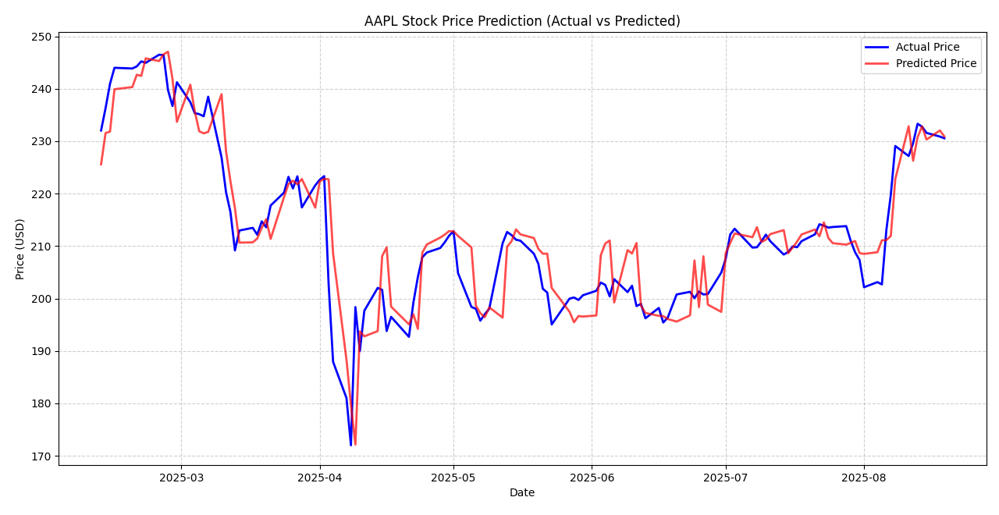

🔚 Conclusion
This project successfully demonstrates the application of machine learning techniques to predict stock market behavior using historical data.

🔹 Classification (Up/Down Prediction)
Using a logistic regression model, we predicted whether the stock price would increase or decrease on the next trading day. This binary classification approach provides a straightforward method for identifying potential trading signals based on trend direction. Although simple, such models can serve as the foundation for more complex trading systems.

🔹 Regression (Next Day Closing Price Prediction)
By employing a Random Forest Regressor, we estimated the next day's closing price based on technical indicators and historical values. This regression approach provides quantitative predictions, which are valuable for portfolio management, risk assessment, and algorithmic trading strategies.

THANK YOU

