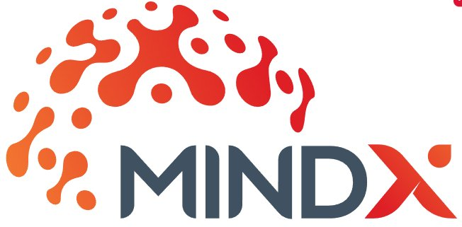 | STAFF PERFORMANCE FEEDBACK FORM  Technology with a Human Touch • mindxtech.ai  MIND X SDN BHD • B-16-1, Tower B, Vertical Business Suite, Avenue 3, Bangsar South, 59200 Kuala Lumpur • xplorers@mindxtech.ai • +60 3 6043 1700

Employee Name |  | Reviewer Name
Employee Position |  | Reviewer Position
Department |  | Department
Type of Appraisal |  | Projects Managed
Appraisal Period |  | Appraisal Due

PERFORMANCE APPRAISAL
Performance Factor | Employee Score | Weightage | Reviewer Score | Weightage | Reviewer's Comments
01. Subject Knowledge / Expertise  Consider the employee's skill level, knowledge and understanding of all phases of the job and those requiring improved skills and/or experience. |  | 0.20 |  | 0.20
02. Work Execution & Coordination  Measures effectiveness in planning, organizing, and efficiently handling tasks and activities assigned on time, while eliminating unnecessary activities. |  | 0.20 |  | 0.20
03. Communication (Internal & Client)  Effective in listening, expressing ideas, and providing relevant and timely information to management, coworkers, subordinates and customers. |  | 0.15 |  | 0.15
04. Problem Solving  Measures effectiveness in understanding problems and making suggestions for rectifying the issue, and apply timely, practical decisions. |  | 0.15 |  | 0.15
05. Teamwork  Measures how well this individual gets along with fellow employees and able to work cooperatively to get work done. |  | 0.15 |  | 0.15
06. Independent Action  Measures effectiveness in time management; initiative and independent action within prescribed limits. |  | 0.05 |  | 0.05
07. Dependability  How well employees comply with instructions and perform under unusual circumstances; consider record of attendance and punctuality. |  | 0.05 |  | 0.05
08. Learning Initiatives  Consider the initiatives taken by the employee in pursuing upskilling opportunities within own limits (i.e., online resources, courses). |  | 0.05 |  | 0.05
TOTAL SCORE |  |  |  |  | Competency Level: 1 = Poor | 5 = Excellent

Score Component | Score | Weightage
Employee Score |  | 0.3
Reviewer Score |  | 0.7

EMPLOYEE KEY ACHIEVEMENT GOALS
Goal Description | Score | Weightage | Comments
01. |  | 0.6
02. |  | 0.2
03. |  | 0.2
* Goal descriptions filled jointly by employee and reviewer; scored by reviewer only. Competency Level: 1 = Poor | 5 = Excellent |  | Score

Score Component | Score | Weightage
Performance Score |  | 0.8
Goal(s) Achievement Score |  | 0.2
FINAL SCORE

COMMENTS
Comments from Employee | Comments from Reviewer | Comments from CEO

SIGNATURES
Employee Signature | Reviewer / Team Lead Signature | CEO Signature
Signature: ___________________  Date: ________________________ | Signature: ___________________  Date: ________________________ | Signature: ___________________  Date: ________________________

