**Name: Nafeeur Rahman**

SQL SELECT, WHERE, DISTINCT practice

1. Write a select statement to return all columns and rows from the customer table.

**SELECT * FROM customer**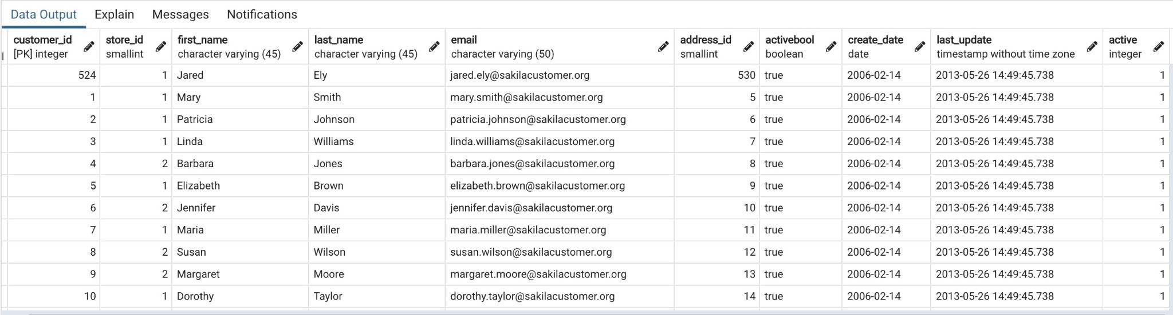

1. Write a query to select first name, last name, and email from the customer table.

**SELECT first_name, last_name, email FROM customer**

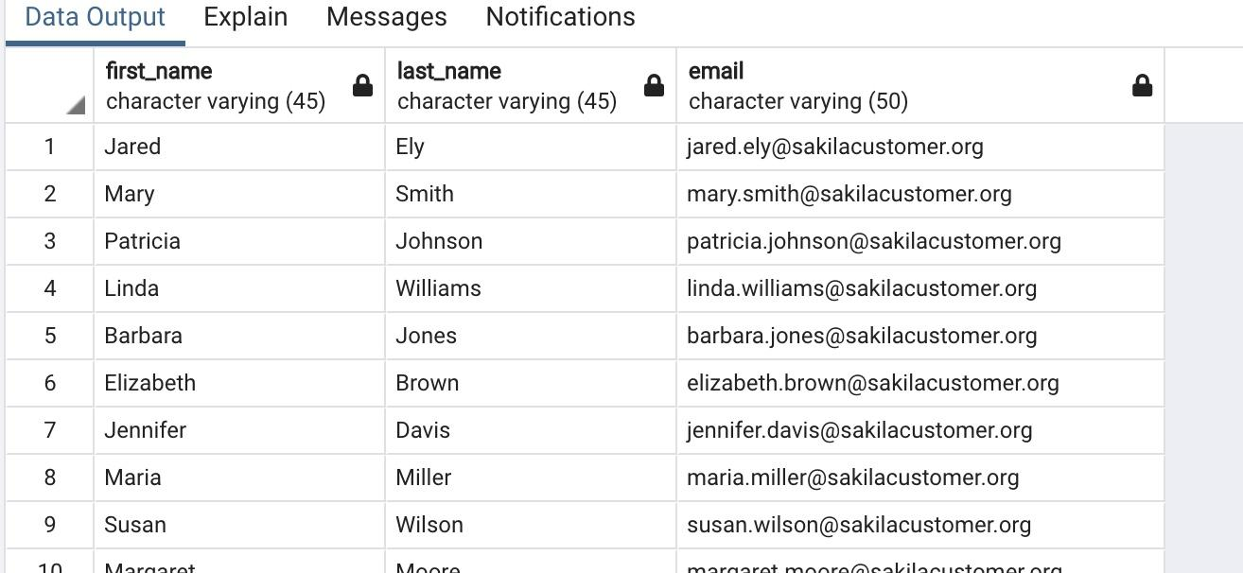

1. Write a query to return all rows and columns from the film table.

**SELECT * FROM film**

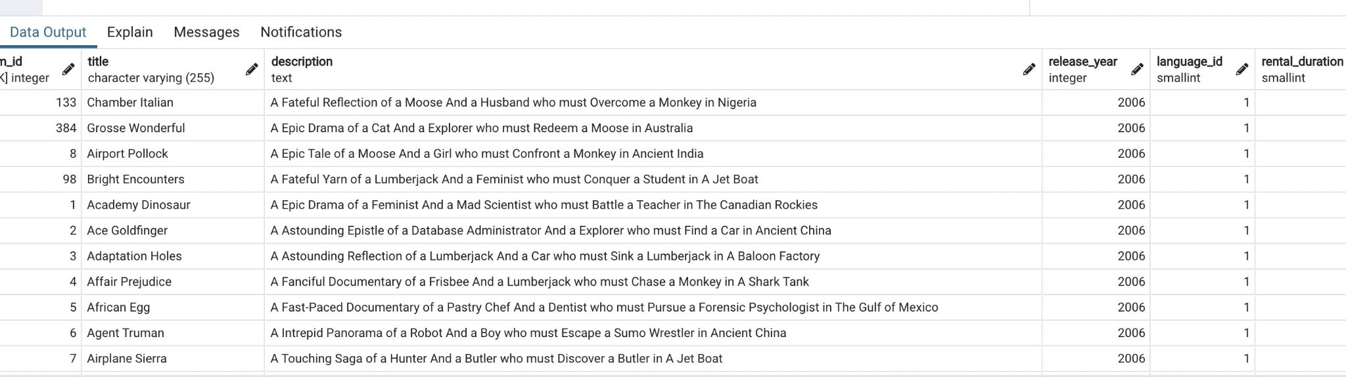

1. Write a query to return unique rows from the release_year column in the film table.

**SELECT DISTINCT release_year FROM film**

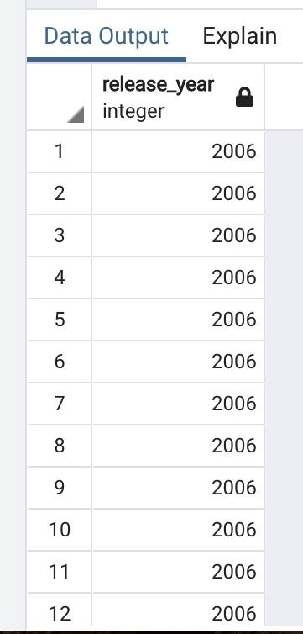

1. Write a query to return unique rows from the rental_rate column in the film table.

**SELECT DISTINCT rental_rate FROM film**

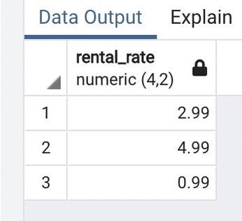

1. A customer left us some feedback about our store. Write a query to find her email address – for Nancy Thomas.

**SELECT email FROM customer**

**WHERE email LIKE '%nancy%';**

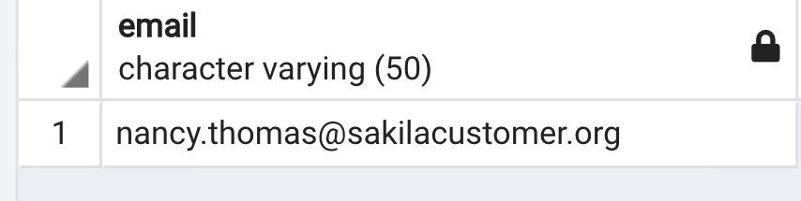

1. We’re trying to find a customer located at a certain address ‘259 Ipoh Drive’ – can you find their phone number?

**SELECT phone FROM address**

**WHERE address LIKE '%259 Ipoh Drive%'**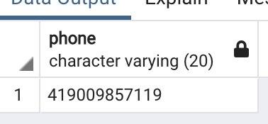

1. Write a query from the customer table, where store id is 1 and address id is greater than 150.

**SELECT * FROM customer**

**WHERE store_id = 1 AND address_id > 150;**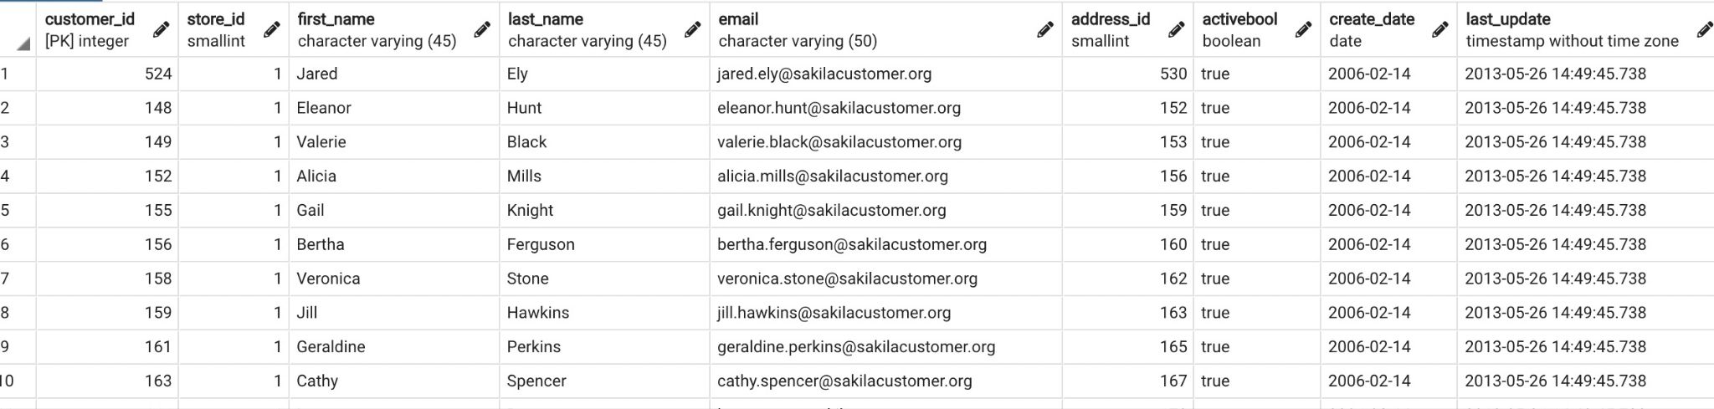

1. Write a query from the payment table where the amount is either 4.99 or 1.99.

**SELECT amount FROM payment**

**WHERE amount = 4.99 OR amount = 1.99;**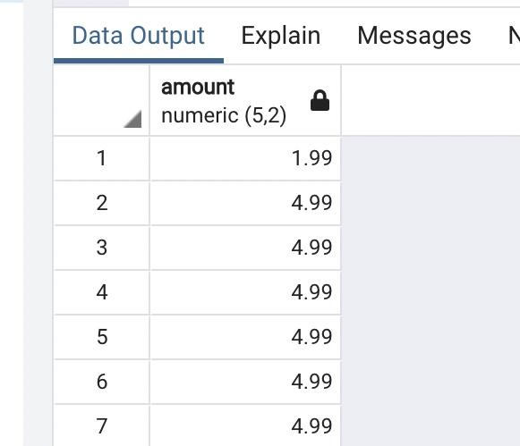

1. Write a query to return a list of transitions from the payment table where the amount is greater than 5.

**SELECT amount, payment_date FROM payment**

**WHERE amount > 5;**