ClauseChain — Technical Memo
Measured Legal Evidence for Digital Trade | UN Global Hackathon: AI for Digital Trade Regulatory Analysis | RDTII Pillars 6, 7, 8, 9
ClauseChain is an open-source AI pipeline that maps digital trade regulation to the UN RDTII framework. Its thesis is that citation alone is not enough: a real quote can come from a repealed act, a non-binding guideline, an unofficial translation, or a clause whose exception changes the rule. ClauseChain verifies the whole evidence chain — span, source authority, current-law status, legal structure, predicate meaning, and counter-evidence — before any output ships.
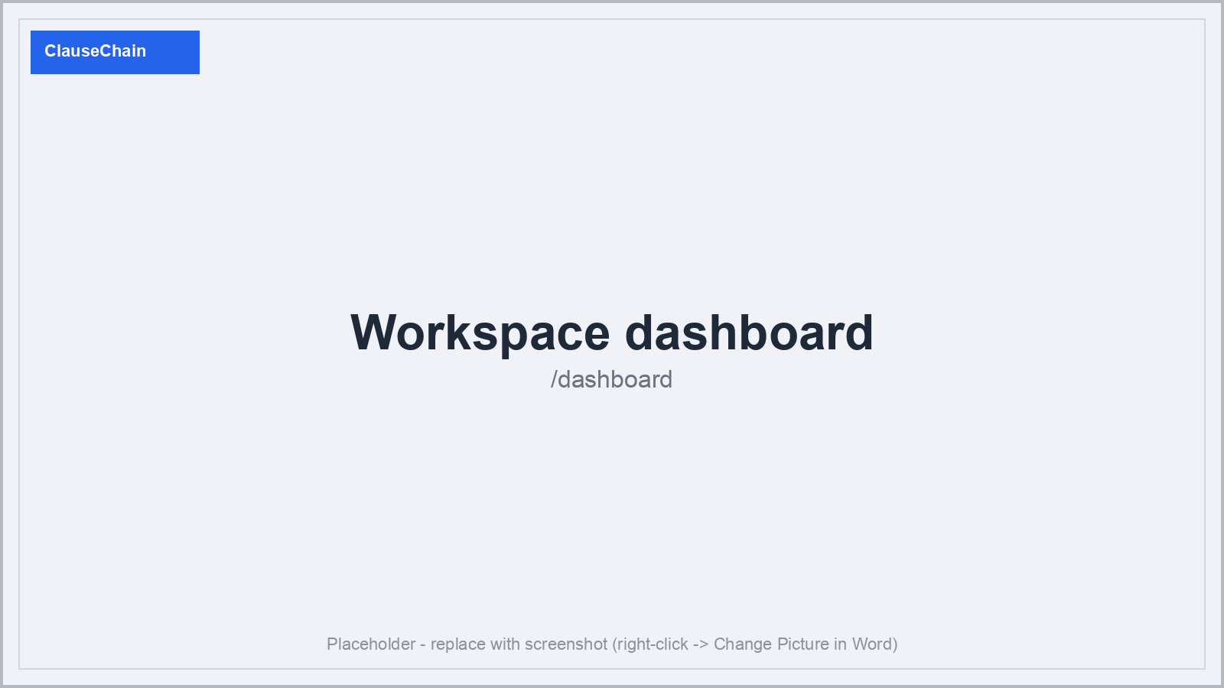
Figure 1 — ClauseChain workspace dashboard.

1. Proposed System Architecture
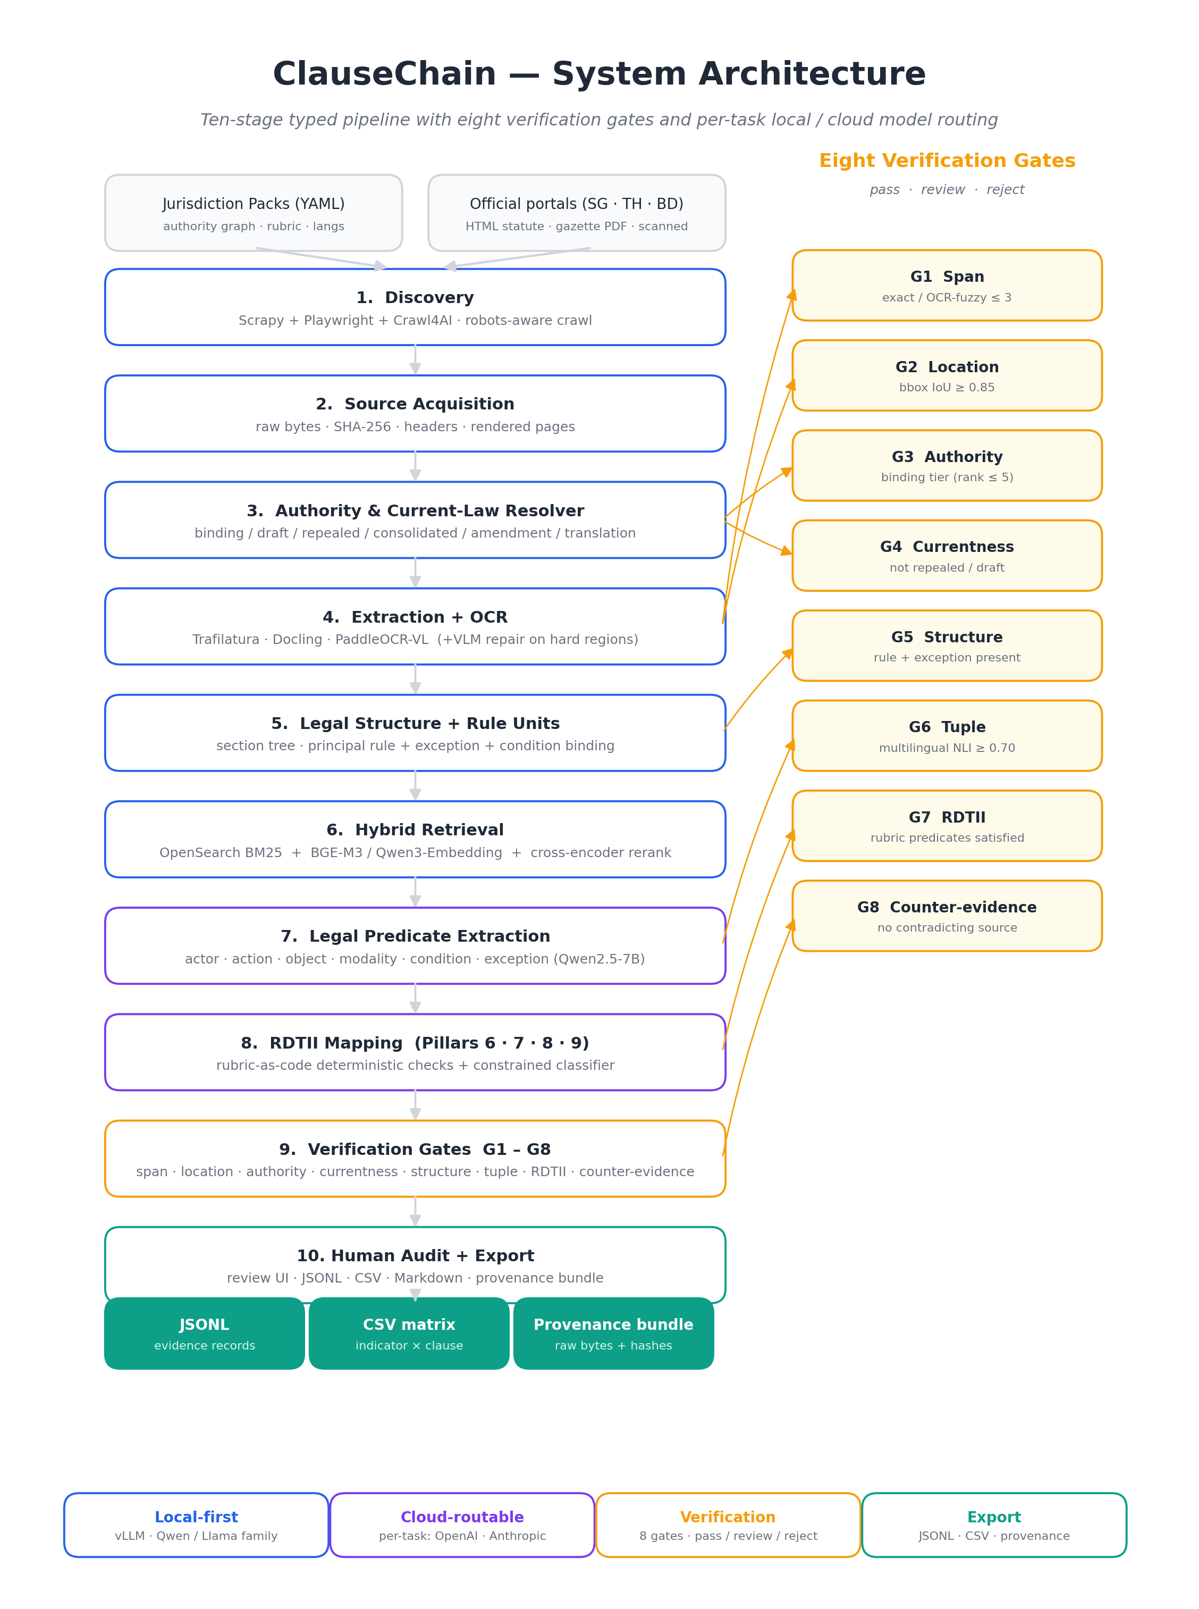
Figure 0 — ClauseChain system architecture: ten-stage typed pipeline (left), eight verification gates G1-G8 mapped to the stage that produces the evidence each gate checks (right), and the local/cloud routing legend.
ClauseChain is a ten-stage typed pipeline (Figure 0). Each stage emits a structured artifact and a measurable quality signal:
Stage | Responsibility
0 Jurisdiction Pack | authority hierarchy, seed sources, citation patterns, language config, RDTII rubric
1 Discovery | polite crawl of official statute databases, gazettes, regulator portals
2 Acquisition | raw bytes, SHA-256, HTTP headers, rendered page images
3 Authority Resolver | binding / draft / repealed / consolidated / amendment / translation classification
4 Extraction + OCR | HTML / native PDF / scanned PDF with text, bbox, per-token confidence
5 Structure + Rule Units | section tree plus principal-rule + exception + condition binding
6 Retrieval | hybrid BM25 + multilingual dense + cross-encoder rerank
7 Predicate Extraction | actor / action / object / modality / condition / exception tuple
8 RDTII Mapping | rubric-as-code deterministic checks + constrained classifier
9 Verification Gates | eight gates G1-G8 (span, location, authority, currentness, structure, tuple, RDTII, counter-evidence)
10 Audit + Export | review UI, JSONL / CSV / Markdown / provenance bundle

The application surface lives at /dashboard plus six pipeline routes: /pipeline/{crawl, harvest, extract, map, trace, export}. A working Next.js 16 / React 19 / TypeScript prototype is in-repo and is what every figure in this memo screenshots.
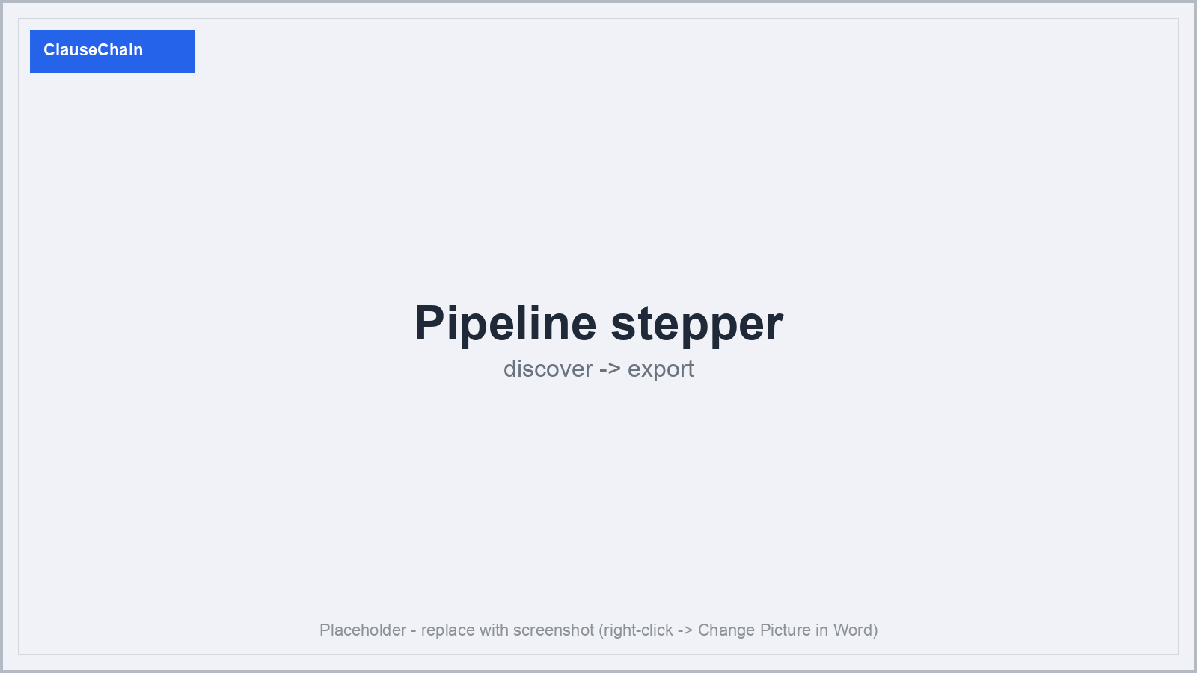
Figure 2 — Nine-stage pipeline stepper (discover -> export) shown across all pipeline pages.

2. Tools, Models, and Methods
ClauseChain is local-first on a single L40S-class GPU, with per-task optional cloud routing to OpenAI or Anthropic. All demo documents are public legal text from official portals, so operators may safely mix local and cloud per pipeline step.
Task | Local default | Cloud option
Crawling | Scrapy + Playwright + Crawl4AI | n/a (deterministic)
HTML extraction | Trafilatura + legal DOM parser | n/a
PDF extraction | Docling + PyMuPDF | n/a
OCR + bbox | PaddleOCR-VL / PaddleOCR | n/a (coordinate-native)
OCR repair (VLM) | Qwen2-VL-7B | gpt-5.4-mini or claude-haiku-4-6
Embeddings | BGE-M3 / Qwen3-Embedding | text-embedding-3-large
Reranking | BGE-reranker-v2-m3 | LLM-as-judge
Predicate extraction | Qwen2.5-7B / Llama-3.1-8B-Instruct | gpt-5.4-mini or claude-haiku-4-6
RDTII mapping | Qwen2.5-7B | gpt-5.4 or claude-sonnet-4-6
NLI verifier (G6/G7) | DeBERTa-v3 multilingual NLI | gpt-5.4-mini or claude-haiku-4-6

Serving stack: vLLM for local LLMs; FastAPI services; Celery / RQ workers; Postgres + pgvector; OpenSearch (BM25) + Qdrant (dense); MinIO object storage; Next.js audit UI; Docker Compose for the prototype. Routing modes per task: always_local, always_cloud, confidence_threshold, confidence_margin.
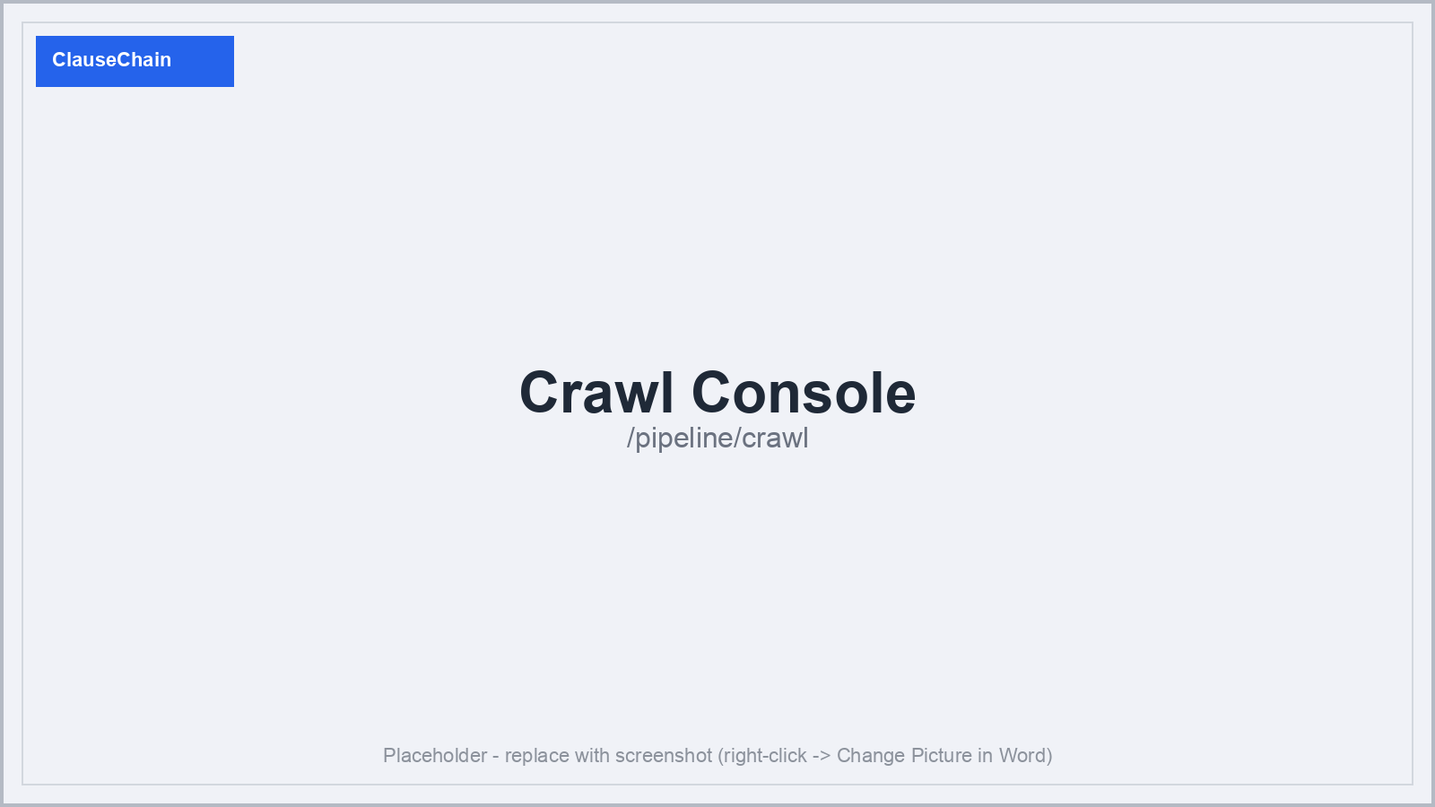
Figure 3 — Crawl Console: politely-crawled candidate documents with type tags (HTML statute, native PDF, scanned PDF, regulator guideline, blocked).
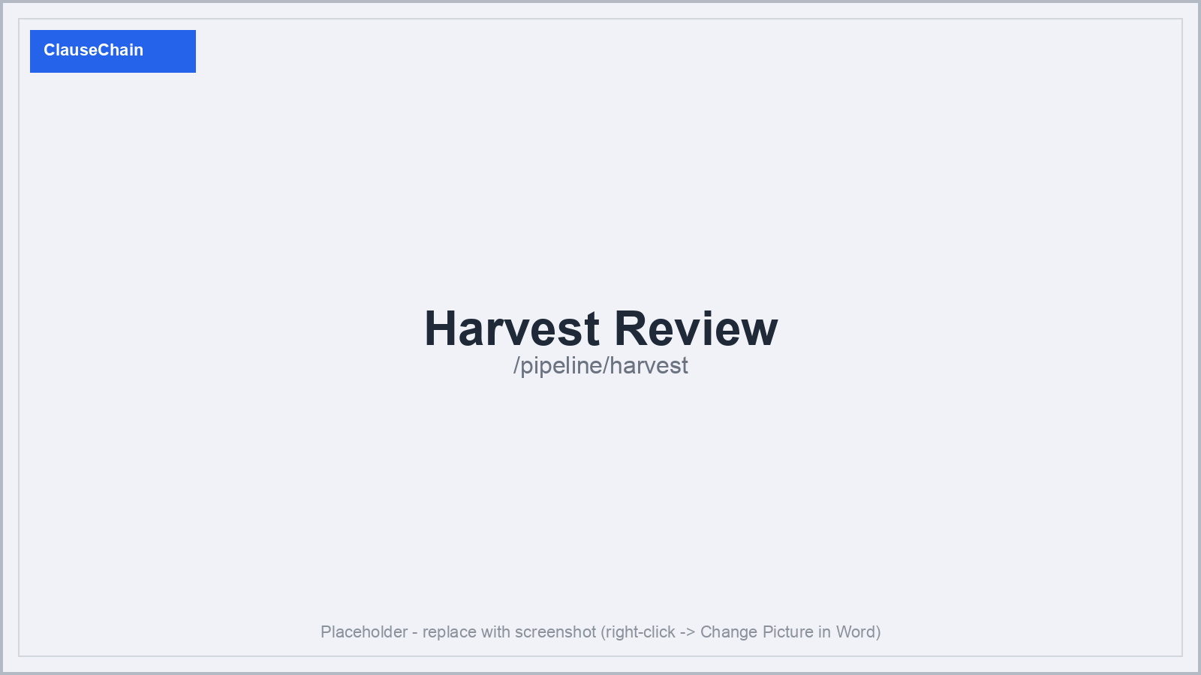
Figure 4 — Harvest Review: human keep/discard before expensive extraction begins.
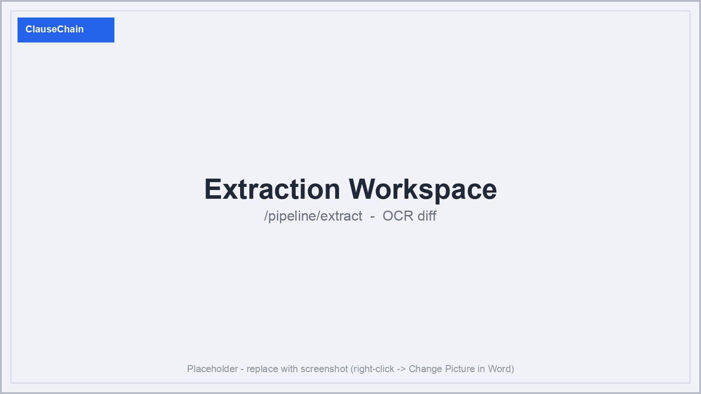
Figure 5 — Extraction Workspace OCR diff: PaddleOCR-VL vs. Tesseract disagreement on a scanned Bengali page, with edit distance and confidence.
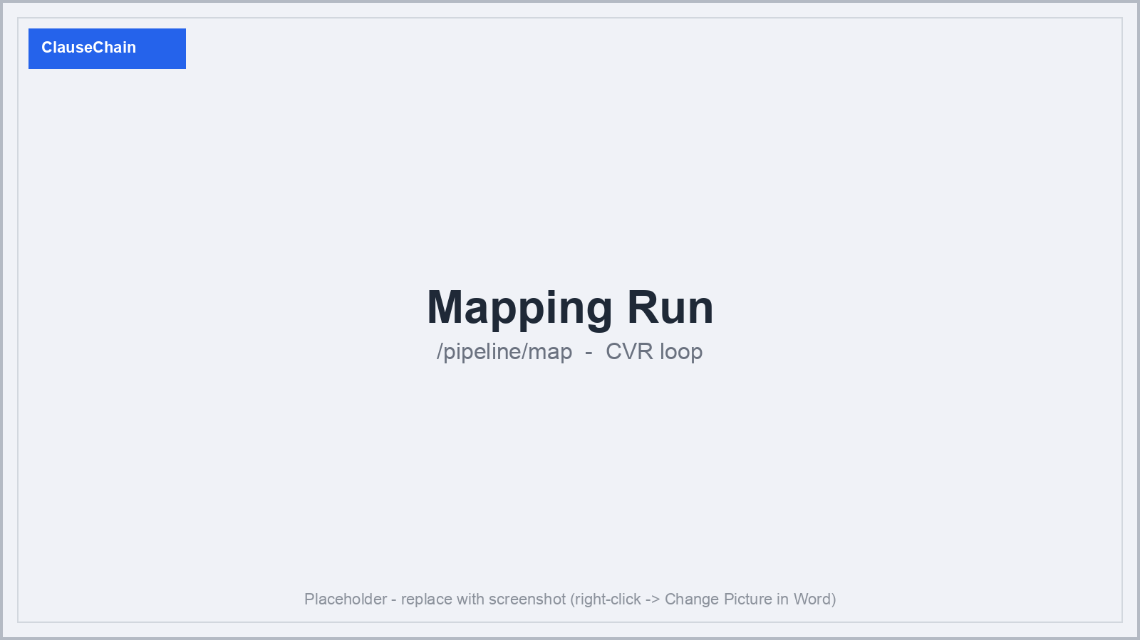
Figure 6 — Mapping Run: L0-L3 autonomy selector and the CVR (Cite / Verify / Reject) loop streaming clauses in real time.

3. Accuracy, Transparency, and Cost-Efficiency

Accuracy — eight verification gates
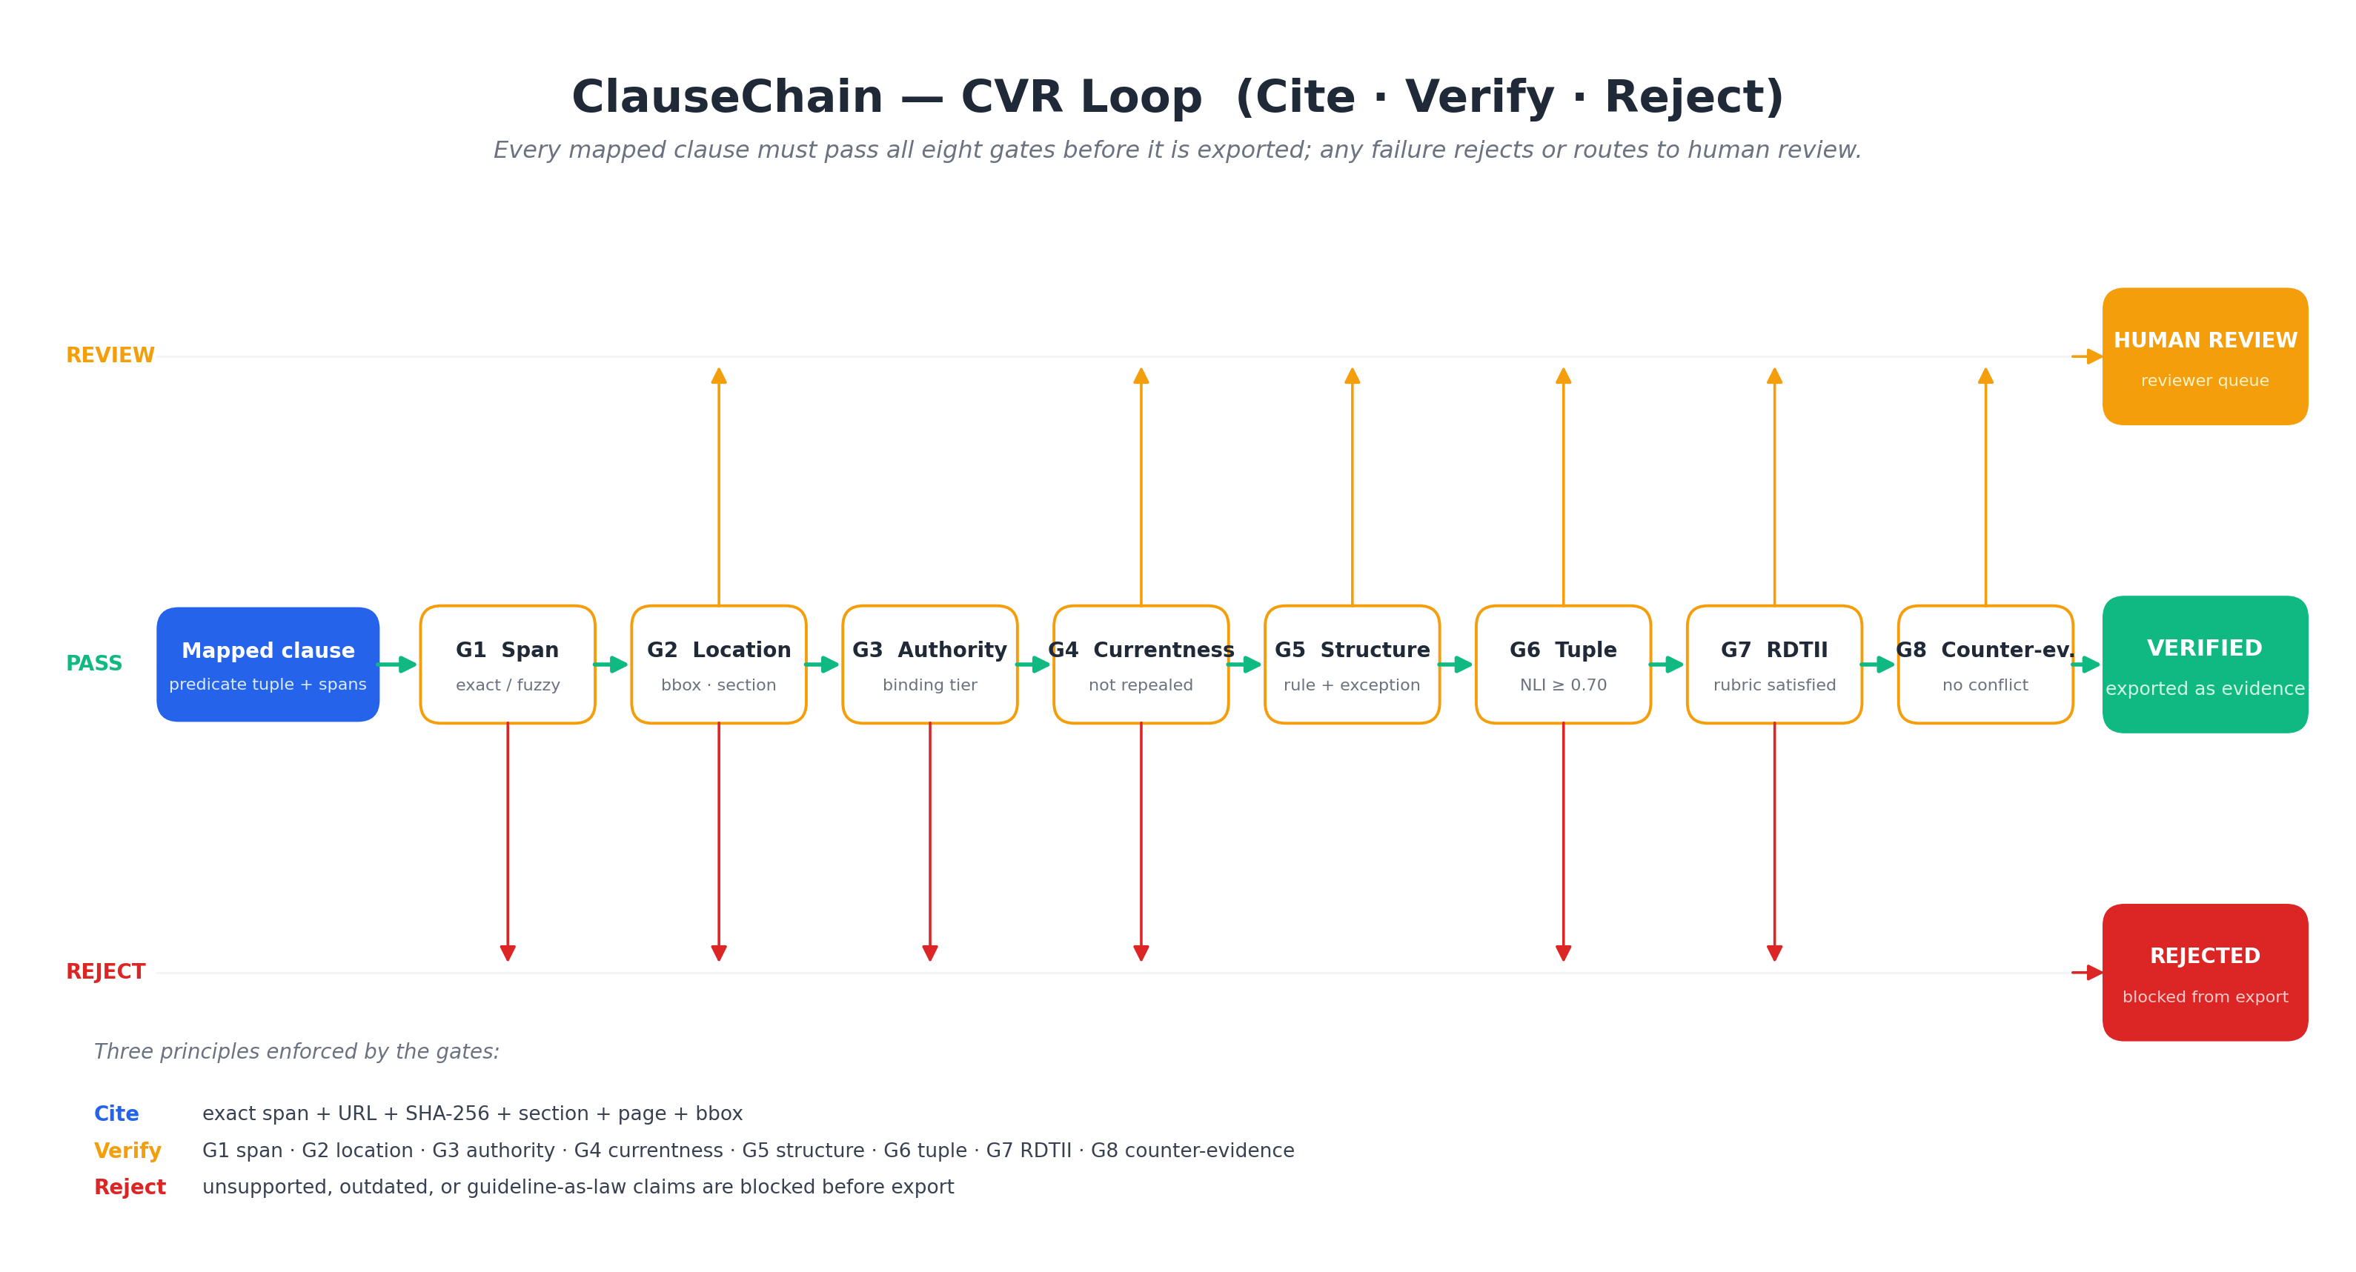
Figure 9 — CVR loop. A mapped clause flows left-to-right through the eight gates on the PASS lane; any uncertain outcome routes up to the REVIEW lane, any disqualifying result drops to the REJECT lane. Only PASS through all eight gates produces a VERIFIED exportable record.
Figure 9 shows the CVR loop. Every claim runs G1 Span (exact byte match, or OCR-fuzzy edit distance <= 3 in OCR regions only), G2 Location (bbox IoU >= 0.85 or section-path match), G3 Authority (binding tier rank <= 5; guidelines never support binding claims), G4 Currentness (not repealed, draft, or superseded), G5 Structure (correct legal unit with exception present), G6 Tuple (multilingual NLI >= 0.70 across populated predicate fields), G7 RDTII (required rubric predicates present, no exclusion triggered), G8 Counter-evidence (corpus search for repeal, amendment, conflict, definition shift). Any failure rejects or routes to human review. Per-stage metrics — discovery recall@20, OCR CER, section-boundary F1, retrieval recall@20, tuple field accuracy, pillar macro-F1, citation exact-match, abstention calibration — are reported with bootstrap confidence intervals against five baselines.
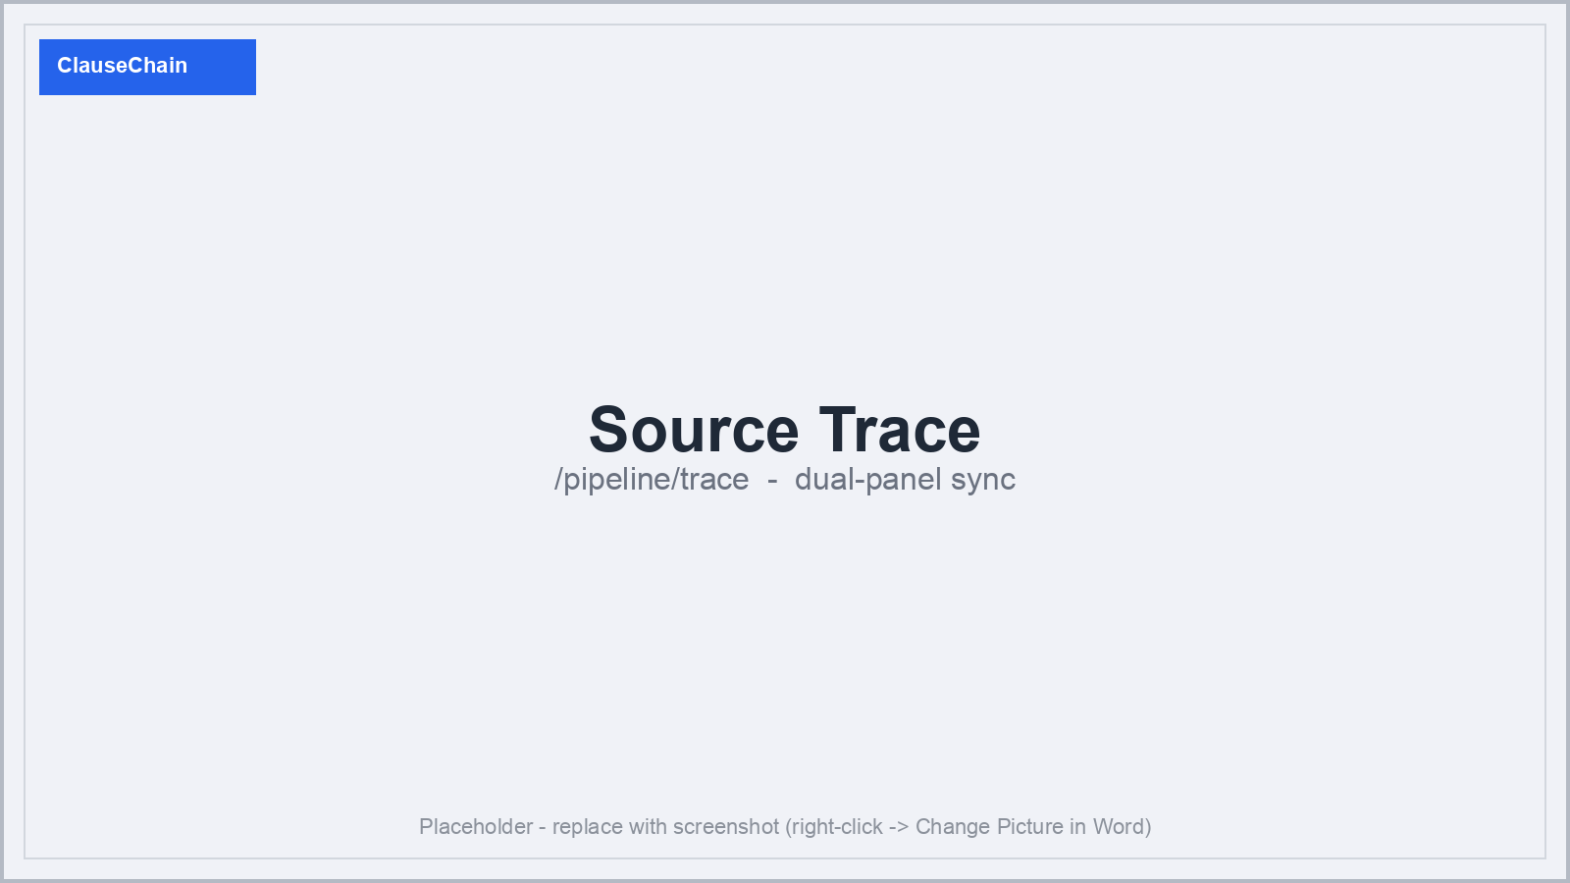
Figure 7 — Source Trace: dual-panel synchronized scroll between extracted clauses and the original source, with per-gate dots, confidence, and match type.

Transparency — provenance bundle
Every exported record carries: source URL, raw-source SHA-256, retrieval timestamp, section, page, char offsets, bbox where available, verbatim quote, span SHA-256, OCR confidence, the eight gate results, and model identity (e.g. local:Qwen2.5-7B or cloud:anthropic:claude-sonnet-4-6). A second analyst on a different machine can re-verify every claim from the provenance bundle alone.
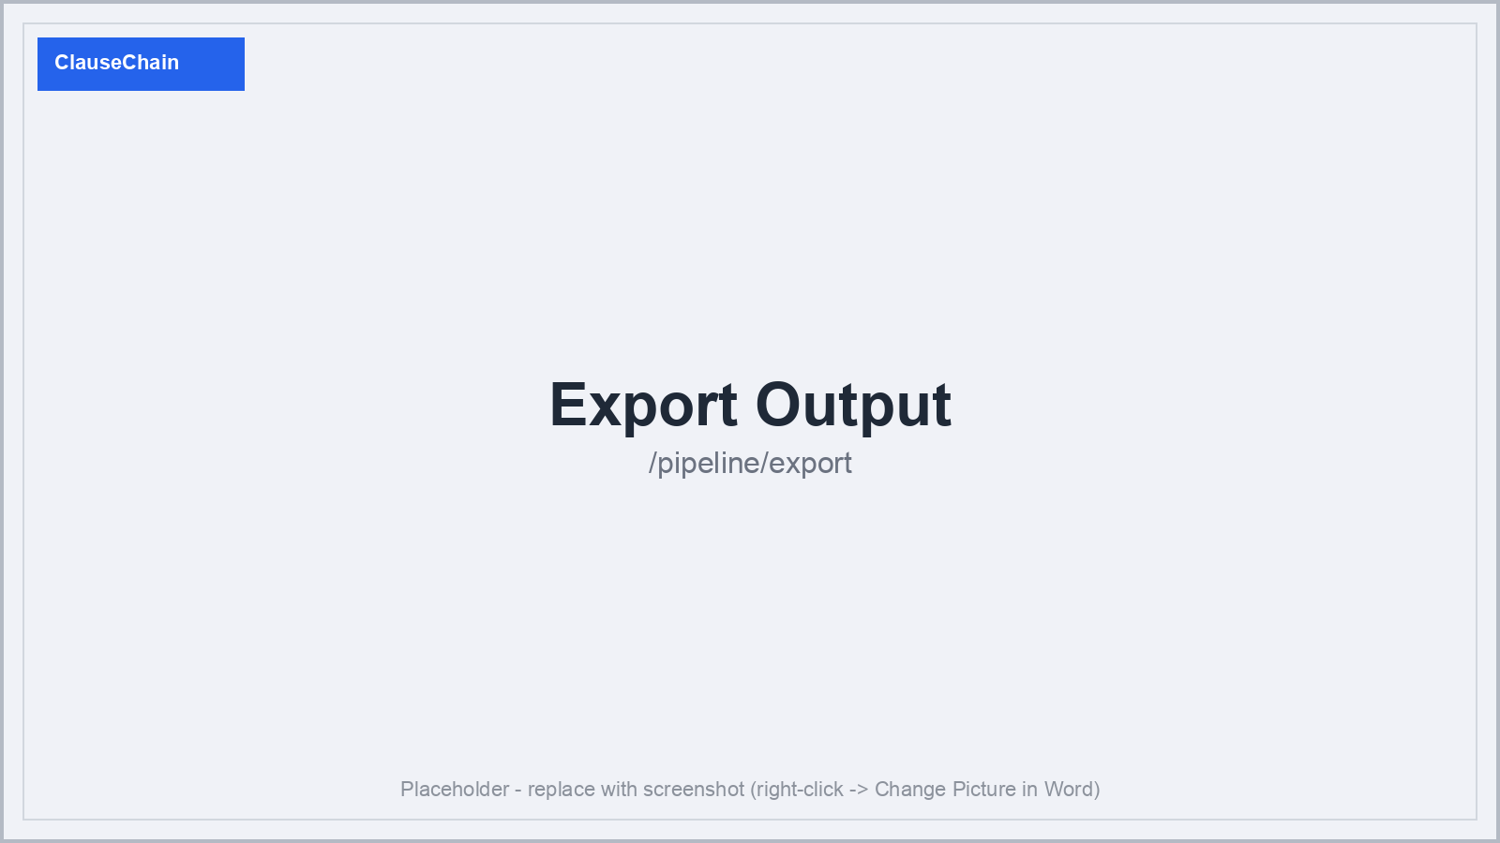
Figure 8 — Export Output: machine-readable records (JSON / CSV / JSONL) with discovery tags, CVR gate results, and verbatim citations.

Cost-efficiency
Local-first default avoids per-token cost entirely. Expensive VLM repair runs only on low-confidence OCR regions; cross-encoder reranking and NLI verification run on small candidate sets, not the full corpus. Cloud escalation is opt-in, per-task, and capped by a per-run USD budget; when the cap hits, the pipeline falls back to local automatically and logs the cap event. Documents tagged 'restricted' in the jurisdiction pack refuse cloud routing entirely. Per-run cost is reported by task and provider so operators can tune the local-vs-cloud split per pipeline.

