

**BANGLADESH UNIVERSITY OF ENGINEERING AND TECHNOLOGY**

**DHAKA, BANGLADESH**

**Course No:** EEE270

**Course Title:** Electrical Drives and Instrumentation Sessional

**Experiment No:** 07

**Experiment Name:** Study the Characteristic of Instrumentation Amplifier.

**Date of Performance**: 15-07-2022 **Name:** Sidratul Muntaha Khan

**Date of Submission:** 06-08-2022 **Student ID:** 1905009

**Group : 02** **Group Partner:** 1905008

1905010

1905012

1905013

1905014

1905015

1405040

**OBJECTIVE:**

The objective of this experiment is to study the characteristic of instrumentation amplifier.

**THEORY:**

Instrumentation amplifier is an extension of the difference amplifier and it amplifier is the difference between its input signals. It is one of the most useful and versatile op amp circuits for Precision measurement and process control. At least one of them can be found in every data acquisition unit. It is made up from three op amps and seven resistors. The resistor R' is variable to balance out any common-mode voltage. Only the register aR, is used to set the gang according to the following equation:

Where,

a = aR/R

E1 is the signal applied to the (+) input

E2 is the signal applied to the (-) input

V0 is the output voltage

**EQUIPMENTS:**

1. Op amp 741 ( three pieces)
2. Resistance 1 KΩ (five pieces)
3. Pot 5 KΩ (two pieces)
4. Oscilloscopes
5. DC power supply

**CIRCUIT DIAGRAM:**

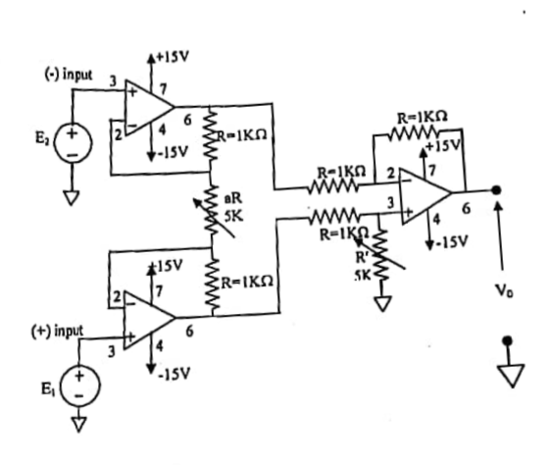

Fig: Instrumentation Amplifier with DC input

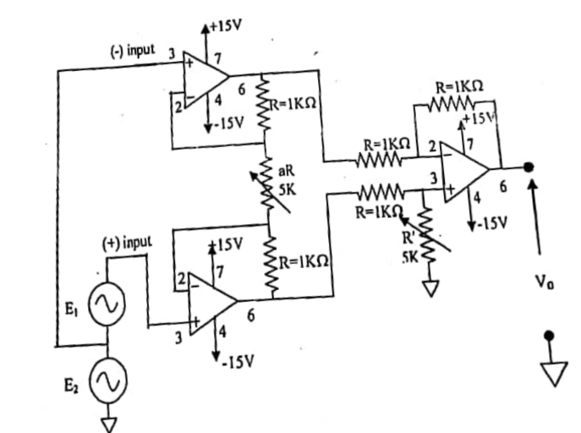

Fig: Instrumentation Amplifier with AC input

**REPORT:**

1. DATA TABLE:

|  |  |  |  |  |  |  |  |
| --- | --- | --- | --- | --- | --- | --- | --- |
| E1(V) | E2(V) | V0(V) | Gain = | aR | R | A = aR/R | Gain = |
| 3 | 2 | 0.98 | 0.98 | 21.5 | 1 | 21.5 | 1.09 |
| 1.1 | 3 | 1.6 | 0.84 | 21.5 | 1 | 21.5 | 1.09 |

1. Is there any discrepancy between the to gains? If so why?

ANS: No, there were not any discrepancies in the gains, since the instruments used here are digital, so there are no human errors.

**LAB DIAGRAMS:**

**E1 = 100 mV (p-p):**

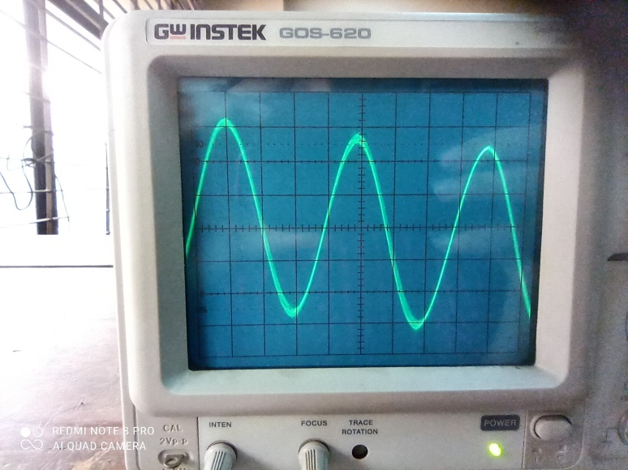

**E2 = 1V (p-p):**

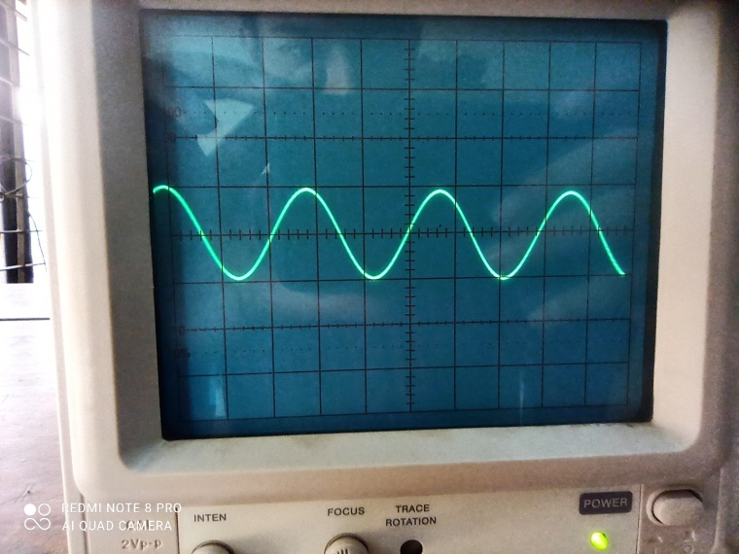

**V0:**

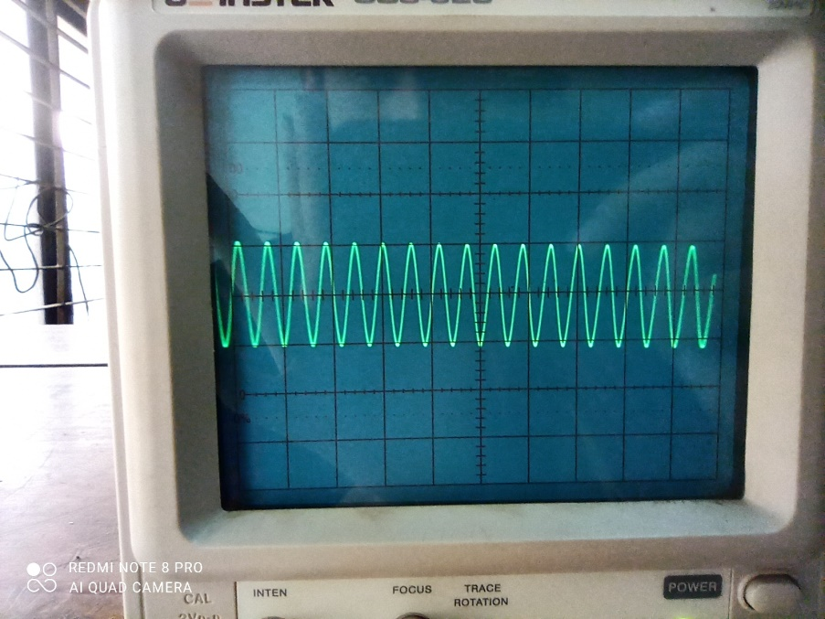

**INPUT OUTPUT TOGETHER**

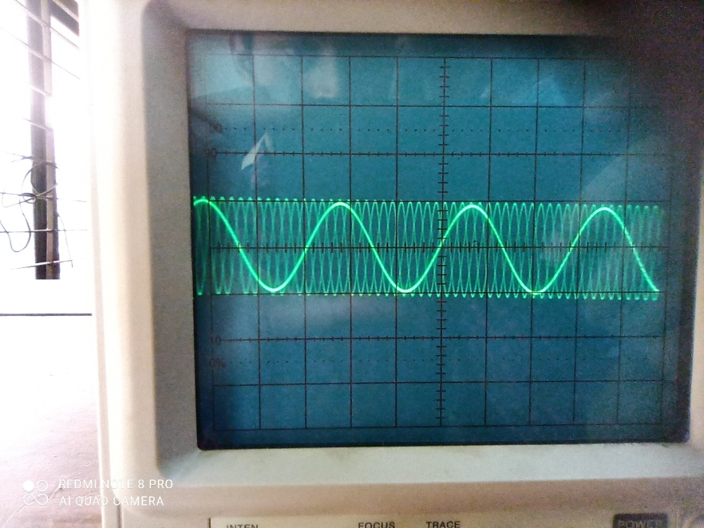

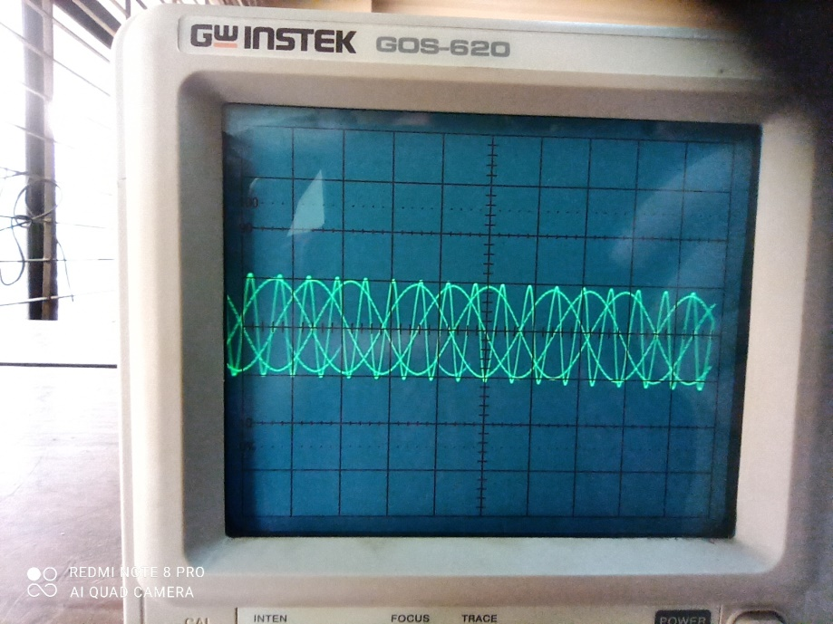

**QUESTIONS:**

1. **What are the characteristics of an instrumentation amplifier?**

ANS: The important points to be noted in this amplifier are listed as follows:

* These amplifiers are known for the amplification of the low-level output signals. Hence it must possess high values of gain.
* It contains a higher amount of input impedance.
* It possesses a low amount of output impedance. To protect the circuit from the effect of loading.
* To generate the maximum outcome such that it can generate undistorted output signals. It must have high slew rates.
* High CMRR is the most important consideration because the input of this amplifier is from the output of the transducer.

In this way, the instrumentation amplifier possesses certain important characteristics in comparison to the other amplifiers.

1. **Write down some application of instrumentation amplifier.**

ANS: The applications of the instrumentation amplifier include the following.

* These amplifiers mainly involve where the accuracy of high differential gain is required, strength must be preserved in noisy surroundings, as well as where huge common-mode signals are there. Some of the applications are
* Instrumentation amplifiers are used in data acquisition from small o/p transducers like [thermocouples](https://www.elprocus.com/thermocouple-types/), strain gauges, measurements of [Wheatstone bridge](https://www.elprocus.com/wheatstone-bridge-working-and-its-applications/), etc.
* These amplifiers are used in navigation, medical, radar, etc.
* These amplifiers are used to enhance the S/N ratio ([signal to noise](https://www.elprocus.com/stereo-noise-reduction-circuit-working-application/)) in audio applications like audio signals with low amplitude.
* These amplifiers are used for imaging as well as video data acquisition in the conditioning of high-speed signal.
* These [amplifiers](https://www.elprocus.com/classification-of-amplifiers-classes-its-applications/) are used in RF cable systems for amplification of the high-frequency signal.

1. **What are the advantages of the instrumentation amplifier over difference amplifier.**

ANS: The key differences between the operational amplifier and instrumentation amplifier include the following.

* An[operational amplifier (op-amp)](https://www.elprocus.com/operational-amplifiers/) is one kind of an integrated circuit
* The instrumentation amplifier is one type of differential amplifier
* Instrumentation amplifier can be built with three operational amplifiers.
* The differential amplifier can be built with a single[operational amplifier](https://www.elprocus.com/op-amp-ics-pin-configuration-features-working/).
* The output voltage of difference amplifier gets affected because of the mismatch resistors
* Instrumentation amplifier offers gain with a single resistor of its primary phase which does not need a resistor matching.

**DISCUSSION:**

We learned the important characteristics of an instrumentation amplifier as well as its performance in comparison to a standard Differential Amplifier in this experiment. Because the design of a standard Differential Amplifier is dependent on the feedback network, achieving high gain requires a high input resistance, which is quite impractical. In contrast, an instrumentation amplifier requires less input resistance for the same gain. As a result, instrumentation amplifiers are preferred in a variety of fields.

