**Qatar University**

**College of Engineering**

**CMPS 405: Operating Systems**

**Fall 2024**

**(Section B04)**

**Project Phase-1**

***Submitted to:***

Dr. Heba Dawoud

|  |  |  |
| --- | --- | --- |
| **Student** | **Name** | **ID** |
| **#1** | Nafin Mahmoud | 201913152 |
| **#2** | Khamis Al-Kubaisi |  |
| **#3** | Khalid Abdallah |  |
| **#4** | M. Reyad Tuama Halabi |  |

**Server-Side Tasks (VM1)**

Task-1:

- Create local user accounts for each client on the server.









- Install and enable SSHD

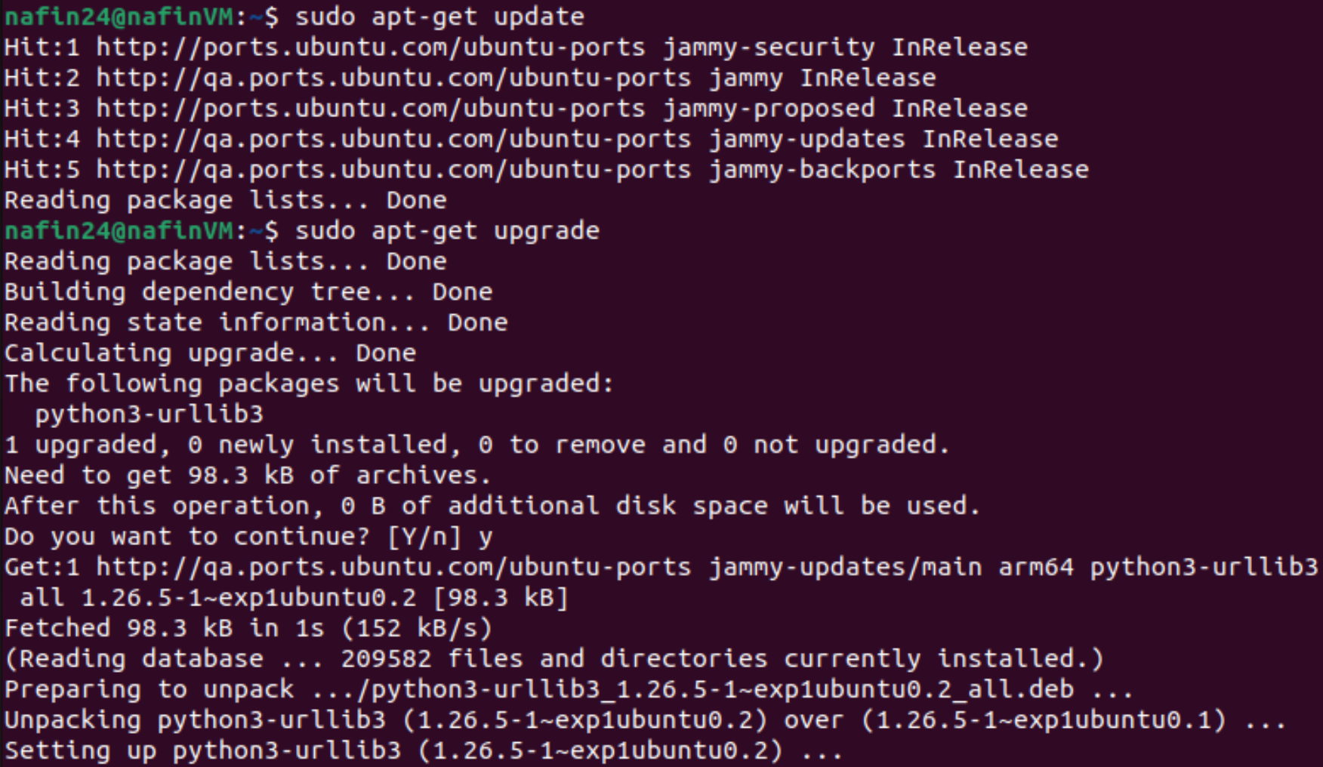

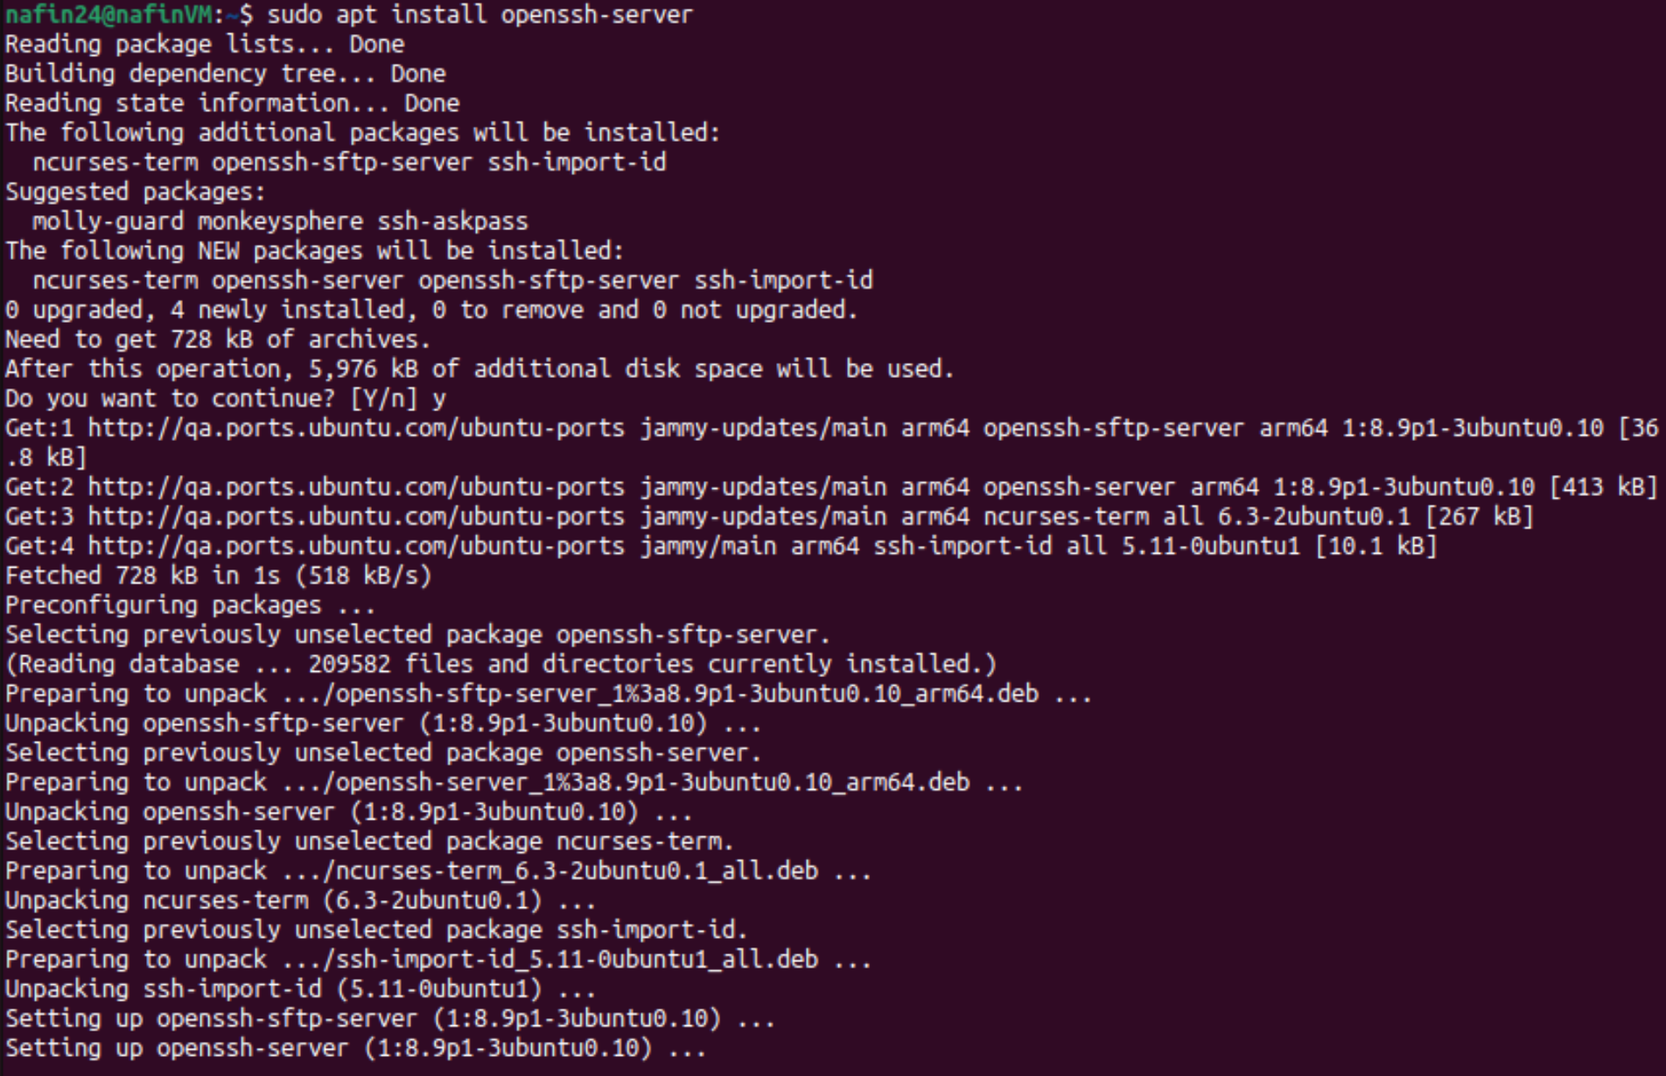



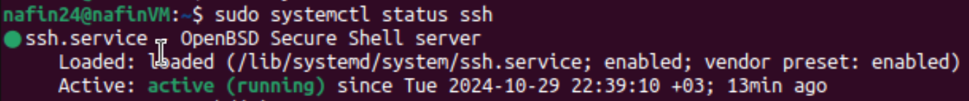

- Configure SFTP for file transfer operations.



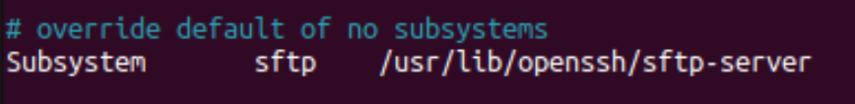

Task-2:

* Enable SSH access for clients using local account credentials, that is, configure SSHD server such that clients can access any file via their local accounts, using username and password.

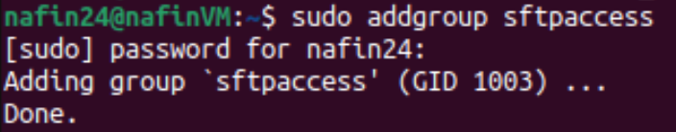

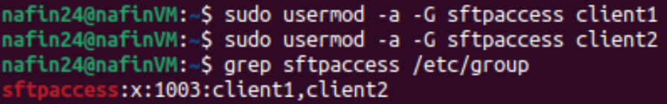



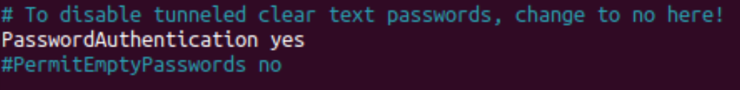

* Set up SFTP for file uploads/downloads.





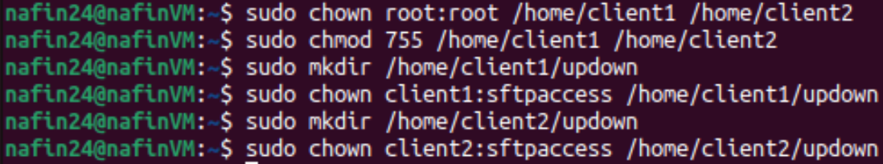

* Secure copy will be used to transfer files to and from server.





Task-3:

* Server-Side Shell script 1: (network.sh)

#!/bin/bash  
  
# Check whether ping and traceroute are installed. Otherwise, install all network tools  
if ! command -v ping &> /dev/null || ! command -v traceroute &> /dev/null; then  
    echo "Installing ping and traceroute"  
    sudo apt-get update -y  
    sudo apt-get install -y iputils-ping traceroute net-tools  
fi    
  
# Creating log file for network  
log="network.log"  
echo "Testing Connection on $(date)" > $log  
  
# Checking connectivity  
check() {  
    # Taking one IP at a time  
    local target_IP=$1  
    echo "Testing connection for $target_IP"  
  
    # Test with ping  
    if ping -c 3 -W 5 "$target_IP" &> /dev/null; then  
        # If good connection, then log result  
        echo "$(date '+%Y-%m-%d %H:%M:%S') - Testing connection with $target_IP is successful" | tee -a "$log"  
    else  
        # If ping fails, then call traceroute  
        echo "$(date '+%Y-%m-%d %H:%M:%S') - Testing connection with $target_IP has failed, calling traceroute now" | tee -a "$log"  
        ./traceroute.sh "$target_IP"  
    fi  
}  
  
# Check connection for each IP three times  
for i in {1..3}; do  
    for target_IP in "$@"; do   
        check "$target_IP"  
    done  
done



* Server-Side Shell script 1: (traceroute.sh)

#!/bin/bash  
  
# Check if a target IP was provided  
  
if [ "$#" -eq 0 ]; then  
    echo "No ip was provided"  
    exit 1  
fi  
  
target_IP=$1  
log="network.log"  
  
# Log the start of the traceroute process  
echo "Running traceroute for $target_IP" | tee -a "$log"  
  
# Display routing table  
echo "Routing table:" | tee -a "$log"  
netstat -nr | tee -a "$log"  
  
# Display hostname  
echo "Hostname: $(hostname)" | tee -a "$log"  
  
# Testing local DNS server connection  
echo "Testing local DNS server connection" | tee -a "$log"  
nslookup [google.com](http://google.com) | tee -a "$log"  
  
# Tracing route to google  
echo "Tracing route to [google.com](http://google.com)" | tee -a "$log"  
traceroute [google.com](http://google.com) | tee -a "$log"  
  
# Tracing route to the target IP  
echo "Tracing route to $target_IP" | tee -a "$log"  
traceroute "$target_IP" | tee -a "$log"  
  
# Ping [google.com](http://google.com)  
echo "Pinging [google.com](http://google.com)" | tee -a "$log"  
ping -c 3 -W 5 [google.com](http://google.com) | tee -a "$log"   
  
# Check connectivity to target IP  
if ! ping -c 3 -W 5 "$target_IP" &> /dev/null; then  
    echo "Cannot reach target $target_IP, rebooting now" | tee -a "$log"  
    sudo reboot  
else  
    echo "Reconnected to $target_IP" | tee -a "$log"  
fi

