

DEPARTMENT OF COMPUTER SCIENCE AND ENGINEERING

Course: CSE489
Name: MD. Nafis Kamal
ID: 22301031
Email: md.nafis.kamal@g.bracu.ac.bd
Project Title: A loyalty based app for salon, The Loyalty Salon app.

Project Features:
By the end of this course, implemented features:
- Login system and new account creation system.
- Customer dashboard with acquired loyalty points , active booking dashboard, service booking , cancel booking , view previous bookings and view user profile for the customer.
- Admin dashboard with active booking details, history of previous bookings , statistics of current customer base.
- Barber dashboard with active booking details, history of previous bookings and their total earnings.

Screenshots: 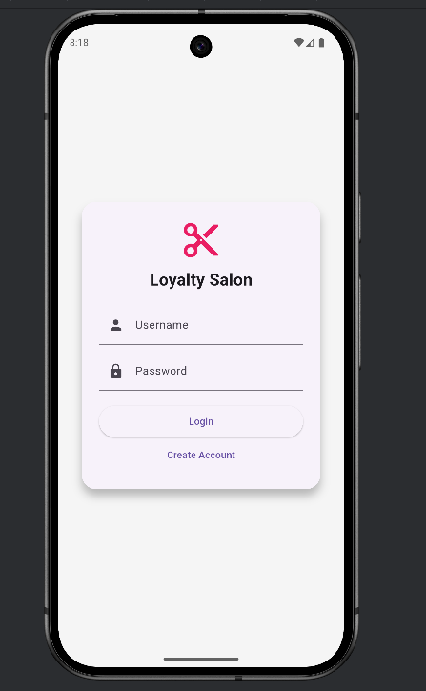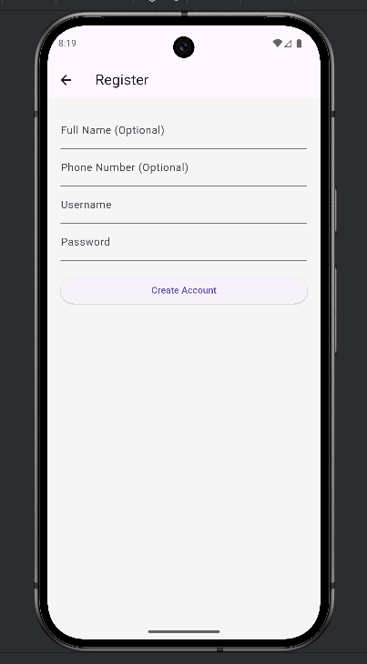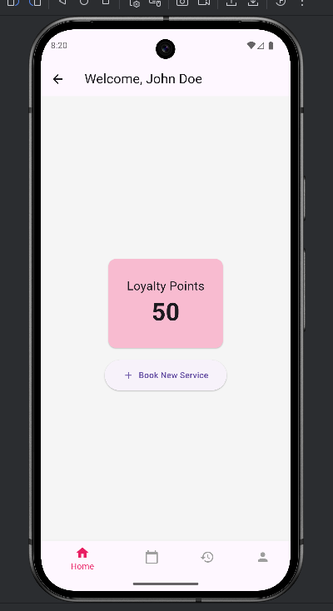

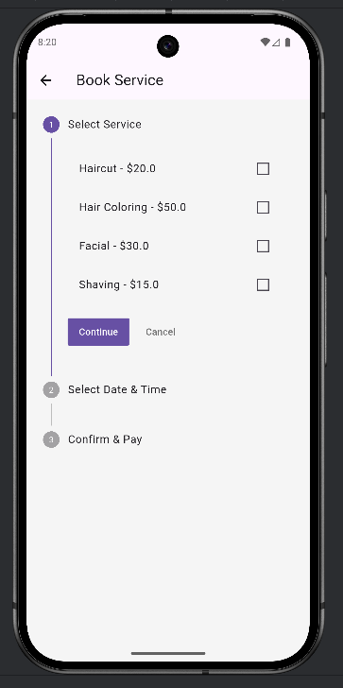 | 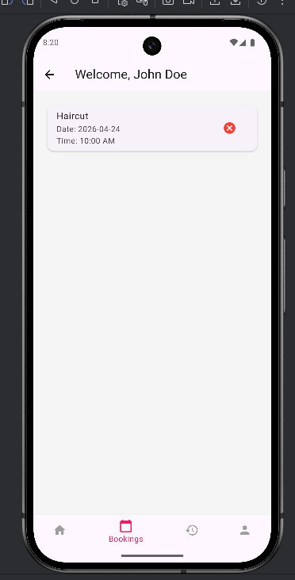
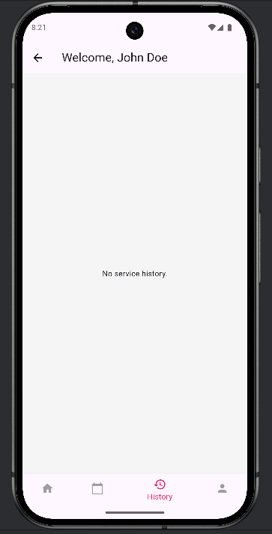 | 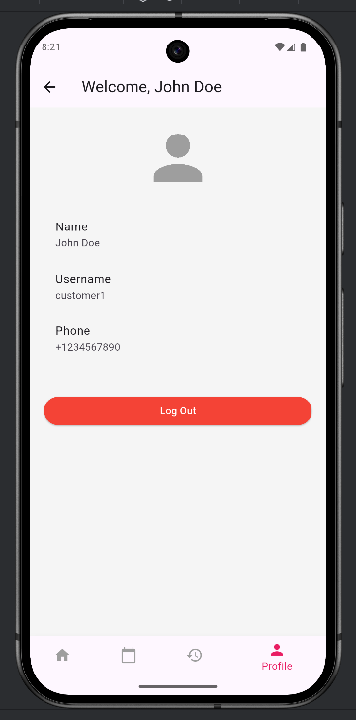

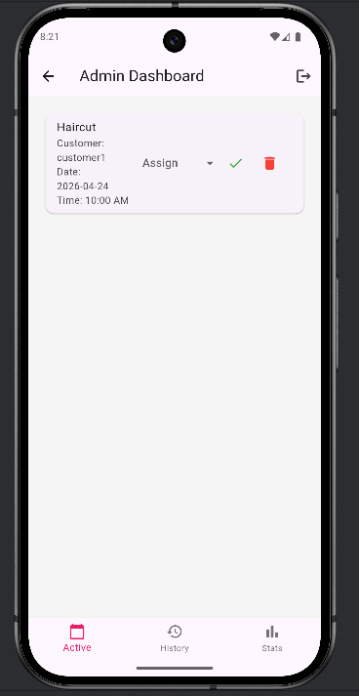 | 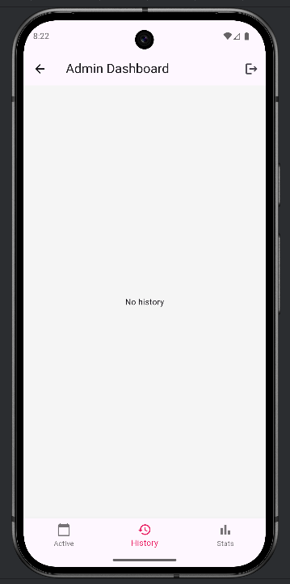
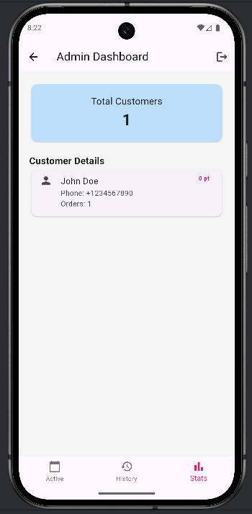 | 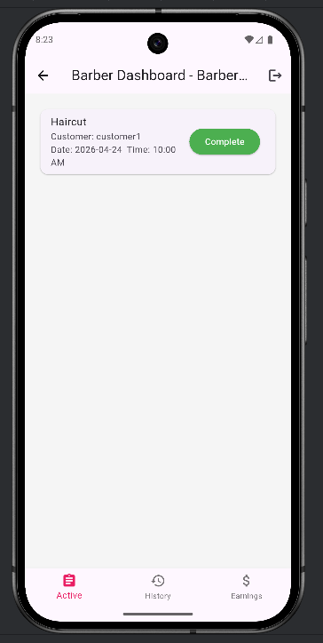

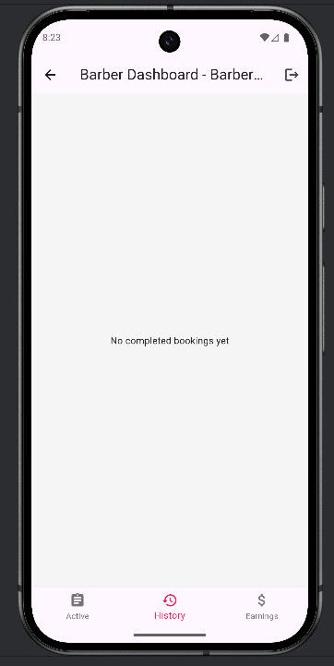 | 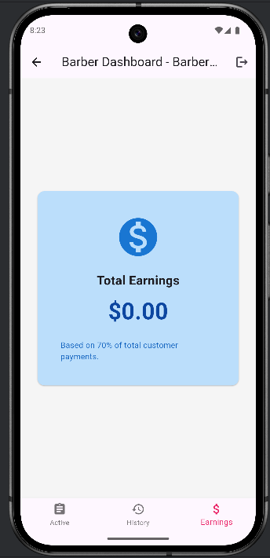

Online Resources used:
a) Reference:
- ChatGPT for brinastorming new ideas for app
- Youtube videos for tutorials and problem solving
links - https://www.youtube.com/watch?v=1xipg02Wu8s
https://www.youtube.com/watch?v=HQ_ytw58tC4

- Gemini for ideas of designing diagrams efficiently

Future Enhancements:
Following enhancement can be added to the current system which will improve the system.
- Have a cloud database to make app more reachable.
- Have a online payment option.
- Have a reminder option for both customer and barber that would remind them of their bookings prior to their booked time.
- Excel sheet export option from the statistics tab.

