**Purchasing behaviour of Bangladeshi Gen Z’s in E-commerce market**

**Abstract**

This study delves into the e-commerce purchasing habits of Generation Z in Bangladesh, aiming to decode the patterns, preferences, and influential factors shaping their online shopping behavior. By analyzing data from a broad spectrum of Gen Z consumers, the research uncovers their shopping frequency, favored platforms, preferred product categories, spending patterns, and the significant role of social media in their buying decisions. The findings spotlight Gen Z's inclination towards online shopping, motivated by the allure of convenience, diverse choices, and competitive prices, with a particular emphasis on using mobile devices. Fashion and electronics emerge as top picks, although concerns about payment security, product authenticity, and customer service signal areas ripe for improvement.

**1.1 Introduction:**

The Internet is a comprehensive communication network that links numerous networks globally, enabling individuals to exchange information, opinions, and reviews. It has revolutionized not only everyday life but also the realm of business. The advent of the Internet has transformed how businesses operate and how consumers approach purchasing decisions. The introduction of e-commerce by many companies has led to decreased market costs, consequently lowering the prices of products and services. This development aids business professionals in grasping consumer preferences, tastes, and requirements for goods and services. The Internet has had a significant impact on society, especially on consumers who are increasingly turning to this new platform for buying and selling goods and services. The e-commerce sector is vast and thriving, serving as a conduit for extensive business transactions through electronic trading. Nowadays, nearly 90% of companies maintain a website, including those not directly involved in e-commerce activities.

**1.2 Origin of the study:**

In the early years of e-commerce, buying online was an intellectual activity strictly dominated by “techies” and semi-technology literate individuals. This demographic was more comfortable and in tune with Internet’s capabilities. But in recent years, the number of customers, also making the technology to increase online shopping is regular. Internet helps consumers, to know more about products and services, and it also tells the positive and negative experience of other consumers.Generation Z, individuals born between 1995 and 2010 and often referred to as Digital Natives, have been immersed in the internet and social media from a young age. For them, technology seamlessly integrates into their lives.

**1.3 Objective of the study:**

➢ To understand the frequency and patterns of online shopping among Bangladeshi generation Z.

➢ To identify the key product categories preferred by generation Z in online shopping.

➢ To examine the factors influencing online purchasing decisions.

➢ To assess the impact of social media and digital advertising on purchasing decisions.

➢ To evaluate the challenges and barriers faced by Gen Z in online shopping.

**1.4 Scope of the Study:**

This research focuses on understanding the motivations, attitudes, and intentions behind Gen Z's online shopping behaviors. It offers insights for e-commerce companies looking to develop strategies that engage Gen Z shoppers, meet their requirements, and ensure their loyalty. Targeting Gen Z as the primary participants, this study acknowledges their increasing population and significant impact on the financial performance of both digital and physical stores.

**1.5 Limitations of the study:**

➢ This study has been based on the current situation in Bangladesh. Therefore, the critical

**Theoretical background**

The rapid expansion of the Internet has significantly propelled the growth of e-commerce and online shopping. This digital evolution allows consumers to easily find what they need online, while enabling sellers to broaden their reach and enhance their communication with customers. Despite the opportunities, the e-commerce landscape is fiercely competitive, with success often resting on a business's ability to understand and meet consumer demands. Research indicates that Gen Z, those born from 1990 onwards and raised during the digital age, tend to exhibit low brand loyalty and require more effort to engage and retain their interest. Characterized by their high educational attainment, creativity, and tech proficiency, Gen Z shoppers are drawn to the latest innovations, value simplicity and security, seek experiences that offer an escape, hold high standards, and prioritize the overall experience.

**2.2 Literature review**

E-commerce involves the procurement of goods and services in an online platform by both the companies and consumers. To participate in e-commerce, potential customers need cell phones and access to the World Wide Web (Lucking-Reiley & Spulber, 2001; Niranjanamurthy et al., 2013). Some scholars argued that the business utilization of the web is restricted because of the data transmission constraint (Parvin et al., 2007). There have also been some better shopping requirements, such as links to the platform, a fair loading time, clear product definition, reliability of purchases and efficiencies in navigation (Limayem et al., 2000). Some research finds that visitor numbers are four times higher than the average visitor when the site uses local language 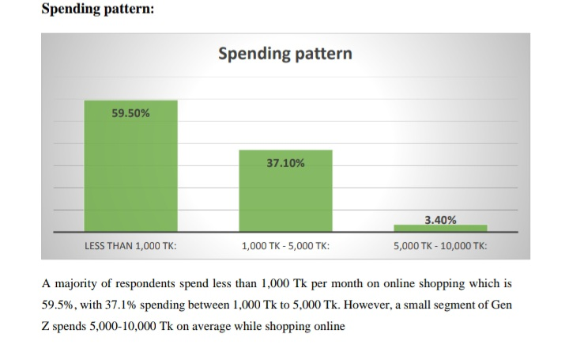

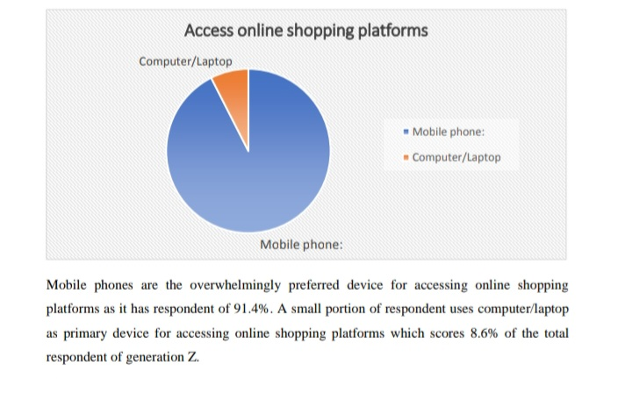

**References:**

Abir, T., Husain, T., Waliullah, S.S.A., Yazdani, D.M.N., Salahin, K.F. and Rahman, M.A. (2020). Consumer Buying Behavior towards E-Commerce: A Survey Study of Consumers at a Selected Online Shopping Site in Dhaka, Bangladesh. Open Journal of Business and Management, 08(06), pp.2716–2728. doi:https://doi.org/10.4236/ojbm.2020.86168.Awan, A.G. and Zahra, S.Z. - (2014). IMPACT OF INNOVATIONS ON CONSUMERS’ BEHAVIOUR: A CASE STUDY OF PAK ELECTRON LIMITED. [online] European Journal of Business and Innovation Research (EJBIR). Available at: https://eajournals.org/ejbir/vol-2issue6december-2014/impact-innovations-consumers-behaviour-case-study-pak-electron-limited/.Bewicke, H. (2023). Gen Z consumer behavior: What you need to know. [online] Talon.One. Available at: https://www.talon.one/blog/gen-z-consumer-behavior-what-you-need-to-know.

Eldridge, A. (2022). Generation Z | Definition, Characteristics, Trends, & Birth Years |

Britannica.[online]www.britannica.com.Availableat:https://www.britannica.com/topic/Generation-Z.

Feng, R. and Ivanov, A. (2023). Does a generational gap exist in online shopping attitudes? A

comparison of Chinese consumer generations from the media system dependency

perspective. Telematics and Informatics Reports, [online] 12, p.100106.

doi:https://doi.org/10.1016/j.teler.2023.100106.

Ferdous, J., Alam, M.T. and Mahbub, A. (2022). Drivers for Online Shopping: Considering the

Most Important Factors in Dhaka Metropolis, Bangladesh. Expert Journal of Marketing,

[online] 10(1). Available at: https://marketing.expertjournals.com/23446773-1004/.

Fokina, M. (2023). Online Shopping Statistics: Ecommerce Trends for 2022. [online] Tidio.

Available at: https://www.tidio.com/blog/online-shopping-statistics/.

Companies. [online] McKinsey & Company. Available at:

https://www.mckinsey.com/industries/consumer-packaged-goods/our-insights/true-gen-

generation-z-and-its-implications-for-companies