SRINIVAS INSTITUTE OF TECHNOLOGY, MANGALORE

DEPARTMENT OF COMPUTER SCIENCE AND ENGINEERING
Report On UI/UX BCS456C

Project Title
"StreamFlex: One Place For All Your Series & Movie Needs"

Submitted By
Disha
4SN23CS038

Under the guidance of
Prof.Shruthi V S
Assistance professor
2024-2025

CHAPTER 1

INTRODUCTION

StreamFlex is a dynamic streaming platform inspired by the global success of Netflix, designed to deliver high-quality entertainment through an intuitive, user-friendly interface. It serves as a robust clone of Netflix, offering an extensive library of movies, TV series, and trending content across various genres. With a sleek design and seamless navigation, StreamFlex replicates the Netflix experience while providing personalized recommendations and curated content sections like “Top Picks for You.”
At the heart of StreamFlex lies an engaging homepage that highlights featured titles—such as Stranger things—with detailed descriptions and vibrant visuals. The platform includes easy access to categories like Movies, Series, Popular, and Trends, enabling users to discover new favorites effortlessly. Users can switch between light and dark modes and enjoy a streamlined login system for a personalized watch experience.

Problem Statement

In the era of digital entertainment, audiences increasingly demand seamless access to high-quality streaming content. However, many existing platforms either lack intuitive user interfaces, personalized content recommendations, or struggle with high subscription costs and regional content limitations. This creates a fragmented viewing experience, especially for users seeking a smooth, centralized, and engaging entertainment solution.Additionally, new or independent content creators often face challenges in getting their work featured on major platforms, limiting exposure and diversity in streaming catalogs. Viewers, in turn, miss out on discovering unique and culturally relevant content.StreamFlex aims to address these issues by providing a Netflix-style streaming platform that is visually engaging, easy to navigate, and equipped with essential features such as content categorization, user profiles, personalized suggestions, and dark/light mode options. By offering a well-organized and accessible interface, StreamFlex enhances the user experience while creating opportunities for broader

CHAPTER 2

REQUIREMENT SPECIFICATION

Hardware Requirements
The minimum/recommended hardware configuration required for developing the proposed software is given below:
- Any dual-core processor (Intel, AMD, or ARM), such as Intel i3 or Apple M1.
- Minimum 4 GB RAM (8 GB recommended for smoother multitasking).
- Only a few megabytes required for local files (HTML, CSS, images).
- SSD recommended for faster performance, though not mandatory.
- 13-inch or larger screen for optimal layout rendering.
- Minimum resolution of 1366×768 pixels.
- A modern browser with HTML5, CSS3, and JavaScript support (e.g., Chrome, Firefox, Safari, Edge).
- Compatible with Windows 10 or later, macOS, or any modern Linux distribution.

Software Requirements
- Front End
- Html
- CSS
- JavaScript
- Vs code
- Chrome, Firefox, Safari or any other supported browser.

Software Tools Used
The front end of the StreamFlex platform is developed using HTML, CSS, and JavaScript to create a responsive and interactive user interface. Visual Studio Code is used as the main development environment, while browsers like Chrome, Firefox, and Safari are utilized for testing and debugging. These tools work together to deliver a Netflix-like experience with smooth navigation and rich visuals. The user interface is designed to be intuitive, visually engaging, and accessible across multiple devices.

Front End Tool

Visual Studio Code (VS Code) is a free and open-source code editor developed by Microsoft,
widely used in front-end web development. It provides features such as syntax highlighting, intelligent code completion, debugging tools, terminal integration, and version control support. VS Code is built on Electron and is compatible with Windows, macOS, and Linux operating systems. It supports multiple programming languages and is highly extensible through a vast marketplace of extensions tailored to web development needs.Visual Studio Code offers powerful development features like IntelliSense for smart code suggestions, built-in Git Integration, and real-time collaboration with extensions like Live Share. It is particularly effective in working with HTML, CSS, and JavaScript, which are essential technologies for developing the front end of StreamFlex. The editor supports a wide range of frameworks and libraries, including React, Vue, Angular, and Bootstrap, enhancing productivity in responsive web design. It also includes support for live preview through extensions such as Live Server, which enables developers to instantly view updates in the browser as changes are made to the code.The interface of VS Code is user-friendly, featuring customizable layouts, themes, and keybindings to suit individual developer preferences. With features like file structure navigation, multi-tab editing, and intelligent refactoring tools, VS Code allows efficient handling of complex projects. Its integration with Node.js, REST Client, and browser developer tools further extends its capabilities for full-stack development. Visual Studio Code competes with other popular editors like Sublime Text and Atom, but stands out due to its performance, community support, and Microsoft-backed development.

CHAPTER 3
IMPLEMENTATION
index login.html

<!DOCTYPE html>
<html lang="en">
<head>
<meta charset="UTF-8">
<title>StreamFlex Login</title>
<link rel="stylesheet" href="register styles.css">
</head>
<body>
<div class="login-container">
<h2 class="login-title">Sign In</h2>
<form class="auth-form">
<div class="input-group">
<input type="text" required>
<label>Email or phone number</label>
</div>
<div class="input-group">
<input type="password" required>
<label>Password</label>
</div>
<button type="submit"
class="submit-btn">Sign In</button>
<div class="form-options">
<div class="save-credentials">
<input type="checkbox" id="save-login">
<label for="save-login">Remember me</label>
</div>
<a href="#" class="help-link">Need help?</a>
</div>
</form>
<p class="signup-prompt">New to our service?
<a href="#">Sign up now</a></p>
<p class="security-notice">
This page is protected by Google reCAPTCHA to ensure you're not a bot.
<a href="#">Learn more.</a>
</p>
</div>
</body>
</html>

CHAPTER 4

RESULT AND DISCUSSION
  - Home page

Figure 4.1 shows Home page for watching their favourite movies ,series , shows and online games
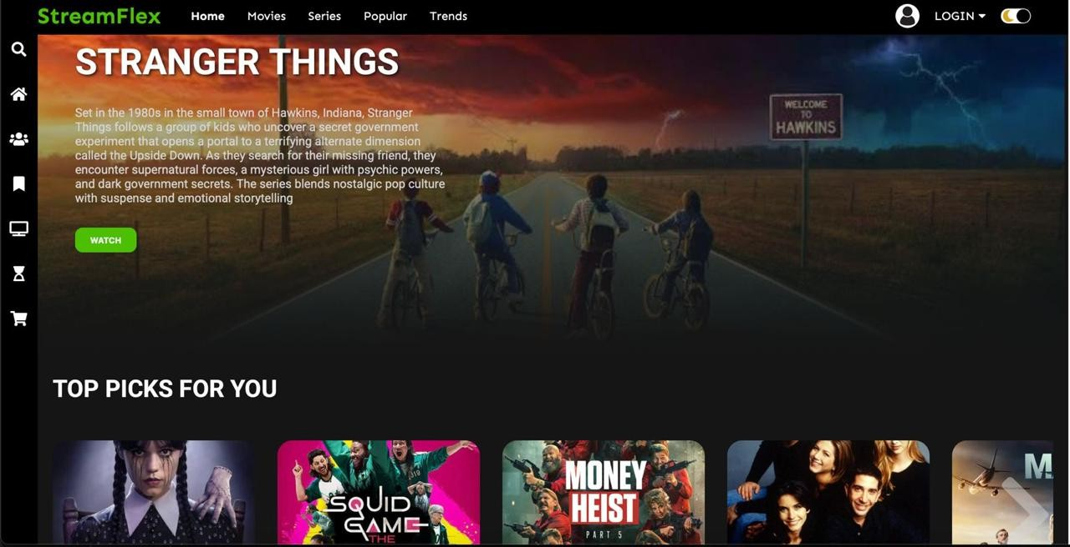
Fig 4.1:Home page
  - Registration page
Figure 4.2 shows the sign in page for user sign up
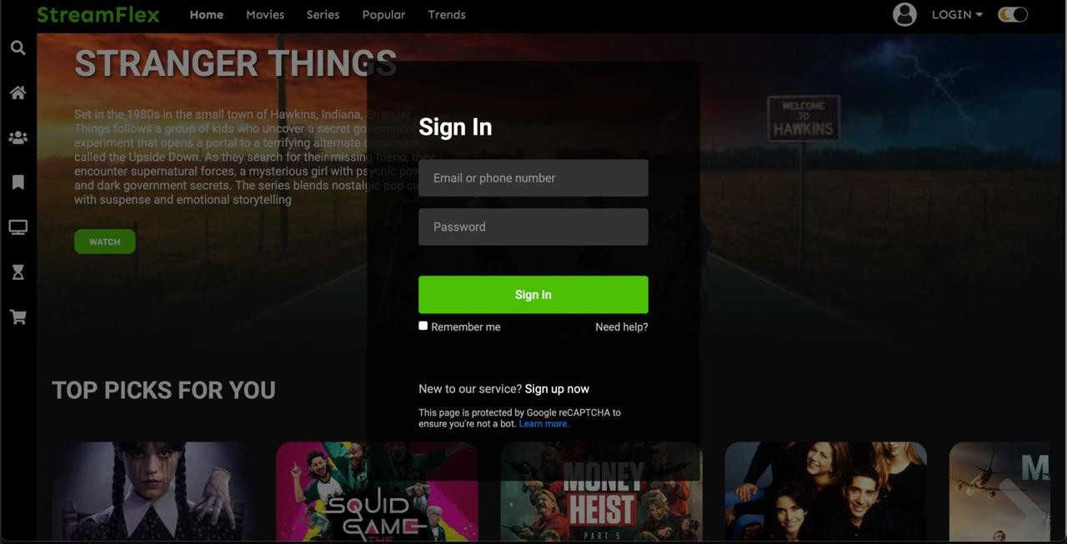
Fig 4.2: registration page

CONCLUSION

StreamFlex is a feature-rich streaming platform designed to replicate the functionality and user experience of popular services like Netflix. By utilizing modern web technologies such as HTML, CSS, and JavaScript, along with development tools like Visual Studio Code, the platform delivers a sleek, responsive, and user-friendly interface. StreamFlex organizes content effectively, offering categories like trending shows, movies, and personalized recommendations to enhance viewer engagement. This project demonstrates how a well-structured front-end design can provide an immersive digital entertainment experience, serving as both a learning tool for developers and a foundation for future enhancements such as backend integration, user accounts, and real-time streaming capabilities.
Moreover, the implementation of dark and light mode features improves accessibility and personalization for users. The layout is designed to be responsive across various devices, including desktops, tablets, and smartphones. With further development, StreamFlex has the potential to evolve into a fully functional streaming application with real-world applicability.

