Q14.
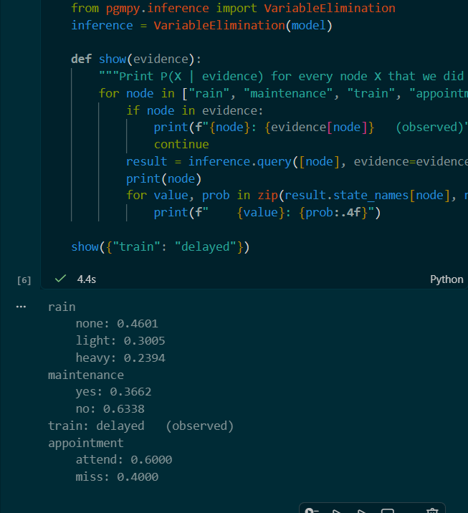

Q15.
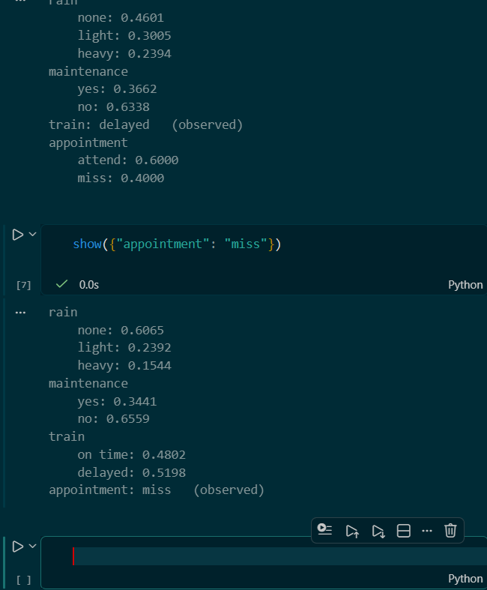

Q16.
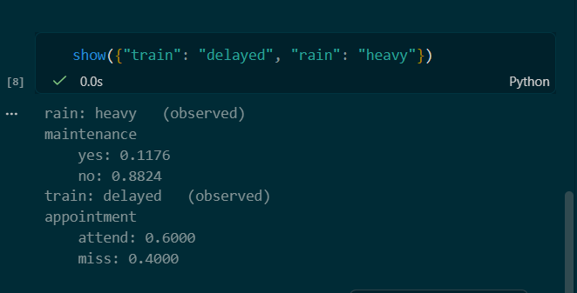

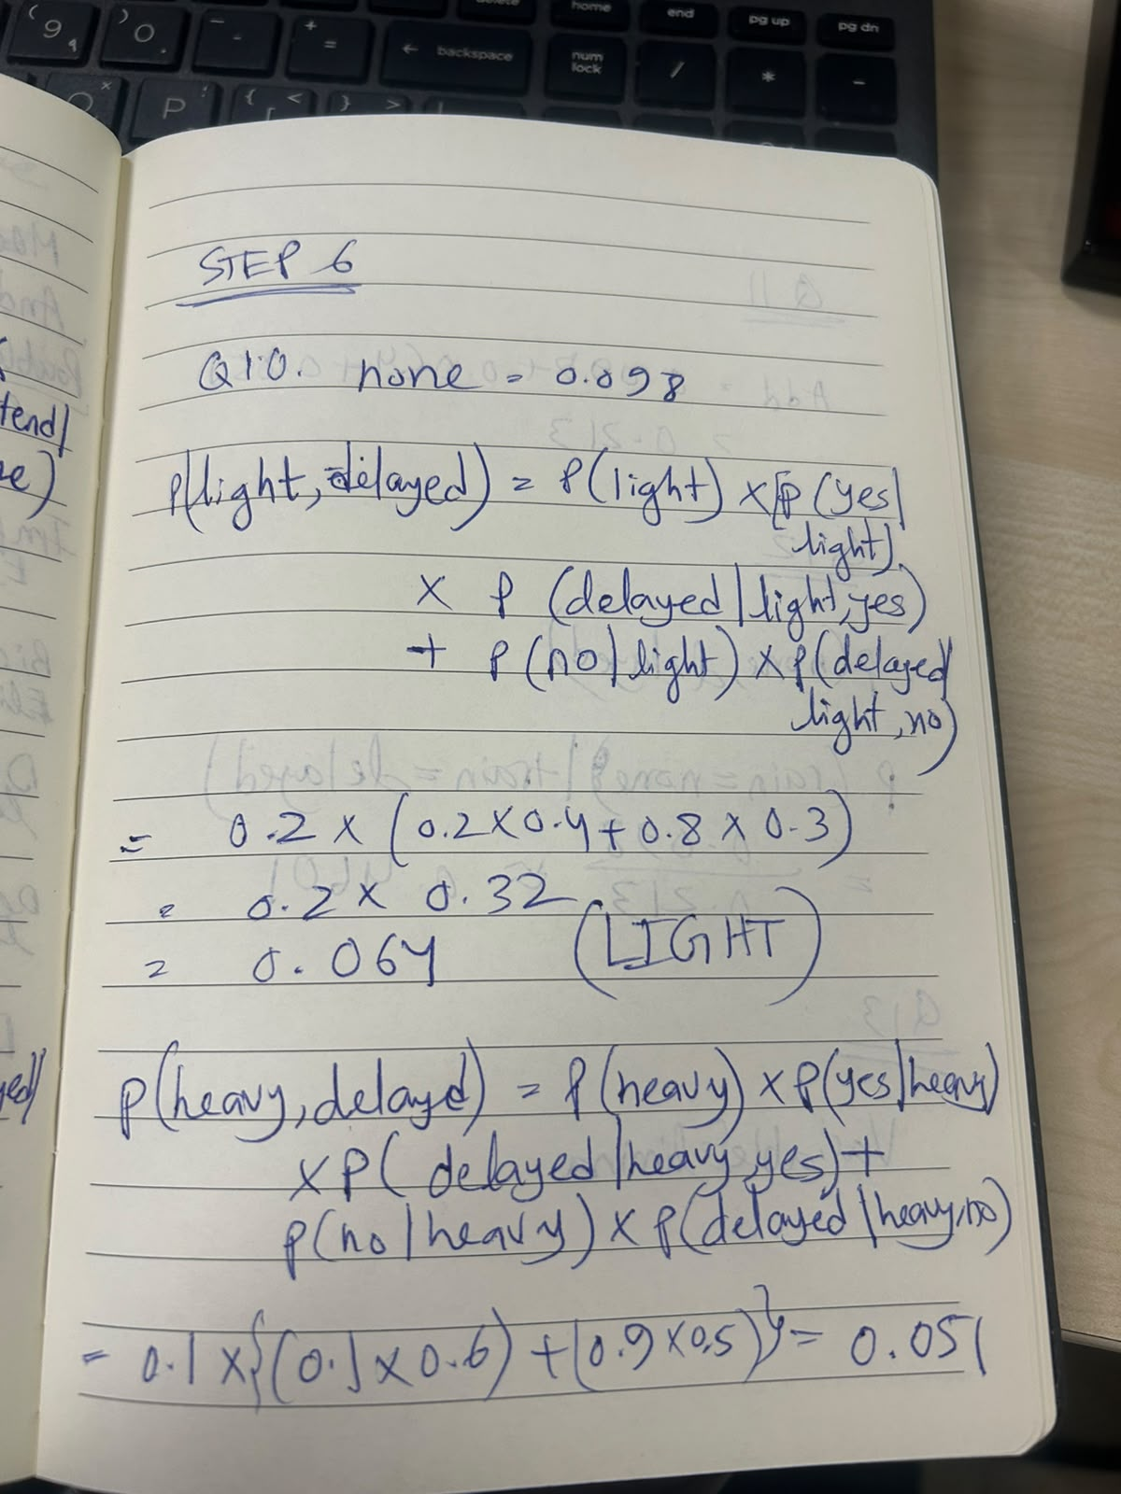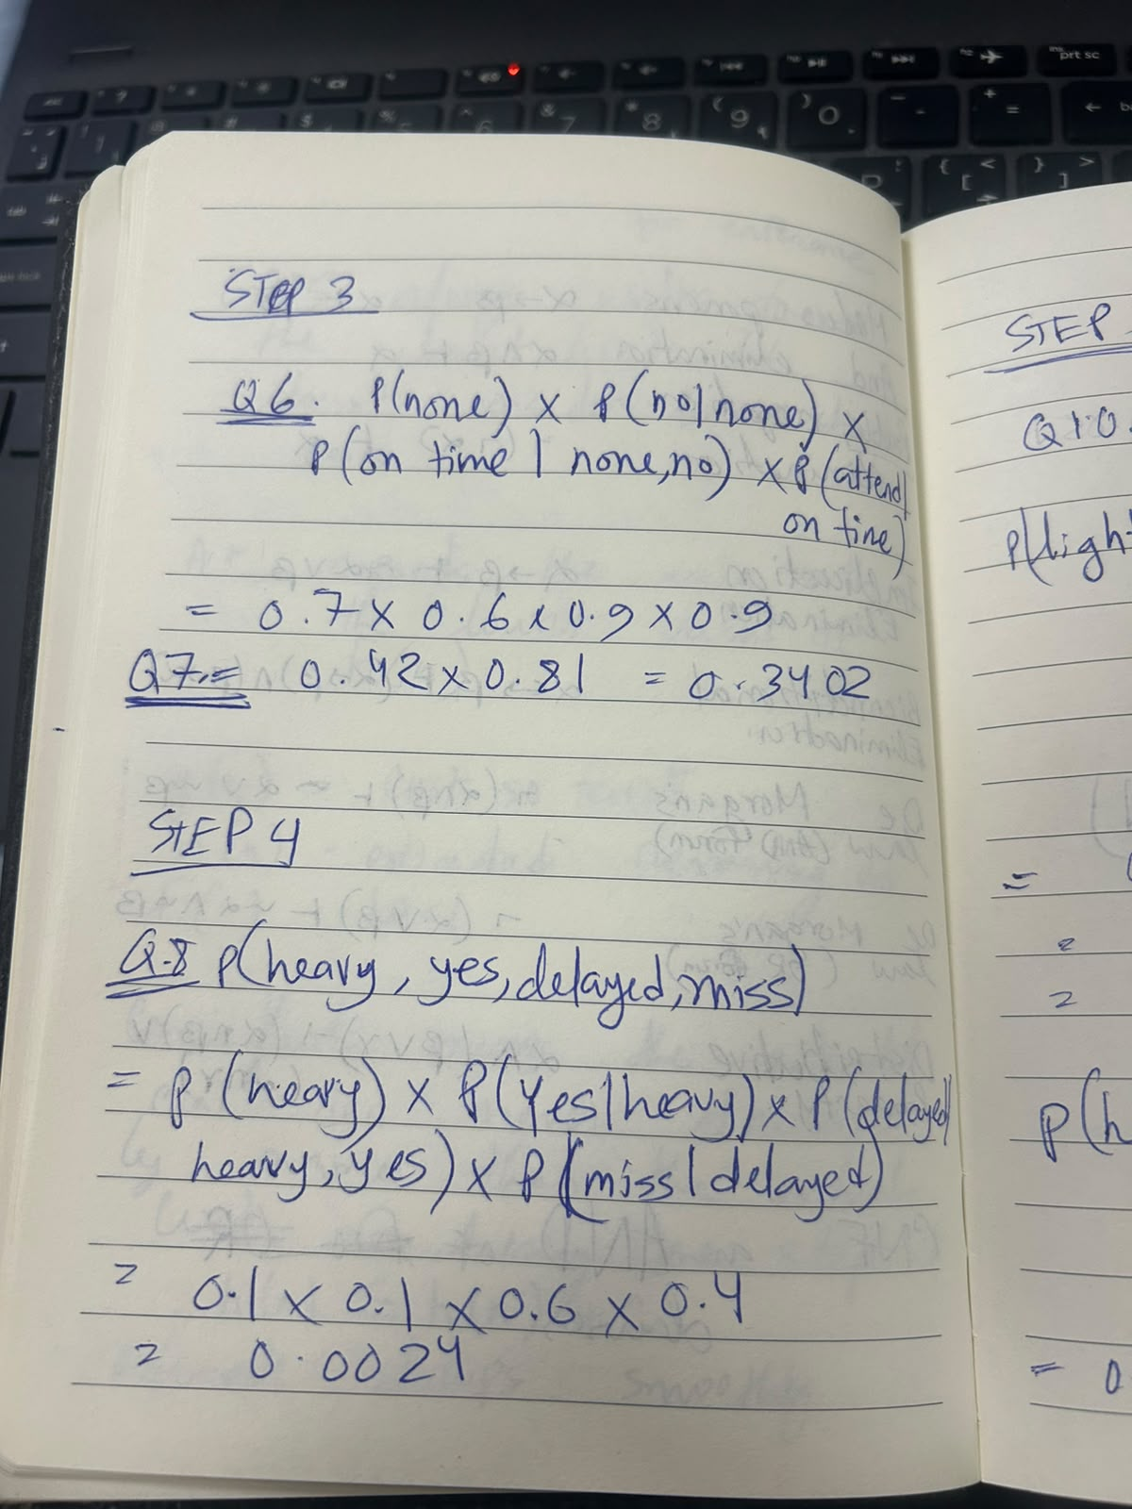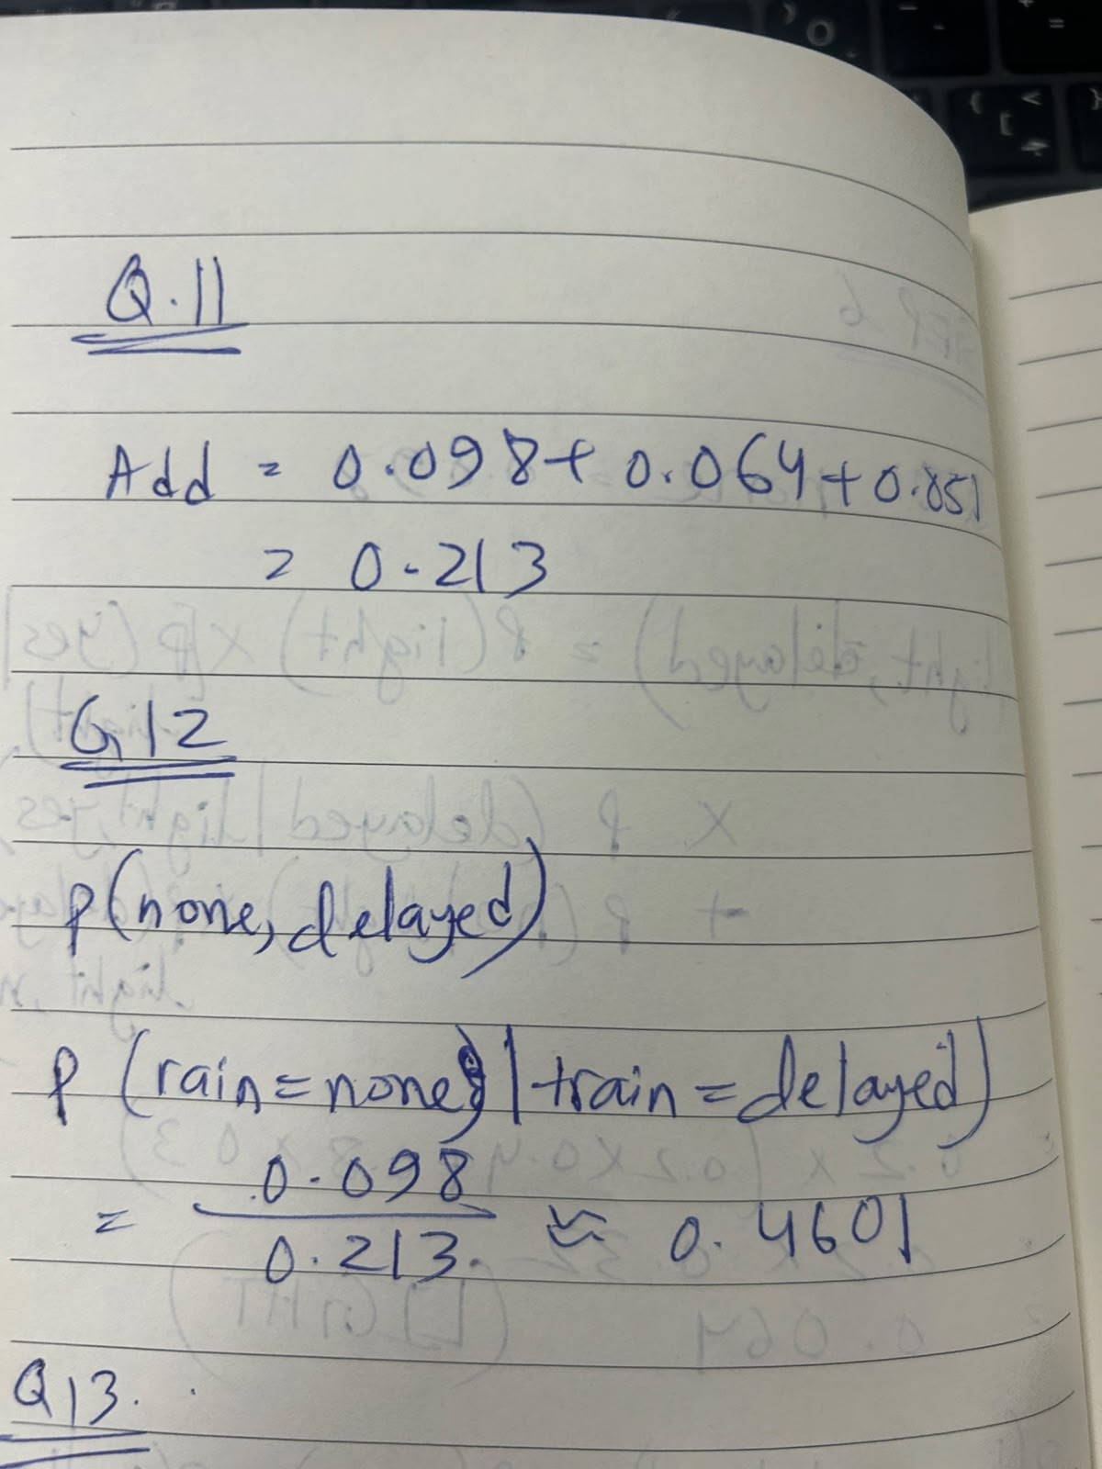

### Question 13
VariableElimination performs exact inference. It calculates the exact same mathematical sums and normalization as hand enumeration, but optimizes the order of operations to run faster.

### Question 14
Appointment depends only on Train (its direct parent). Once Train is observed, knowledge of Rain or Maintenance provides no additional information, so P(miss | delayed) is read directly from the Appointment CPT (0.4).

### Question 16
Missing the appointment increases the likelihood that the train was delayed, and a delayed train increases the likelihood that it rained heavily. Evidence flows upward through the network.

### Question 18
Under heavy rain, the train delay probability is nearly the same whether maintenance occurred or not (0.6 vs 0.5). Because the delay provides weak conditional evidence for maintenance, the probability increases only slightly.

