LOAN DEFAULT RISK ANALYSIS
Final Report — Portfolio Insights & Recommendations

1. Executive Summary
This report analyses 9,578 historical loan records to identify the major factors influencing loan default risk. The dataset includes key borrower characteristics such as FICO score, annual income, debt-to-income (DTI) ratio, revolving credit utilization, recent credit inquiries, delinquency history, and loan purpose. Overall, the loan portfolio has a 16.01% default rate, with borrowers having an average FICO score of 711 and an average interest rate of 12.26%, indicating a portfolio with generally good credit quality.
The analysis reveals that default risk is not evenly distributed across the portfolio but is concentrated within specific borrower segments. Variables such as loan purpose, FICO score, DTI ratio, revolving credit utilization, and recent credit inquiries emerge as the strongest predictors of default. These insights provide a foundation for improving credit underwriting, risk-based pricing, and portfolio monitoring, enabling lenders to identify high-risk borrowers more effectively while supporting better lending decisions and reducing future credit losses.
10,000 | 16.01% | 711 | 12.26%
Total Loans | Overall Default Rate | Avg. FICO Score | Avg. Interest Rate

2. Dashboard Overview
To present the analysis in a clear and interactive format, the data was consolidated into a single dashboard that summarizes the portfolio from both a high-level and detailed perspective. The dashboard combines key performance indicators (KPIs), interactive filters, and multiple visualizations covering loan purpose, FICO score bands, debt-to-income (DTI) bands, revolving credit utilization, recent credit inquiries, and credit policy status. This layout enables users to quickly understand the overall portfolio while exploring the factors that contribute to loan default.
The interactive filters allow users to focus on specific borrower segments and compare their performance across different risk dimensions. By moving from the overall portfolio view to detailed visualizations, lenders can identify high-risk groups, evaluate default patterns, and make more informed decisions regarding underwriting, risk-based pricing, and portfolio monitoring. The dashboard therefore serves as an effective decision-support tool for understanding borrower behaviour and improving credit risk management.

3. Default Rate by Loan Purpose
Loan purpose is one of the most significant factors influencing default risk in this portfolio. Default rates vary considerably across loan categories, ranging from 11.21% for major purchase loans to 27.79% for small business loans, making small business lending the highest-risk segment. Educational loans also record a relatively high default rate of 20.12%, suggesting that borrowers in these categories are more likely to experience repayment difficulties than the average borrower.
On the other hand, major purchase and credit card loans have the lowest default rates, remaining well below the overall portfolio average of 16.01%. Loan categories such as debt consolidation, home improvement, and other purposes fall closer to the portfolio average, representing moderate levels of risk. These findings demonstrate that loan purpose is an effective indicator of borrower risk and should be considered when designing underwriting policies, risk-based pricing strategies, and portfolio monitoring practices to improve lending decisions and reduce future credit losses.
Purpose | Default Rate
Small Business | 27.79%
Educational | 20.12%
Home Improvement | 17.01%
All Other | 16.60%
Debt Consolidation | 15.24%
Credit Card | 11.57%
Major Purchase | 11.21%

GRAPH - 01
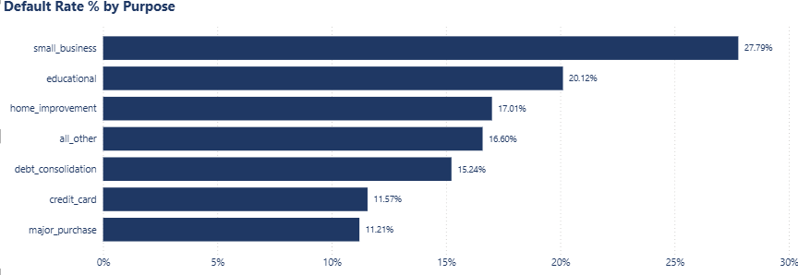

4. Default Rate by FICO, DTI & Revolving Utilization
FICO score is the strongest predictor of loan default in the portfolio. Borrowers in the Low FICO band have a default rate of 23.62%, compared with only 7.43% for the High FICO band, while the Medium FICO group records 15.63%. This highlights the strong relationship between credit score and repayment risk.
A similar pattern is observed for DTI ratio and revolving credit utilization. Borrowers with higher debt burdens and higher credit utilization consistently show higher default rates than those with lower levels. Together, these factors provide a reliable basis for improving underwriting, risk-based pricing, and credit risk management.
Segment | Band | Default Rate
FICO Band | Low | 23.62%
FICO Band | Medium | 15.63%
FICO Band | High | 7.43%
DTI Band | High | 18.33%
DTI Band | Medium | 16.10%
DTI Band | Low | 14.83%
Revolving Utilization | High | 18.97%
Revolving Utilization | Medium | 16.33%
Revolving Utilization | Low | 12.43%

GRAPH – 02 , 03, 04
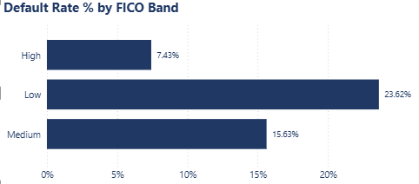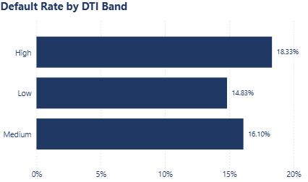
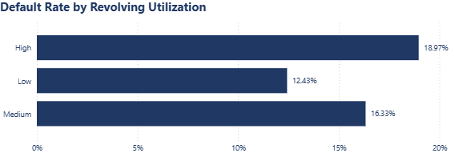

5. Credit Policy Mix
The portfolio consists of 80.5% policy-compliant loans and 19.5% policy exception loans. Policy exception loans represent borrowers who were approved despite not fully meeting the lender's standard credit criteria.
Comparing the performance of these two groups helps evaluate the effectiveness of the credit policy. This analysis supports better underwriting decisions, risk-based pricing, and overall credit risk management.
GRAPH - 05
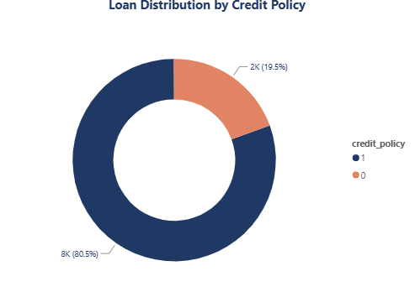

6. Recent Credit Inquiries
The number of recent credit inquiries has a clear impact on loan default risk. Borrowers with fewer inquiries have lower default rates, while default rates increase as inquiry counts rise.
Although borrowers with very high inquiry counts represent a small sample, the overall trend shows that frequent credit inquiries are a useful early indicator of higher credit risk and should be considered during loan approval.
GRAPH - 06
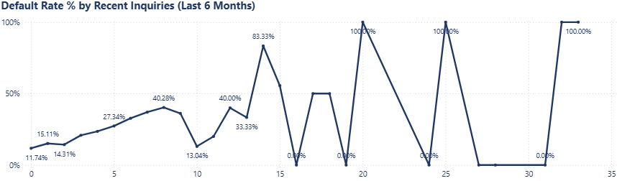

7. Key Insights
The analysis identifies a small number of borrower characteristics that consistently explain loan default risk across the portfolio. These findings provide a clear basis for improving lending decisions and strengthening credit risk management.

- Loan purpose, FICO score, and recent credit inquiries are the strongest predictors of loan default.
- Small business (27.79%) and educational (20.12%) loans have the highest default rates and require stricter underwriting.
- Low-FICO borrowers default at 23.62%, compared with 7.43% for high-FICO borrowers, making credit score the most reliable risk indicator.
- Borrowers with high DTI (18.33%) and high revolving credit utilization (18.97%) also exhibit above-average default risk.
- Borrowers with 10 or more recent credit inquiries show significantly higher default rates and should undergo additional credit assessment.
- The 19.5% policy-exception loan segment should be monitored separately to evaluate the effectiveness of underwriting policies over time.

8. Recommendations
Based on the findings of this analysis, the following recommendations can help reduce loan defaults while maintaining healthy portfolio growth. These actions focus on strengthening underwriting practices, improving risk assessment, and applying more effective pricing strategies.

- Apply risk-based pricing for small business and educational loans, as these categories have the highest observed default rates.
- Use minimum FICO score and maximum DTI thresholds for automatic approvals, while routing borderline applications for manual review.
- Flag borrowers with more than 5–6 recent credit inquiries for additional verification before approving a loan.
- Monitor policy-exception loans separately and review their performance regularly to assess the effectiveness of current underwriting standards.
- Include revolving credit utilization along with FICO score and DTI ratio when evaluating borrower risk.
- Develop a composite credit risk score by combining FICO, DTI, revolving utilization, and recent credit inquiries to improve default prediction and support more accurate lending decisions.

