

MOUNT ZONAH
MEDICAL FITNESS CERTIFICATE

Applicant Information
Name: N/a
Sex: N/a
D.O.B: N/a
CID: N/a
Number: N/a
Weight: N/a
MFC Reason: N/a
Date: N/a

Test Reports:
Report Title | Result
Blood Test:  Red blood Cells (RBC)- 4.35 to 5.65(Man),3.92 to 5.13(Women)  White Blood Cells (WBC)- 4500-11000/mm3  Platelets (PLT): 152 to 361 | ALL GOOD
MRI Test:  1. Extensive tissue loss in the right temporal/occipital region  with ex vacuo prominence of the right lateral ventricle and  Wallerian degeneration of the right cerebral peduncle.  2. Subtle focal defects of periventricular white matter probably  due  to superimposed small vessel ischemic disease.  3. Previous studies are kept from being made available for  review. At such time that a previous study becomes available,  an addendum will be issued. | ALL GOOD
Eye Test:  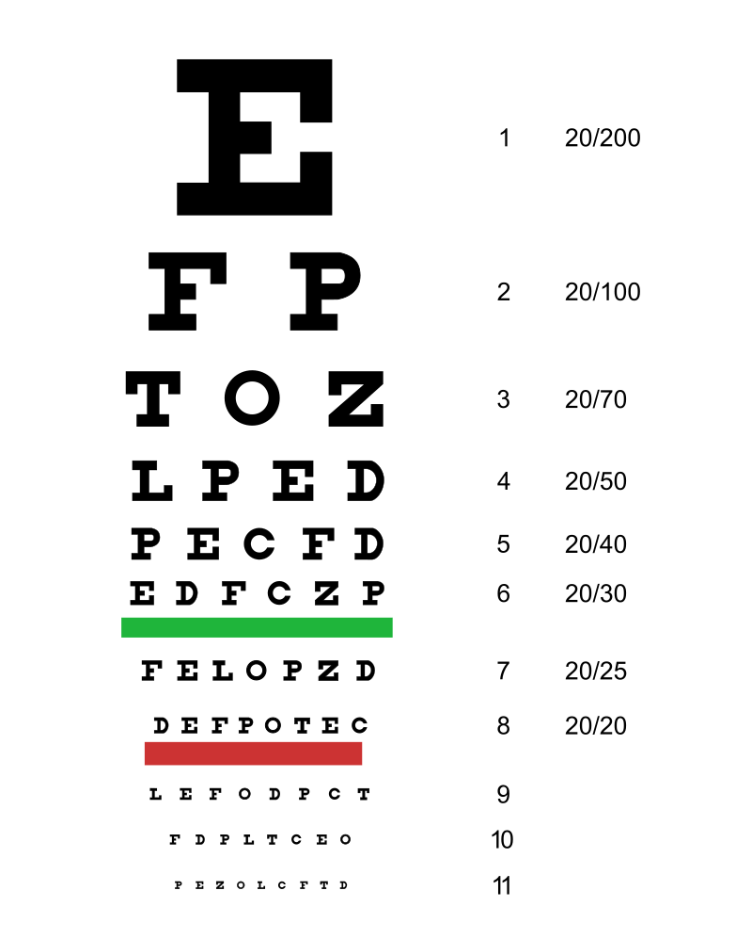  Successfully Read All the Text In This Chart | ALL GOOD
Signature of Medical Officer: N/a


MOUNT ZONAH
MEDICAL FITNESS CERTIFICATE
Applicant Information

Name: N/a
Sex: N/a
D.O.B: N/a
CID: N/a
Number: N/a
Weight: N/a
MFC Reason: N/a
Date: N/a

Description: I have examined and certified that he is free from deafness or any other infirmity, mental or physical, likely to interfere with the efficiency of his work and found to possess good health.
Name of Medical Officer: N/a
Signature of Medical Officer: N/a

