Report on Fat Data
Group 2
2025-01-17
#Fat Data
- Introduction to R and Data Exploration
This report presents an analysis of body fat percentage and body measurements using R, a programming language designed for statistical analysis and visualizations. The dataset includes a variety of variables, which will be examined to provide a clearer understanding of the data.
###Data loading
library(faraway)
data(fat)
The library() function is used to load the faraway package into the R session. Then the data() function is used to load the fat dataset from the faraway package into the session.
###Data types
str(fat)
## 'data.frame': 252 obs. of 18 variables:
## $ brozek : num 12.6 6.9 24.6 10.9 27.8 20.6 19 12.8 5.1 12 ...
## $ siri : num 12.3 6.1 25.3 10.4 28.7 20.9 19.2 12.4 4.1 11.7 ...
## $ density: num 1.07 1.09 1.04 1.08 1.03 ...
## $ age : int 23 22 22 26 24 24 26 25 25 23 ...
## $ weight : num 154 173 154 185 184 ...
## $ height : num 67.8 72.2 66.2 72.2 71.2 ...
## $ adipos : num 23.7 23.4 24.7 24.9 25.6 26.5 26.2 23.6 24.6 25.8 ...
## $ free : num 135 161 116 165 133 ...
## $ neck : num 36.2 38.5 34 37.4 34.4 39 36.4 37.8 38.1 42.1 ...
## $ chest : num 93.1 93.6 95.8 101.8 97.3 ...
## $ abdom : num 85.2 83 87.9 86.4 100 94.4 90.7 88.5 82.5 88.6 ...
## $ hip : num 94.5 98.7 99.2 101.2 101.9 ...
## $ thigh : num 59 58.7 59.6 60.1 63.2 66 58.4 60 62.9 63.1 ...
## $ knee : num 37.3 37.3 38.9 37.3 42.2 42 38.3 39.4 38.3 41.7 ...
## $ ankle : num 21.9 23.4 24 22.8 24 25.6 22.9 23.2 23.8 25 ...
## $ biceps : num 32 30.5 28.8 32.4 32.2 35.7 31.9 30.5 35.9 35.6 ...
## $ forearm: num 27.4 28.9 25.2 29.4 27.7 30.6 27.8 29 31.1 30 ...
## $ wrist : num 17.1 18.2 16.6 18.2 17.7 18.8 17.7 18.8 18.2 19.2 ...
Our dataset contains 252 observations (rows) of 18 variables (columns). Most variables are numeric except the age which is an integer.
###Frequency table of variables age (integer) and density (numeric)
age_tab <- table(fat$age)
age_tab
##
## 22 23 24 25 26 27 28 29 30 31 32 33 34 35 36 37 38 39 40 41 42 43 44 45 46 47
## 2 4 4 4 6 7 7 2 2 4 4 3 4 10 2 3 2 5 17 10 12 13 9 2 6 11
## 48 49 50 51 52 53 54 55 56 57 58 60 61 62 63 64 65 66 67 68 69 70 72 74 81
## 5 9 7 5 4 2 8 10 4 4 3 1 4 5 1 4 3 2 4 1 2 2 5 1 1
The age_tab creates an ascending array of the variable age with the number of times (frequency) each age appears in the dataset.
density_tab <- table(fat$density)
density_tab
##
## 0.995 1.0101 1.014 1.018 1.0202 1.0207 1.0209 1.0217 1.0236 1.025 1.0254
## 1 1 1 1 1 1 1 1 1 2 1
## 1.0256 1.0258 1.0263 1.0264 1.0269 1.0271 1.0279 1.028 1.0283 1.0287 1.0298
## 1 1 1 1 1 1 1 1 1 1 1
## 1.0304 1.0308 1.0313 1.0316 1.0317 1.0322 1.0325 1.0328 1.0333 1.0334 1.034
## 1 1 1 2 1 1 1 1 1 1 2
## 1.0346 1.0355 1.0356 1.0358 1.037 1.0372 1.0373 1.0374 1.0377 1.0378 1.0382
## 1 1 1 1 1 1 2 1 1 1 1
## 1.0384 1.0386 1.0387 1.0396 1.0398 1.0399 1.0403 1.0404 1.0411 1.0412 1.0414
## 2 1 1 1 1 2 2 1 1 1 3
## 1.0416 1.0418 1.0422 1.0424 1.0429 1.043 1.0433 1.0434 1.0435 1.0438 1.0439
## 1 1 1 2 1 1 1 1 1 1 1
## 1.0452 1.0453 1.0459 1.0462 1.0468 1.047 1.0472 1.0473 1.0477 1.048 1.0481
## 1 1 1 2 2 1 1 1 2 1 1
## 1.0483 1.0484 1.0486 1.0488 1.0491 1.0492 1.0498 1.0499 1.05 1.0502 1.0503
## 1 3 1 1 1 1 1 1 1 2 1
## 1.0505 1.0506 1.051 1.0512 1.0513 1.0515 1.052 1.0521 1.0522 1.0524 1.0525
## 1 1 1 1 1 1 2 1 1 3 1
## 1.0529 1.053 1.0538 1.0542 1.0543 1.0547 1.0549 1.055 1.0551 1.056 1.0561
## 1 1 1 1 2 1 2 1 1 1 1
## 1.0563 1.0568 1.0569 1.0571 1.0573 1.0575 1.0578 1.0582 1.0583 1.0584 1.0587
## 1 1 1 1 1 2 1 1 1 1 2
## 1.059 1.0593 1.0594 1.0599 1.0601 1.0603 1.0607 1.061 1.062 1.0622 1.0623
## 1 1 1 1 1 2 1 4 1 1 1
## 1.0624 1.0631 1.0636 1.064 1.0641 1.0644 1.0646 1.0647 1.0648 1.065 1.0652
## 1 1 1 1 1 1 1 1 2 1 1
## 1.0653 1.0664 1.0665 1.0666 1.0668 1.067 1.0671 1.0673 1.0674 1.0678 1.068
## 1 1 1 2 1 1 1 1 1 2 1
## 1.0689 1.069 1.0693 1.0703 1.0704 1.0705 1.0706 1.0708 1.0709 1.0713 1.0716
## 1 1 1 1 2 1 1 1 1 1 1
## 1.0719 1.072 1.0722 1.0725 1.0726 1.0728 1.073 1.0736 1.074 1.0742 1.0745
## 1 1 1 1 1 1 1 1 1 2 1
## 1.0751 1.0754 1.0756 1.0758 1.0761 1.0763 1.077 1.0771 1.0775 1.0776 1.0785
## 1 1 1 1 1 1 1 1 2 1 1
## 1.0788 1.079 1.0794 1.0795 1.0796 1.08 1.0807 1.0811 1.0812 1.0814 1.0819
## 1 2 1 1 1 1 1 1 1 1 1
## 1.0829 1.083 1.084 1.0841 1.0847 1.0848 1.0853 1.0854 1.0862 1.0873 1.0874
## 1 1 1 1 1 1 1 1 1 1 1
## 1.09 1.0903 1.0906 1.091 1.0911 1.0926 1.0983 1.0991 1.1089
## 1 1 1 1 1 1 1 1 1
The density_tab creates an array of the density of people in our dataset.We notice that most of the values are unique values and the highest frequency is 4.
###Visualizations
##Barplot of integer variable age
barplot(age_tab, col = "grey")
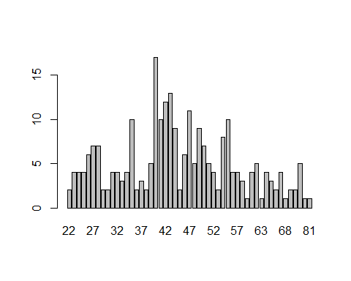
The barplot shows that the age with the highest frequency is 40 years old which appears 17 times in our dataset.
##Histogram of numeric variable density
hist(fat$density, main = "Histogram of body density",
xlab = "density")
abline(v = mean(fat$density), col = "red")
abline(v = median(fat$density), col = "blue")
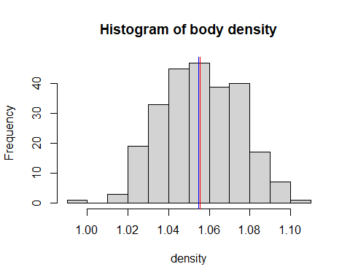
The histogram of body density shows that the highest frequency is between the densities 1.05 and 1.06 .The red line and the blue line show respectively the mean and the median of the body density.
###Custom function
custom_median <- function(x){
if (length(x) %% 2 == 0){
result = (sort(x)[length(x)/2] + sort(x)[(length(x)/2)+1])/2
}else{
result = sort(x)[(length(x)+1)/2]
}
return(result)
}
custom_median(fat$weight)
## [1] 176.5
custom_mean <- function(x) {
sum_x <- sum(x)
n <- length(x)
result = sum_x / n
return(result)
}
custom_mean(fat$weight)
## [1] 178.9244
The median of the weight of people in the fat dataset is 176.5 and the mean is 178.9244
###Relevance of statistical reasoning and how it can be applied in analyzing our dataset
Statistical reasoning helps in summarizing and interpreting data in order to gain valuable insights.
In analyzing our datasets on body fat measurements statistical reasoning helps in understanding the relationship between variables like weight and height which can be useful in predictions. It helps us summarize the dataset by computing the median and the mean of the weight of people.
- Data Presentation and Sampling
Our dataset includes measurements of people’s height,weight,…and age of people. We presume that they have been collected through a survey.
###Sampling
sampled_fat <- fat[sample(nrow(fat), size = 30), ]
print(sampled_fat)
## brozek siri density age weight height adipos free neck chest abdom hip
## 133 23.1 23.6 1.0452 47 197.00 73.25 25.8 151.2 37.8 103.6 99.8 103.2
## 161 9.9 9.4 1.0775 31 151.25 72.25 20.4 136.2 35.0 94.0 81.2 91.5
## 43 30.4 31.6 1.0279 48 217.00 70.00 31.2 151.1 37.3 113.3 111.2 114.1
## 47 11.2 10.8 1.0742 40 133.50 67.50 20.6 118.5 33.6 88.2 73.7 88.5
## 7 19.0 19.2 1.0549 26 181.00 69.75 26.2 146.6 36.4 105.1 90.7 100.3
## 51 10.7 10.2 1.0756 47 158.25 72.25 21.3 141.4 34.9 90.2 86.7 98.3
## 116 16.7 16.7 1.0607 40 158.00 69.25 23.4 131.7 36.3 97.0 86.6 92.6
## 241 17.0 17.0 1.0599 65 127.50 65.75 20.8 105.9 34.7 93.0 79.7 87.6
## 220 15.1 15.0 1.0646 53 154.50 69.25 22.7 131.2 37.6 93.9 88.7 94.5
## 183 11.9 11.5 1.0725 40 145.75 67.25 22.7 128.4 35.5 95.5 83.6 91.6
## 179 22.0 22.5 1.0477 38 187.25 69.25 27.5 146.1 38.0 102.7 92.7 101.9
## 243 29.3 30.4 1.0304 66 234.25 72.00 31.8 165.6 41.4 119.7 109.0 109.1
## 146 14.4 14.2 1.0664 24 156.00 70.75 21.9 133.6 35.7 92.7 81.9 95.3
## 66 28.9 30.0 1.0313 55 183.50 67.50 28.3 130.4 40.9 103.0 100.3 104.2
## 24 17.6 17.7 1.0584 32 148.75 70.00 21.4 122.6 35.5 86.7 80.0 93.4
## 180 16.8 16.9 1.0603 39 234.75 74.50 29.8 195.3 42.8 109.5 104.5 109.9
## 236 18.4 18.6 1.0563 62 168.75 67.50 26.1 137.6 38.3 104.7 95.6 93.7
## 73 9.1 8.5 1.0796 56 160.75 73.75 20.8 146.1 36.4 93.6 82.9 96.3
## 209 10.1 9.6 1.0771 47 160.50 70.25 22.9 144.3 36.0 99.8 83.9 91.8
## 71 23.7 24.3 1.0439 62 167.50 71.50 23.1 127.8 35.5 97.6 91.5 98.5
## 217 13.8 13.6 1.0678 51 149.25 69.75 21.6 128.7 34.8 92.8 81.1 96.3
## 204 6.8 6.0 1.0854 44 184.00 74.00 23.7 171.4 37.9 100.8 89.1 102.6
## 110 21.0 21.4 1.0500 40 168.50 69.25 24.7 133.1 34.2 97.8 92.3 100.6
## 215 19.3 19.5 1.0543 50 172.75 73.00 22.8 139.4 37.4 98.7 87.6 96.1
## 79 21.1 21.5 1.0498 81 161.25 70.25 23.0 127.2 37.8 96.4 95.4 99.3
## 138 28.4 29.4 1.0325 43 187.75 74.00 24.1 134.4 37.7 97.8 98.6 100.6
## 90 14.3 14.1 1.0666 48 176.00 73.00 23.3 150.9 36.7 96.7 86.5 98.3
## 137 21.4 21.8 1.0491 39 166.75 70.75 23.5 131.0 37.0 92.9 86.1 95.6
## 92 18.1 18.2 1.0573 44 179.75 69.50 26.2 147.3 39.2 101.9 93.2 100.6
## 145 10.8 10.3 1.0754 23 188.15 77.50 22.1 168.4 38.0 96.6 85.3 102.5
## thigh knee ankle biceps forearm wrist
## 133 61.2 38.1 22.6 33.5 28.6 17.9
## 161 52.5 36.6 21.0 27.0 26.3 16.5
## 43 67.7 40.9 25.0 36.7 29.8 18.4
## 47 53.3 34.5 22.5 27.9 26.2 17.3
## 7 58.4 38.3 22.9 31.9 27.8 17.7
## 51 52.6 37.2 22.4 26.0 25.8 17.3
## 116 55.9 36.3 22.1 29.8 26.3 17.3
## 241 50.7 33.4 20.1 28.5 24.8 16.5
## 220 53.7 36.2 22.0 28.5 25.7 17.1
## 183 54.1 36.2 21.8 31.4 28.3 17.2
## 179 64.7 39.5 24.7 34.8 30.3 18.1
## 243 63.7 42.4 24.6 35.6 30.7 19.5
## 146 56.4 36.5 22.0 33.5 28.3 17.3
## 66 64.8 40.2 22.7 34.8 30.1 18.7
## 24 54.9 36.2 22.1 29.8 26.7 17.1
## 180 69.5 43.1 25.8 39.1 32.5 19.9
## 236 54.4 37.1 22.7 30.3 26.3 18.3
## 73 52.9 37.5 23.1 29.7 27.3 18.2
## 209 53.0 36.2 22.5 31.4 27.5 17.7
## 71 56.6 38.6 22.4 31.5 27.3 18.6
## 217 53.8 36.5 21.5 31.3 26.3 17.8
## 204 60.6 39.0 24.0 32.9 29.2 18.4
## 110 57.5 36.8 22.8 32.1 26.0 17.3
## 215 57.1 38.1 21.8 28.6 26.7 18.0
## 79 53.5 37.5 21.5 31.4 26.8 18.3
## 138 63.6 39.2 23.8 34.3 28.4 17.7
## 90 60.4 39.9 24.4 28.8 29.6 18.7
## 137 58.8 36.1 22.4 32.7 28.3 17.1
## 92 58.9 39.7 23.1 31.4 28.4 18.8
## 145 59.1 37.6 23.2 31.8 29.7 18.3
A simple random sampling is done by first determining the number of rows in the fat data. Then, 30 rows are randomly selected using the sample() function, and the sample is displayed.
###Custom function
custom_median <- function(x){
if (length(x) %% 2 == 0){
result = (sort(x)[length(x)/2] + sort(x)[(length(x)/2)+1])/2
}else{
result = sort(x)[(length(x)+1)/2]
}
return(result)
}
custom_median(sampled_fat$weight)
## [1] 168
custom_mean <- function(x) {
sum_x <- sum(x)
n <- length(x)
result = sum_x / n
return(result)
}
custom_mean(sampled_fat$weight)
## [1] 171.9967
The median of the sampled_fat and the mean are approximative to the population’s weight median and mean.
###Visualizations ## pie chart for numeric variable height
height_tab <- table (sampled_fat$height)
height_tab
##
## 65.75 67.25 67.5 69.25 69.5 69.75 70 70.25 70.75 71.5 72 72.25 73
## 1 1 3 4 1 2 2 2 2 1 1 2 2
## 73.25 73.75 74 74.5 77.5
## 1 1 2 1 1
pie(height_tab)
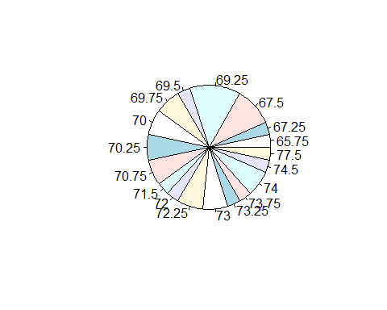
##histogram for integer variable age
age_tab <- table (sampled_fat$age)
age_tab
##
## 23 24 26 31 32 38 39 40 43 44 47 48 50 51 53 55 56 62 65 66 81
## 1 1 1 1 1 1 2 4 1 2 3 2 1 1 1 1 1 2 1 1 1
hist(sampled_fat$age, main = "Histogram of age of sampled_fat",
xlab = "Age")
abline(v = mean(sampled_fat$age), col = "red")
abline(v = median(sampled_fat$age), col = "blue")
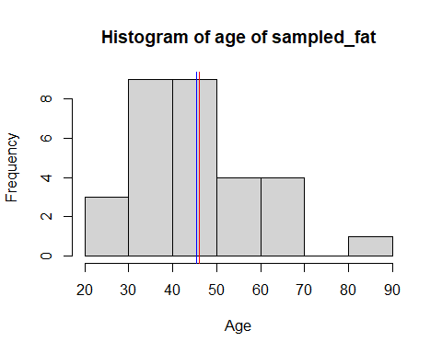 We notice that the age with highest frequency which was 40 years old is now around 45 years old.
###Boxplot for numeric variable weight
weight_tab <- table (sampled_fat$weight)
weight_tab
##
## 127.5 133.5 145.75 148.75 149.25 151.25 154.5 156 158 158.25 160.5
## 1 1 1 1 1 1 1 1 1 1 1
## 160.75 161.25 166.75 167.5 168.5 168.75 172.75 176 179.75 181 183.5
## 1 1 1 1 1 1 1 1 1 1 1
## 184 187.25 187.75 188.15 197 217 234.25 234.75
## 1 1 1 1 1 1 1 1
boxplot(sampled_fat$weight)
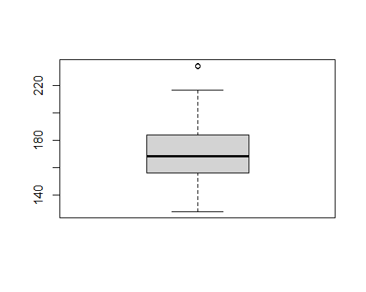 ###Scatter plot to analyze relationship
plot(x = sampled_fat$height, y = sampled_fat$weight, col = "green", pch = 16,
xlab = "Height", ylab = "Weight",
main = "Relationship between Height and Weight")
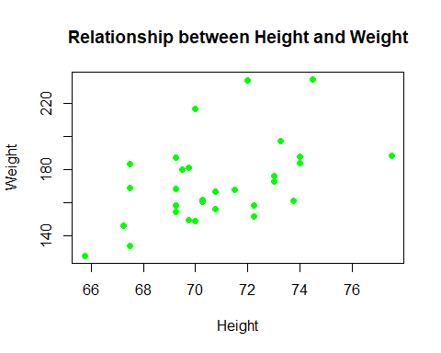
This scatter plot shows a positive relationship between height and weight. As weight increases, height also tends to increase. This observation shows that taller individuals generally have a higher weight.

