**American International University Bangladesh**

**

**Project Title: Point of Sales – Bus Ticket**

**Submitted to:**

**Mr. Shazzat Hossain**

**Lecturer,**

**Department of Computer Science,**

**American International University Bangladesh**

**Submitted by:**

**Name: Nazmi, Nafisul Islam**

**ID: 15-29550-2**

**Course: Object Oriented Programming I (JAVA)**

**Section: J**

**Semester: Summer 2015-2016**

**Date of Submission: 5 September, 2016**

**Introduction:**

This project is aimed to build a software for bus station’s ticket selling. In most of the stations, we see salesman are using mobile phone/walkie talkie to communicate with other nearby stations of the company to inform about selling a ticket. But we are aiming to build an automatic solution for making the job easier. In our system, we are using a central database. All the information regarding ticket selling will be written in the database. As a result, we won’t have to avoid clash tickets manually. Rather whenever a ticket is being sold, other salesman would automatically see which seats are already taken.   
Our system is suitable for companies which allow prior booking up to 6 days, which is enough for most of the companies.

**Targeted Users:**

Salesman at Bus Stations

**Features:**

* Central Database, so no change of clash tickets while selling tickets.
* User would be able to delete booking information when needed.
* User would be able to add new districts of service.
* User would be able to add new bus schedule.
* Tickets can be printed after booking is done.

**Design:**

The first element needed in our system is the database.

**E-R Diagram:**

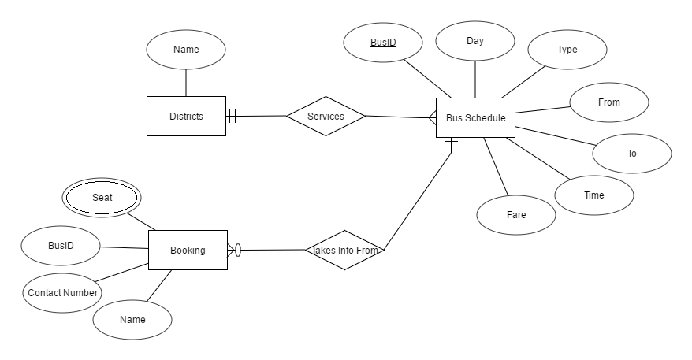

Take a note that, in the diagram booking is shown as just one table. But in the actual design we have included seven different tables for seven days of the week.

**Schema of the Tables:**

District (Name)

Bus Schedule (BusID, Day, Type, From, To, Time, Fare)

SundayBooking(BusID, Seat, Contact_no, Name)

MondayBooking(BusID, Seat, Contact_no, Name)

TuesdayBooking(BusID, Seat, Contact_no, Name)

WednesdayBooking(BusID, Seat, Contact_no, Name)

ThursdaydayBooking(BusID, Seat, Contact_no, Name)

FridayBooking(BusID, Seat, Contact_no, Name)

SaturdayBooking(BusID, Seat, Contact_no, Name)

SQL Commands needed to create the tables are included in a separate text file.

Next, let us take a look at the use cases.

**Use Case Diagram:**

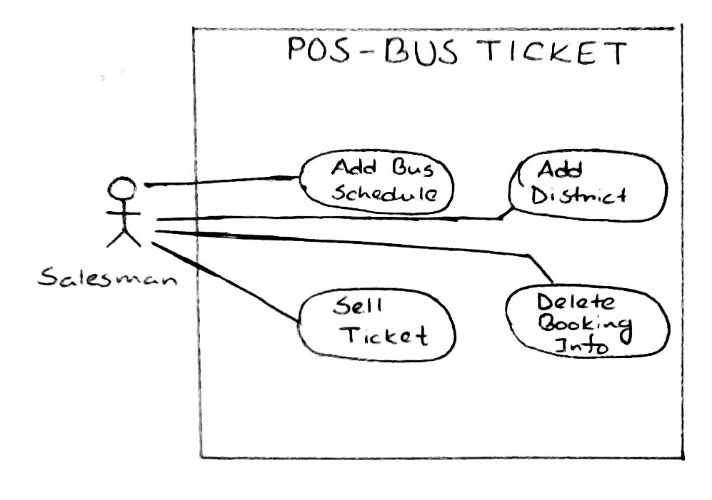

The Use Case Diagram represents the things the user would be able to do with our system.

The Class Diagram is shown in the next Page.

**Class Diagram:**

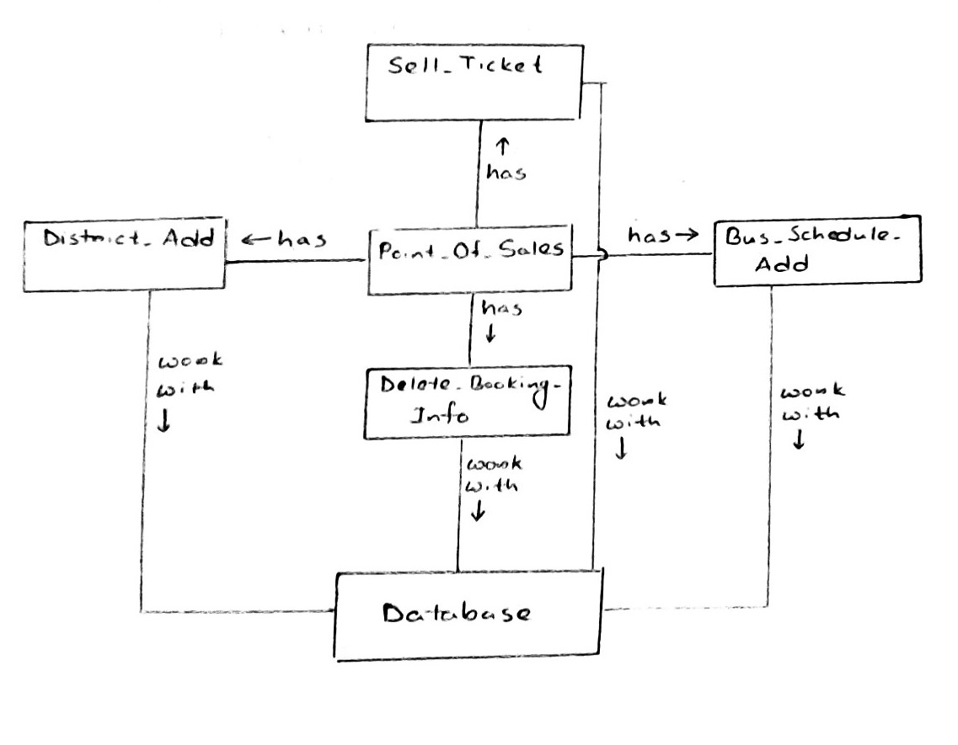

Basically the main design is shown in the diagram. While implementing, we used inner classes also, which are not shown here. The source code of the total system is included in a separate zip folder.

**Conclusion:**

Our system would be useful for most of the bus companies who still sell tickets and keep records manually. Using our system, the rate of clashes would be nearly zero. And their job would become much easier.