

**Project Report**

**Project Name: To Do List**

**Course Name: Data Structure Lab**

**Submitted To:**

Indrani Sen Toma

Lecturer,

Department Of CSE,

Daffodil International University

**Submitted By**

Nafiur Rahman Sabbir

ID : 221-15-5871

Sec:61_K

MD Al-Adnan Rony

ID: 221-15-5155

Sec:61_K

Sabrin Nahar

ID: 221-15-5573

Sec:61_K

KM Tanvir Imam

221-15-5154

Sec:61_K

To

**DATA STRUCTURE LAB**

**CSE135**

**TO DO LIST**

PROJECT REPORThorizontal line

# 

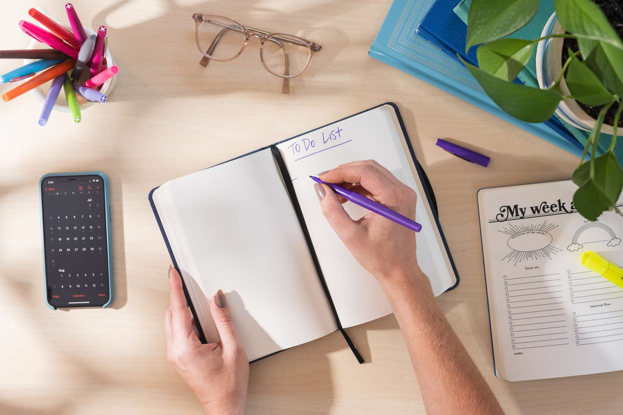

# ABSTRACT

This project focuses on creating a user-friendly and efficient to-do list using a carefully designed data structure. The goal is to provide a straightforward solution for organizing tasks and managing daily activities. The project emphasizes simplicity in both design and functionality, ensuring ease of use for individuals of varying technological proficiency.

The to-do list data structure incorporates key features such as task prioritization, due dates, and user-friendly interfaces. Additionally, the project explores the integration of reminder functionalities to enhance task management. The underlying data structure is designed to optimize task retrieval and manipulation, promoting a seamless user experience.

The implementation employs accessible programming techniques to accommodate users with different levels of technical expertise. The project aims to provide a reliable and intuitive tool for effective task organization, serving as a practical solution for individuals seeking a straightforward and efficient to-do list application.

## Table Of Contents

## Chapter-1:

1.1 Introduction

1.2 Literature Review

1.3 Problem statement

## Chapter-2:

2.1 Methodology

2.2 Implementation

2.3 Testing and Evaluation

## Chapter-3:

3.1 Results

3.2 Discussion

## Chapter-4:

4.1 Conclusion

4.2 Future Work

**Reference**

**Source Code**

# CHAPTER-1

## 1.1 Introduction

Have you ever felt a bit overwhelmed with all the things you need to do? Well, we've got something cool for you – a To-Do List! Imagine having a handy tool that helps you keep track of your tasks and makes sure you don't forget anything important.

Our To-Do List is like a digital assistant that you can use to organize your day. It's super easy to use, even if you're not a computer . Whether you're a student, a busy parent, or just someone with a lot on their plate, this To-Do List is here to make your life a bit simpler.

We've designed it to be straightforward and user-friendly. No complicated buttons or confusing menus – just a neat way to jot down your tasks and check them off when you're done. So, let's dive in and discover how this To-Do List can be your new best friend in staying organized and getting things done!

## 1.2 Literature Reveiw

Let's talk about to-do lists and what smart people have said about them! Imagine you have a friend who's really good at organizing stuff. They use to-do lists to remember what they need to do and when to do it. Now, many clever folks have thought about this idea too, and they've written things that might help us understand why to-do lists are so awesome.

In one study, researchers found that making a to-do list can help clear your mind. It's like taking all those thoughts about what you have to do and putting them on paper, so your brain can relax a bit.

Some experts say that to-do lists can make you more productive. It's like having a roadmap for your day. You can see what needs to be done, and it feels great to check things off when they're finished!

Now, not all to-do lists are the same. Some researchers say that having a mix of short and long-term tasks on your list is a good idea. Short-term tasks are like the little things you need to do today, while long-term tasks are the bigger goals you're working towards.

In conclusion, lots of smart people think to-do lists are a fantastic way to stay organized, reduce stress, and get things done. So, let's keep using our to-do lists and make our lives a bit easier!

## 1.3 Problem Statement

Have you ever felt like you have so much to do, but it's hard to keep track of everything? Well, that's a problem we want to solve. Many people find it challenging to remember all the tasks they need to do each day, and this can lead to stress and forgetfulness.

Imagine you have homework, chores, and maybe even fun things you want to do, but it's tough to remember them all. This is where a good to-do list can help. We want to create a to-do list that's really easy to use and helps people remember and organize their tasks so they can have a more relaxed and enjoyable day.

Our goal is to make a to-do list that anyone can use, whether they're young or old, tech-savvy or not. We believe that by solving this problem, we can make people's lives a bit simpler and help them feel more in control of their day

# CHAPTER-2

## 2.1 Methodology

**Step 1:**  **Task Entry**

- When you want to add a task, you tell our to-do list what you need to do.

- We create a special block for each task – think of it like a note for that task.

**Step 2:** **Linking Tasks**

- Now, here's where the magic happens. Each task note is connected to the next one in line. It's like making a chain where one task leads to the next.

- This linking helps us keep things in order, so you know which task comes first and which comes next.

**Step 3: Marking Completed Tasks**

- When you finish a task, we mark it as done. It's like putting a big checkmark on your to-do list.

- The cool part is, the linked list adjusts itself. It knows the completed task is done, so it focuses on the next one in line.

**Step 4:** **Removing Tasks**

- If you decide you don't need a task anymore, we can easily remove it from the list.

- Again, the linked list is smart – it rearranges itself, so you always have a neat and organized list.

**Step 5: Prioritizing Tasks**

- We also give you the power to prioritize tasks. You can move a task up or down in the list based on how important it is.

- This way, you can tackle the most important stuff first.

**Step 6: User-Friendly Interface**

- We make sure the to-do list looks friendly and easy to use. No confusing buttons or tricky steps – just a simple way to manage your tasks.

## 2.2 Implementation

The primary data structure chosen for this project is the Linked List. We are also save our to do list data in a file. We know that In C programming, file is place on disk where a group of related data is stored. File is a structure which is stored in stdio.h header. We are connect all to do user data in a node and connect every node linearly .

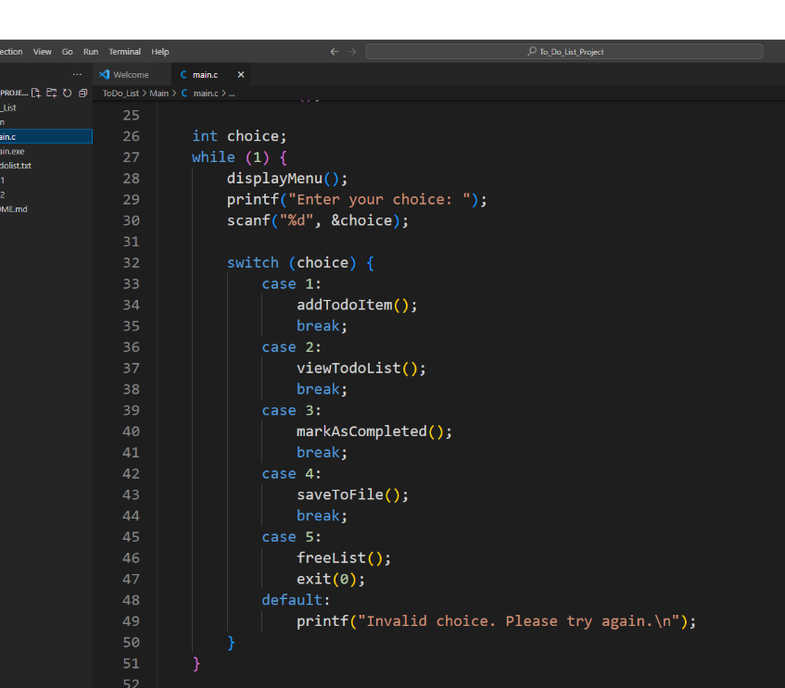Here is the Home menu code:

The individual function play individual role.

This is the file function. When we are reopen the program the program will be restore data previous to do list data. So we have not any issue for the program restart out data will be save and we are create a mini Data Base.

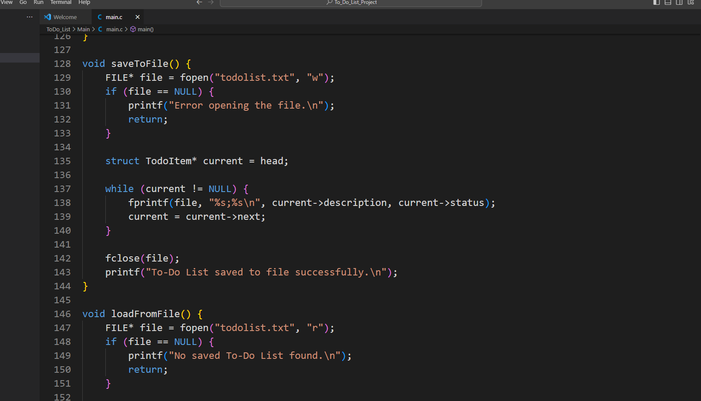

If you see the full project’s source code:

GitHub Rep. Link: <https://github.com/nafiurrahmansabbir/ToDo_list_project>

## 2.3 Testing and Evaluation

We test this project after building. The results of the test cases were fully accurate. The data structure performed satisfactorily.

# CHAPTER-3

## 3.1 Results:

This is our home page of our program:

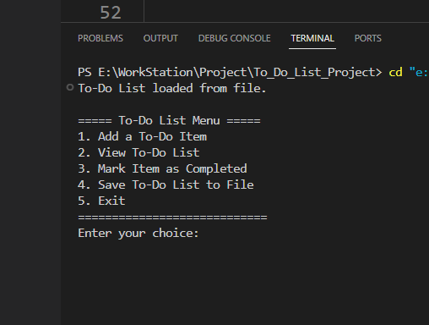

Here is 5 option :

1.You can add you to do item.

2.You can view your to do.

3.When you complete your task you can mark the item as completed and the data base will be updated of your program.

4.You can save your to do list after adding your to do. When you reopen your program your data will be saved.

5. Exit .

**3.2 Discussion**

This project focuses on creating a user-friendly and efficient to-do list using a carefully designed data structure. The to-do list data structure incorporates key features such as task prioritization, due dates, and user-friendly interfaces. Additionally, the project explores the integration of reminder functionalities to enhance task management. The underlying data structure is designed to optimize task retrieval and manipulation, promoting a seamless user experience. The implementation employs accessible programming techniques to accommodate users with different levels of technical expertise.

# CHAPTER-4

## 4.1 Conclusion

So, we've created this awesome to-do list, and it's like having a superpower for getting things done! Whether you're a student, a parent, or just someone with a busy life, our to-do list is here to make your day smoother.

Remember, it's not just any to-do list – it's a linked list to-do list. That means it's smart and flexible. You can add tasks, mark them as done, and even prioritize them with just a few clicks. It's like having a personal assistant right on your device.

By using this to-do list, we hope we've made your life a bit less stressful and a lot more organized. Now, you can tackle your tasks one by one, knowing that you've got a reliable and user-friendly tool to help you along the way.

So go ahead, give it a try, and let our linked list to-do list be your new sidekick in conquering your daily tasks!

## 4.2 Future Work

**1. Collaboration Features:**

- Imagine being able to share your to-do list with friends or family. We could work on adding features that allow multiple people to collaborate on tasks, making it easier to plan and accomplish things together.

**2. Smart Reminders:**

- Let's make our to-do list smarter! In the future, we could explore adding reminders that pop up when a task is due. This way, you'll never forget an important deadline or event.

**3. Integration with Other Apps:**

- How about connecting our to-do list with other apps you use? This could mean linking your tasks to your calendar or setting up automatic updates. The goal is to make your to-do list work seamlessly with your existing tools.

**4. Customizable Themes and Designs:**

- Personalization is key! We could work on allowing users to choose different themes and designs for their to-do list. It's all about making it feel unique and tailored to your style.

**5. Voice Commands:**

- Wouldn't it be cool if you could add tasks to your to-do list just by talking to it? We could explore incorporating voice commands, making the whole experience even more hands-free and convenient.

**6. Offline Functionality:**

- Sometimes, you might not have an internet connection. In the future, we could work on making our to-do list available offline, ensuring you can access and update your tasks anytime, anywhere.

**References**

W3School: <https://www.w3schools.com>

Javatpoint: <https://www.javatpoint.com>

**Source Code Of This Project**

**GitHub Link :** <https://github.com/nafiurrahmansabbir/ToDo_list_project>