Vehicle Tracking System

Microcontroller Based System Design Lab – CSE 3216

**Submitted to:**

**Sk. Murad hassan ANIK, lecturer (aust)**

**Mr. Sujan Sarker, lecturer (aust)**

**Submitted By:**

**Nafiur Rashid | 15.01.04.059**

**MD. Arman Morshed | 15.01.04.061**

**Overview:**

In this project we are going to **track a vehicle using GPS and GSM**. This **Vehicle Tracking System** can also be used for Soldier Tracking System and many more. Tracking of vehicle is a process in which we track the vehicle location in form of **Latitude and Longitude** (GPS coordinates). GPS Coordinates are the value of a location. This kind of **Vehicle Tracking System Project** is widely in tracking Cabs/Taxis, stolen vehicles, school/colleges buses etc.

**Components Required:**

* GSM Module
* GPS Module
* Arduino
* 16x2 LCD
* Power Supply
* Connecting Wires
* 10 K POT

**Features:**

* SMS based communication
* Find latitude and longitude via GPS module
* Sent message is received by GSM module
* GPS module and GSM module status will be shown in LCD Display

We tried our best to implement those features but unable to implement SMS based communication feature.

**Working principle:**

In this project, Arduino is used for controlling whole the process with a **GPS Receiver and GSM module**. GPS Receiver is used for detecting coordinates of the vehicle, GSM module is used for sending the coordinates to user by SMS. And an optional 16x2 LCD is also used for displaying status messages or coordinates. We have used GPS Module Ublox neo 6m and GSM Module SIM900C.

When we ready with our hardware after programming, we power it up. Then we just need to send a SMS, “Track Vehicle”, to the system that is placed in our vehicle. We can also use some prefix (#) or suffix (*) like #Track Vehicle*, to properly identify the starting and ending of the string.

Sent message is received by GSM module which is connected to the system and sends message data to Arduino. Arduino reads it and extract main message from the whole message. And then compare it with predefined message in Arduino. If any match occurs then Arduino reads coordinates by extracting $GPGGA String from GPS module data and send it to user by using GSM module. This message contains the coordinates of vehicle location.

**Circuit Diagram:**

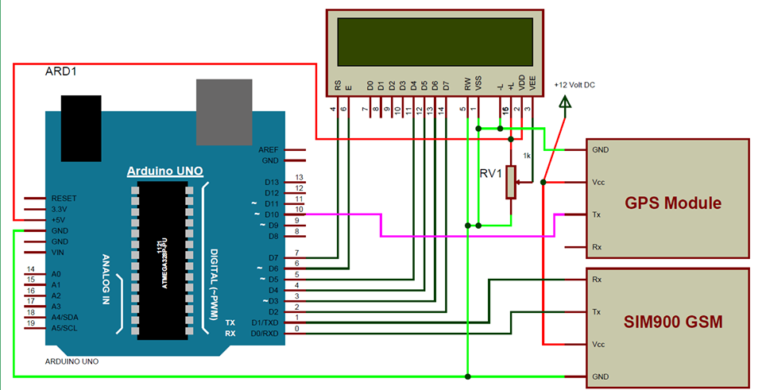

**Screenshot:**

**Conclusion:**

We tried our best to make this project a success. We’ve tried to implement all the features we proposed.

In future, we will try that Real time location would be stored in server. It can be merged with google maps. We will try our best to let our customer see the location of this vehicle through android app.