VMs provide a full virtualized environment with a separate operating system running on top of a hypervisor. This means that each VM has its own dedicated hardware resources, including CPU, memory, storage, and network interfaces. Each VM can run its own applications, and multiple VMs can be hosted on a single physical machine. However, the downside of VMs is that they can be resource-intensive and slow to start up.
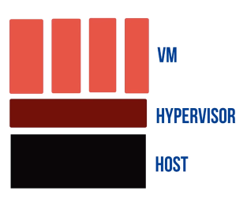

Containers, on the other hand, provide a lightweight and flexible way to package applications and their dependencies into a single self-contained unit. Unlike VMs, containers share the underlying host operating system kernel and other resources, which makes them much more lightweight and efficient than VMs. This means that multiple containers can run on a single physical machine, and they can be started and stopped quickly.
