**CURRICULUM VITAE**

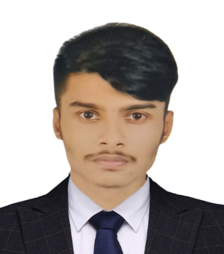 **OF**

**Nazmul Hasan Shanto**

**Email**[**:** nazmulhassannh698947@gmail.com](mailto:nazmulhassannh698947@gmail.com)

**PHONE: 01721812805**

**Tejkunipara, Tejgaon, Dhaka-1215.**

|  |
| --- |
| **CAREER OBJECTIVE:** |

To work in an environment where there is an opportunity of self-assessment and self-improvement in both individual and group-based work that will ultimately lead to the further development. And work hard in an organization where punctuality, sincerity, creativity and a challenging goal is its importance. To rise as high as one can & to make others feel my presence.

|  |
| --- |
| **ACADEMIC QUALIFICATION:** |

**B.SC. IN CSE (Running)**

Institute : Bangladesh University

Board : Dhaka

Passing Year : 2027 (approximate)

|  |
| --- |
| **Higher Secondary Certificate (H.S.C)** |

Institute : Baf Shaheen school and collage

Group : Science

Result : CGPA- 5.00 /5.00

Board : Dhaka

Passing Year : 2022

|  |
| --- |
| **Secondary School Certificate (S.S.C)** |

Institute : Government Science School

Group : Science

Result : CGPA- 4.17/5.00

Board : Dhaka

Passing Year : 2020

|  |
| --- |
| **Computer Skills:** |

* Software: Microsoft Office ( MS-Word, Power Point, Excel ), Adobe Photoshop, etc.

|  |
| --- |
| **Language Skills:** |

* Bangali: Good in speaking, listening and writing
* English: Good in speaking, listening and writing
* Hindi: Good in speaking and listening

|  |
| --- |
| **HOBBYS & PERSONALITY:** |

* Hobby : Photography, sports, music, reading, movies, tv-series etc
* Personality : Friendly, creative, innovative, quick learner, meticulous, well organized

etc.

|  |
| --- |
| **EXPERIENCE:** |

|  |
| --- |
| **PERSONAL INFORMATION:** |

* Father's Name : Ataul Haque
* Mother's Name : Nasima Begum
* Permanent Address : vill. Kanil. P.o:gorarkanda dist. Jamalpur p.s.jamalpur
* Nationality : Bangladeshi
* Date of Birth : 10st January, 2004
* Religion : Islam
* Marital Status : Single
* Gender : Male

I do solemnly affirm that the information contained herein is correct to the best of my knowledge and belief.

|  |
| --- |
|  |

Nazmul Hasan Shanto

Date: