
ASSIGNMENT DASHBOARD APPLICATION
Workforce Allocation · Revenue Capacity · Plan-to-Execution
AS-BUILT DOCUMENT
Application Version 12.0.0 · Document Revision 1.2
13 August 2026
Prepared by Nafiz Pervez

DOCUMENT CONTROL
Table 1 — Document Information
Item | As-Built Value
Document Name | As-Built Document – Assignment Dashboard Application
Document Reference | AD-ABD-001
Project Name | Assignment Dashboard Application
Application Package | workforce-allocation-dashboard
Application Version | 12.0.0
Prepared By | Nafiz Pervez
Date Updated | 13 August 2026
Date Released | 13 August 2026
Revision | 1.2
Security | Internal – Confidential
Volume | 1 of 1

Table 2 — Preparation and Review
Role | Name | Designation | Signature | Date
Prepared by | Nafiz Pervez | Software Developer |  | 13 August 2026
Reviewed by
Approved by

TABLE OF CONTENTS
SECTION / APPENDIX | PAGE
1. INTRODUCTION | 8
2. SYSTEM OVERVIEW | 9
3. FUNCTIONAL AS-BUILT DESCRIPTION | 10
4. SYSTEM ARCHITECTURE AND DATA FLOW | 16
5. DATA ARCHITECTURE | 18
6. BUSINESS RULES AND CALCULATION LOGIC | 21
7. API AND INTERFACE CATALOGUE | 23
8. IMPORT AND EXPORT SPECIFICATIONS | 24
9. SECURITY DESIGN | 26
10. ENVIRONMENT AND DEPENDENCIES | 26
11. INSTALLATION AND DEPLOYMENT | 30
12. OPERATIONS, BACKUP AND TROUBLESHOOTING | 33
13. VERIFICATION AND ACCEPTANCE | 34
14. SOURCE CODE OVERVIEW | 35
15. KNOWN CONSTRAINTS AND RECOMMENDATIONS | 37
APPENDIX A – COMPLETE API REGISTER | 39
APPENDIX B – DATABASE DATA DICTIONARY | 41
APPENDIX C – SOURCE FILE INVENTORY | 45
APPENDIX D – FORMULA AND RULE QUICK REFERENCE | 48
APPENDIX E – IT REQUIREMENTS | 49
Page numbers shown in the Table of Contents, List of Figures and List of Tables are fixed to this issued revision so that they remain visible in Microsoft Word, Word Online, LibreOffice and document previews.

LIST OF FIGURES
FIGURE | PAGE
Figure 1 — Reserve Revenue designation-rate configuration | 12
Figure 2 — Pre-Sale Product planned resource and revenue breakdown | 13
Figure 3 — Skill Development Plan-to-Execution view | 14
Figure 4 — Pre-Sale Plan-to-Execution view | 14
Figure 5 — Logical Application Architecture | 16
Figure 6 — Data Flow Diagram – Level 0 (System Context) | 17
Figure 7 — Data Flow Diagram – Level 1 (Major Processes) | 17
Figure 8 — Plan-to-Execution Processing Flow | 18
Figure 9 — As-Built Data Model (SQLite) | 19
Figure 10 — Recommended Production Deployment Topology | 30
LIST OF TABLES
TABLE | PAGE
Table 1 — Document Information | 2
Table 2 — Preparation and Review | 2
Table 3 — Abbreviations | 7
Table 4 — As-Built Baseline | 8
Table 5 — Stakeholders and Responsibilities | 9
Table 6 — Functional Module Inventory | 10
Table 7 — Executive KPI Definitions | 10
Table 8 — Approved Time Sheet Work Types | 13
Table 9 — Sensitive Workflow Controls | 15
Table 10 — Application Components | 18
Table 11 — Database Tables | 20
Table 12 — Project Classification Rules | 21
Table 13 — Project Portfolio Rules | 22
Table 14 — API Summary | 23
Table 15 — Common API Responses | 24
Table 16 — Project Import Mapping | 24
Table 17 — Time Sheet Import Fields | 25
Table 18 — Security Controls | 26
Table 19 — Runtime and Browser Dependencies | 26
Table 20 — Configuration Variables | 27
Table 21 — Suggested Host Sizing | 28
Table 22 — Deployment Environment Record | 29
Table 23 — Deployment Verification | 31
Table 24 — Backup and Restore Checklist | 33
Table 25 — Troubleshooting Guide | 33
Table 26 — Functional Acceptance Checklist | 34
Table 27 — Representative Calculation Tests | 35
Table 28 — Backend Key Files | 36
Table 29 — Frontend Key Areas | 36
Table 30 — Known Constraints and Recommendations | 37
Table 31 — Improvement Roadmap | 37
Table 32 — Complete API Register | 39
Table 33 — Data Dictionary – employees | 41
Table 34 — Data Dictionary – projects | 41
Table 35 — Data Dictionary – assignments | 42
Table 36 — Data Dictionary – timesheet_entries | 42
Table 37 — Data Dictionary – designation_revenue_rates | 43
Table 38 — Data Dictionary – committed_revenue_targets | 43
Table 39 — Data Dictionary – presale_products | 43
Table 40 — Data Dictionary – presale_product_settings | 43
Table 41 — Complete Source File Inventory | 45
Table 42 — Formula Quick Reference | 48
Table 43 — IT Requirements and Deployment Record | 49

LIST OF ABBREVIATIONS
Table 3 — Abbreviations
Abbreviation | Meaning
API | Application Programming Interface
CRUD | Create, Read, Update and Delete
DFD | Data Flow Diagram
ERD | Entity Relationship Diagram
FY | Fiscal Year; displayed using the ending-year convention
HTTP / HTTPS | Hypertext Transfer Protocol / Secure HTTP
KPI | Key Performance Indicator
N/A | Not Available / Not Applicable availability marker
PS | Professional Services
REST | Representational State Transfer
SA | Sales Agreement / Opportunity reference used in project data
SPA | Single-page style browser experience assembled from HTML fragments
SQL | Structured Query Language
UQ | Unique constraint
WAL | Write-Ahead Logging
XLSX | Microsoft Excel Open XML Workbook

1. INTRODUCTION

1.1 Purpose
This as-built document records the implemented design, data model, interfaces, calculations, operating procedures and maintenance requirements of the Assignment Dashboard Application. It is intended to provide an authoritative technical and functional baseline for support, deployment, enhancement and audit activities.

1.2 Intended Audience
- Application owner: confirms business rules, operational ownership and data governance.
- Professional Services management: uses KPI, capacity, utilization, revenue and delivery analysis.
- Resource planners: maintain projects, resources and weekly assignments.
- Application support and developers: deploy, diagnose, maintain and extend the source.
- Infrastructure and security teams: host the Node.js process, protect the database and review access controls.

1.3 Scope
The documented scope covers the complete web application supplied in the source snapshot: password authentication, employee and project administration, project and assignment Excel workflows, the Resource Assignment Matrix, reserve-revenue configuration, committed targets, Pre-Sale Product management, Work Summary Time Sheet ingestion, KPI and sales analytics, the Plan-to-Execution Map, Planned vs Actual charts, SQLite persistence, database migrations, deployment and operational support.

1.4 Exclusions and Assumptions
- The supplied package did not include the live production database records; the document therefore describes schema and behavior rather than production data volumes.
- No external identity provider, email service, cloud platform or enterprise database is implemented in the supplied code.
- Production host names, TLS certificates, service accounts, backup locations and approver names remain environment-specific and must be recorded by the deployment owner.
- Screenshots in this document are implementation evidence supplied during development and may contain representative data.

1.5 As-Built Baseline
Table 4 — As-Built Baseline
Baseline Item | Recorded Value | Verification Basis
Application name | Assignment Dashboard Application / Workforce Allocation Dashboard | HTML title, README and package metadata
Package version | 12.0.0 | package.json
Source snapshot date | 10 August 2026 | uploaded ZIP and Git working tree
Architecture | Node.js + Express + SQLite + modular browser JavaScript | source inspection
Database engine | Node built-in node:sqlite | sqlite-driver.js and package requirements
Runtime | Node.js 24.x target; minimum 22.13.0 | README and package engines
Default listener | 0.0.0.0:9002 | server/config.js

2. SYSTEM OVERVIEW

2.1 Business Objective
The application provides one operational workspace for planning Professional Services capacity, assigning resources by week, tracking project and opportunity characteristics, configuring internal revenue assumptions, importing actual time, and comparing planned effort with delivered effort. It replaces disconnected spreadsheets with a persistent, interactive dashboard while preserving Excel-based interchange for project, assignment and time-sheet data.

2.2 Primary Stakeholders and Responsibilities
Table 5 — Stakeholders and Responsibilities
Stakeholder | Primary Responsibilities | Key Outputs
Dashboard administrator | Authenticate, maintain resources and projects, manage imports, resolve data issues | Clean master data and usable fiscal-year matrix
Resource planner | Create, edit, reschedule and remove weekly allocations; maintain products and customer metadata | Resource Assignment Matrix and planned hours
PS management | Review capacity, utilization, running projects, committed targets and delivery variance | KPI decisions, staffing and revenue outlook
Time Sheet owner | Upload approved Work Summary Time Sheet work types and verify totals | Actual effort dataset
Application support | Operate Node.js service, secure configuration, back up SQLite, verify health and migrations | Available and recoverable service
Developer | Maintain modular source, database migrations and calculation consistency | Controlled application releases

2.3 Operating Concept
1. User authenticates through the password login page and receives a signed, time-limited cookie.
2. The browser loads static HTML fragments, CSS and modular JavaScript, then retrieves all master and analytical data through authenticated REST APIs.
3. Resources, projects and weekly assignments are maintained interactively or imported from Excel.
4. Actual effort is imported from a Work Summary Time Sheet workbook and normalized into approved work types.
5. Designation rates, committed targets and Pre-Sale Product settings are persisted in SQLite.
6. Backend and frontend calculation modules derive utilization, capacity, project portfolio, revenue and plan-to-execution datasets.
7. Users filter, drill down and export without changing the underlying source records unless a save action is submitted.

2.4 Functional Module Inventory
Table 6 — Functional Module Inventory
Module | As-Built Capabilities | Persistence / Primary Source
Authentication | Password login, logout, signed cookie, API guard | Environment configuration; cookie
Executive KPIs | Active resources, running projects, average utilization, assigned projects, committed target, allocated capacity | Calculated from SQLite
Resource management | Add, edit, activate/deactivate, workdays and delete | employees
Project management | CRUD, project imports, sales metadata, fiscal period and deal status | projects
Resource Assignment Matrix | 48 fixed fiscal slots, assignment CRUD, presets, filtering, multi-select delete, revenue labels | assignments + master data
Reserve Revenue | Intrasourcing and shared Local/Pre-Sale/Training rate per designation | designation_revenue_rates
Committed Targets | Intrasourcing and Local target amounts | committed_revenue_targets
Pre-Sale Product | Product amount, probability percent, thresholds, planned resources/hours/revenue | presale_products + settings + assignments
Work Summary | Time Sheet upload, team/individual summaries, approved work-type normalization | timesheet_entries
Plan-to-Execution | Planned vs actual resources, hours, budgets, variance, filters and detail dialogs | assignments + timesheet + rates + products
Sales analytics | New Logo / Repeat / Reactive, PS revenue and PS-type charts | projects
Excel interchange | Project import, assignment import/export and Time Sheet import | browser SheetJS + APIs

3. FUNCTIONAL AS-BUILT DESCRIPTION

3.1 Authentication and Session Entry
The login page accepts a single configured dashboard password. On success, the server creates an HMAC-SHA256 signed expiry token and stores it in the HttpOnly wa_auth cookie. The default lifetime is twelve hours. All static application content and /api/ routes are guarded after the authentication router; unauthenticated API calls receive HTTP 401 and page requests redirect to /login.

3.2 Executive KPI Row
Table 7 — Executive KPI Definitions
KPI | As-Built Definition | Drill-Down
Active Resources | Employees where active = 1 | Resource list / edit modal
Running Projects | Closed Won Professional Services projects, progress below 100%, Closed Won Date on or after 1 March 2025 | Running project list with timing and revenue
Avg Utilization | Fiscal-year utilization averages after unavailable-slot exclusions | Per-resource utilization detail
Assigned Projects | Running, Weighted Prospect and Prospect portfolio counts | Filtered project lists
Committed Target | Saved Intrasourcing + Local targets; calculated assignment revenue used as fallback until saved | Target modal
Allocated Capacity | Remaining monetary capacity after planned Intrasourcing and Local allocation | Resource and revenue detail

3.3 Resource Management
- Employees have code, name, department, designation, annual Workdays, email, active state and creation timestamp.
- Names are canonicalized for configured aliases before insertion or update.
- Workdays must be a non-negative integer and default to 220.
- Activation is a toggle; inactive resources remain stored but are excluded from active-resource calculations and planning displays.
- Deleting an employee cascades to that employee’s assignments through the database foreign key.

3.4 Project Management
Projects store opportunity, customer, product, commercial, progress and scheduling metadata. The system supports manual CRUD and two import partitions: forecast projects in the current fiscal year, and historical projects outside it. The fiscal period is recalculated from Closed Won Date when available. Duplicate project codes are supported by the compatibility migration and import matching uses increasingly broad combinations of code, name, product and amount.

3.5 Resource Assignment Matrix
- The matrix displays an April-to-March fiscal year as twelve months with four application weeks per month.
- Assignments link one employee to one project for one year/month/week slot and store allocation percentage plus optional customer and product metadata.
- A single click selects a card. An immediate double-click opens the editor. Multiple selected cards can be deleted together after confirmation.
- Presets calculate date ranges; rescheduling deletes one assignment and creates one or more replacement slots in a transaction.
- The summary columns show Intrasourcing, Local, Pre-Sale, Training, Skill Development and General Admin allocation, plus revenue columns and a sticky Total Allocation column.
- Filters include project, resource, month, stage, amount, Closed Won Date and Project Closing Date.

3.6 Reserve Revenue
Reserve Revenue stores exactly two editable non-negative hourly rates for each supported designation: an Intrasourcing rate and a shared Local / Pre-Sale / Training rate. Legacy columns remain synchronized in the table for compatibility, but the active API exposes only intrasourcing_rate and local_rate.
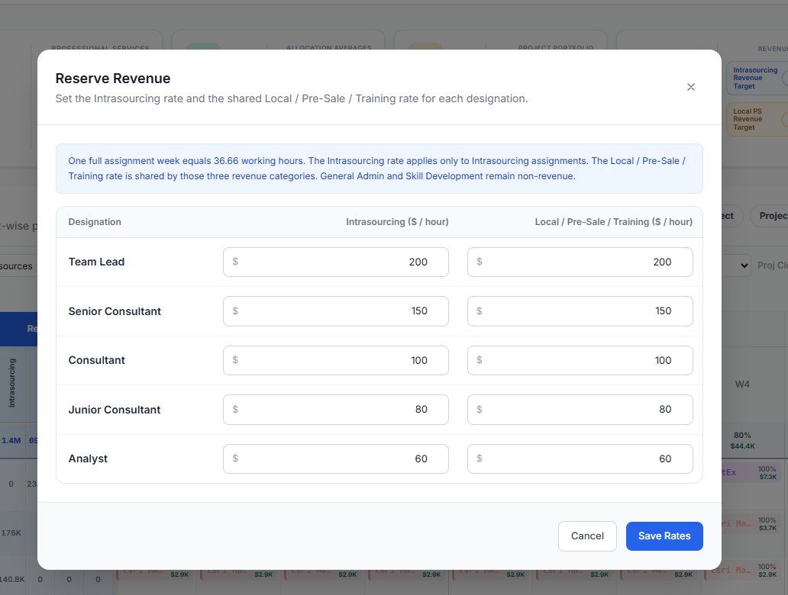
Figure 1 — Reserve Revenue designation-rate configuration
The shared Local / Pre-Sale / Training rate is used for those three revenue-capable categories; General Admin and Skill Development are non-revenue.

3.7 Pre-Sale Product Master
The Pre-Sale Product modal maintains a case-insensitive unique product name, a non-negative reference amount, a confidence percentage from 0 to 100, and global Secured / Best Case thresholds. Product rows are sorted by confidence percentage descending and then by name. A referenced product cannot be removed, while renaming updates matching assignment product selections within the save transaction.
- Secured: percent is greater than or equal to the configured Secured threshold.
- Best Case: percent is greater than or equal to Best Case and below Secured.
- Prospect: percent is below Best Case.
- The new planning breakdown groups effective fiscal-year Pre-Sale assignments by product and person, then displays planned hours, designation rate and person-specific planned revenue.
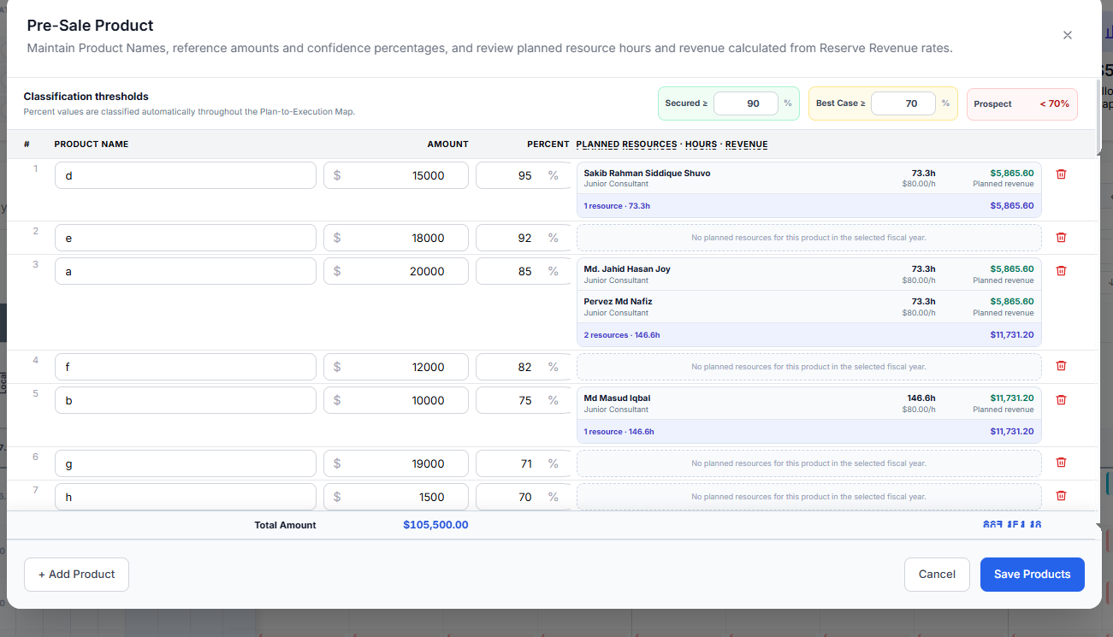
Figure 2 — Pre-Sale Product planned resource and revenue breakdown
The right-hand breakdown is derived from effective fiscal-year assignments and the saved shared designation rate. Product reference Amount and effort-based planned revenue remain separate values.

3.8 Work Summary Time Sheet
The browser reads an XLSX workbook through SheetJS. It selects a sheet named “Time Sheet” when present, otherwise the first sheet, normalizes the required columns, aggregates duplicate rows, and submits the result to the bulk API. Uploaded months replace existing records for those months by default. Team and individual charts show only the six approved work types in a fixed business order.
Table 8 — Approved Time Sheet Work Types
Display Order | Canonical Work Type | Accepted Variants / Notes
1 | Training Delivery | Exact normalized text
2 | Skill Development | Exact normalized text
3 | Service Delivery - Local PS | Hyphenated or space-separated Local PS
4 | Service Delivery - Intrasourcing | Hyphenated or space-separated Intrasourcing
5 | Pre - Sales | Pre-Sales, Pre Sales, Presales or Pre - Sales
6 | General Admin | Exact normalized text

3.9 Plan-to-Execution Map
The Plan-to-Execution Map reconciles assignment-derived planned effort with monthly Work Summary Time Sheet effort. Generic categories such as Pre-Sale, General Admin, Training Delivery and Skill Development aggregate by Work Type; named delivery projects remain project-specific unless resolved through an alias or generic service-delivery bucket. The view provides planned/actual resources, effort, budgets, a central variance card, resource flow lines and per-person detail records.
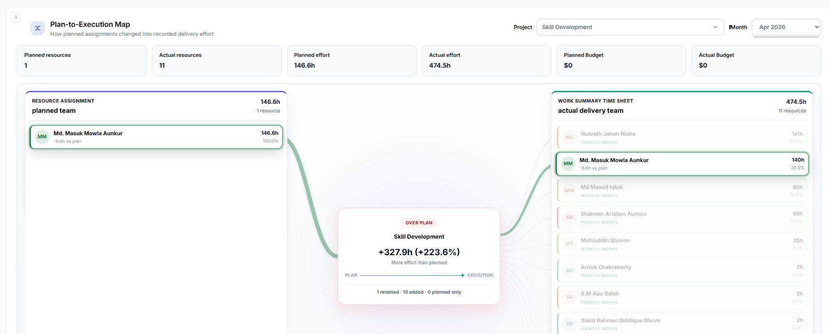
Figure 3 — Skill Development Plan-to-Execution view
Skill Development is explicitly classified, has planned and actual detail records, and remains non-revenue; therefore its planned and actual budgets are zero.
For Pre-Sale, an additional product filter and confidence controls scope all metrics and detail records. Planned and actual budget are effort-based, while the central Impact amount is the distinct included product reference amount. Each resource card can open Planned Details or Actual Details, including after a month filter is applied.
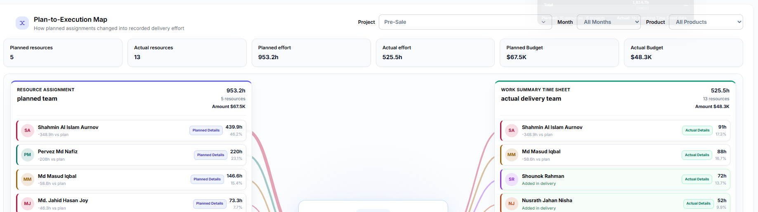
Figure 4 — Pre-Sale Plan-to-Execution view

3.10 Planned vs Actual and Sales Analytics
- Planned vs Actual supports Percent Wise and Revenue Wise modes with a local fiscal-year selector.
- Acquisition analytics classify accounts as NEW LOGO, REPEAT or REACTIVE using their Closed Won fiscal history.
- PS revenue charts use Product Amount when positive, otherwise Opportunity Amount / Budget as fallback.
- PS Type analytics count System Support and Project Implementation rows based on Product Name, Project Name and Product Family.
- Project lists and chart tooltips provide the underlying project records for auditability.

3.11 Import, Export and Modal Protection
Project and assignment workflows use browser-side SheetJS parsing and server-side validation. Assignment export includes backup identifiers and matching fields to support restore after project list replacement. Selected sensitive configuration modals use a separate password-verification endpoint and client-side temporary access state; this is an additional UI control, not a replacement for dashboard authentication.
Table 9 — Sensitive Workflow Controls
Workflow | Implemented Control | Operator Verification
Project Excel import | Required fields, normalized dates/numbers and server-side partition logic | Review result counts and fiscal-year placement before acceptance.
Assignment fiscal-year import | Optional full fiscal-year replacement with employee/project reconciliation | Export the current fiscal year and retain the workbook before replacement.
Work Summary Time Sheet upload | Approved work-type normalization and month-based upsert/replacement | Reconcile uploaded months, source metadata and total hours.
Pre-Sale Product configuration | Separate protected-modal password plus authenticated product APIs | Confirm thresholds, reference amounts and product-linked assignments.
Reserve Revenue configuration | Separate protected-modal password plus non-negative server validation | Confirm both designation rates and resulting capacity/revenue outputs.
Production source deployment | Idempotent migrations; live database is not part of source replacement | Checkpoint and back up workforce.db; never run reset/seed against production.

4. SYSTEM ARCHITECTURE AND DATA FLOW

4.1 Logical Architecture (Application)
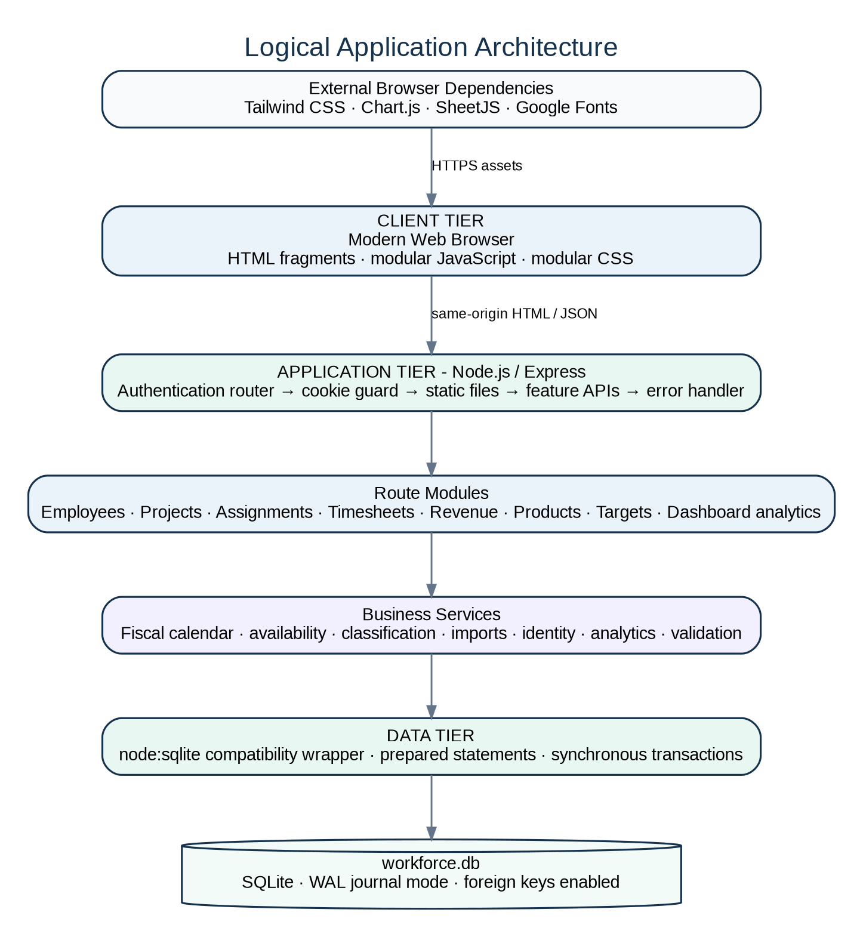
Figure 5 — Logical Application Architecture
The browser contains no build artifact or framework runtime. HTML fragments are fetched and inserted, then classic scripts initialize shared state and feature modules. Express provides authentication, static delivery and REST endpoints. Route modules call synchronous service and database functions. SQLite is stored locally in workforce.db with WAL mode and foreign-key enforcement enabled.

4.2 Data Flow Diagram Level 0
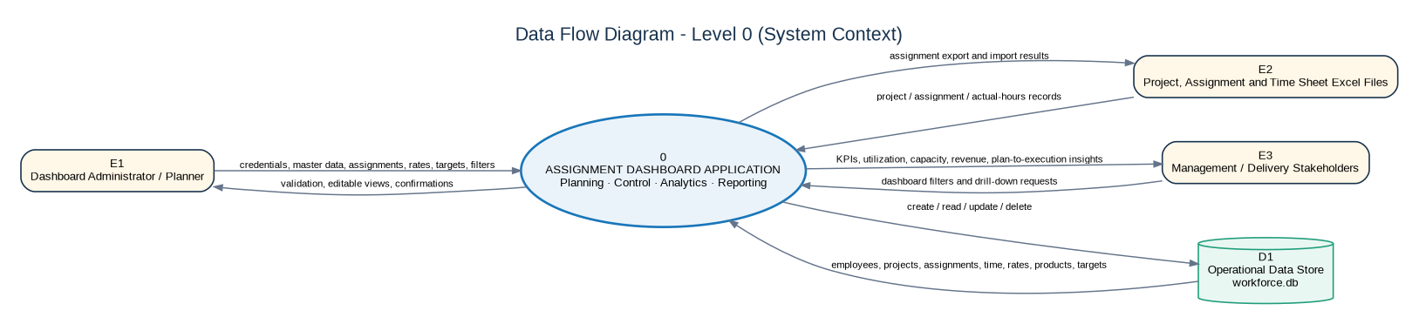
Figure 6 — Data Flow Diagram – Level 0 (System Context)
At context level, the Assignment Dashboard receives credentials and planning actions from administrators, structured Excel data from project/assignment/time owners, and filter or drill-down requests from management. It returns validated edits, analytical dashboards and assignment exports while persisting operational data in the SQLite store.

4.3 Data Flow Diagram Level 1
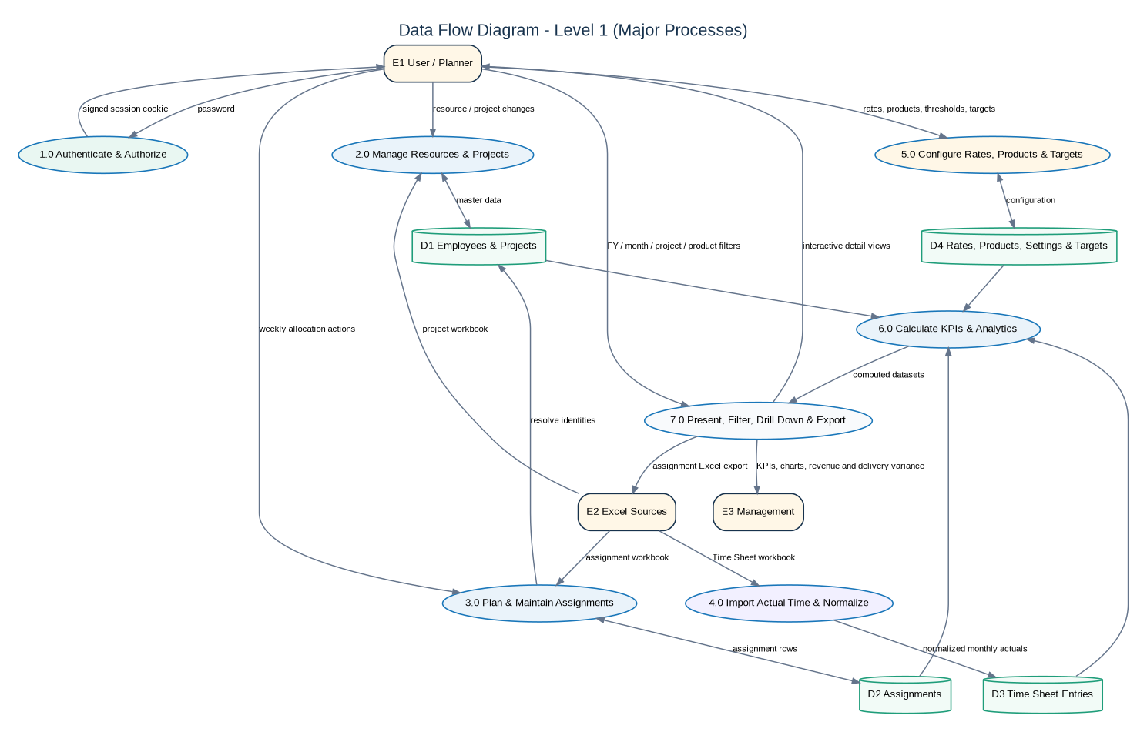
Figure 7 — Data Flow Diagram – Level 1 (Major Processes)
Level 1 separates authentication, master-data maintenance, assignment planning, actual-time ingestion, financial configuration, analytics computation and presentation/export. The diagram also separates the four logical data domains even though they are implemented as tables in one SQLite database file.

4.4 Major Application Components
Table 10 — Application Components
Layer | Component | Responsibility
Browser | public/index.html | Shell, CDN references, fragment placeholders and script load order
Browser | public/views/ | Header and dashboard section fragments
Browser | public/js/modules/core/ | Shared state, API, identity, designations, work schedule and availability
Browser | public/js/modules/dashboard/ | KPI, matrix summaries, workload, monthly plan and sales analytics
Browser | public/js/modules/timesheets/ | Time Sheet model, charts and plan-to-execution matching
Browser | public/js/modules/ui/ | Modals, events, assignment editing and protected configuration
Server | server/app.js | Express middleware pipeline and central error handling
Server | server/auth/ | Login page, cookie creation/validation and request guard
Server | server/routes/ | REST endpoints grouped by feature
Server | server/services/ | Reusable business rules, imports, validation and analytics
Data | server/database/ | Connection, schema, migrations, seed and reset functions
Data | sqlite-driver.js | Compatibility wrapper around node:sqlite

4.5 Plan-to-Execution Processing
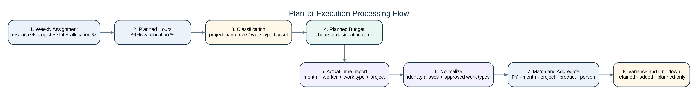
Figure 8 — Plan-to-Execution Processing Flow
Planned effort originates from the weekly assignment percentage and standard week. Actual effort originates from normalized Time Sheet quantities. Identity aliases, work-type buckets, project aliases, fiscal/month scope and Pre-Sale product shares determine how the two streams are reconciled. Detail rows are accumulated alongside summary maps so team-card totals can be traced to source records.

5. DATA ARCHITECTURE

5.1 Database Technology and Location
The application uses Node.js built-in synchronous SQLite through a small compatibility wrapper. The database path is fixed to workforce.db in the project root. Each connection enables WAL journal mode and foreign keys. The application initializes the base schema and executes idempotent migrations on first database access during process startup.
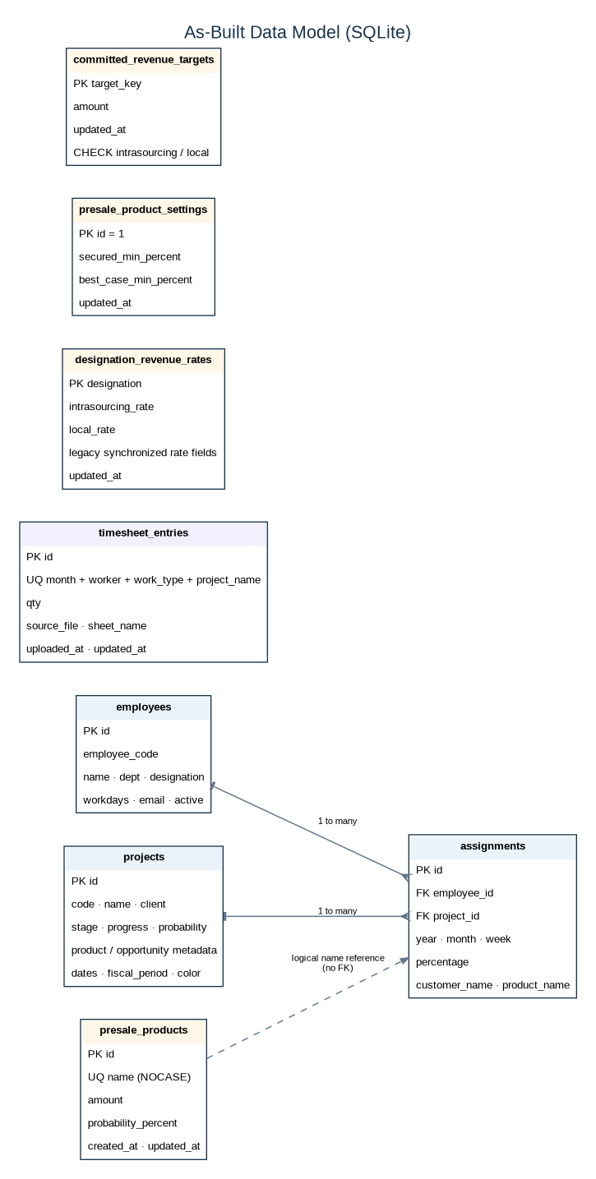
Figure 9 — As-Built Data Model (SQLite)

5.2 Persisted Tables
Table 11 — Database Tables
Table | Purpose | Key Controls
employees | Resource master and annual capacity inputs | Primary key; name required; active and workdays defaults
projects | Opportunity/project master and sales analytics inputs | Primary key; indexes on fiscal period and import row
assignments | Weekly resource allocation | Foreign keys to employee and project; period/employee/project indexes
timesheet_entries | Normalized monthly actual effort | Unique month + worker + work type + project
designation_revenue_rates | Designation hourly-rate configuration | Primary key designation; non-negative checks
committed_revenue_targets | Manual Intrasourcing and Local targets | Allowed-key check; non-negative amount
presale_products | Pre-Sale master products | Case-insensitive unique name; amount and percent checks
presale_product_settings | Single global confidence-threshold row | id fixed to 1; threshold validation in service

5.3 Relationships and Deletion Behavior
- employees.id → assignments.employee_id is one-to-many with ON DELETE CASCADE.
- projects.id → assignments.project_id is one-to-many with ON DELETE CASCADE.
- Assignment product_name relates logically to presale_products.name by case-insensitive text. There is no database foreign key; server validation protects normal create/update workflows.
- Time Sheet workers and projects are stored as text to preserve source data and are reconciled through canonical identity and matching rules rather than foreign keys.

5.4 Schema Migration Strategy
Migrations are executed at startup and catch “already present” conditions so upgrades can be applied repeatedly. Current migrations add employee active/designation/workdays, assignment customer/product metadata, project fiscal/import fields, Time Sheet storage, revenue tables, committed targets, Pre-Sale Product tables and known-person canonicalization. A compatibility migration rebuilds projects when a legacy unique code constraint is detected, allowing duplicate opportunity codes needed by imported product rows.

5.5 Data Safety
- SQLite may create workforce.db-wal and workforce.db-shm while the process is running.
- Backups should be taken after stopping the application or after an explicit checkpoint so the database and WAL state are consistent.
- File-system permissions must allow the Node.js service account to read and write the database directory.
- PRAGMA integrity_check should be part of restore and periodic health procedures.

6. BUSINESS RULES AND CALCULATION LOGIC

6.1 Fiscal Calendar
The fiscal year runs from April through March and is presented using the ending-year label. FY2027 covers April 2026 through March 2027. Fiscal quarters are Q1 April–June, Q2 July–September, Q3 October–December and Q4 January–March. Closed Won Date is the preferred source for project fiscal period; a normalized supplied fiscal value is used only when no valid date can be parsed.

6.2 Standard Work Schedule
Core planning constants
WORK_HOURS_PER_WEEK = 36.66
planned_hours = 36.66 × allocation_percentage ÷ 100
application_fiscal_weeks = 12 months × 4 weeks = 48 slots

The application deliberately models four planning weeks per month. It is a planning grid, not an ISO calendar-week engine. One hundred percent allocation contributes 36.66 hours for one matrix slot.

6.3 Project-Name Allocation Classification
Table 12 — Project Classification Rules
Priority | Category | Current Main-Matrix Rule | Revenue Treatment
1 | Unavailable | Normalized name equals N/A, Not Applicable, Not Available or Not Application | Excluded from analytics
2 | Intrasourcing | Name contains “Intrasource” in the main classifier | Intrasourcing rate
3 | Pre-Sale | Name contains Pre Sale / Pre-Sale | Shared Local rate for effort-budget views; card shows Product Amount
4 | Training | Name contains Training Delivery | Shared Local rate in detail/revenue views
5 | Skill Development | Name contains Skill Development / Skill-Development | Non-revenue
6 | General Admin | Name contains General Admin / General-Admin | Non-revenue
7 | Local | All unmatched project names | Shared Local rate

6.4 Availability and N/A
An N/A assignment marks an unavailable employee/year/month/week slot. The marker remains visible and editable, but the marker and every other assignment in the same slot are excluded from effective assignment analytics. Available-week denominators are reduced only for that resource. For annual capacity, each resource-month containing one or more N/A markers deducts 18.33 Workdays once, and adjusted Workdays cannot fall below zero.

6.5 Allocation and Utilization
As-built utilization formulas
category_average(resource) = sum(category allocation percentages) ÷ available fiscal weeks
Intrasourcing Utilization = Intrasourcing
Billable Utilization = Intrasourcing + Local
Project Utilization = Intrasourcing + Local + Pre-Sale + Training
Skill Development and General Admin are excluded from the three utilization metrics.

The Total Allocation column is broader than utilization and sums the displayed allocation categories, including Skill Development and General Admin. The total/average row is computed over currently visible available resources.

6.6 Planned Revenue and Capacity
Revenue-capacity formulas
assignment_revenue = planned_hours × designation_hourly_rate
Max Capacity Amount = Σ(adjusted_workdays × 8 × shared_local_rate)
Capacity Allocated = planned Intrasourcing revenue + planned Local revenue
Remaining Allocated Capacity = Max Capacity Amount − Capacity Allocated

Matrix aggregate planned-revenue totals include Intrasourcing and Local only. Pre-Sale assignment cards display the product reference Amount and do not multiply it by every person/week. Training does not contribute to capacity allocated. Skill Development and General Admin are non-revenue.

6.7 Committed Targets
Committed Target is the sum of Intrasourcing and Local target values. Each target persists independently. Until a target is manually saved, the browser can use calculated assignment revenue as the fallback. Committed targets do not change designation hourly rates.

6.8 Running Project and Portfolio Rules
Table 13 — Project Portfolio Rules
Metric / Status | Rule
Running Project | Stage = Closed Won; Product Family = Professional Service(s); Progress < 100%; valid Closed Won Date ≥ 2025-03-01.
Running PS Revenue | Direct sum of Product Amount; no Opportunity Amount or Budget fallback.
Weighted Prospect | Stage is not Closed Won and Probability ≥ 75.
Prospect | Stage is not Closed Won and Probability < 75.
NEW LOGO | First Closed Won fiscal occurrence for an account.
REPEAT | Same fiscal year as first occurrence or next consecutive fiscal year.
REACTIVE | Closed Won after a gap greater than one fiscal year.
Acquisition-chart eligibility | Closed Won with a fiscal year and not still an active Running Project.

6.9 Pre-Sale Product and Budget Rules
- Product Amount is a reference/opportunity amount and is counted distinctly for the central Impact value.
- Planned budget contribution = planned hours × employee shared Local rate.
- Actual budget contribution = actual hours × matched employee shared Local rate.
- Per-product planned resource revenue = effective fiscal-year planned hours × shared Local rate for that person’s designation.
- Secured / Best Case / Prospect membership uses the persisted threshold row.
- Product removal is blocked while assignments reference the product; rename updates assignment product names.

6.10 Plan-to-Execution Matching
Pre-Sale, General Admin, Training Delivery and Skill Development always aggregate by canonical Time Sheet Work Type. Generic Service Delivery – Intrasourcing and Local PS labels can aggregate by Work Type, while named delivery projects remain project-name matched. Person aliases are canonicalized. Month, product and confidence filters are applied to both summary and detail records. Skill Development and General Admin produce zero budgets because their rate field resolves to null.

6.11 Sales Revenue Amount Rules
For historical sales revenue analytics, Product Amount is used when it is positive. When missing or zero, Opportunity Amount or Budget is used as fallback. This fallback applies to the sales charts, not to the Running Project PS Revenue KPI, which uses Product Amount directly.

7. API AND INTERFACE CATALOGUE

7.1 API Design
The application exposes same-origin REST-style JSON APIs under /api/. All are protected by the dashboard authentication guard. Request bodies are parsed as JSON up to 25 MB and URL-encoded form data. Route handlers use prepared statements and generally return JSON objects or arrays. A central Express error handler returns HTTP 500 with an error message for unhandled failures.

7.2 Endpoint Summary
Table 14 — API Summary
Domain | Routes | Purpose
Authentication | GET /login; POST /login; POST /logout | Login page, cookie creation and logout
Employees | GET/POST /api/employees; PUT/PATCH/DELETE by id | Resource CRUD, Workdays and active state
Projects | GET/POST /api/projects; POST import; PUT/DELETE by id | Project CRUD and partitioned import
Assignments | GET/POST; bulk; import; PUT; reschedule; DELETE | Weekly allocation lifecycle
Timesheets | GET; POST bulk; DELETE /api/timesheet-summary | Actual-effort persistence
Revenue configuration | GET/PUT revenue-rates; committed-targets; presale-products/settings | Financial assumptions and product master
Dashboard | stats, trends, workload, utilization, portfolio, deadlines, pipeline and sales charts | Computed analytical datasets
Miscellaneous | fiscal-years, modal-access/verify, health | Supporting functions

7.3 Validation and HTTP Behavior
Table 15 — Common API Responses
Condition | Typical Status | Behavior
Successful read/update | 200 | JSON array or object
Successful creation/import | 201 | Created record or import summary
Missing/invalid input | 400 | JSON error with validation message
Authentication required / wrong modal password | 401 | JSON error or login page
Entity not found | 404 | JSON error
Referenced Pre-Sale product removal | 409 | Conflict with explanatory error
Unhandled server/database error | 500 | Central JSON error; stack logged to console

7.4 API Data Principles
- Employee names are canonicalized on write and Time Sheet read.
- Project fiscal periods are calculated from dates and returned with deal-status fields.
- Assignment responses join employee/project information and current Pre-Sale Product amount/percent.
- Bulk Time Sheet uploads use upsert semantics on month + worker + work type + project.
- Pre-Sale Product save is an authoritative full-set replacement performed in a transaction.
- Dashboard APIs accept fiscal-year and other query parameters where applicable and return calculation-ready JSON.

8. IMPORT AND EXPORT SPECIFICATIONS

8.1 Project Import
The browser parses Excel rows and submits normalized JSON to /api/projects/import. The server requires Opportunity Number/code and Opportunity Name/name, normalizes dates and numbers, derives fiscal period from Close Date, applies project colors and divides the import into current-fiscal-year forecast or out-of-current-year historical mode.
Table 16 — Project Import Mapping
Logical Field | Accepted Excel Names / Source | Processing
code | Opportunity Number | Uppercase normalized code; required
name | Opportunity Name | Trimmed; required
account_name / client | Account Name | Customer display and deal grouping
opportunity_owner | Opportunity Owner | Text
probability | Probability (%) | Normalized percentage
product_family | Product Family | Classification and running-project logic
product_name | Product Name / Product Description | Revenue and product categorization
product_amount | Product Amount | Non-negative numeric reference
opp_amount / budget | Amount | Opportunity amount
end_date | Close Date | U.S. month/day/year import supported; fiscal period calculated
created_date | Created Date | Normalized date
stage | Stage | Defaults to Prospect
import_row_no | Source Row / Excel Row | Restore matching

8.2 Assignment Import and Export
The assignment export workbook contains a Summary sheet and an Assignments sheet. It records Resource ID/Name, project backup identifiers, opportunity and product fields, slot values, derived start/end dates and allocation percentage. The import can replace all assignments in the selected fiscal year before inserting valid rows. Employee resolution prefers Resource ID then unique normalized Resource Name. Project resolution prefers import row and old project id, then increasingly broad code/name/product/amount combinations; duplicates are allowed and the first best match is used.

8.3 Work Summary Time Sheet Import
Table 17 — Time Sheet Import Fields
Field | Requirement | Normalization / Persistence
Month | Required | Normalized month label used for ordering and fiscal matching
Work Type | Required | Mapped to one of six approved types; unsupported types are excluded from summary views
Worker | Required | Canonical person alias mapping
Project Name | Optional but retained | Used for named project matching and drill-down
Qty (Hrs) | Required numeric | Aggregated and saved as qty
Source File / Sheet | Generated metadata | Saved for audit and latest-upload display

8.4 Import Safety and Reconciliation
- Review import result counts for received, deleted, imported, skipped and failed rows.
- Back up workforce.db before replacing a project partition or a fiscal year of assignments.
- Ensure imported Pre-Sale assignments use a Product Name that exists in the Pre-Sale Product master; normal interactive writes enforce this requirement.
- Verify Time Sheet total hours and uploaded months after each bulk import.
- Use assignment export before a project list replacement when assignments must be restored against duplicates.

9. SECURITY DESIGN

9.1 Implemented Controls
Table 18 — Security Controls
Control | As-Built Implementation | Operational Requirement
Dashboard authentication | Shared password validated server-side | Set DASHBOARD_PASSWORD privately
Session integrity | HMAC-SHA256 signed expiry token | Set long random DASHBOARD_AUTH_SECRET
Cookie attributes | HttpOnly; SameSite=Lax; Path=/; 12-hour Max-Age; Secure when HTTPS detected | Deploy behind HTTPS and preserve X-Forwarded-Proto
API guard | Unauthenticated /api requests return 401 | Do not bypass requireDashboardAuth
Modal access | Timing-safe separate password verification | Set MODAL_ACCESS_PASSWORD; treat as UI protection
SQL safety | Prepared statements for operational queries | Maintain parameterized patterns
Database referential integrity | Foreign keys enabled; assignment cascades | Keep PRAGMA foreign_keys ON
Input checks | Required fields, ranges and non-negative financial values | Preserve server-side validation
Secrets | Environment variables supported | Do not commit real secrets or place them in this document

9.2 Authentication Flow
1. GET /login renders the password page unless a valid cookie already exists.
2. POST /login compares the submitted password with the configured dashboard password.
3. The server signs an expiry timestamp with AUTH_SECRET and sets wa_auth.
4. requireDashboardAuth validates expiry and signature using timing-safe comparison.
5. Authenticated requests proceed to static content and API routes; logout clears the cookie.

9.3 Security Gaps to Manage
- Terminate TLS at a trusted reverse proxy.
- Restrict inbound access by network, VPN or identity-aware proxy.
- Use a dedicated low-privilege service account and restrict database-directory permissions.
- Rotate dashboard, modal and HMAC secrets; never use source defaults in production.
- Consider stronger password governance, CSRF protection, audit logging, rate limiting and security headers for the next controlled release.

10. ENVIRONMENT AND DEPENDENCIES

10.1 Runtime Requirements
Table 19 — Runtime and Browser Dependencies
Component | As-Built Version / Requirement | Purpose
Node.js | Target 24.x; minimum 22.13.0 | Server runtime and built-in SQLite
npm | Compatible with Node.js installation | Dependency installation and scripts
Express | ^4.19.2 | HTTP server and routing
cors | ^2.8.5 | CORS middleware
SQLite | node:sqlite built into Node | Persistent operational database
Chart.js | 4.4.4 from jsDelivr | Dashboard charts
SheetJS xlsx | 0.18.5 from jsDelivr | Excel import/export
Tailwind CSS | CDN runtime | Utility classes in views
Google Fonts | Inter and JetBrains Mono | UI typography
Browser | Current Chrome, Edge or equivalent | ES6 JavaScript, fetch, canvas, file APIs

10.2 Configuration Variables
Table 20 — Configuration Variables
Variable | Default / As-Built Behavior | Production Guidance
HOST | 0.0.0.0 | Bind to loopback when only a local reverse proxy should connect
PORT | 9002 | Reserve and expose through reverse proxy
DASHBOARD_PASSWORD | Compatibility value exists in source | Set a private strong value
MODAL_ACCESS_PASSWORD | Compatibility value exists in source | Set separately where practical
DASHBOARD_AUTH_SECRET | Derived from password and root path when absent | Set a long random stable secret to avoid session invalidation
DEFAULT_ANNUAL_WORKDAYS | 220 in root config.js | Change only when the organization-wide fallback annual Workdays changes; employee-specific overrides remain unchanged.
PIPELINE_MULTIPLIER | 2.5 in root config.js | Approved multiplier used by Pipeline Target Summary calculations.
PROBABLE_REALIZED_THIS_FY | 74,146 in root config.js | Update the expected current-fiscal-year realization used in the Local Target Next FY / pipeline planning calculation.

10.2.1 Where to Set Passwords and Application Defaults
The application has two configuration locations. Security/runtime values are defined in server/config.js and can be overridden by environment variables. Business-planning defaults are maintained in the root-level config.js. Before the first production start, the deployment owner shall review both files and replace all compatibility values with approved environment-specific values.
- server/config.js — Review HOST, PORT, DASHBOARD_PASSWORD, MODAL_ACCESS_PASSWORD and DASHBOARD_AUTH_SECRET. The password and secret environment variables override source fallback behavior and are preferred for production.
- root config.js — Review DEFAULT_ANNUAL_WORKDAYS, PIPELINE_MULTIPLIER and PROBABLE_REALIZED_THIS_FY. These numeric planning defaults are edited directly when approved business assumptions change.

Password configuration procedure
For a local/internal installation where no secret manager is available, open server/config.js and change the fallback value after process.env.DASHBOARD_PASSWORD || and process.env.MODAL_ACCESS_PASSWORD ||. Do not use the compatibility password in production. For production deployment, set DASHBOARD_PASSWORD and MODAL_ACCESS_PASSWORD as service environment variables instead of storing real passwords in the source.
Set DASHBOARD_AUTH_SECRET to a long, random and stable value through the service environment. Changing this value invalidates existing signed login sessions. Keep it separate from the dashboard password and do not publish the real value in this As-Built Document.

Planning configuration procedure
Open the root-level config.js to review DEFAULT_ANNUAL_WORKDAYS, PIPELINE_MULTIPLIER and PROBABLE_REALIZED_THIS_FY. These are application-wide fallback/planning constants. After changing them, restart the Node.js process and verify the corresponding dashboard and Fiscal Year Report values.

10.3 Network Requirements
- Client browsers require access to the application origin.
- By default, browsers also require outbound HTTPS to fonts.googleapis.com, fonts.gstatic.com, cdn.tailwindcss.com and cdn.jsdelivr.net.
- For an offline or restricted network, vendor and serve Tailwind, Chart.js, SheetJS and fonts locally, then update public/index.html.
- The Node.js server itself does not call external services in the supplied source.

10.4 Suggested Host Sizing
Table 21 — Suggested Host Sizing
Environment | CPU | Memory | Storage | Notes
Developer / Test | 2 cores | 4 GB | 2 GB plus data | Suitable for local verification
Small internal production | 2–4 cores | 4–8 GB | 10 GB plus backup retention | Single Node process and SQLite file
Larger data / concurrency | 4+ cores | 8+ GB | Sized from database and exports | Load test; consider managed DB and multi-user architecture if growth requires

10.5 Deployment Environment Record
Table 22 — Deployment Environment Record
Environment Item | As-Built / Required Record | Owner / Evidence
Environment name | Development / Test / Production — To Be Confirmed | Deployment owner
Application URL and TLS certificate | To Be Confirmed; HTTPS required for production | Infrastructure / certificate record
Application host and service wrapper | To Be Confirmed; Node.js service/process manager | Infrastructure runbook
Listener and reverse-proxy mapping | Internal default 0.0.0.0:9002; external mapping To Be Confirmed | Reverse-proxy configuration
Service account and application directory | To Be Confirmed; restricted read/write permissions | OS account and ACL evidence
Database and backup locations | Project-root workforce.db; production and backup paths To Be Confirmed | Backup register / restore test
Timezone, maintenance window and support contacts | To Be Confirmed | Operational handover record

11. INSTALLATION AND DEPLOYMENT

11.1 Deployment Topology
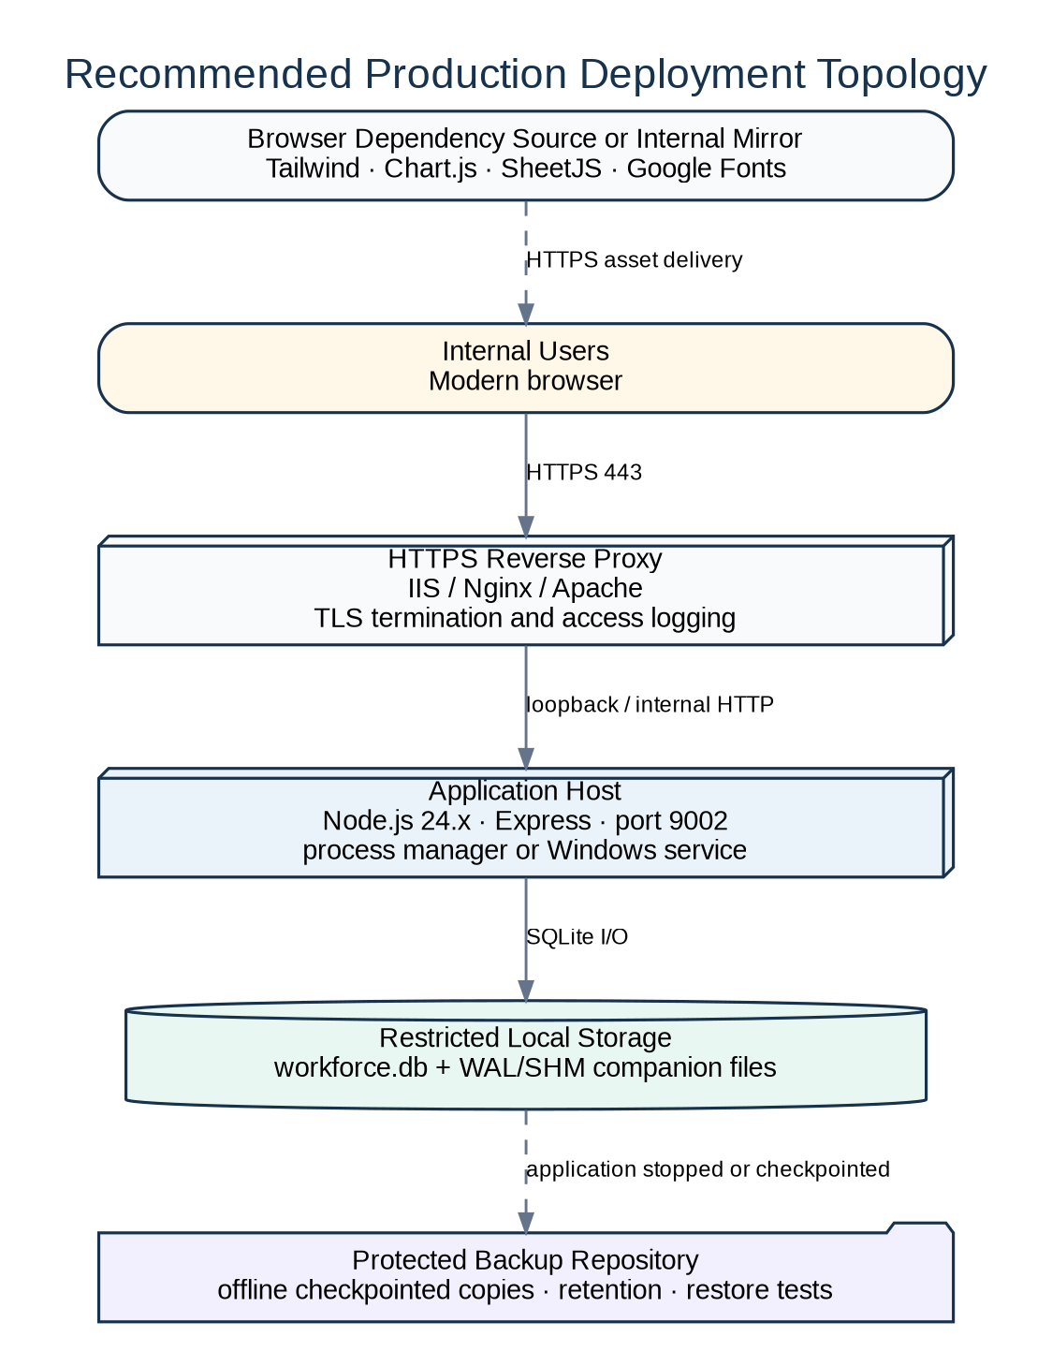
Figure 10 — Recommended Production Deployment Topology

11.2 Installation Procedure
1. Provision a supported Windows or Linux host with Node.js 24.x and npm.
2. Create a restricted application directory and copy the supplied project files, excluding any development-only .git directory if policy requires.
3. Restore the approved production workforce.db into the project root. Do not seed or reset it.
4. Run npm ci when package-lock.json is retained; otherwise run npm install.
5. Review server/config.js and the root-level config.js. Configure HOST/PORT as required; set private DASHBOARD_PASSWORD and MODAL_ACCESS_PASSWORD values; set a long stable DASHBOARD_AUTH_SECRET (prefer service environment variables in production); and confirm DEFAULT_ANNUAL_WORKDAYS, PIPELINE_MULTIPLIER and PROBABLE_REALIZED_THIS_FY.
6. Start the process with npm start and confirm the console listener message.
7. Open /api/health through an authenticated session and verify {"ok":true}.
8. Configure a process manager or Windows service for restart-on-failure and controlled startup.
9. Place an HTTPS reverse proxy in front of the service and restrict direct access to port 9002.
10. Complete the deployment verification checklist and record the backup/rollback point.
Application installation and start
npm ci
# Review server/config.js and root config.js
# Production secrets: DASHBOARD_PASSWORD, MODAL_ACCESS_PASSWORD, DASHBOARD_AUTH_SECRET
npm start

11.3 Reverse Proxy Requirements
- Forward the original Host and X-Forwarded-Proto headers.
- Proxy the application root and all /api/, /css/, /js/ and /views/ paths without rewriting them.
- Set request-size limits above the application’s expected Excel-derived JSON payload but within organizational policy.
- Enable TLS, access logging, sensible timeouts and IP/network restrictions.

11.4 Windows Convenience Start
autorun.bat invokes npm start. It is suitable for interactive local startup but does not provide service recovery, secret management or production logging. Use a controlled Windows service wrapper, Task Scheduler configuration or process manager for production.

11.5 Deployment Verification
Table 23 — Deployment Verification
Check | Expected Result
Node and npm versions | Node ≥ 22.13; target 24.x
Dependency installation | No unresolved packages
Database file permissions | Service can read/write workforce.db directory
Startup migration | No migration errors in console
Login page | Accessible over HTTPS
Invalid login | Rejected with clear message
Valid login | Dashboard loads and wa_auth is set
Protected API | Unauthenticated request returns 401
Health | Authenticated /api/health returns ok
Static/CDN assets | No browser-console failures
Data smoke test | Employees/projects load; no unintended seed/reset
Database integrity | PRAGMA integrity_check = ok

12. OPERATIONS, BACKUP AND TROUBLESHOOTING

12.1 Startup and Shutdown
Start the application through the configured service manager. For shutdown, stop accepting traffic, terminate the Node.js process cleanly and confirm no process holds the database files before copying or replacing them. Startup automatically creates missing schema elements and applies migrations.

12.2 Backup Procedure
Table 24 — Backup and Restore Checklist
Step | Backup | Restore
1 | Notify users and stop the application or obtain a verified SQLite checkpoint. | Stop the application and preserve the failed database separately.
2 | Copy workforce.db and any present -wal / -shm companions together. | Copy the approved backup into the project root with original name.
3 | Store in an access-controlled, versioned location with timestamp and application version. | Confirm owner and file permissions for the service account.
4 | Record file size/hash and retain according to policy. | Start the application and allow migrations to run.
5 | Periodically test a restore in a non-production directory. | Run integrity check and functional smoke tests.

12.3 Database Integrity Check
Example controlled integrity check
const { getAppDb } = require('./server/database');
const db = getAppDb();
console.log(db.prepare('PRAGMA integrity_check').all());
db.close();

12.4 Logging and Monitoring
The supplied application logs startup information, migration corrections and unhandled errors to standard output/error. It does not implement structured file logging, metrics or tracing. Production should capture stdout/stderr through the service manager and monitor process availability, reverse-proxy errors, disk capacity, database backup age and /api/health availability.

12.5 Troubleshooting Guide
Table 25 — Troubleshooting Guide
Symptom | Likely Cause | Action
Port already in use | Another process uses 9002 | Set PORT or stop conflicting process
Login loops | Cookie/secret/proxy mismatch | Clear wa_auth; verify stable secret and X-Forwarded-Proto
node:sqlite unavailable | Node version too old | Upgrade to Node ≥ 22.13; target 24.x
Dashboard loads without data | Missing/unreadable workforce.db or empty source | Check path, permissions and console; do not seed production
Excel parsing unavailable | CDN blocked | Provide local SheetJS or allow approved CDN
Pre-Sale product cannot be deleted | Assignments reference product name | Change/remove assignment references first
Capacity lower than expected | N/A months deduct Workdays | Review unavailable assignment markers
Skill Development appears as Local | Classification source not updated or stale browser assets | Confirm current frontend/backend files and clear cache
Intrasourcing appears as Local | Project uses “Intrasourcing” while main matcher expects “Intrasource” | Rename consistently or correct classifier in controlled release
Large upload fails | Proxy/body-size limit | Review proxy limit and Express 25 MB JSON limit
Database locked / I/O error | Competing process or storage/permission issue | Ensure single writer instance and local writable disk

12.6 Upgrade and Rollback
1. Back up the database and record the current source version before deployment.
2. Deploy source to a staging copy and start it against a restored database copy so migrations are tested.
3. Run syntax, login, CRUD, import and calculation smoke tests.
4. Deploy source without replacing production workforce.db.
5. If rollback is required, stop the process, restore the prior source and—only if an incompatible migration was introduced—the matching database backup. Current migrations are additive/idempotent and are intended to remain backward compatible.

13. VERIFICATION AND ACCEPTANCE

13.1 Static and Startup Verification
- Run node --check across public/, server/ and root JavaScript entry points.
- Start under the target Node.js runtime and review migration output.
- Confirm login, logout, cookie expiry and unauthenticated API behavior.
- Run PRAGMA integrity_check and verify “ok”.

13.2 Functional Regression Checklist
Table 26 — Functional Acceptance Checklist
Area | Acceptance Evidence
Authentication | Invalid password rejected; valid password opens dashboard; logout clears session.
Employee CRUD | Create, edit, Workdays update, active toggle and delete cascade.
Project CRUD | Create/edit/delete, fiscal-period update and deal-status result.
Project import | Forecast and historical partition behavior; duplicate matching; results.
Assignment lifecycle | Create, bulk create, edit, reschedule, select, double-click edit and delete.
Assignment import/export | Export workbook, replace fiscal year, restore resolution and result counts.
N/A behavior | Slot exclusion and one 18.33 Workday deduction per affected month.
Classification | Intrasourcing, Local, Pre-Sale, Training, Skill Development, General Admin and unavailable.
Revenue rates | Five designations; two non-negative values; persistence.
Committed targets | Save, reload and fallback behavior.
Pre-Sale Product | Create/edit/rename/remove, sort, thresholds, referenced-delete protection.
Pre-Sale planning detail | Person, hours, rate and revenue by product reconcile to effective assignments.
Time Sheet upload | Approved work types, month replacement, totals and metadata.
Team/individual charts | Ordering, legend colors and worker normalization.
Plan-to-Execution | Project/month filters, planned/actual totals, retained/added/planned-only.
Pre-Sale details | Product/category filters, impact reset, budgets and resource details.
Skill Development details | Planned and Actual Details remain available with month filter; budgets are zero.
Running projects | Stage/family/progress/date and Product Amount rules.
Capacity | Adjusted Workdays, max amount, allocated amount and remaining amount.
Sales analytics | New Logo/Repeat/Reactive, PS revenue and PS Type charts.
Responsive UI | KPI wrapping, modal scroll, compact Pre-Sale Product and matrix sticky columns.
Backup restore | Restored database passes integrity and smoke tests.

13.3 Calculation Test Cases
Table 27 — Representative Calculation Tests
Case | Input | Expected
Planned hours | 100% one slot | 36.66 h
Planned hours | 50% one slot | 18.33 h
Unavailable denominator | 1 N/A slot in 48-slot FY | 47 available weeks for that resource
Workdays deduction | N/A in two months; base 220 | Adjusted Workdays 183.34
Billable utilization | Intra 20, Local 30, Pre-Sale 10 | 50; Pre-Sale excluded
Project utilization | Intra 20, Local 30, Pre-Sale 10, Training 5 | 65
Pre-Sale confidence | Secured 90, Best Case 70, Product 85 | Best Case
Planned revenue | 18.33 h × $100/h | $1,833.00
Capacity | 200 adjusted days × 8 × $100/h | $160,000.00
Fiscal period | 29 Oct 2025 | Q3-2026

14. SOURCE CODE OVERVIEW

14.1 Bootstrap and Load Order
server.js creates the Express application and listens on the configured host/port. server/app.js composes middleware and routes. The root-level config.js contains business-planning defaults, while server/config.js contains runtime and authentication configuration. public/index.html loads external libraries, core modules, feature modules and finally public/js/app.js. app.js recursively hydrates HTML fragments, initializes event handlers and loads all data.

14.2 Backend Structure
Table 28 — Backend Key Files
Path | Responsibility
server.js | Process entry point and listener
config.js | Root-level business/planning configuration: default annual Workdays, pipeline multiplier and probable realized amount.
server/app.js | Express middleware composition
server/config.js | Paths, listener, passwords, cookie and HMAC configuration
server/auth/index.js | Login/logout, signed cookie and request guard
server/database/connection.js | workforce.db path, WAL and foreign keys
server/database/schema.js | Base table creation
server/database/migrations.js | Idempotent upgrade and compatibility logic
server/routes/*.js | Feature APIs and dashboard datasets
server/services/*.js | Business rules, imports, fiscal, identity, availability, revenue and analytics
sqlite-driver.js | DatabaseSync wrapper and transaction compatibility

14.3 Frontend Structure
Table 29 — Frontend Key Areas
Path | Responsibility
public/index.html | Shell, CDN assets and script order
public/views/header.html | Navigation, search and global actions
public/views/sections/*.html | Dashboard cards, matrix, charts, work summary, insights and projects
public/js/modules/core/ | Shared data, API, state, work schedule and identity rules
public/js/modules/dashboard/ | KPI, matrix summaries, workload, monthly plan and sales
public/js/modules/timesheets/ | Actual-time model, charts and plan-to-execution
public/js/modules/imports/ | Project and assignment Excel workflows
public/js/modules/projects/ | Project and resource list/detail behavior
public/js/modules/ui/ | Assignment and configuration modals plus events
public/css/*.css | Foundation, layout and feature-specific styling

14.4 Source Change Discipline
- Preserve API paths and live data.
- Add schema changes as idempotent migrations.
- Keep the 36.66-hour workweek and four-week-per-month model consistent across modules unless business owners approve a change.
- Apply project classification changes to every frontend and backend classification path.
- Enforce business-critical validation on the server as well as the browser.
- Version cache-busting query strings when browser files change.
- Run syntax checks and the acceptance checklist before release.

15. KNOWN CONSTRAINTS AND RECOMMENDATIONS
Table 30 — Known Constraints and Recommendations
Constraint | As-Built Impact | Recommendation
Shared-password authentication | No individual identity, role or user audit trail. | Maintain controlled password distribution and rotation; add named user accounts only when governance requirements justify the change.
Open CORS and limited web hardening | Any origin can issue cross-origin requests where credentials/policy allow; no explicit security headers or CSRF token. | Restrict CORS, add security headers, CSRF protection and rate limiting.
External browser CDNs | Dashboard import, charts, styling or fonts can fail on restricted/offline networks. | Vendor approved versions locally and apply integrity/version governance.
SQLite single-file design | Best suited to one application instance and modest concurrent write volume. | Keep a single writer; monitor growth; evaluate managed SQL for larger multi-user deployment.
Synchronous database operations | Large imports/queries block the Node event loop during execution. | Profile production data; batch or move heavy work to workers/async DB if needed.
Name-based allocation classification | Local is the fallback and classification depends on project spelling. | Add a persisted project_type field and use name matching only for legacy fallback.
Intrasourcing matcher inconsistency | Main allocation classifier uses /intrasource/i while other modules accept Intrasource or Intrasourcing. | Align all classifiers to /intrasourc(?:e|ing)/i and regression-test existing names.
Pre-Sale Product logical reference | Assignments store product name rather than product id. | Add product_id FK with controlled migration; keep name as display snapshot.
Fixed 48-slot fiscal grid | Four weeks per month does not map exactly to calendar weeks. | Document as planning convention or implement date-based periods if required.
No automated test suite | Verification is manual/static; package scripts contain no test command. | Add unit tests for fiscal, availability, classification, revenue and import rules plus API integration tests.
Console-only logging | No structured audit or persistent diagnostic log. | Implement structured logs, correlation IDs and retention.
Source defaults for secrets | Compatibility passwords exist in source. | Require environment secrets and fail startup when production values are absent.
Live database absent from handover ZIP | Production data volume and record-level quality were not verifiable. | Complete a production data reconciliation and attach signed counts/integrity evidence.

15.1 Prioritized Improvement Roadmap
Table 31 — Improvement Roadmap
Priority | Improvement | Outcome
P1 | Remove source-default secrets; deploy HTTPS; restrict network/CORS; formalize backups | Minimum production control baseline
P1 | Unify allocation classifiers and add automated formula tests | Calculation consistency
P2 | Password governance and audit logging | Accountability and access governance
P2 | Vendor browser dependencies locally | Reliable restricted-network deployment
P2 | Persist project type and Pre-Sale product ID | Data integrity and reduced name dependence
P3 | Structured monitoring and background processing for large imports | Operational scalability
P3 | Evaluate external relational database when concurrency/data growth warrants | Scalable multi-instance architecture

APPENDIX A – COMPLETE API REGISTER
Table 32 — Complete API Register
Method | Path | Purpose
GET | /login | Render login or redirect authenticated user
POST | /login | Validate dashboard password and set signed cookie
POST | /logout | Clear authentication cookie
GET | /api/employees | List employees
POST | /api/employees | Create employee
PUT | /api/employees/:id | Update employee
PATCH | /api/employees/:id/workdays | Update annual Workdays
PATCH | /api/employees/:id/active | Toggle active state
DELETE | /api/employees/:id | Delete employee and cascade assignments
GET | /api/projects | List projects with fiscal/deal status
POST | /api/projects | Create project
POST | /api/projects/import | Import forecast or historical project partition
PUT | /api/projects/:id | Update project
DELETE | /api/projects/:id | Delete project and cascade assignments
GET | /api/assignments | List assignments for fiscal year
POST | /api/assignments | Create one assignment
POST | /api/assignments/bulk | Create assignments for multiple slots
POST | /api/assignments/import | Replace/import fiscal-year assignments
PUT | /api/assignments/:id | Update assignment
POST | /api/assignments/:id/reschedule | Replace one assignment with multiple slots
DELETE | /api/assignments/:id | Delete assignment
GET | /api/timesheet-summary | List actual entries and metadata
POST | /api/timesheet-summary/bulk | Replace/upsert uploaded months
DELETE | /api/timesheet-summary | Clear all actual entries
GET | /api/revenue-rates | List designation rates
PUT | /api/revenue-rates | Save all designation rates
GET | /api/committed-targets | List committed targets
PUT | /api/committed-targets/:targetKey | Save one target
GET | /api/presale-products | List products
PUT | /api/presale-products | Save full product set
GET | /api/presale-product-settings | Read confidence thresholds
PUT | /api/presale-product-settings | Save thresholds
GET | /api/dashboard/stats | Executive KPI dataset
GET | /api/dashboard/trends | Utilization trends
GET | /api/dashboard/workload | Workload distribution
GET | /api/dashboard/utilization | Utilization summary
GET | /api/dashboard/utilization-details | Per-resource utilization detail
GET | /api/dashboard/pipeline | Pipeline data
GET | /api/dashboard/project-portfolio-metrics | Running/weighted/prospect counts
GET | /api/dashboard/running-project-metrics | Running project timing and revenue
GET | /api/dashboard/deadlines | Project deadlines
GET | /api/dashboard/new-logo-chart | New Logo / Repeat / Reactive chart data
GET | /api/dashboard/ps-revenue-chart | PS revenue by fiscal year/category
GET | /api/dashboard/ps-type-chart | Support vs implementation counts
GET | /api/fiscal-years | Available assignment fiscal years
POST | /api/modal-access/verify | Verify protected-modal password
GET | /api/health | Health response

APPENDIX B – DATABASE DATA DICTIONARY

employees
Table 33 — Data Dictionary – employees
Field | Type | Constraint / Default | Purpose
id | INTEGER | PK AUTOINCREMENT | Resource identifier
employee_code | TEXT | DEFAULT '' | External resource code
name | TEXT | NOT NULL | Canonical display name
dept | TEXT | NOT NULL | Department
designation | TEXT | DEFAULT '' | Rate-designation lookup
workdays | INTEGER | NOT NULL DEFAULT 220 | Annual base Workdays
email | TEXT |  | Contact email
created_at | TEXT | DEFAULT CURRENT_TIMESTAMP | Creation timestamp
active | INTEGER | NOT NULL DEFAULT 1 | 1 active, 0 inactive

projects
Table 34 — Data Dictionary – projects
Field | Type | Constraint / Default | Purpose
id | INTEGER | PK AUTOINCREMENT | Project identifier
code | TEXT | NOT NULL | Opportunity/project code; duplicates supported after migration
name | TEXT | NOT NULL | Project/opportunity name
client | TEXT |  | Legacy client name
budget | REAL | DEFAULT 0 | Legacy/amount value
spent_pct | INTEGER | DEFAULT 0 | Legacy spent percentage
end_date | TEXT |  | Closed Won / Close Date
stage | TEXT | DEFAULT 'Prospect' | Sales stage
progress | INTEGER | DEFAULT 0 | Delivery progress percentage
color | TEXT | DEFAULT '#8B5CF6' | Matrix/chart color
priority | TEXT | DEFAULT 'Medium' | Priority label
created_at | TEXT | DEFAULT CURRENT_TIMESTAMP | Database creation timestamp
product_amount | REAL | DEFAULT 0 | Product reference/revenue amount
account_name | TEXT | DEFAULT '' | Account/customer
product_name | TEXT | DEFAULT '' | Product description
opportunity_owner | TEXT | DEFAULT '' | Opportunity owner
opp_amount | REAL | DEFAULT 0 | Opportunity amount
probability | INTEGER | DEFAULT 0 | Probability percentage
created_date | TEXT | DEFAULT '' | Opportunity creation date
project_closing_date | TEXT | DEFAULT '' | Operational closing/deadline date
product_family | TEXT | DEFAULT '' | Product family / PS classification
fiscal_period | TEXT |  | Calculated or imported fiscal period
import_row_no | INTEGER |  | Source row identifier

assignments
Table 35 — Data Dictionary – assignments
Field | Type | Constraint / Default | Purpose
id | INTEGER | PK AUTOINCREMENT | Assignment row
employee_id | INTEGER | NOT NULL FK | Resource; cascade delete
project_id | INTEGER | NOT NULL FK | Project; cascade delete
year | INTEGER | NOT NULL | Calendar year of slot
month | INTEGER | NOT NULL | Month 1–12
week | INTEGER | NOT NULL | Application week 1–4
percentage | INTEGER | NOT NULL DEFAULT 0 | Allocation percentage
customer_name | TEXT | DEFAULT '' | Assignment customer snapshot
product_name | TEXT | DEFAULT '' | Pre-Sale product logical reference
created_at | TEXT | DEFAULT CURRENT_TIMESTAMP | Creation timestamp

timesheet_entries
Table 36 — Data Dictionary – timesheet_entries
Field | Type | Constraint / Default | Purpose
id | INTEGER | PK AUTOINCREMENT | Actual row
month | TEXT | NOT NULL | Source month
worker | TEXT | NOT NULL | Canonicalized worker text
work_type | TEXT | NOT NULL | Canonical work type
project_name | TEXT | NOT NULL DEFAULT '' | Source project text
qty | REAL | NOT NULL DEFAULT 0 | Actual hours
source_file | TEXT |  | Upload filename
sheet_name | TEXT |  | Workbook sheet
uploaded_at | TEXT | DEFAULT CURRENT_TIMESTAMP | First upload timestamp
updated_at | TEXT | DEFAULT CURRENT_TIMESTAMP | Latest update timestamp
UQ |  | month + worker + work_type + project_name | Upsert key

designation_revenue_rates
Table 37 — Data Dictionary – designation_revenue_rates
Field | Type | Constraint / Default | Purpose
designation | TEXT | PK | Supported designation
professional_service_rate | REAL | NOT NULL DEFAULT 0 CHECK ≥ 0 | Legacy synchronized value
intrasourcing_rate | REAL | NOT NULL DEFAULT 0 CHECK ≥ 0 | Intrasourcing hourly rate
local_rate | REAL | NOT NULL DEFAULT 0 CHECK ≥ 0 | Shared Local/Pre-Sale/Training rate
pre_sale_rate | REAL | NOT NULL DEFAULT 0 CHECK ≥ 0 | Legacy synchronized local value
training_rate | REAL | NOT NULL DEFAULT 0 CHECK ≥ 0 | Legacy synchronized local value
updated_at | TEXT | NOT NULL DEFAULT CURRENT_TIMESTAMP | Last save

committed_revenue_targets
Table 38 — Data Dictionary – committed_revenue_targets
Field | Type | Constraint / Default | Purpose
target_key | TEXT | PK CHECK intrasourcing/local | Target category
amount | REAL | NOT NULL DEFAULT 0 CHECK ≥ 0 | Target amount
updated_at | TEXT |  | Null until manually saved

presale_products
Table 39 — Data Dictionary – presale_products
Field | Type | Constraint / Default | Purpose
id | INTEGER | PK AUTOINCREMENT | Product identifier
name | TEXT | NOT NULL UNIQUE NOCASE | Master product name
amount | REAL | NOT NULL DEFAULT 0 CHECK ≥ 0 | Reference amount
probability_percent | REAL | 0–100 check | Confidence percent
created_at | TEXT | NOT NULL DEFAULT CURRENT_TIMESTAMP | Creation timestamp
updated_at | TEXT | NOT NULL DEFAULT CURRENT_TIMESTAMP | Last save

presale_product_settings
Table 40 — Data Dictionary – presale_product_settings
Field | Type | Constraint / Default | Purpose
id | INTEGER | PK CHECK id=1 | Singleton row
secured_min_percent | REAL | NOT NULL DEFAULT 90 | Secured lower bound
best_case_min_percent | REAL | NOT NULL DEFAULT 70 | Best Case lower bound
updated_at | TEXT | NOT NULL DEFAULT CURRENT_TIMESTAMP | Last save

APPENDIX C – SOURCE FILE INVENTORY
The inventory below excludes node_modules, the embedded .git object store and generated database companion files. It records the source and support files present in the supplied application snapshot.
Table 41 — Complete Source File Inventory
Path | Responsibility
.gitignore | Git repository metadata (not production runtime content).
README.md | Operational and developer documentation.
autorun.bat | Windows interactive start helper.
config.js | Root-level business/planning configuration for annual Workdays, Pipeline Multiplier and Probable Realized This FY.
db.js | Database reset/seed command-line entry.
historical_seed.json | Controlled seed dataset; destructive seed/reset use only.
package-lock.json | Locked npm dependency graph.
package.json | Package metadata, engines, dependencies and scripts.
pipeline_seed.json | Controlled seed dataset; destructive seed/reset use only.
public/css/components.css | Feature-specific or foundational stylesheet.
public/css/drag-drop.css | Feature-specific or foundational stylesheet.
public/css/foundation.css | Feature-specific or foundational stylesheet.
public/css/layout.css | Feature-specific or foundational stylesheet.
public/css/matrix-assignments.css | Feature-specific or foundational stylesheet.
public/css/matrix-summary.css | Feature-specific or foundational stylesheet.
public/css/matrix.css | Feature-specific or foundational stylesheet.
public/css/monthly-planned-work.css | Feature-specific or foundational stylesheet.
public/css/planned-actual.css | Feature-specific or foundational stylesheet.
public/css/project-lists.css | Feature-specific or foundational stylesheet.
public/css/sales-charts.css | Feature-specific or foundational stylesheet.
public/css/style.css | Feature-specific or foundational stylesheet.
public/css/timesheets.css | Feature-specific or foundational stylesheet.
public/index.html | Frontend shell and script/style dependency order.
public/js/app.js | Fragment hydration and application bootstrap.
public/js/modules/core/api.js | Shared browser state, API or foundational rule.
public/js/modules/core/availability.js | Shared browser state, API or foundational rule.
public/js/modules/core/data.js | Shared browser state, API or foundational rule.
public/js/modules/core/designations.js | Shared browser state, API or foundational rule.
public/js/modules/core/person-identity.js | Shared browser state, API or foundational rule.
public/js/modules/core/state.js | Shared browser state, API or foundational rule.
public/js/modules/core/work-schedule.js | Shared browser state, API or foundational rule.
public/js/modules/dashboard/insights.js | Dashboard KPI, matrix or sales visualization module.
public/js/modules/dashboard/monthly-planned-work.js | Dashboard KPI, matrix or sales visualization module.
public/js/modules/dashboard/overview.js | Dashboard KPI, matrix or sales visualization module.
public/js/modules/dashboard/resource-summary-metrics.js | Dashboard KPI, matrix or sales visualization module.
public/js/modules/dashboard/resource-summary-totals.js | Dashboard KPI, matrix or sales visualization module.
public/js/modules/dashboard/resource-summary.js | Dashboard KPI, matrix or sales visualization module.
public/js/modules/dashboard/sales-acquisition.js | Dashboard KPI, matrix or sales visualization module.
public/js/modules/dashboard/sales-common.js | Dashboard KPI, matrix or sales visualization module.
public/js/modules/dashboard/sales-ps-type.js | Dashboard KPI, matrix or sales visualization module.
public/js/modules/dashboard/sales-revenue.js | Dashboard KPI, matrix or sales visualization module.
public/js/modules/dashboard/workload.js | Dashboard KPI, matrix or sales visualization module.
public/js/modules/imports/assignments.js | Browser Excel import/export workflow.
public/js/modules/imports/projects.js | Browser Excel import/export workflow.
public/js/modules/projects/lists.js | Project/resource list and detail module.
public/js/modules/projects/resources.js | Project/resource list and detail module.
public/js/modules/timesheets/charts.js | Time Sheet, chart or Plan-to-Execution module.
public/js/modules/timesheets/model.js | Time Sheet, chart or Plan-to-Execution module.
public/js/modules/timesheets/planned-actual-chart.js | Time Sheet, chart or Plan-to-Execution module.
public/js/modules/timesheets/planned-actual-model.js | Time Sheet, chart or Plan-to-Execution module.
public/js/modules/timesheets/team-summary-comparison.js | Time Sheet, chart or Plan-to-Execution module.
public/js/modules/timesheets/ui.js | Time Sheet, chart or Plan-to-Execution module.
public/js/modules/timesheets/upload.js | Time Sheet, chart or Plan-to-Execution module.
public/js/modules/ui/assignment-modal.js | Modal, event or UI interaction module.
public/js/modules/ui/committed-targets-modal.js | Modal, event or UI interaction module.
public/js/modules/ui/events.js | Modal, event or UI interaction module.
public/js/modules/ui/modal-shell.js | Modal, event or UI interaction module.
public/js/modules/ui/presale-products-modal.js | Modal, event or UI interaction module.
public/js/modules/ui/protected-modal-access.js | Modal, event or UI interaction module.
public/js/modules/ui/resource-project-modals.js | Modal, event or UI interaction module.
public/js/modules/ui/revenue-breakdown-modal.js | Modal, event or UI interaction module.
public/js/modules/ui/revenue-rates-modal.js | Modal, event or UI interaction module.
public/views/header.html | HTML fragment for dashboard navigation or section.
public/views/sections/allocation-charts.html | HTML fragment for dashboard navigation or section.
public/views/sections/insights.html | HTML fragment for dashboard navigation or section.
public/views/sections/projects.html | HTML fragment for dashboard navigation or section.
public/views/sections/resource-matrix.html | HTML fragment for dashboard navigation or section.
public/views/sections/sales-acquisition-tab.html | HTML fragment for dashboard navigation or section.
public/views/sections/sales-charts.html | HTML fragment for dashboard navigation or section.
public/views/sections/sales-ps-type-tab.html | HTML fragment for dashboard navigation or section.
public/views/sections/sales-revenue-tab.html | HTML fragment for dashboard navigation or section.
public/views/sections/stats.html | HTML fragment for dashboard navigation or section.
public/views/sections/work-summary.html | HTML fragment for dashboard navigation or section.
server.js | HTTP process entry point.
server/app.js | Express application composition.
server/auth/index.js | Authentication and login implementation.
server/auth/login-page.js | Authentication and login implementation.
server/config.js | Runtime and authentication configuration.
server/database/connection.js | Database connection, schema, migration or seed layer.
server/database/index.js | Database connection, schema, migration or seed layer.
server/database/migrations.js | Database connection, schema, migration or seed layer.
server/database/schema.js | Database connection, schema, migration or seed layer.
server/database/seed-data.js | Database connection, schema, migration or seed layer.
server/database/seeder.js | Database connection, schema, migration or seed layer.
server/routes/assignments.js | Feature-specific Express API router.
server/routes/committed-targets.js | Feature-specific Express API router.
server/routes/dashboard-core.js | Feature-specific Express API router.
server/routes/dashboard-new-logo.js | Feature-specific Express API router.
server/routes/dashboard-ps-type.js | Feature-specific Express API router.
server/routes/dashboard-revenue.js | Feature-specific Express API router.
server/routes/employees.js | Feature-specific Express API router.
server/routes/index.js | Feature-specific Express API router.
server/routes/misc.js | Feature-specific Express API router.
server/routes/presale-products.js | Feature-specific Express API router.
server/routes/projects.js | Feature-specific Express API router.
server/routes/revenue-rates.js | Feature-specific Express API router.
server/routes/timesheets.js | Feature-specific Express API router.
server/services/assignment-import.js | Reusable business/validation/import service.
server/services/assignment-metadata.js | Reusable business/validation/import service.
server/services/availability.js | Reusable business/validation/import service.
server/services/committed-targets.js | Reusable business/validation/import service.
server/services/fiscal.js | Reusable business/validation/import service.
server/services/person-identity.js | Reusable business/validation/import service.
server/services/presale-products.js | Reusable business/validation/import service.
server/services/project-analytics.js | Reusable business/validation/import service.
server/services/project-colors.js | Reusable business/validation/import service.
server/services/project-import.js | Reusable business/validation/import service.
server/services/revenue-rates.js | Reusable business/validation/import service.
server/services/timesheet-normalizer.js | Reusable business/validation/import service.
server/services/values.js | Reusable business/validation/import service.
sqlite-driver.js | node:sqlite compatibility wrapper.

APPENDIX D – FORMULA AND RULE QUICK REFERENCE
Table 42 — Formula Quick Reference
Topic | Formula / Rule
Fiscal year | April–March; FY label is ending calendar year.
Fiscal quarter | Q1 Apr–Jun; Q2 Jul–Sep; Q3 Oct–Dec; Q4 Jan–Mar.
Planning slots | 4 weeks per month; 48 slots per fiscal year.
Planned hours | 36.66 × allocation % ÷ 100.
N/A slot | Exclude marker and all other assignments in same resource/year/month/week.
Adjusted Workdays | max(0, base Workdays − 18.33 × affected N/A months).
Allocation average | sum category percentage ÷ available fiscal weeks.
Intrasourcing utilization | Intrasourcing average.
Billable utilization | Intrasourcing + Local.
Project utilization | Intrasourcing + Local + Pre-Sale + Training.
Assignment revenue | Planned hours × applicable designation rate.
Max capacity | Σ adjusted Workdays × 8 × shared Local rate.
Capacity allocated | Planned Intrasourcing revenue + planned Local revenue.
Remaining capacity | Max capacity − Capacity allocated.
Committed target | Saved Intrasourcing target + saved Local target.
Pre-Sale planned/actual budget | Matched hours × shared Local rate.
Pre-Sale Impact | Distinct included Product Amount values.
Secured | Percent ≥ Secured threshold.
Best Case | Best Case threshold ≤ Percent < Secured threshold.
Prospect | Percent < Best Case threshold.
Running project | Closed Won + PS family + progress < 100 + date ≥ 2025-03-01.
Running PS revenue | Sum Product Amount only.
Sales chart revenue | Product Amount if positive; otherwise Opportunity Amount/Budget.
NEW LOGO | First fiscal Closed Won account occurrence.
REPEAT | Same/next consecutive fiscal year.
REACTIVE | Return after fiscal-year gap > 1.

APPENDIX E – IT REQUIREMENTS

E.1 Application Source and Deployment Record
This appendix records the environment-specific source-control, deployment, access and network requirements for the current internal deployment of the Assignment Dashboard Application. These values shall be reviewed whenever the application is redeployed, the hosting workstation changes, or access controls are rotated.
Table 43 — IT Requirements and Deployment Record
Item | As-Built / Required Value
Source Repository | https://github.com/Esri-Bangladesh/assignment-dashboard
Deployment Branch | development
Deployment Host | Workstation of Debashish Bhowmick
Application Listener | 0.0.0.0:9002
Required Open Port | TCP 9002 inbound to the deployment workstation from authorized client networks
User Access Password | Esr!@9122
Access Scope | Internal / authorized users only

E.2 Network and Security Controls
- Configure the workstation firewall to allow inbound TCP port 9002 only from approved internal client networks or designated support workstations.
- Do not expose TCP port 9002 directly to the public internet. Where an HTTPS reverse proxy is used, client traffic should terminate on the approved proxy port and be forwarded internally to application port 9002.
- Application deployment updates should be taken from the development branch only after validation and after creating a recoverable backup of the live workforce.db database.
- The access password recorded above is operationally sensitive. Distribution of this document should remain restricted to authorized personnel, and the credential should be rotated whenever exposure is suspected or access responsibility changes.

