# ENG5220: Real Time Embedded Programming

# Project Brief: Interview Armour

Team 3: Natalie Flaherty; Eilidh Johnston; Jack Marston

# Introduction

The requirement for this assignment is to “Development, design, construction and promotion of a product requiring real time operation”.

This document outlines the proposed solution and lists the objectives and deliverables required to fulfil the assignment marking guide.

# Proposed Solution

The proposed solution will be a wearable “backpack” that an individual will wear underneath their clothing when they expect to be in a high-stress situation such as a job interview or during examinations, for example.

The backpack will contain a Raspberry Pi and have up to 10 vibrating motor, position in three distinct areas across the upper back. The backpack will work in two modes: autonomous and user initiated.

The autonomous system will be developed to continuously measure the heart rate of an individual wearing a pulse oximeter[1]. By monitoring the heart rate, and using widely acknowledged heart rate values for stress, the system will activate motors when the systems detects a noticeable increase in heart rate. The purpose of the motors is to provide trigger point massage with the intention of reducing the heart rate by relieving the individual’s stress levels.

The motors are grouped into “banks”. It is anticipated that there will be three banks of motors, relating to three different areas of the upper back, shown in Figure 1:

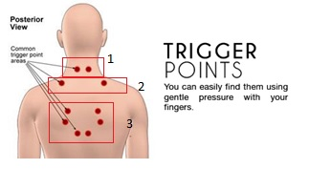

Figure 1 – Diagram of stress relieving trigger points. http://northernspinal.com.au/self-massage-techniques-stress-free-life/

Additionally, the user will have the option of manually switching on the motors by selecting which bank of motors they require from a simple web form.

Figure 2 is a block diagram showing the different aspects of the proposed system:

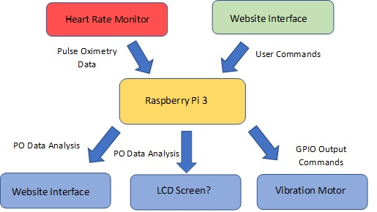

Figure 2 – A block diagram of the proposed solution.

# Objective, Deliverables and Timescales

1. Create the product branding; this will include a logo, colour scheme and product tag line.

**Output:**

* JPEG images of:
  + Logo
  + Product name
  + Product tag line
* Github page
* Instagram Account
* Twitter
* Youtube Channel

**Output:** Powerpoint Presentation required for the initial pitch which will be discussion and assessed.

**Duration:** 1 week.

**Completion:** 30/01/19.

**Risks:** The required usernames are unavailable, and no other suitable name is available.

1. Circuit design

By carrying out a short internet research task and in collaboration with the lab demonstrators, a list of the electronics required to build the circuitry required to control and power the motors should be written and location of these parts should be identified (available at the university or required to be ordered). A diagram of the basic circuitry should be drawn up.

An additional circuit should also be designed, ideally include an LED and a single motor. The purpose of this circuit it to allow the writing of the control code to begin.

**Output:** List of components. Diagram of circuitry. Initial basic circuit.

**Duration:** 1 week.

**Completion:** 8/02/18

**Risks:** No suitable circuit diagram software is available.

1. Build heart rate monitor

Using the available literature, build the heart rate monitor using a suitable photodiode and/or ambient light sensor.

Create full circuit diagram.

Produce test output – corroborate heart rate monitor using output from Apple watch.

**Duration:** 3 weeks

**Completion:** 04/03/19.

**Risks:** Incorrect choice of photodiode choice

Incompatible S/N ratio

1. Build website for controlling the motors remotely

Create an interactive website so that the user can choose which banks of motors to switch on.

**Duration:** 2 weeks

**Completion:** 25/02/19.

**Risks:** No suitable web host can be found

Incorrect commands used for communication

1. The location of the heart rate monitor has yet to be decided on. Ideally, it would be position on the skin of the abdomen.