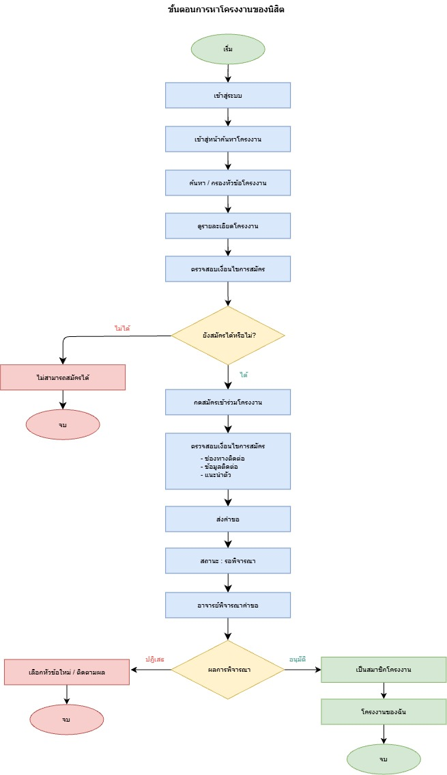

Login 1

S031

S001

T001

S029

S004

S003

S002

S002

S001

S001

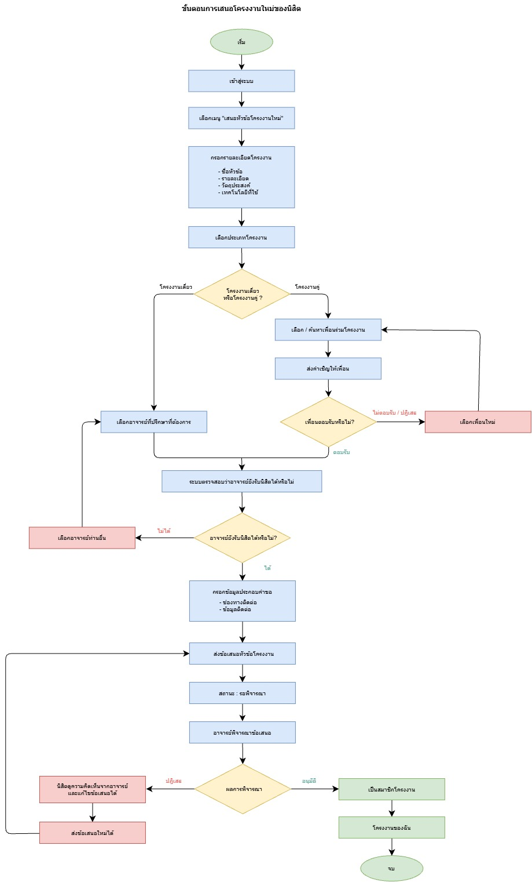
Login 1
S031

S034

S034

T001
S029

S025

S014

S024

S011

S011

S017

S018

S017

S011

S011

S011

S011

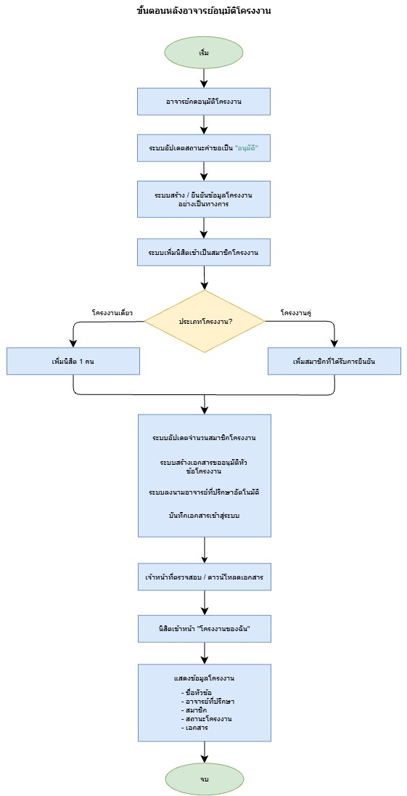

S032
S031
A001
T006
T004

S031

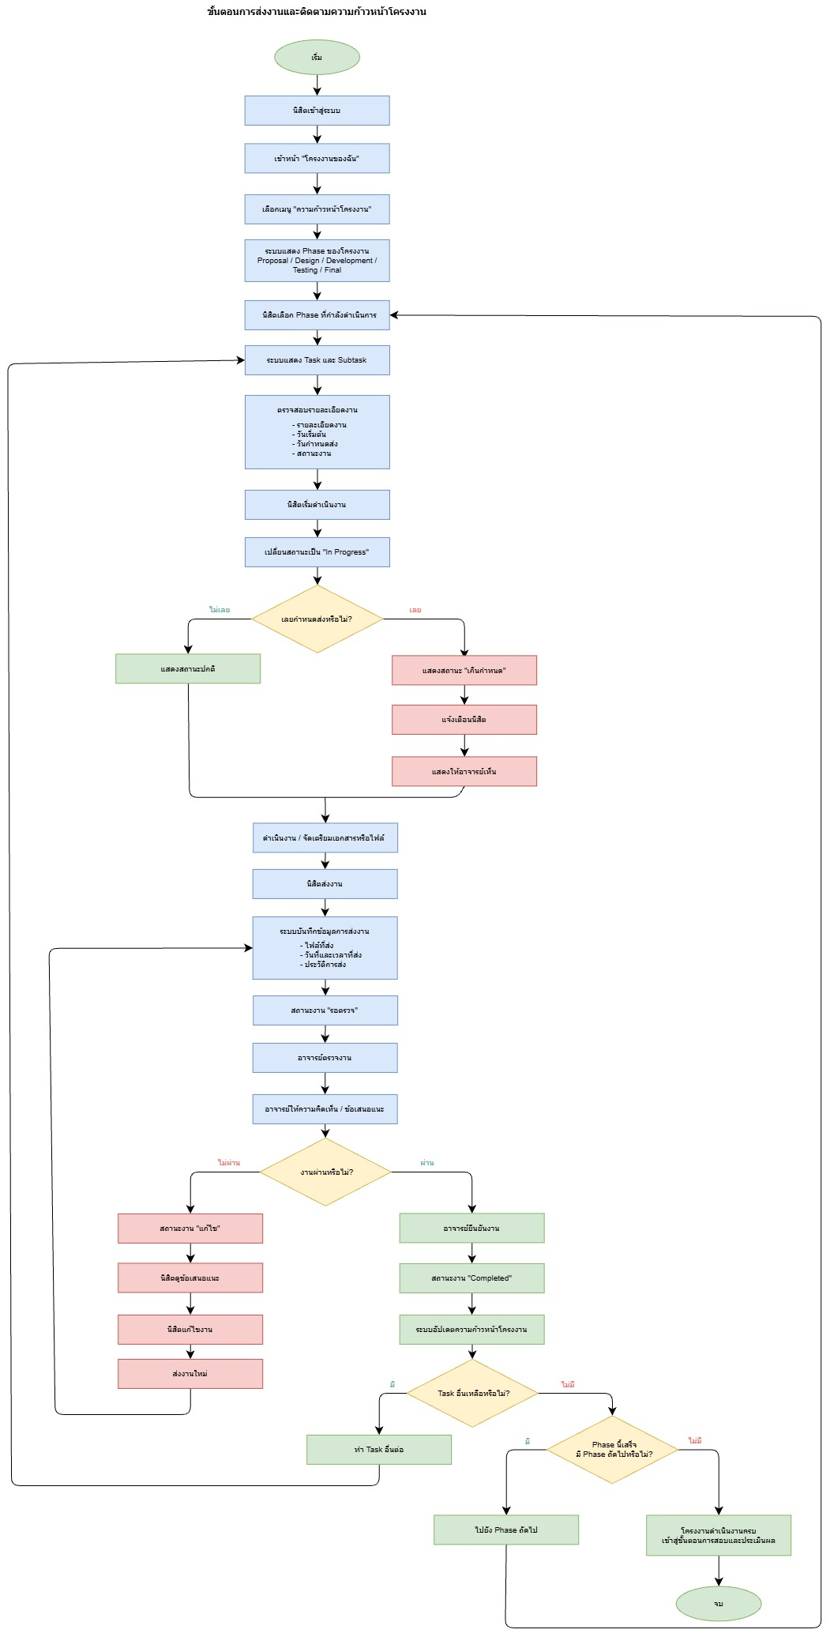
S031
S001
S040

S040

S050

S040

S040

S039

S038
