Rice farming with crop rotation for smallholder farmers in Indonesia

Noviria Syifaun Nafsi, Sineenad Kongtonkun, Inkyin May, Vani Lian

2023-07-13

## Introduction

### Overview

Indonesia is the largest country in Southeast Asia. Rice is the primary staple food crop with a steady increase in annual production, making Indonesia the third largest rice producer in the world. 93% of Indonesia’s total number of farmers are small family farms. Rice is the main crop grown and staple food in Southeast Asia.(Yoshida (1981)) Crop rotation is the practice of planting different crops sequentially on the same plot of land to improve soil health, optimize nutrients in the soil, and combat pest and weed pressure.(Crystal and Whittlesey (2004)) Soybean is a species of legume native to East Asia, widely grown for its edible bean which has numerous uses.(Wright et al. (2005)) Chili is a plant of tropical and subtropical regions for their fleshy fruits.(MOALF (2016))

### Motivation

1. Rice is the primary staple food crop with a steady increase in annual production, making Indonesia the third largest rice producer in the world.
2. Crop rotation can increase crop yields and income than monoculture of rice and it can help disrupt the lifecycle of crop pests and reducing chemical use.
3. Soybean can increase soil fertility and give extra income to farmers.
4. Chili cultivation can improve farmers’ income because of good market price.

### Overview of the project

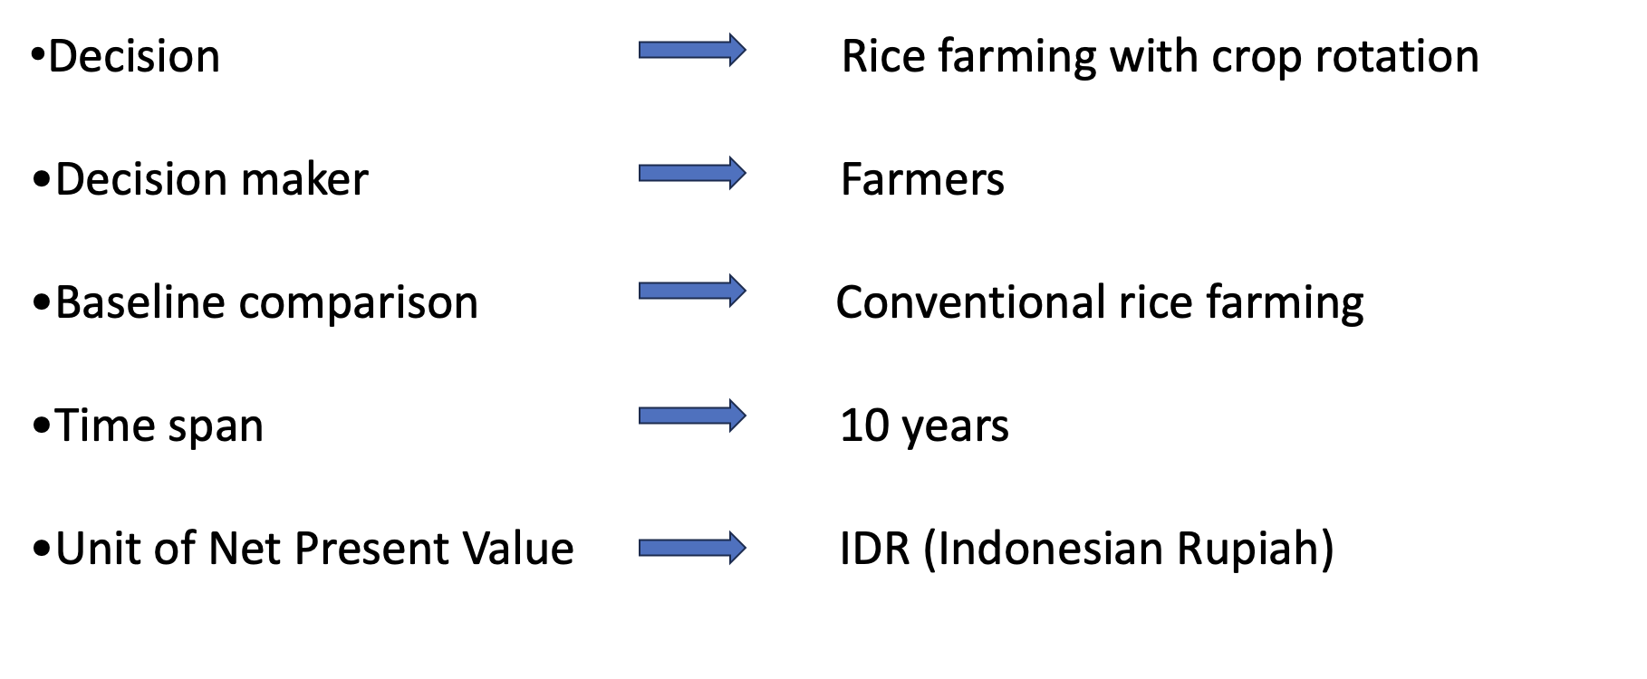

### Conceptual model

This project will analyse the decision of crop rotation (soybean and chili) with rice farming. Total cost is calculated for each crop, which consists of labor, seeds, pesticides, fertilizer, machinery and rent land. The revenues is calculated for each crop production by multiplying the yield of each crop by the selling price of each crop per ha. The total cost, revenues and discount rate are used as variable estimates in order to calculate the Net Present Value (NVP).

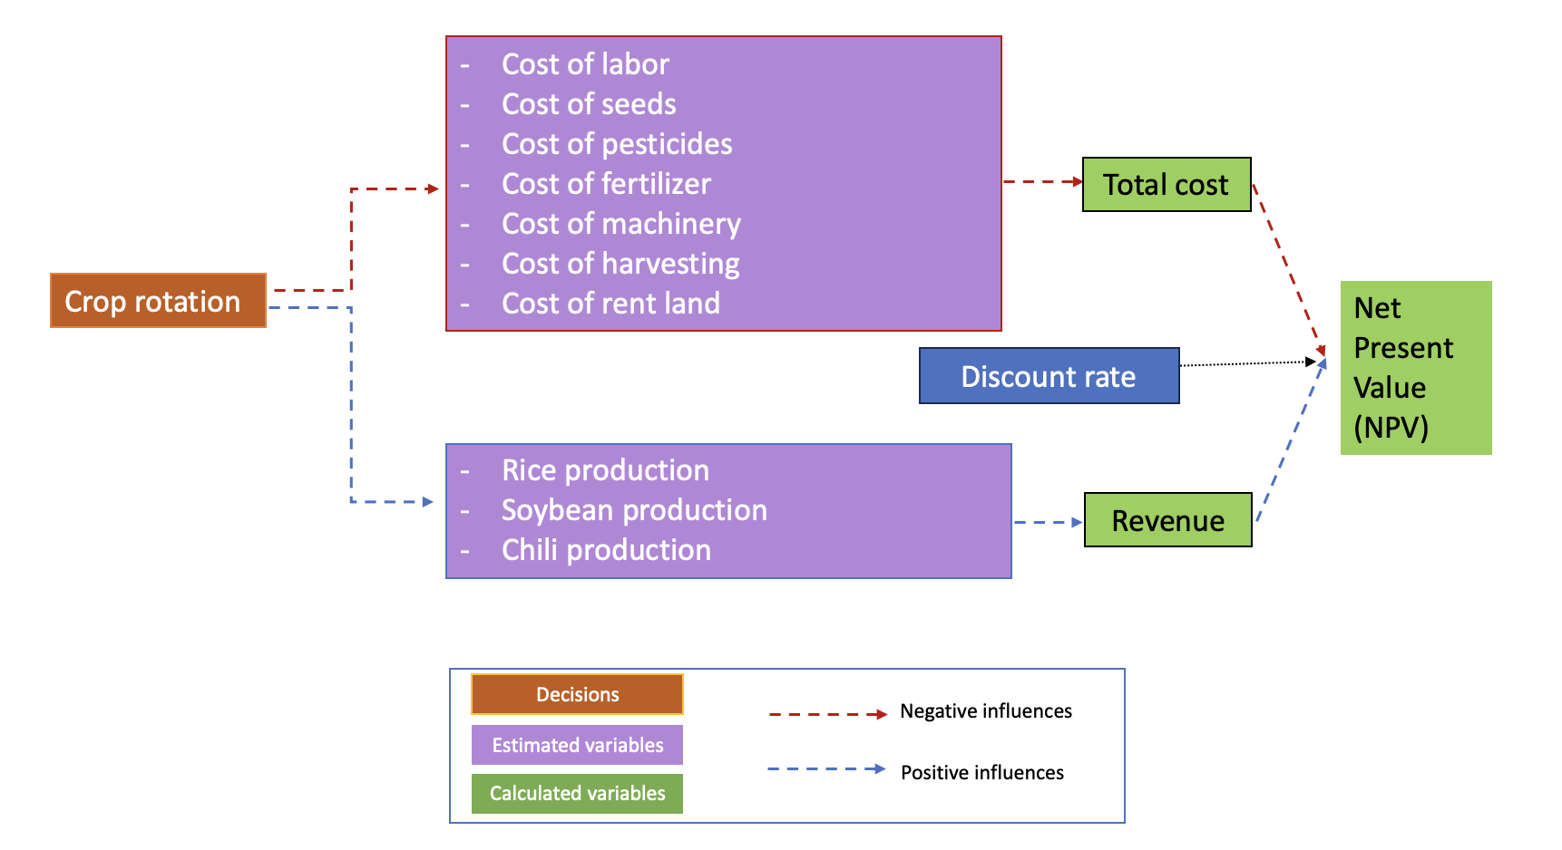

### Variable used in conceptual model

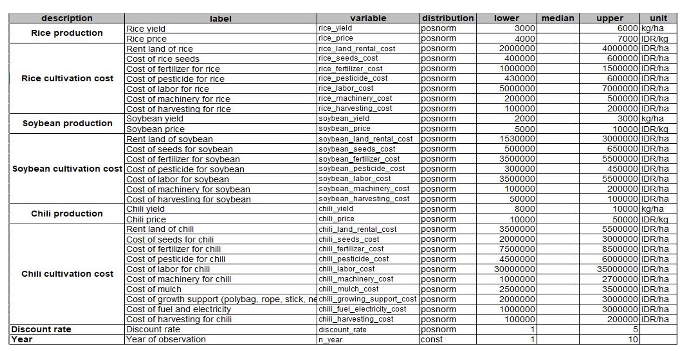

Variable for rice farm and crop rotation for small holder farmers in Indonesia have 8 mains variables that are consist of rice production, rice cultivation cost, soybean production, soybean cultivation cost, chili production, chili cultivation cost, discount rate and year of system. Overall, there are 33 variables that are used for this decision analysis.

**Source** :

BPS (2018), Mucharam et al. (2020), Jagung (2017), Fao (2018), BPS (2022), Amirrullah (2019), Crystal and Whittlesey (2004), Jagung (2017), BRIN (2022), USDA (2012), Setiartiti (2021), Antriyandarti (2015), Krisdiana et al. (2021), Harsono et al. (2020), Schilling (1999), Wandschneider et al. (2019), Sundari et al. (2021)

## Estimate Calculation

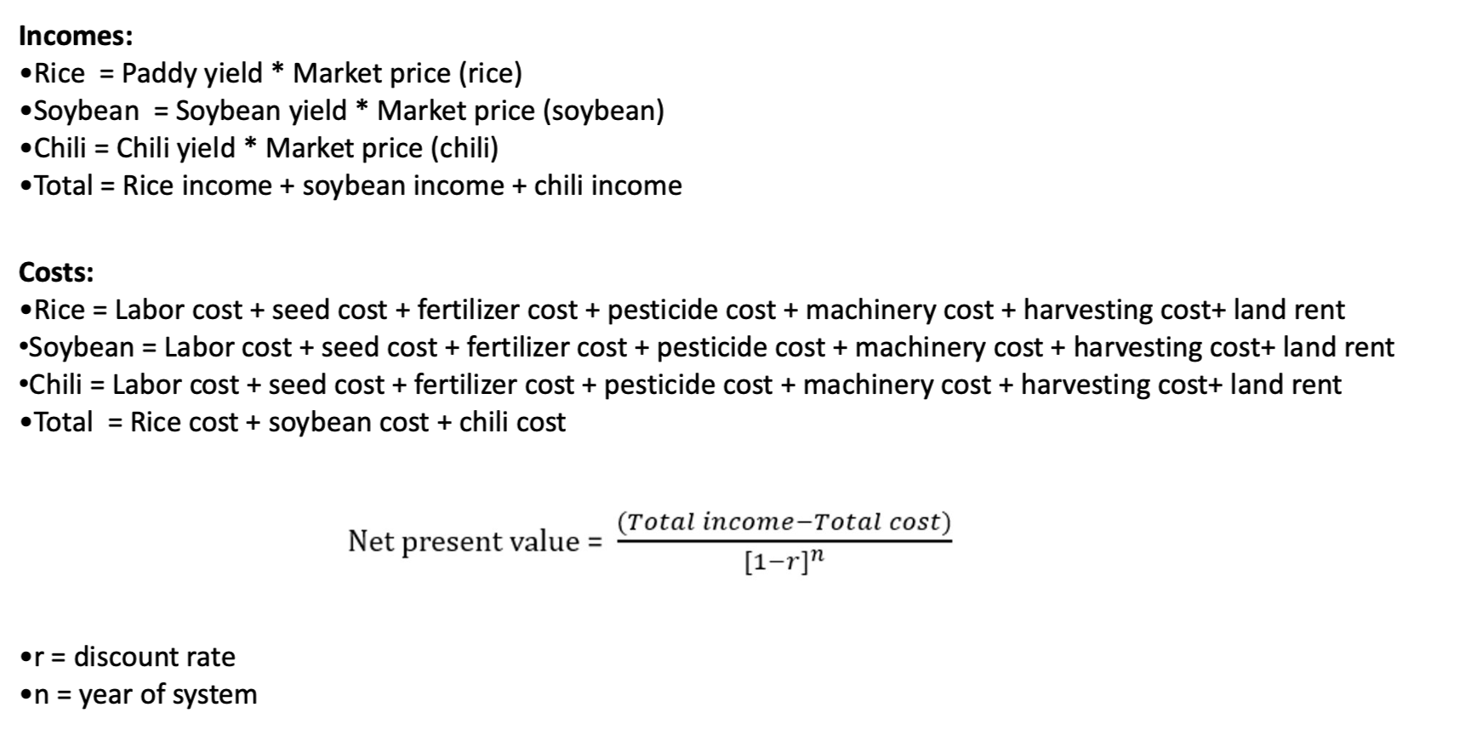 **NPV (Net Present Value)**: In financial terms, the NPV the measurement of the profitability of a project or programme. This is achieved by subtracting the current values of expenditure from the current values of income over a period of time. Income can be referred to as benefit and expenditure can be referred to as cost.

**Discount Rate**: The discount rate is the interest rate used in analysis of discounted cash flow (DCF).

Stantec (2005)

## Decision analysis

### R code

Do, Luedeling, and Whitney (2020)

crop_rotation_decision <- function(){  
   
 # Estimate the income of rice in a normal season  
 rice_income <- vv(rice_yield * rice_price, n=n_year, var_CV=100)  
   
 # Estimate the income of soybean in a normal season  
 soybean_income <- vv(soybean_yield * soybean_price, n=n_year, var_CV=100)  
   
 # Estimate the income of chili in a normal season  
 chili_income <- vv(chili_yield * chili_price, n=n_year, var_CV=100)  
   
 #Estimate the cost of rice farm in a normal season  
 rice_cost_precal <- sum(rice_land_rental_cost, rice_seeds_cost, rice_fertilizer_cost,  
 rice_pesticide_cost, rice_machinery_cost, rice_harvesting_cost)  
 rice_cost <- vv(rice_cost_precal, n=n_year, var_CV=100)  
   
   
 #Estimate the cost of soybean farm in a normal season  
 soybean_cost_precal <- sum(soybean_land_rental_cost, soybean_seeds_cost, soybean_fertilizer_cost,  
 soybean_pesticide_cost, soybean_machinery_cost, soybean_harvesting_cost)  
 soybean_cost <- vv(soybean_cost_precal, n=n_year, var_CV=100)  
   
   
 #Estimate the cost in a normal season  
 chili_cost_precal <- sum(chili_land_rental_cost, chili_seeds_cost, chili_fertilizer_cost,  
 chili_pesticide_cost, chili_machinery_cost, chili_harvesting_cost)  
 chili_cost <- vv(chili_cost_precal, n=n_year, var_CV=100)  
   
   
 # Estimate the profit  
 rice_profit <- vv(rice_income - rice_cost, n=n_year, var_CV=100)  
 soybean_profit <- vv(soybean_income - soybean_cost, n=n_year, var_CV=100)  
 chili_profit <- vv(chili_income - chili_cost, n=n_year, var_CV=100)  
   
   
 # Final result  
 #assuming rice cultivation is 3 times per year   
 rice_cultivation_result = vv(rice_profit*3, n=n_year, var_CV=100)  
   
 #crop rotation decision scenario  
 #if crop rotation of 3 crops is done in one year  
 crop_rotation_result = vv(rice_profit + soybean_profit + chili_profit, n=n_year, var_CV=100)  
   
 #if crop rotation of rice and soybean is done in one year (rice-soybean-rice)  
 rice_soybean_result = vv((rice_profit*2) + soybean_profit, n=n_year, var_CV=100)  
   
 #if crop rotation of rice and chili is done in one year (rice-chili)  
 rice_chili_result = vv(rice_profit + chili_profit, n=n_year, var_CV=100)  
   
   
 # NPV  
 NPV_rice <- discount(rice_cultivation_result, discount_rate, calculate_NPV = TRUE)  
 NPV_crop_rotation <- discount(crop_rotation_result, discount_rate, calculate_NPV = TRUE)  
 NPV_rice_soybean <- discount(rice_soybean_result, discount_rate, calculate_NPV = TRUE)  
 NPV_rice_chili <- discount(rice_chili_result, discount_rate, calculate_NPV = TRUE)  
   
   
 # Cashflow  
 cashflow_crop_rotation <- crop_rotation_result - rice_cultivation_result  
 cashflow_rice_soybean <- rice_soybean_result - rice_cultivation_result  
 cashflow_rice_chili <- rice_chili_result - rice_cultivation_result  
   
   
 # Generate the list of outputs from the Monte Carlo simulation  
 return(list(Rice_NPV = NPV_rice,  
 crop_rotation_NPV = NPV_crop_rotation,  
 rice_soybean_NPV = NPV_rice_soybean,  
 rice_chili_NPV= NPV_rice_chili,  
 NPV_decision_crop_rotation = NPV_crop_rotation - NPV_rice,  
 NPV_decision_rice_soybean = NPV_rice_soybean - NPV_rice,  
 NPV_decision_rice_chili = NPV_rice_chili - NPV_rice,  
 cashflow_crop_rotation = cashflow_crop_rotation,  
 cashflow_rice_soybean = cashflow_rice_soybean,  
 cashflow_rice_chili = cashflow_rice_chili  
 ))  
}  
  
# Run the Monte Carlo simulation using the model function  
input_estimates <- read.csv("new_variable_estimates.csv", sep=";")  
  
crop_rotation_mc_simulation <- mcSimulation(estimate = as.estimate(input_estimates),  
 model_function = crop_rotation_decision,  
 numberOfModelRuns = 1000,  
 functionSyntax = "plainNames")  
  
# Run the Monte Carlo simulation using the model function  
input_estimates <- read.csv("new_variable_estimates.csv", sep=";")  
  
crop_rotation_mc_simulation <- mcSimulation(estimate = as.estimate(input_estimates),  
 model_function = crop_rotation_decision,  
 numberOfModelRuns = 1000,  
 functionSyntax = "plainNames")

### Plot NPV distribution analysis

#### NPV for crop rotation (rice-soybean-chili)

decisionSupport::plot_distributions(mcSimulation_object = crop_rotation_mc_simulation,   
 vars = c("crop_rotation_NPV", "Rice_NPV"),  
 method = 'smooth_simple_overlay')

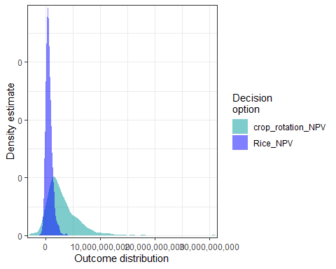

decisionSupport::plot_distributions(mcSimulation_object = crop_rotation_mc_simulation,   
 vars = c("crop_rotation_NPV", "Rice_NPV"),  
 method = 'boxplot')

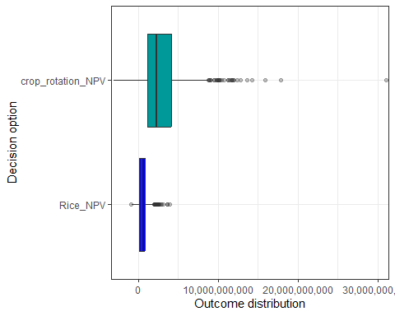

decisionSupport::plot_distributions(mcSimulation_object = crop_rotation_mc_simulation,   
 vars = c("NPV_decision_crop_rotation"),  
 method = 'boxplot_density')

## Warning: The following aesthetics were dropped during statistical transformation: x  
## ℹ This can happen when ggplot fails to infer the correct grouping structure in  
## the data.  
## ℹ Did you forget to specify a `group` aesthetic or to convert a numerical  
## variable into a factor?

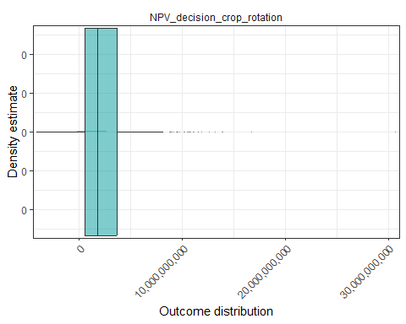

#### NPV for crop rotation (rice-soybean-rice)

decisionSupport::plot_distributions(mcSimulation_object = crop_rotation_mc_simulation,   
 vars = c("rice_soybean_NPV","Rice_NPV"),  
 method = 'smooth_simple_overlay')

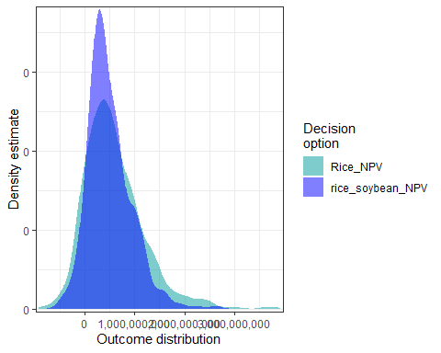

decisionSupport::plot_distributions(mcSimulation_object = crop_rotation_mc_simulation,   
 vars = c("rice_soybean_NPV","Rice_NPV"),  
 method = 'boxplot')

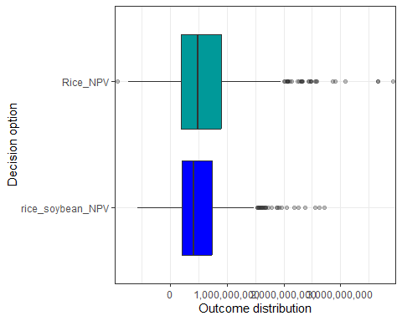

decisionSupport::plot_distributions(mcSimulation_object = crop_rotation_mc_simulation,   
 vars = c("NPV_decision_rice_soybean"),  
 method = 'boxplot_density')

## Warning: The following aesthetics were dropped during statistical transformation: x  
## ℹ This can happen when ggplot fails to infer the correct grouping structure in  
## the data.  
## ℹ Did you forget to specify a `group` aesthetic or to convert a numerical  
## variable into a factor?

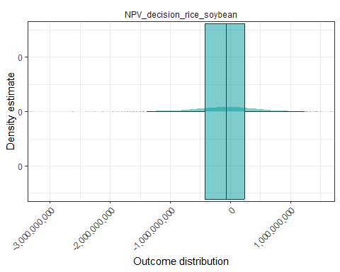

#### NPV for crop rotation (rice-chilli)

decisionSupport::plot_distributions(mcSimulation_object = crop_rotation_mc_simulation,   
 vars = c("rice_chili_NPV","Rice_NPV"),  
 method = 'smooth_simple_overlay')

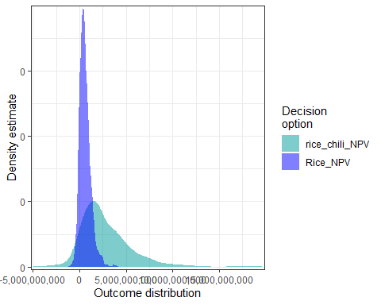

decisionSupport::plot_distributions(mcSimulation_object = crop_rotation_mc_simulation,   
 vars = c("rice_chili_NPV","Rice_NPV"),  
 method = 'boxplot')

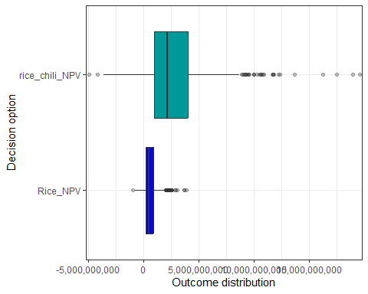

decisionSupport::plot_distributions(mcSimulation_object = crop_rotation_mc_simulation,   
 vars = c("NPV_decision_rice_chili"),  
 method = 'boxplot_density')

## Warning: The following aesthetics were dropped during statistical transformation: x  
## ℹ This can happen when ggplot fails to infer the correct grouping structure in  
## the data.  
## ℹ Did you forget to specify a `group` aesthetic or to convert a numerical  
## variable into a factor?

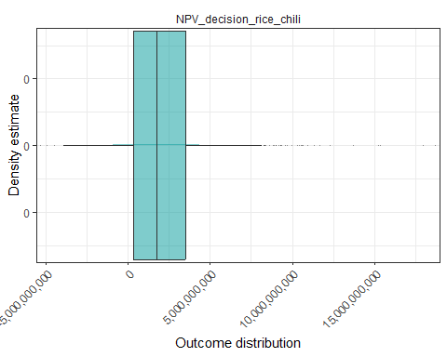

### Cashflow analysis

#### With crop rotation of 3 crops (rice-soybean-chili)

plot_cashflow(mcSimulation_object = crop_rotation_mc_simulation, cashflow_var_name = "cashflow_crop_rotation")

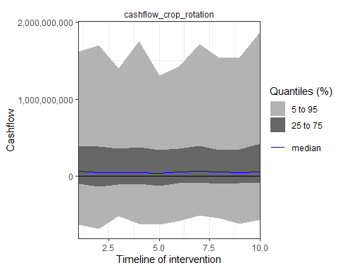

#### With crop rotation of rice and soybean (rice-soybean-rice)

plot_cashflow(mcSimulation_object = crop_rotation_mc_simulation, cashflow_var_name = "cashflow_rice_soybean")

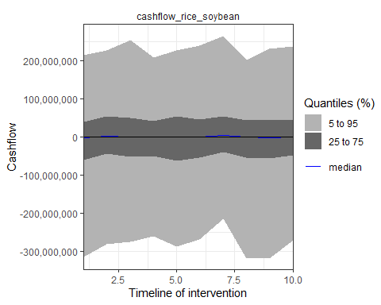

#### With crop rotation of rice and chili (rice-chili)

plot_cashflow(mcSimulation_object = crop_rotation_mc_simulation, cashflow_var_name = "cashflow_rice_chili")

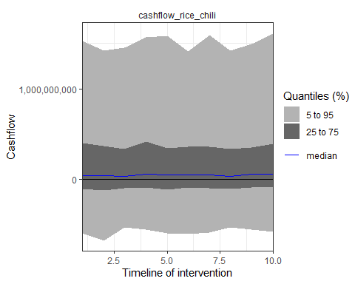

### Value of Information (VoI) analysis

mcSimulation_table <- data.frame(crop_rotation_mc_simulation$x, crop_rotation_mc_simulation$y[1:7])

#### EVPI crop rotation

evpi_crop_rotation <- multi_EVPI(mc = mcSimulation_table, first_out_var = "crop_rotation_NPV")

## [1] "Processing 6 output variables. This can take some time."  
## [1] "Output variable 1 (crop_rotation_NPV) completed."  
## [1] "Output variable 2 (rice_soybean_NPV) completed."  
## [1] "Output variable 3 (rice_chili_NPV) completed."  
## [1] "Output variable 4 (NPV_decision_crop_rotation) completed."  
## [1] "Output variable 5 (NPV_decision_rice_soybean) completed."  
## [1] "Output variable 6 (NPV_decision_rice_chili) completed."

plot_evpi(evpi_crop_rotation, decision_vars = "NPV_decision_crop_rotation")

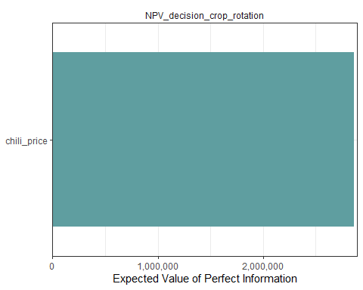

#### EVPI rice and soybean

evpi_rice_soybean <- multi_EVPI(mc = mcSimulation_table, first_out_var = "rice_soybean_NPV")

## [1] "Processing 5 output variables. This can take some time."  
## [1] "Output variable 1 (rice_soybean_NPV) completed."  
## [1] "Output variable 2 (rice_chili_NPV) completed."  
## [1] "Output variable 3 (NPV_decision_crop_rotation) completed."  
## [1] "Output variable 4 (NPV_decision_rice_soybean) completed."  
## [1] "Output variable 5 (NPV_decision_rice_chili) completed."

plot_evpi(evpi_rice_soybean, decision_vars = "NPV_decision_rice_soybean")

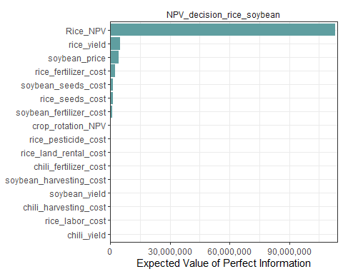

#### EVPI rice and chilli

evpi_rice_chili <- multi_EVPI(mc = mcSimulation_table, first_out_var = "rice_chili_NPV")

## [1] "Processing 4 output variables. This can take some time."  
## [1] "Output variable 1 (rice_chili_NPV) completed."  
## [1] "Output variable 2 (NPV_decision_crop_rotation) completed."  
## [1] "Output variable 3 (NPV_decision_rice_soybean) completed."  
## [1] "Output variable 4 (NPV_decision_rice_chili) completed."

plot_evpi(evpi_rice_chili, decision_vars = "NPV_decision_rice_chili")

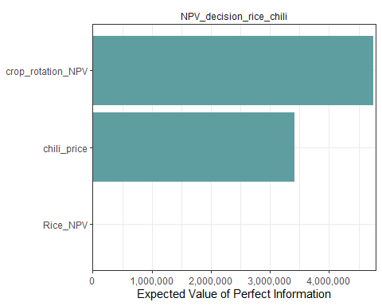

### Projection to Latent Structures (PLS) analysis

#### With crop rotation of 3 crops (rice-soybean-chili)

pls_result_crop_rotation <- plsr.mcSimulation(object = crop_rotation_mc_simulation,  
 resultName = names(crop_rotation_mc_simulation$y)[5], ncomp = 1)  
plot_pls(pls_result_crop_rotation, threshold = 0)

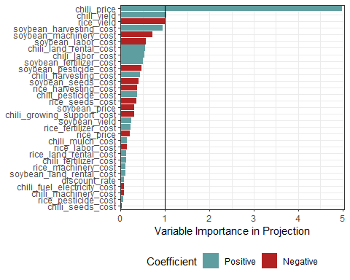

#### With crop rotation of rice and soybean (rice-soybean-rice)

pls_result_rice_soybean <- plsr.mcSimulation(object = crop_rotation_mc_simulation,  
 resultName = names(crop_rotation_mc_simulation$y)[6], ncomp = 1)  
plot_pls(pls_result_rice_soybean, threshold = 0)

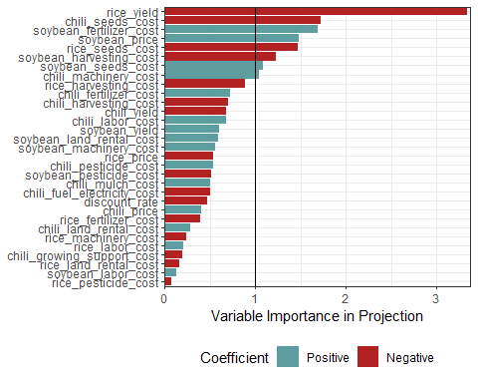

#### With crop rotation of rice and chili (rice-chili)

pls_result_rice_chili <- plsr.mcSimulation(object = crop_rotation_mc_simulation,  
 resultName = names(crop_rotation_mc_simulation$y)[7], ncomp = 1)  
plot_pls(pls_result_rice_chili, threshold = 0)

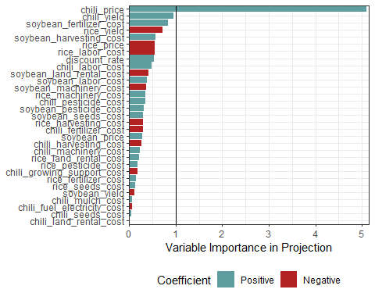

## Results

### With crop rotation of 3 crops (rice-soybean-chili)

compound_figure(mcSimulation_object = crop_rotation_mc_simulation,   
 input_table = input_estimates, plsrResults = pls_result_crop_rotation,   
 EVPIresults = evpi_crop_rotation, decision_var_name = "NPV_decision_crop_rotation",   
 cashflow_var_name = "cashflow_crop_rotation",   
 base_size = 7)

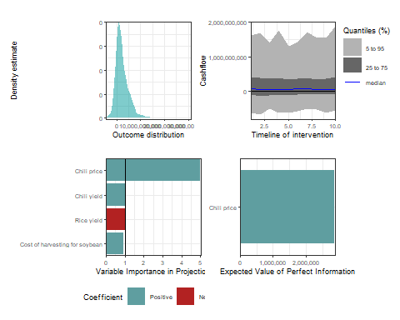

### With crop rotation of rice and soybean (rice-soybean-rice)

compound_figure(mcSimulation_object = crop_rotation_mc_simulation,   
 input_table = input_estimates, plsrResults = pls_result_rice_soybean,   
 EVPIresults = evpi_rice_soybean, decision_var_name = "NPV_decision_rice_soybean",   
 cashflow_var_name = "cashflow_rice_soybean",   
 base_size = 7)

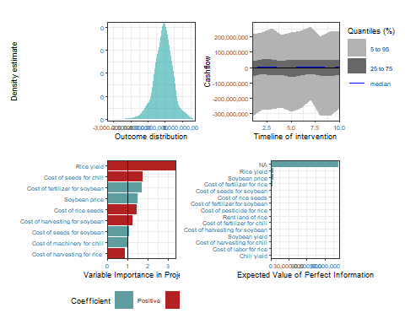

### With crop rotation of rice and chili (rice-chili)

compound_figure(mcSimulation_object = crop_rotation_mc_simulation,   
 input_table = input_estimates, plsrResults = pls_result_rice_chili,   
 EVPIresults = evpi_rice_chili, decision_var_name = "NPV_decision_rice_chili",   
 cashflow_var_name = "cashflow_rice_chili",   
 base_size = 7)

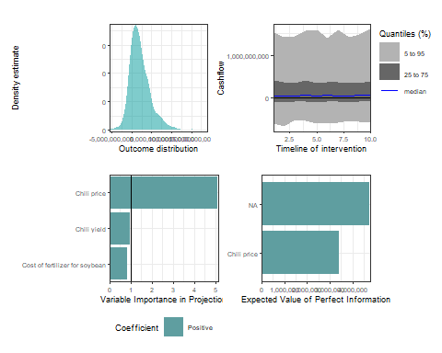

## Conclusion

1. This project has proven that selecting the appropriate crop rotation between rice, soybean, and chili seem profitable for achieving optimal results with respect to higher income for rice farming.
2. The decision to rotate crops between rice and chili is still applicable with slightly smaller profits.
3. Crop rotation between rice, soybean, and rice is less efficient than other options with respect to sustainable income.

## Recommendtion

1.We **recommend** Indonesian smallholder farmers to implement crop rotation either for three crops **(rice, soybean, and chili)** or two crops **(rice and chili)** as it seems more profitable than growing rice only all year around.

2.However, we would **not recommend** to implement crop rotation between **rice and soybean** as it seems not so profitable.

## What we have learned from this project?

1. Rice farming with crop rotation of soybean and chili can be implemented by Indonesian smallholder farmers to get higher income.
2. However, not every crops are profitable to be rotated with rice.
3. There are more uncertainties in crop rotation of rice and soybean compared to other scenarios. Thus, further data and research still needed.

## Reference

Amirrullah, Johanes. 2019. “The Effect of Various Crop Rotation on the Improvement of Soil Properties of Irrigation Paddy Field.”

Antriyandarti, Ernoiz. 2015. “Competitiveness and Cost Efficiency of Rice Farming in Indonesia.” *Journal of Rural Problems* 51: 74–85. <https://doi.org/10.7310/arfe.51.74>.

BPS. 2018. “[SOUH2018] Struktur Ongkos Usaha Tanaman Cabai Besar Per Hektar Per Musim Tanam Di Indonesia.”

———. 2022. “Statistik Indonesia 2022.”

BRIN. 2022. “Competitiveness of Indonesian Rice Prices in the International Market.” In *E3S Web of Conferences*. Vol. 361. EDP Sciences. <https://doi.org/10.1051/e3sconf/202236101016>.

Crystal, Eric, and Peter Whittlesey. 2004. “THE ROLE OF RICE IN SOUTHEAST ASIA.”

Do, Hoa, Eike Luedeling, and Cory Whitney. 2020. “Decision Analysis of Agroforestry Options Reveals Adoption Risks for Resource-Poor Farmers.” *Agronomy for Sustainable Development* 40 (June). <https://doi.org/10.1007/s13593-020-00624-5>.

Fao. 2018. “SMALL FAMILY FARMS COUNTRY FACTSHEET.” [www.fao.org/family-farming/data-sources/dataportrait/farm-size/en](https://www.fao.org/family-farming/data-sources/dataportrait/farm-size/en).

Harsono, Arief, Didik Harnowo, Erliana Ginting, and Dian Adi Anggraeni Elisabeth. 2020. “Opportunities to Achieve Self-Sufficiency.” [www.intechopen.com](https://www.intechopen.com).

Jagung, Kedelai. 2017. “Nilai Produksi Dan Biaya Produksi Per Musim Tanam Per Hektar Budidaya Tanaman Padi Sawah, Padi Ladang, Jagung, Dan Kedelai, 2017 Uraian Padi Sawah Padi Ladang.”

Krisdiana, Ruly, Nila Prasetiaswati, Imam Sutrisno, Fachrur Rozi, Arief Harsono, and Made Jana Mejaya. 2021. “Financial Feasibility and Competitiveness Levels of Soybean Varieties in Rice-Based Cropping System of Indonesia.” *Sustainability (Switzerland)* 13 (August). <https://doi.org/10.3390/su13158334>.

MOALF. 2016. “Chilli Production.” <https://www.southdevonchillifarm.co.uk/onli>.

Mucharam, Iim, Ernan Rustiadi, Akhmad Fauzi, and Harianto. 2020. “Assessment of Rice Farming Sustainability: Evidence from Indonesia Provincial Data.” *International Journal of Sustainable Development and Planning* 15 (December): 1323–13332. <https://doi.org/10.18280/ijsdp.150819>.

Schilling, Robert. 1999. “THE SOYBEAN COMMODITY SYSTEM IN INDONESIA : OVERVIEW AND PROPOSALS.”

Setiartiti, Lilies. 2021. “Critical Point of View: The Challenges of Agricultural Sector on Governance and Food Security in Indonesia.” In *E3S Web of Conferences*. Vol. 232. EDP Sciences. <https://doi.org/10.1051/e3sconf/202123201034>.

Stantec. 2005. “Helping Our Clients Prioritise Programmes and Projects.”

Sundari, M. T., Darsono, J. Sutrisno, and E. Antriyandarti. 2021. “Analysis of Chili Farming in Indonesia.” In *IOP Conference Series: Earth and Environmental Science*. Vol. 905. IOP Publishing Ltd. <https://doi.org/10.1088/1755-1315/905/1/012046>.

USDA. 2012. “INDONESIA: Stagnating Rice Production Ensures Continued Need for Imports.”

Wandschneider, Tiago, Paul Gniffke, Teddy Kristedi, Kuntoro Boga, Witono Adiyoga, and Howard Hall N/A N/A. 2019. “Final Report: Eastern Indonesia Agribusiness Development Opportunities-Chilli Value Chain Project Number.”

Wright, Jerry, Bill Wilcke, Edward Usset, Ward Stienstra, Michael Schmitt, Gary Sands, George Rehm, et al. 2005. “SOYBEAN FIELD BOOK.”

Yoshida, Shouichi. 1981. “Fundamentals of Rice Crop Sciences.”