Title:- AI-POWERED DRIVER DROWSINESS DETECTION AND SMART ACCIDENT ALERT SYSTEM
BATCH NO: 24
Introduction
Road accidents caused by driver fatigue and drowsiness are a major concern in modern transportation systems. Many accidents occur when drivers lose attention due to tiredness or sleep while driving. Traditional safety systems are not capable of continuously monitoring driver behaviour to detect such conditions.
This project presents an AI-Powered Driver Drowsiness Detection and Smart Accident Alert System that continuously monitors the driver's face and vehicle conditions using sensors and intelligent algorithms. The system uses a camera to detect eye closure, blinking rate, and head movement to identify signs of fatigue. If drowsiness is detected, the system immediately alerts the driver using a buzzer and LCD warning messages.
In addition, the system integrates MEMS sensors, ultrasonic sensors, and IoT communication to detect accidents and send emergency alerts. This intelligent safety system helps prevent accidents and ensures quick emergency response, thereby improving road safety.
Software Requirements
- Arduino IDE — Used to write and upload programs to the Arduino microcontroller.
- OpenCV / AI Model — Used for facial detection and drowsiness analysis.
- Python — Used to implement the AI-based driver monitoring logic and integrate computer vision algorithms.
- ESP8266 IoT Module — Used for wireless communication and sending alert messages.
- Bot Application (Telegram/Alert Bot) — Sends emergency notifications to users.

Sample Code
#include <LiquidCrystal.h>

LiquidCrystal lcd(7,6,5,4,3,2);

int buzzer = 8;
int motor = 9;
int sensor = 10; // input from drowsiness detection module

void setup()
{
lcd.begin(16,2);
pinMode(buzzer, OUTPUT);
pinMode(motor, OUTPUT);
pinMode(sensor, INPUT);

lcd.print("Driver System");
}

void loop()
{
int state = digitalRead(sensor);

if(state == HIGH) // drowsiness detected
{
digitalWrite(buzzer, HIGH);
digitalWrite(motor, LOW);

lcd.clear();
lcd.print("DROWSINESS");
lcd.setCursor(0,1);
lcd.print("ALERT!");
}
else
{
digitalWrite(buzzer, LOW);
digitalWrite(motor, HIGH);

lcd.clear();
lcd.print("Driver Safe");
}

delay(500);
}
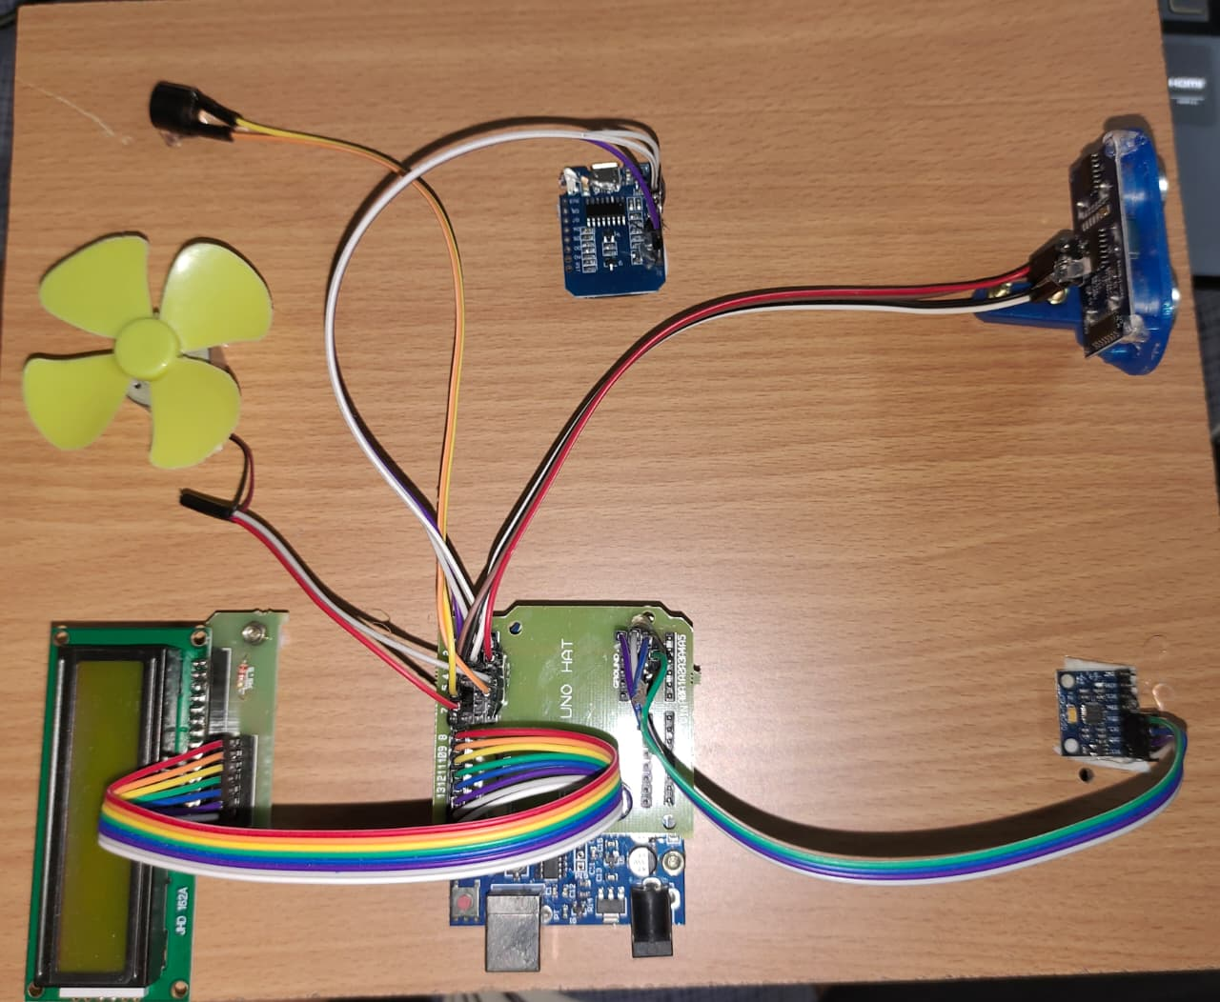
Fig 1: Hardware Implementation
(Arduino, Sensors and Modules Mounted on the System)

The hardware setup consists of an Arduino microcontroller, MEMS sensor, ultrasonic sensor, LCD
display, buzzer, DC motor, ESP8266 module, and camera module. The Arduino acts as the central
controller that processes sensor inputs and controls system outputs.

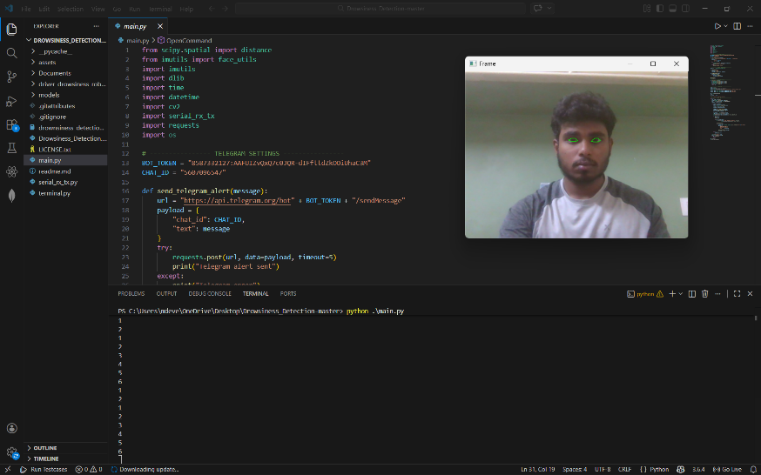
Fig 2: Driver Monitoring System
(Camera Monitoring Driver Face)

A camera placed on the vehicle dashboard continuously records the driver’s face. Computer vision

techniques are used to identify facial landmarks such as the eyes and head position in order to

monitor blinking patterns and eye closure duration.
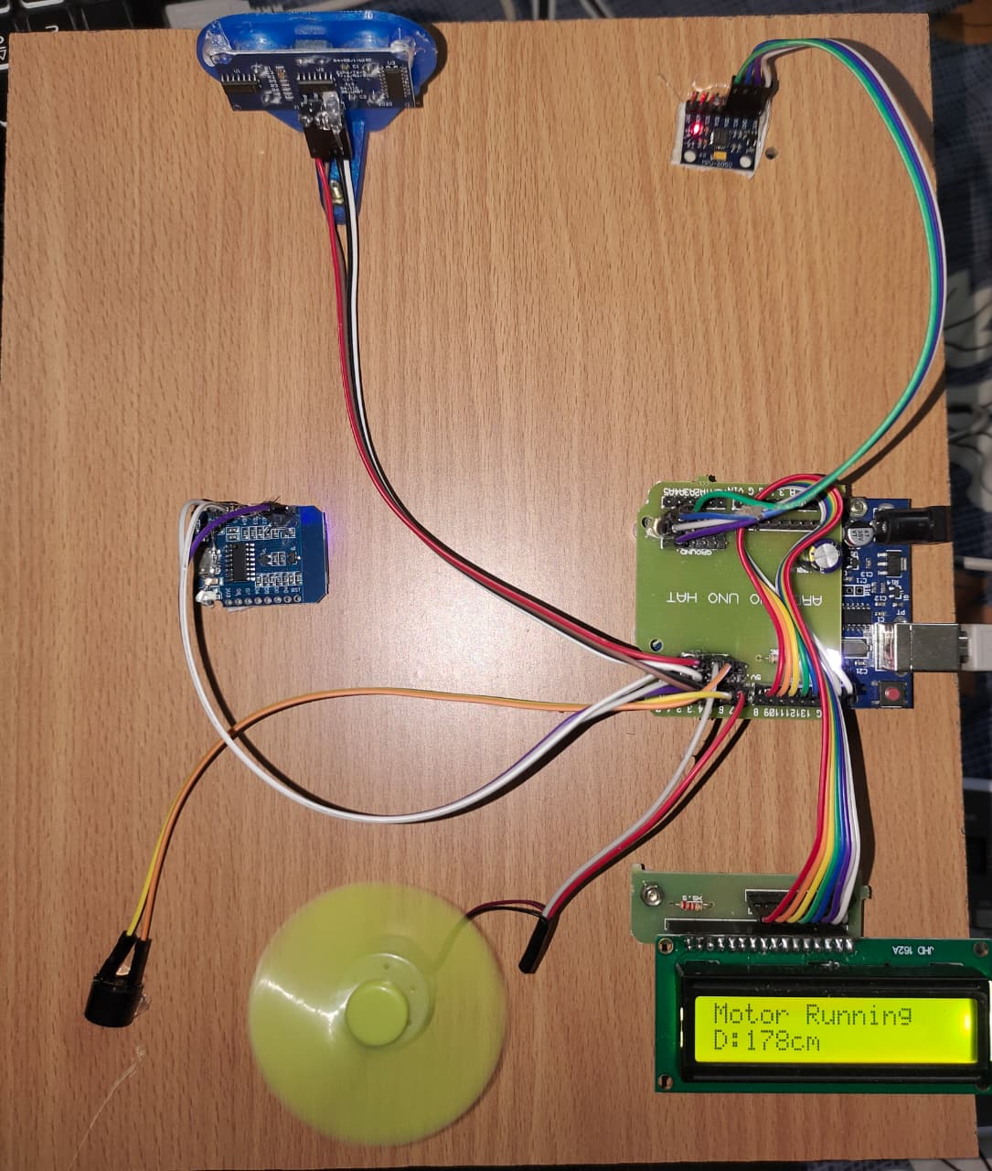
Fig 3: Sensor-Based Safety Detection
(MEMS and Ultrasonic Sensors Working)

The MEMS sensor detects sudden head movement or tilt that indicates driver fatigue or accident
conditions. The ultrasonic sensor measures the distance between the vehicle and nearby obstacles to
avoid collisions.
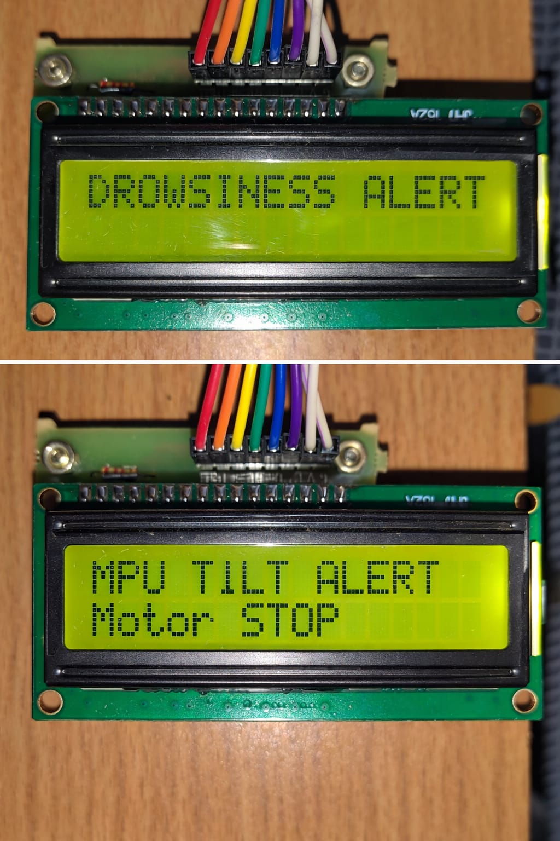
Fig 4: Alert and Warning System
(LCD Display and Buzzer Notification)

When drowsiness or unsafe conditions are detected, the system activates a buzzer alert and displays warning messages on the LCD screen to notify the driver and prevent accidents.
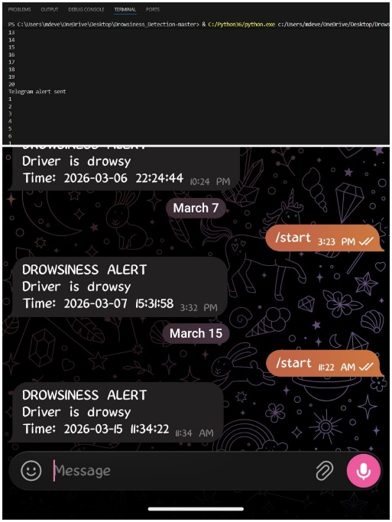
Fig 5: IoT Alert Notification
(Bot Application Sending Emergency Message)

The IoT module sends real-time alert messages to a mobile device through a bot application. This
feature ensures that emergency contacts are informed immediately if an accident or dangerous
situation occurs.

Conclusion
- Successfully developed an AI-based driver drowsiness detection system for real-time monitoring.
- Integrated MEMS and ultrasonic sensors for accident and obstacle detection.
- Implemented buzzer and LCD alerts to warn the driver during unsafe conditions.
- Used IoT communication to send emergency notifications through a mobile bot application.
- The system is cost-effective, reliable, and suitable for modern vehicle safety applications.

