**Assignment -87**

**Nagender Sarampelli**

1 IAM settings are region specific or NOT

A screenshot of a computer

Description generated with very high confidence

From above snap we can conclude that It is not Region specific. You can check the circle indicates and proves the statement.

2.By default, users have no permissions when first addedA screenshot of a computer screen

Description generated with very high confidenceA screenshot of a computer screen

Description generated with very high confidenceA screenshot of a computer screen

Description generated with very high confidence

From above snaps we can conclude that by default, users have no permissions. We can add manually permissions.

3.Active Directory Federation (AD) Can authenticate to AWS with AD using SAML.

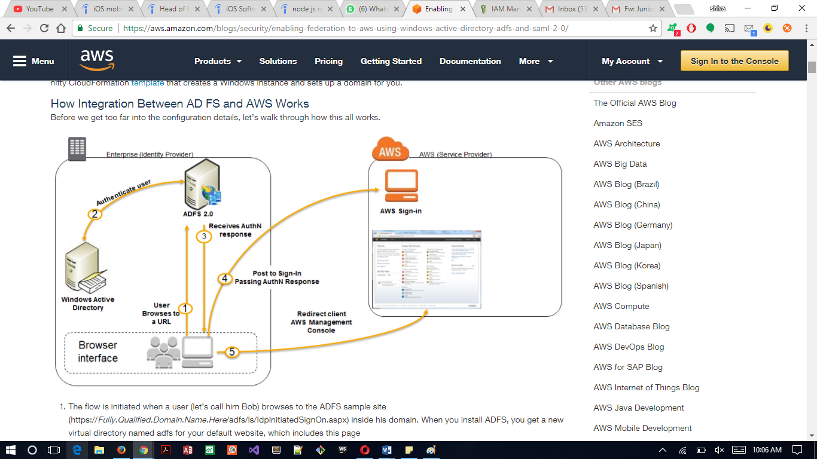

Ans: Yes, ADF can authenticate to AWS with AD using SAML.

Here we can authenticate against AD first and then assign temporary security credentials

1. Web Identity Federation to AWS via Facebook or any other social sites

A screenshot of a computer

Description generated with very high confidence

Ans:

we can authenticate application using socials network websites like Gmail, LinkedIn or Facebook.

We are using identity provider to authenticate.

Here we have gone to Gmail. We verified our identity with Gmail and we have been given an access token. We than go to AWS.

5.AssumeRoleWithWebIdentity API call used to obtain temporary security credentials when authenticating using Web Identity Federation?

A screenshot of a computer

Description generated with very high confidence

A screenshot of a computer

Description generated with very high confidence

Ans:

Here we get security credentials. Using token, we get temporary security credentials by calling AssumeRoleWithWebIdentity API.

Than we can access the AWS resources through setting the action in the form of S3(List Bucket or GetObject).