TouchGfx NumericKeypad CustomContainer:
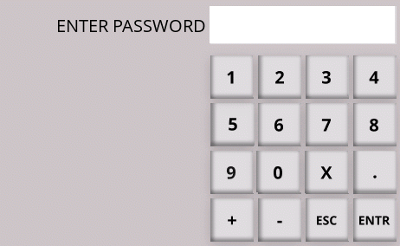

Steps to use it in your TouchGFX project:
- Import the CustomContainer package “ModelKeypadCntnr1.tpkg” in your TouchGFX project (Edit->import->Custom Container)
- Goto your CustomContainer components and pick the ModelKeypadCntr1 and place that on your Screen ( we used Screen2 in this example), preferably under modalWindow.
- Then Modify your Screen2View.c and Scren2View.h files as shown in the attached files
- You can use this for password or for normal application by setting or resetting the flag in the function call
modelKeypadCntnr11.setType((const char *)"ENTER PASSWORD",4,true);
- send an email to sailurao@yahoo.com if you need any help

