WAY 1 TO RUN

----------------------

1)create a virtual environment

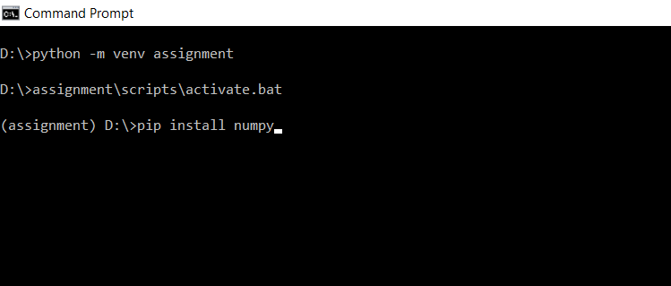

2)install packages for assignment in virtual environment

pip install pandas

pip install numpy

pip install sklearn

2) place the python file under the virtual environment

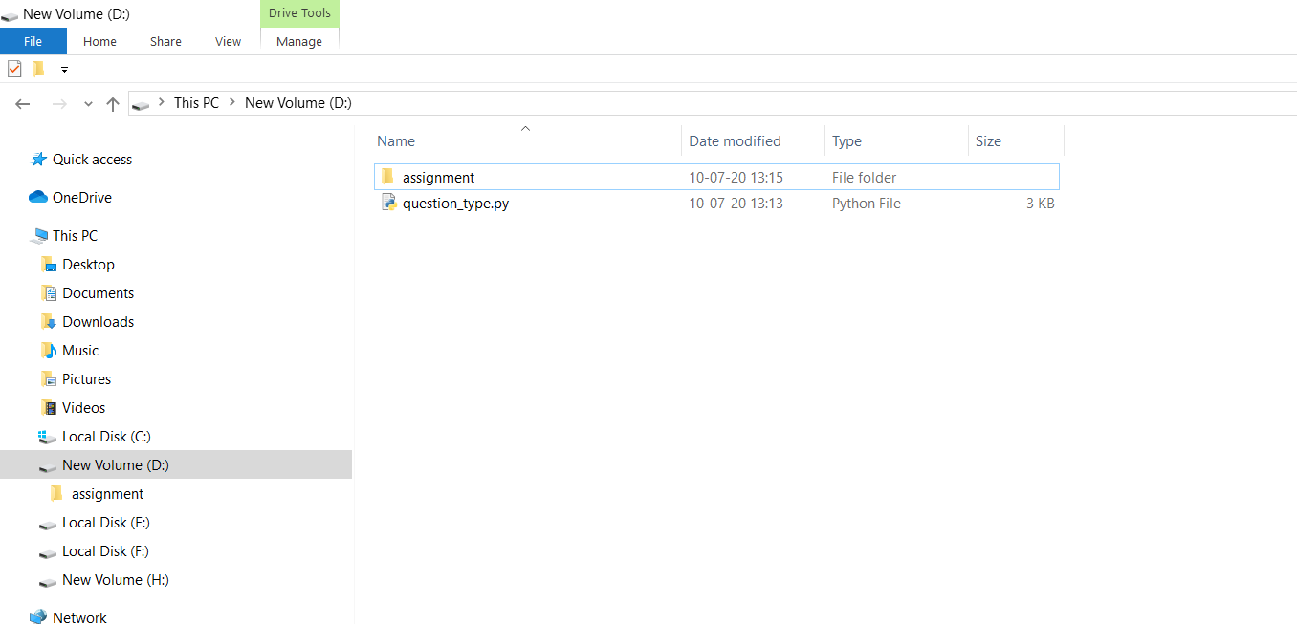

3)Run python file where it is located

Ex: it is located D:\ > then to run

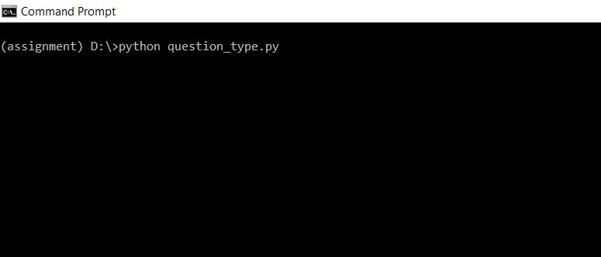

WAY 2 TO RUN:

------------------------

1) Install required packages

2)Open question_type.py file in any editor like IDLE, Pycharm

3)now run the code in IDLE press f5 ( OR )

Pycharm have command prompt to run the code where file is located

Ex:

D:\>Python question_type.py