CERTIFICATE

Name of the Lab : OPERATING SYSTEMS

Name of the Student :

Student Regd. No. : 18BQ1A05K3

CLASS : III B.TECH. I SEM CSE – D

GIT HUB LINK: [Click to view my repository](https://github.com/nagababuthota984/5K3-OS-LAB)

INDEX

|  |  |  |
| --- | --- | --- |
| S. No. | Name of the Experiment | Page No. |
| 3 (a) | Simulate Multiprogramming with a fixed number of tasks (MFT) |  |
| 3 (b) | Simulate Multiprogramming with a variable number of tasks (MVT) |  |
|  |  |  |

**EXPERIMENT NO: 3 (a)**

**AIM :** Simulate Multiprogramming with a fixed number of tasks (MFT)

**DESCRIPTION :** Main task of this program is to allocate the incoming processes to the suitable holes into the physical memory, Where physical memory(RAM) is splitted into fixed number of partitions, each one with variable size. The incoming number of processes or tasks are fixed by default.

**LIBRARIES USED:** Language : python 3, Systems having python version >= 3 will produce output as expected. No additional libraries have been used.

**PROGRAM-1:**

**def firstfit(partitions,processes):**

**result = [-1]*len(partitions)**

**internalfrag = [-1]*len(partitions)**

**for i in range(0,len(processes)):**

**for j in range(0,len(partitions)):**

**if processes[i] <= partitions[j] and result[j] == -1:**

**result[j] = i+1**

**internalfrag[j] = partitions[j] - processes[i]**

**break**

**fitname = "First fit"**

**output(partitions,processes,result,internalfrag,fitname)**

**def bestfit(partitions,processes):**

**result = [-1]*len(partitions)**

**internalfrag = [-1]*len(partitions)**

**for i in range(0,len(processes)):**

**mini = sum(partitions)**

**minindex = -1**

**flagbit = False**

**for j in range(0,len(partitions)):**

**if processes[i] <= partitions[j] and result[j] == -1 and partitions[j]-processes[i]<=mini:**

**minindex = j**

**mini = partitions[j] - processes[i]**

**flagbit = True**

**if flagbit and minindex!=1:**

**result[minindex] = i+1**

**internalfrag[minindex] = mini**

**fitname = "Best Fit"**

**output(partitions,processes,result,internalfrag,fitname)**

**def worstfit(partitions,processes):**

**result = [-1]*len(partitions)**

**internalfrag = [-1]*len(partitions)**

**for i in range(0,len(processes)):**

**maxi = -1**

**maxindex = -1**

**flagbit = False**

**for j in range(0,len(partitions)):**

**if processes[i] <= partitions[j] and result[j] == -1 and partitions[j]-processes[i]>=maxi:**

**maxindex = j**

**maxi = partitions[j] - processes[i]**

**flagbit = True**

**if maxindex != -1 and flagbit:**

**result[maxindex] = i+1**

**internalfrag[maxindex] = maxi**

**else:**

**continue**

**fitname = "Worst Fit"**

**output(partitions,processes,result,internalfrag,fitname)**

**def output(partitions,processes,result,internalfrag,fitname):**

**print("\n")**

**print("------------"+fitname+"------------")**

**print("Partitions: ".ljust(23),partitions)**

**print("Processes: ".ljust(23),processes)**

**print("Allocation: ".ljust(23),result)**

**print("Internal Fragmentation:".ljust(23),internalfrag)**

**#unallocated processes**

**print("--------Unallocated processes--------")**

**isunalloc = False**

**for i in range(len(processes)):**

**if i+1 not in result:**

**isunalloc = True**

**print("Process "+str(i+1)+" cannot be allocated")**

**if isunalloc == False:**

**print("All processes have been allocated successfully")**

**print("\n")**

**#execution begins here.**

**phymem = int(input("Enter the size of physical memory : "))**

**partitions = []**

**no_partitions = int(input("Enter number of partitions : "))**

**for i in range(0,no_partitions):**

**partitions.append(int(input("Enter partition"+str(i+1)+" size: ")))**

**if sum(partitions) == phymem:**

**processes = []**

**no_processes = int(input("Enter number of processes incoming :"))**

**for j in range(0,no_processes):**

**processes.append(int(input("Enter process"+str(j+1)+" size: ")))**

**#input has been taken**

**firstfit(partitions,processes)**

**bestfit(partitions,processes)**

**worstfit(partitions,processes)**

**ASK USER THE SIZE OF PHYSICAL MEMORY FOR USER PROCESSES:**

**ASK USER SIZE OF PARTITION1:**

**ASK USER SIZE OF PARTITION1:**

**NOTE: SUM OF SIZE OF ALL PARTITIONS = SIZE OF PYSICAL MEMORY**

**ASK USER SIZE OF PROCESS1:**

**ALLOCATE PARTITION WHERE THIS PROCESS CAN FIT**

**DO YOU WANT TO CONTINUE: Y/N**

**IF YES**

**ASK USER SIZE OF PROCESS2:**

**DO YOU WANT TO CONTINUE: Y/N**

**N**

|  |  |
| --- | --- |
| PARTITION NUMBER | PARTITION SIZE (MB) |
| 1 | 100 |
| 2 | 80 |
| 3 | 120 |
| 4 | 200 |

|  |  |
| --- | --- |
| PROCESS NUMBER | PROCESS SIZE  (MB) |
| 1 | 70 |
| 2 | 90 |
| 3 | 110 |
| 4 | 150 |

**OUTPUT: \*** it should be same when your program gets executed

BEST FIT ALGORITHM

|  |  |  |  |  |
| --- | --- | --- | --- | --- |
| PARTITION NUMBER | PARTITION SIZE (MB) | PROCESS NUMBER | PROCESS SIZE  (MB) | INTERNAL FRAGMENTATION |
| 1 | 100 | 2 | 90 | 10 |
| 2 | 80 | 1 | 70 | 10 |
| 3 | 120 | 3 | 110 | 10 |
| 4 | 200 | 4 | 150 | 50 |

FIRST FIT ALGORITHM

|  |  |  |  |  |
| --- | --- | --- | --- | --- |
| PARTITION NUMBER | PARTITION SIZE (MB) | PROCESS NUMBER | PROCESS SIZE  (MB) | INTERNAL FRAGMENTATION |
| 1 | 100 | 1 | 70 | 30 |
| 2 | 80 |  |  |  |
| 3 | 120 | 2 | 90 | 30 |
| 4 | 200 | 3 | 110 | 90 |

PROCESS 4 CAN NOT FIT AS THERE IS NO FREE SPACE.

WORST FIT ALGORITHM

|  |  |  |  |  |
| --- | --- | --- | --- | --- |
| PARTITION NUMBER | PARTITION SIZE (MB) | PROCESS NUMBER | PROCESS SIZE  (MB) | INTERNAL FRAGMENTATION |
| 1 | 100 |  |  |  |
| 2 | 80 |  |  |  |
| 3 | 120 | 2 | 90 | 30 |
| 4 | 200 | 1 | 70 | 130 |

**OUTPUT SCREEN SHOTS:**

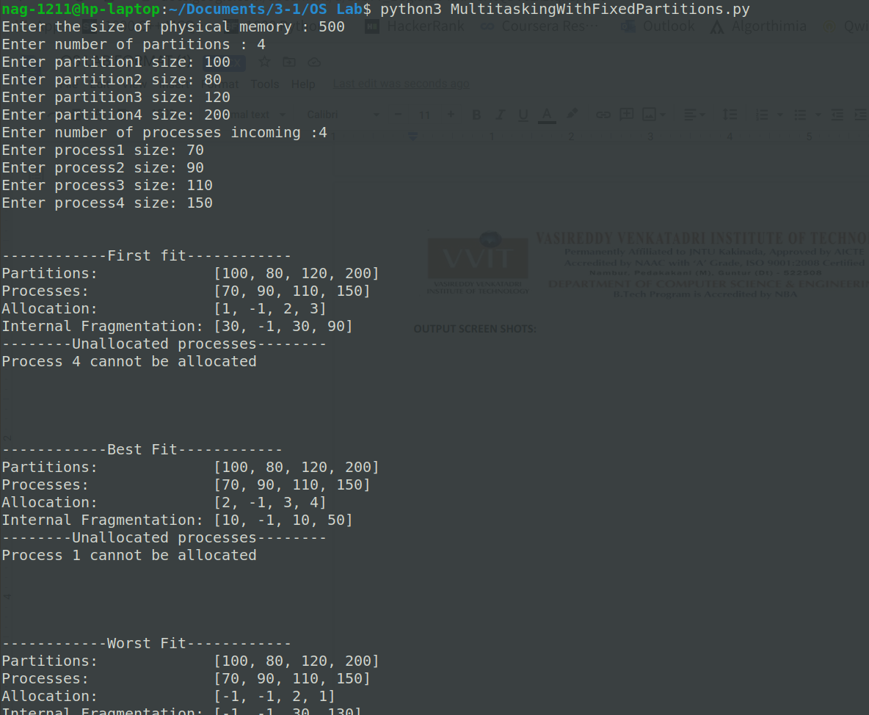

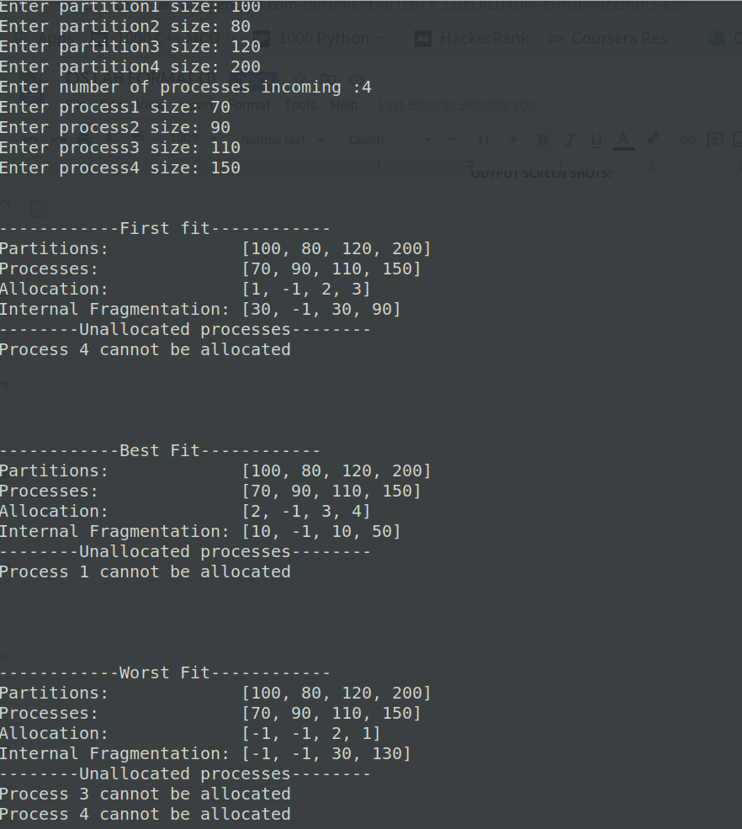

**EXPERIMENT NO: 3 (B)**

**AIM :** Simulate Multiprogramming with a variable number of tasks (MVT)

**DESCRIPTION :** Main task of this program is to allocate the incoming processes to the suitable holes into the physical memory. The incoming number of processes or tasks are not fixed by default, it is the choice of user to give any number of tasks.

**LIBRARIES USED:** Language : python 3, Systems having python version >= 3 will produce output as expected. No additional libraries have been used.

**PROGRAM-1:**

**phymem = int(input("Enter the size of Physical memory: "))**

**Again = True**

**process_number = 0**

**processes = {}**

**unallocated = {}**

**cumulativesum = 0**

**while Again:**

**Again = False**

**process_number+=1**

**process_name = input("\nEnter the name of the process: ")**

**process_size = int(input("Enter the size of the process: "))**

**if cumulativesum + process_size <=phymem:**

**cumulativesum += process_size**

**processes[process_name] = [process_number,process_size]**

**confirm = input("Is there process incoming?[Y/N]")**

**if confirm.upper() == 'Y':**

**Again = True**

**else:**

**unallocated[process_name] = [process_number,process_size]**

**confirm = input("Current process didn't fit in the memory!! Is there any process still incoming?[Y/N]")**

**if confirm.upper() == 'Y':**

**Again = True**

**print("\nProcessName\tPartitionNumber\tProcessSize")**

**print("---------------|----------------|------------")**

**for k,v in processes.items():**

**print(k.ljust(15)+str(v[0]).center(16)+str(v[1]).center(11))**

**print("\nExternal Fragmentation =",phymem-cumulativesum)**

**print("\n--------Unallocated processes--------")**

**print("ProcessName\tProcessSize")**

**for k,v in unallocated.items():**

**print(k.ljust(15)+str(v[1]).center(11))**

**ASK USER THE SIZE OF PHYSICAL MEMORY FOR USER PROCESSES: 500 MB**

**ASK USER SIZE OF PROCESS1:**

**ALLOCATE PARTITION WHERE THIS PROCESS CAN FIT**

**DO YOU WANT TO CONTINUE: Y/N**

**IF YES**

**ASK USER SIZE OF PROCESS2:**

**DO YOU WANT TO CONTINUE: Y/N**

**N**

|  |  |
| --- | --- |
| PROCESS NUMBER | PROCESS SIZE  (MB) |
| 1 | 70 |
| 2 | 90 |
| 3 | 110 |
| 4 | 150 |
| 5 | 100 |

**OUTPUT : \*** it should be same when your program gets executed

|  |  |  |
| --- | --- | --- |
| PROCESS NUMBER | PROCESS SIZE  (MB) | PARTITION SIZE  (MB) |
| 1 | 70 | 70 |
| 2 | 90 | 90 |
| 3 | 110 | 110 |
| 4 | 150 | 150 |
| 5 | 100 | CAN NOT FIT IN MEMORY |

EXTERNAL FRAGMENTATION : 500 –(70+90+110+150) = 80 MB

**OUTPUT SCREEN SHOTS:**

