Traffic management projects often involve processing and analyzing traffic data to improve traffic flow, reduce congestion, enhance safety, and optimize transportation systems. To get started with a traffic management project, you can follow these steps:

**1. Define the Project Scope:**

Determine the specific goals and objectives of your traffic management project. Are you focusing on congestion reduction, traffic signal optimization, route planning, or something else?

**2. Data Collection:**

Collect relevant traffic data from various sources, such as traffic cameras, sensors, GPS devices, and public transportation systems. This data may include information on vehicle counts, speed, and location.

**3. Data Preprocessing:**

Data preprocessing is a crucial step to clean and prepare your data for analysis. This may include:

- Removing duplicates and outliers.

- Imputing missing values.

- Normalizing or standardizing data.

- Converting data into a usable format (e.g., CSV, JSON).

**4. Data Integration:**

Integrate data from various sources to create a unified dataset for analysis. This might involve merging data from different sensors or sources.

**5. Exploratory Data Analysis (EDA):**

Perform EDA to gain insights into your dataset. Visualization and statistical analysis can help you identify patterns, trends, and anomalies in the data.

6**. Feature Engineering:**

Create new features that can enhance your analysis. For example, you might calculate traffic density, congestion levels, or time-based features.

**7. Data Modeling:**

Build machine learning or statistical models to analyze traffic data. Common models include:

- Traffic flow prediction models.

- Congestion detection models.

- Route optimization algorithms.

**8. Model Training and Validation:**

Split your dataset into training and testing sets to train and evaluate the performance of your models. You may also consider using cross-validation techniques to ensure robust model performance.

**9. Traffic Management Strategies:**

Implement strategies based on your model's outputs. This could include:

- Adjusting traffic signals in real-time.

- Providing real-time traffic information to drivers.

- Suggesting alternate routes during congestion.

**10. Monitoring and Feedback Loop:**

Continuously monitor the effectiveness of your traffic management strategies. Collect feedback and adapt your strategies as needed.

11. **Visualization and Reporting:**

Present your findings and results through visualizations, reports, and dashboards to convey insights to stakeholders and the public.

12. **Optimization and Maintenance:**

Regularly optimize your traffic management strategies based on new data and feedback. Maintenance and updates are essential for long-term success.

13. **Public Awareness and Communication:**

Communicate the benefits of your traffic management project to the public, as well as any changes or improvements they can expect.

Remember that the success of a traffic management project often relies on the quality and quantity of data, as well as the effectiveness of the models and strategies employed. Additionally, collaboration with transportation authorities, city planners, and other relevant stakeholders is critical for the successful implementation of traffic management solutions.

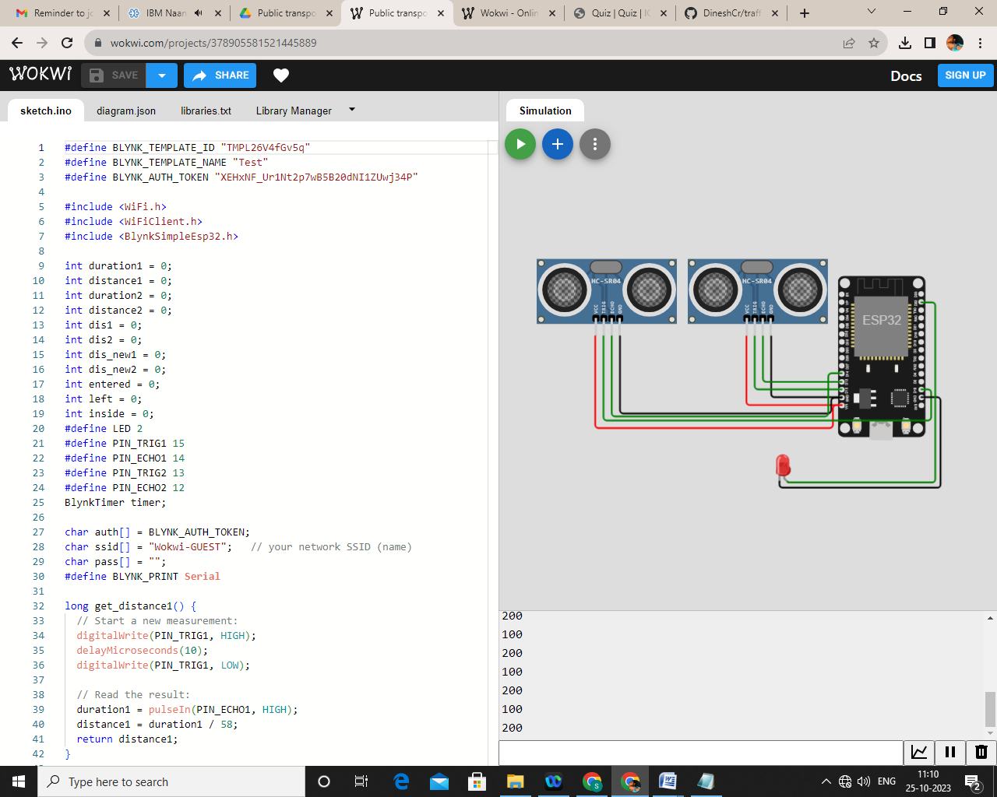

#define BLYNK_TEMPLATE_ID "TMPL26V4fGv5q"

#define BLYNK_TEMPLATE_NAME "Test"

#define BLYNK_AUTH_TOKEN "XEHxNF_Ur1Nt2p7wB5B20dNI1ZUwj34P"

#include <WiFi.h>

#include <WiFiClient.h>

#include <BlynkSimpleEsp32.h>

int duration1 = 0;

int distance1 = 0;

int duration2 = 0;

int distance2 = 0;

int dis1 = 0;

int dis2 = 0;

int dis_new1 = 0;

int dis_new2 = 0;

int entered = 0;

int left = 0;

int inside = 0;

#define LED 2

#define PIN_TRIG1 15

#define PIN_ECHO1 14

#define PIN_TRIG2 13

#define PIN_ECHO2 12

BlynkTimer timer;

char auth[] = BLYNK_AUTH_TOKEN;

char ssid[] = "Wokwi-GUEST";   // your network SSID (name)

char pass[] = "";

#define BLYNK_PRINT **Serial**

long get_distance1() {

  // Start a new measurement:

  digitalWrite(PIN_TRIG1, HIGH);

  delayMicroseconds(10);

  digitalWrite(PIN_TRIG1, LOW);

  // Read the result:

  duration1 = pulseIn(PIN_ECHO1, HIGH);

  distance1 = duration1 / 58;

  return distance1;

}

long get_distance2() {

  // Start a new measurement:

  digitalWrite(PIN_TRIG2, HIGH);

  delayMicroseconds(10);

  digitalWrite(PIN_TRIG2, LOW);

  // Read the result:

  duration2 = pulseIn(PIN_ECHO2, HIGH);

  distance2 = duration2 / 58;

  return distance2;

}

void myTimer() {

**Serial**.println("100");

  dis_new1 = get_distance1();

  dis_new2 = get_distance2();

  if (dis1 != dis_new1 || dis2 != dis_new2){

**Serial**.println("200");

    if (dis1 < dis2){

**Serial**.println("Enter loop");

      entered = entered + 1;

      inside = inside + 1;

      digitalWrite(LED, HIGH);

      Blynk.virtualWrite(V0, entered);

      Blynk.virtualWrite(V2, inside);

      dis1 = dis_new1;

      delay(1000);

      digitalWrite(LED, LOW);

    }

    if (dis1 > dis2){

**Serial**.println("Leave loop");

      left = left + 1;

      inside = inside - 1;

      Blynk.virtualWrite(V1, left);

      Blynk.virtualWrite(V2, inside);

      dis2 = dis_new2;

      delay(1000);

    }

  }

}

 void setup() {

**Serial**.begin(115200);

  pinMode(LED, OUTPUT);

  pinMode(PIN_TRIG1, OUTPUT);

  pinMode(PIN_ECHO1, INPUT);

  pinMode(PIN_TRIG2, OUTPUT);

  pinMode(PIN_ECHO2, INPUT);

  Blynk.begin(auth, ssid, pass, "blynk.cloud", 8080);

  timer.setInterval(1000L, myTimer);

}

void loop() {

  Blynk.run();

  timer.run();

}