ML HW-1

Q1:

Code: Q1.R

Output:

|  |  |  |
| --- | --- | --- |
| Round | Games Played | Final Balance |
| 1 | 5 | 0 |
| 2 | 4 | 0 |
| 3 | 10 | 1300 |
| 4 | 10 | 1800 |
| 5 | 10 | 1000 |
| 6 | 10 | 1400 |
| 7 | 9 | 0 |
| 8 | 10 | 1400 |
| 9 | 10 | 1600 |
| 10 | 10 | 1300 |

Explanation:

This system takes very long to run and once you've lost several times in a row you make really huge bets. In exchange for increasing your chances of winning, you're willing to lose a larger amount than normal if you do lose.

Q2:

Code: Q2.R

Plots:

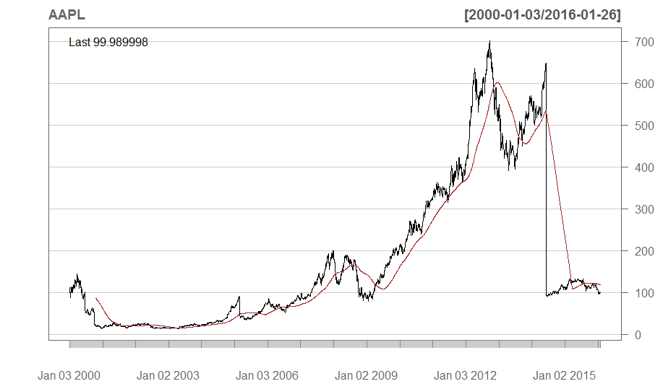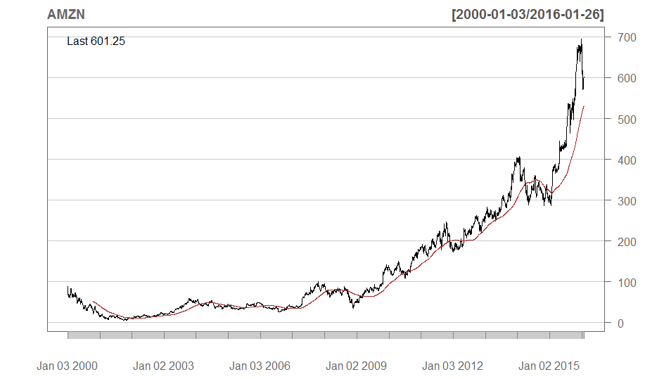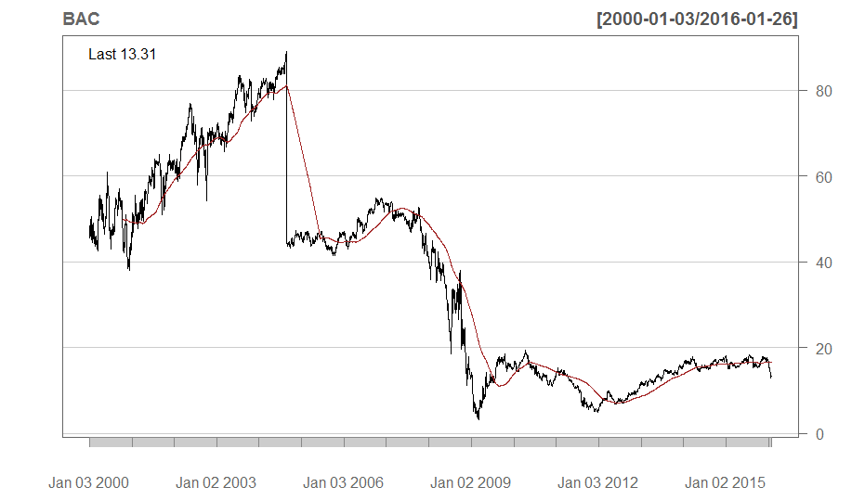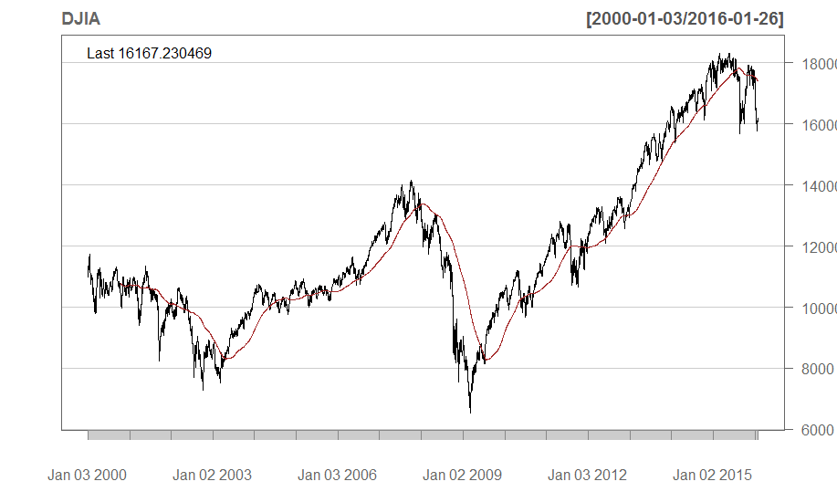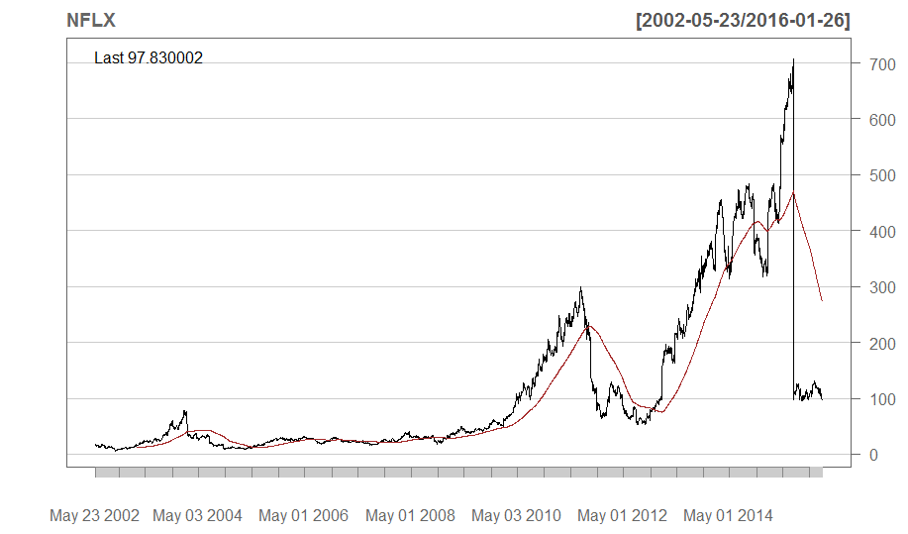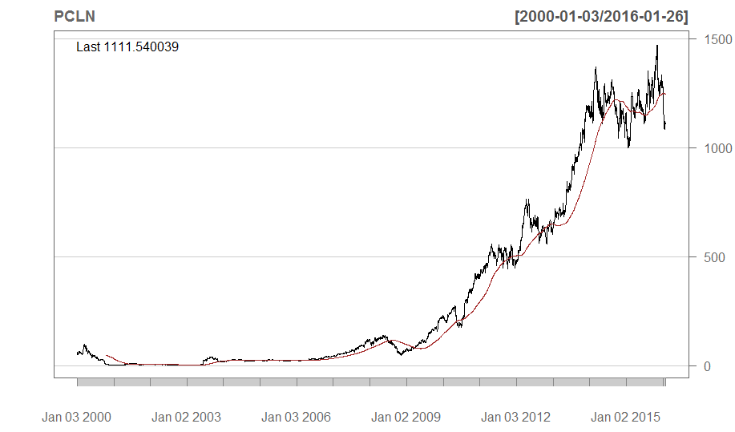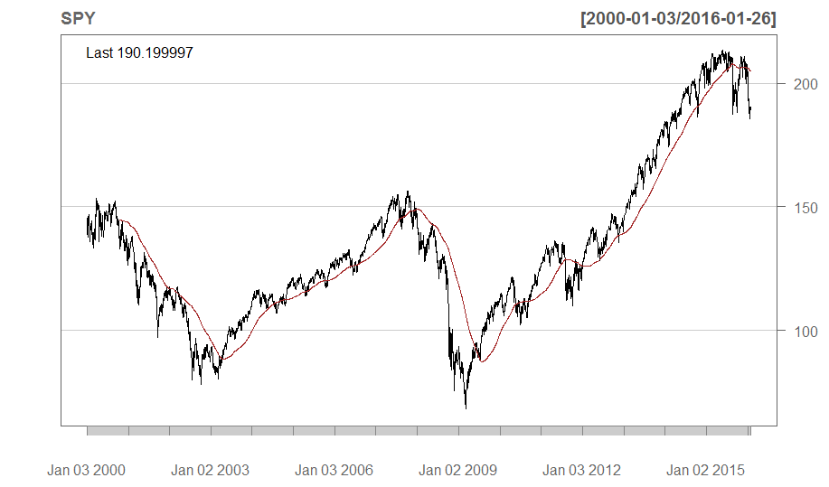

Explanation:

SMA Crossover is a better approach than Buy and Hold because you even when there is a drop in stock price for a short time SMA provides more profit in long term. With SMA you buy when the price crosses over (rises above) the moving average and you sell when the price drops below the moving average. SMA follows market trends and doesn’t sell at peak or buy at bottom.

Table:

|  |  |  |  |  |
| --- | --- | --- | --- | --- |
| Stock | Buy and Hold | | SMA Crossover | |
| CAGR | Performance | CAGR | Performance |
| DJIA | 2.7 | 1.53 | 1.6 | 1.29 |
| SPY | 2.1 | 1.40 | 3.7 | 1.79 |
| AAPL | -0.4 | 0.94 | 9.2 | 4.08 |
| BAC | -6.4 | 0.35 | -6.8 | 0.33 |
| NFLX | 15.2 | 6.83 | 24.4 | 19.61 |
| PCLN | 22.2 | 24.88 | 23.8 | 30.60 |
| AMZN | 13.5 | 7.56 | 16.7 | 11.86 |