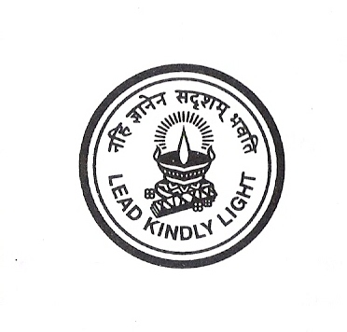

SRI KUMARAN CHILDRENS HOME, CBSE

CERTIFICATE

This is to certify that NAGABHARAN N and ARVIND P students from class XII have done their COMPUTER SCIENCE project at SRI KUMARAN CHILDRENS HOME, CBSE, from 2009 to 2010.

The project work entitled “SOCCER MANAGER” embodies the original work done by NAGABHARAN N and ARVIND P during their above academic year.

……………………………… ……………………………
Internal Examiner’s External Examiner’s
Signature Signature

Date:……………………… School Rubber Stamp

