# VISVESVARAYA TECHNOLOGICAL UNIVERSITY

## Belgaum-590014

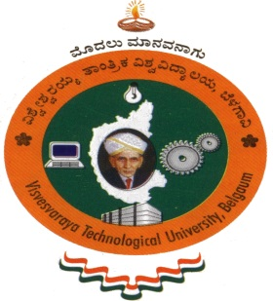

**Project Report**

**On**

**“HAND-CRICKET”**

###### Submitted in partial fulfillment of the requirements for the VI Semester

**Computer Graphics and Visualization Lab (10CSL67)**

## Bachelor of Engineering

## IN

# COMPUTER SCIENCE AND ENGINEERING

## For the Academic year

**2013-2014**

**BY**

**NAGABHARAN.N 1PE10CS054**

**NAVEEN KUMAR.M 1PE10CS056**



**Department of Computer Science and Engineering**

**PESIT BANGALORE SOUTH CAMPUS**

**HOSUR ROAD**

**BENGALURU-560100**

**PESIT BANGALORE SOUTH CAMPUS**

**HOSUR ROAD**

**BENGALURU-560100**



**DEPARTMENT OF COMPUTER SCIENCE AND ENGINEERING**

## *CERTIFICATE*

*This is to certify that the project entitle* ***“HAND-CRICKET”* *is*** *a bonafide work carried out by* ***NAGABHARAN.N*** *and* ***NAVEEN KUMAR .M*** *bearing USN* ***1PE10CS054 and 1PE10CS056*** *respectively*,*in Computer Graphics and Visualization Lab (10CSL67) for the 6th Semester in partial fulfillment for the award of Degree of Bachelor of Engineering in Computer Science and Engineering of Visvesvaraya Technological University, Belgaum during the year 2013 - 2014.*

***--------------------------- ---------------------------***

***Signature of the guide Signature of the HOD***

**Sarasvati.V Dr.Srikanta Murthy**

Assistant Professor Head of the Department

Dept. of CSE Dept. of CSE

PESIT BSC, Bengaluru. PESIT BSC, Bengaluru.