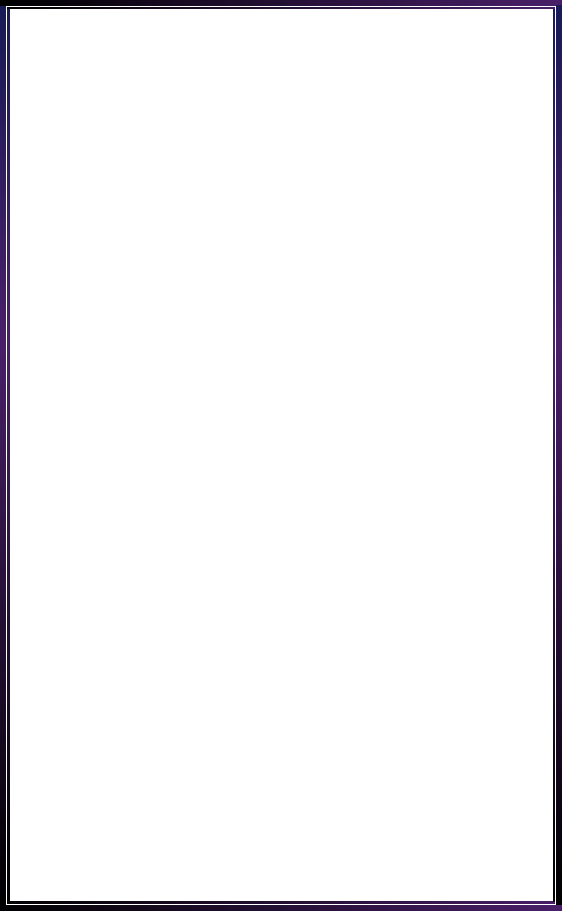

**INNOVATE. CREATE. SOLVE**

Bengaluru, Karnataka, India

AN

INTERNSHIP REPORT

ON

“Tribute To LG”

#### Bachelor of Engineering

#### In

#### Information Science and Engineering

#### 

#### Submitted by: NAGABUSHAN V (1AP18IS016)

#### 

#### 

**APS COLLAGE OF ENGINEERING**

**2021**

#### 

#### 

## ABOUT THE COMPANY

IC Solution (ICS) is a digital service provider that aims to provide software, designing and marketing solutions to individuals and businesses. At ICS, we believe that service and quality is the key to success

We provide all kinds of technological and designing solutions from Billing Software to Web Designs or any custom demand that you may have. Experience the service like none other!

Some of our services include:

Development - We develop responsive, functional and super-fast websites.

We keep User Experience in mind while creating websites. A website should load quickly and should be accessible even on a small view-port and slow internet connection.

Mobile Application - We offer a wide range of professional Android, iOS & Hybrid app development services for our global clients, from a start up to a large enterprise.

Design - We offer professional Graphic design, Brochure design & Logo design. We are experts in crafting visual content to convey the right message to the customers.

Consultancy - We are here to provide you with expert advice on your design and development requirement.

Videos - We create a polished professional video that impresses your audience

Table of contents i

Overview of the Project 1

About LG 2

Why LG Phones are discontinued 4

Tools Used 5

Implementation 21

Snapshots 21

Bibliography 25

## OVERVIEW OF THE PROJECT

## Project Name: Tribute to LG

**Team Members:**

NAGABUSHAN V

## This project is based on Web Development And its Applications. The main objective of this project is to learn the implementation of HTML, CSS and JavaScript. The basic webpage of this project is created using HTML and styling of the webpage is done using CSS.

## This webpage is about one of the greatest companies of all time

## LG ELECTRONICS INDIA

## LG’s philosophy revolves around people, sincerity, and sticking to the fundamentals.

## It is to understand our customers and to offer optimum solutions and new experiences through ceaseless innovation, thus helping our customers lead better lives.

## ABOUT LG

# BACKGROUND :

# Based in South Korea, LG Electronics (LGE) had a global turnover of US$ 29.9 billion in 2003. LGE has 50 affiliated companies across the globe, with 300 offices and presence in 120 countries. With over 64,000 employees, it focuses on four main businesses - Electronics and Telecommunications, Services, Finance and Chemicals. LGE has 20 R&D centers worldwide and has subsidiaries in 76 countries.

# Established in 1997, LG Electronics India (LGEI) is a wholly-owned subsidiary of LG Electronics, South Korea. It is one of the leading companies in consumer electronics, home appliances and computer peripherals in India. It has a turnover of almost US$ 1000 million in India. LGEI’s sales are increasing with a CAGR of 40 per cent over the past five years.

# LG is the market leader in various segments like colour TVs, microwave ovens, frost-free refrigerators, washing machines and air-conditioners, with market shares of 26.2 per cent, 41.2 per cent, 37.9 per cent, 34.1 per cent and 34 per cent respectively

# LG Electronics India received the Occupational Health & Safety Management System OHSAS 18001:1999 certification from the British Standards Institution (BSI), India, for a systematic approach towards Occupational Health and Safety Management System.

## INDIA CHALLENGES :

## The challenges faced by LG when it entered the market in 1995 were:

## Low brand awareness about LG in India

## One of the last MNCs to enter India. (Samsung, Sony & Panasonic entered in 1995 & LG in 1997.) • High import duty.

## Competition from local players and other multinational companies in the consumer electronics segment

## Price sensitiveness of Indian consumers

### FACTORS FOR SUCCESS:

### Innovative marketing strategies

### Local and efficient manufacturing to reduce cost

### Product localization

### Regional channel strategy and wide distribution network

## LEVERAGING THE INDIA ADVANTAGE:

## India’s IT advantage :

## LG Electronics has awarded a contract to develop IT solutions to LG Soft India (LGSI). The project involves development and support for ERP, SCM, CRM and IT-enabled services for LG Electronics’ 60 overseas subsidiaries and manufacturing facilities worldwide.

## LGSI has offices in San Jose, London and Seoul with over 300 professionals in the development facility at Bangalore. All its offices are networked for swifter communication and decision making.

## R&D potential :

## LG has set up research and development facilities in India at Bangalore and is in the process of setting up another at Pune. Both the units carry out R&D work for the domestic market as well as for the parent company. It also does customised R&D for specific countries to which it exports products.

### FUTURE PLANS

## LG has a positive perception of India and the Indian consumer. LG is making a foray into the e-commerce market in India and has partnered with various local websites like fabmall.com, rediff.com, indiatimes.com, and indiaplaza.com. LG is also planning to invest over US$ 208 million in India over the next three years to expand the business. Mobile software development is also on LG’s agenda

## HTML/PHP/CSS/JavaScript

## HTML

HTML is a markup language used for structuring and presenting content on the web and the fifth current major version of HTML standard. HTML5 includes detailed processing models to encourage more interoperable implementations; it extends, improves and rationalizes the markup available for documents, and introduces markup and application programming interfaces (APIs) for complex web applications.

#### PHP

PHP is a general-purpose scripting language especially suited to web development. The PHP reference implementation is now produced by The PHP Group. PHP originally stood for Personal Home Page, but it now stands for the recursive initialize PHP: Hypertext Preprocessor. Fast, flexible and pragmatic, PHP powers everything from your blog to the most popular websites in the world.

**CSS**

Cascading Style Sheets (CSS) is a simple mechanism for adding style (e.g., fonts, colors and spacing) to Web documents. These pages contain information on how to learn and use CSS and on available software. They also contain news from the CSS working group.

## JavaScript

JavaScript often abbreviated as JS, is a high-level, interpreted programming language. It is a language which is also characterized as dynamic, weakly typed, prototype-based and multi-paradigm. Alongside HTML and CSS, JavaScript is one of the three core technologies of the World Wide Web. JavaScript enables interactive web pages and thus is an essential part of web applications. The vast majority of websites use it, and all major web browsers have a dedicated JavaScript engine to execute it.

#### 

## Why LG phones are discontinued

### The reason why LG decides to quit is they faced Loss over several billion dollars in Mobile department. The are many reasons for loss

### Pricing ( they are not pricing competitively)

### Innovation (am not saying they are bad at innovation, they are actually super excellent but they are innovating something for each and every mobile and not considering the innovation of previous Mobile, so developers also can't work well for that single Mobile)

### Updates (updates are usually slow from there track records)

### Naming (There is a big confusion in naming smartphone nowadays and LG is first of all, they will just name their smartphone with unusual order and very rare name which people can easily forget).

# TOOLS USED

##### **OVERALL DESCRIPTION**

A reliable and scalable database driven web application with security features that is easy to use and maintain is the requisite.

##### **SPECIFICATION REQUIREMENTS**

The Specific Requirements for **“Tribute To LG”** is stated as follows:

### Software Requirements

* Visual Studio Code 2019.
* Google Chrome or Microsoft Edge of latest version.
* Front End: HTML, CSS, JS
* Linux 7.1 or Windows XP/7/8/10 OS

### Hardware Requirements

* Pentium 200-MHz computer with a minimum of 64 MB of RAM (128 MB of RAM recommended).
* Monitor with a refresh rate of at least 40Hz for a smooth GUI experience (optional).

# IMPLEMENTATION

# Source Code (P1.HTML):

# <!DOCTYPE html>

# <html long="en">

# <head>

# <meta charset="UTF-8" />

# <meta http-equiv="X-UA-Compatible" content="IE=edge" />

# <meta name="viewport" content="width=device-width, initial-scale=1.0" />

# <link rel="stylesheet" href="style.css" />

# <title>Mobiles</title>

# </head>

# <body>

# <div class="card-container">

# <div class="card">

# <div class="flip-card">

# <div class="flip-card-inner">

# <div class="flip-card-front">

# <img src="gif/velvet 5g.gif" alt="Avatar" />

# </div>

# <div class="flip-card-back">

# <h2>VELVET 5G</h2>

# <p>Released May 15 2020, <br /></p>

# <p>180g, 7.9mm thickness</p>

# <p>Android 10, up to Android 11</p>

# <p>128GB storage, microSDXC</p>

# <p>6.8"inch Display</p>

# <p>1080x2460 pixels</p>

# <p>48MP 2160p</p>

# <p>6/8GB RAM</p>

# <p>Snapdragon 765G 5G</p>

# <p>4300mAh</p>

# <p>Li-Po Battery</p>

# </div>

# </div>

# </div>

# </div>

# </div>

# <div class="card-container">

# <div class="card">

# <div class="flip-card">

# <div class="flip-card-inner">

# <div class="flip-card-front">

# <img src="images/w41-pro.jpg" alt="Avatar" />

# </div>

# <div class="flip-card-back">

# <h2>W41 PRO</h2>

# <p>Released 2021, March 03</p>

# <p>201g, 9.3mm thickness</p>

# <p>Android 10</p>

# <p>128GB storage, microSDXC</p>

# <p>6.55"</p>

# <p>900x1600 pixels</p>

# <p>48MP</p>

# <p>Helio G35 Processor</p>

# <p>1080p</p>

# <p>6GB RAM</p>

# <p>5000mAh Battery</p>

# </div>

# </div>

# </div>

# </div>

# </div>

# <div class="card-container">

# <div class="card">

# <div class="flip-card">

# <div class="flip-card-inner">

# <div class="flip-card-front">

# <img src="images/lg-k42.jpg" alt="Avatar" />

# </div>

# <div class="flip-card-back">

# <h2>K42</h2>

# <p>Display 6.60-inch (720x1600) </p>

# <p>Processor MediaTek Helio P22</p>

# <p>Front Camera 8MP</p>

# <p>Rear Camera 13MP + 5MP + 2MP + 2MP</p>

# <p>RAM 3GB</p>

# <p>Storage 64GB</p>

# <p>Battery Capacity 4000mAh</p>

# <p>OS Android 10</p>

# </div>

# </div>

# </div>

# </div>

# </div>

# <div class="card-container">

# <div class="card">

# <div class="flip-card">

# <div class="flip-card-inner">

# <div class="flip-card-front">

# <img src="images/lg-velvet-4g.jpg" alt="Avatar" />

# </div>

# <div class="flip-card-back">

# <h2>WING</h2>

# <p>Released 2020, October 15</p>

# <p>260g, 10.9mm thickness</p>

# <p>Android 10</p>

# <p>128GB/256GB storage, microSDXC</p>

# <p>6.8"</p>

# <p>64MP</p>

# <p>2160p</p>

# <p>8GB RAM</p>

# <p>Snapdragon 765G 5G</p>

# <p>4000mAh Battery</p>

# </div>

# </div>

# </div>

# </div>

# </div>

# <div class="card-container">

# <div class="card">

# <div class="flip-card">

# <div class="flip-card-inner">

# <div class="flip-card-front">

# <img src="images/lg-v60-thinq-5g-b.jpg" alt="Avatar" />

# </div>

# <div class="flip-card-back">

# <h2>V60</h2>

# <p>Released 2020, March 20</p>

# <p>213g (Global)/ 218g (Verizon), 8.9mm thickness</p>

# <p>Android 10</p>

# <p>128GB/256GB storage, microSDXC</p>

# <p>6.8" Inch</p>

# <p>1080x2460 pixels</p>

# <p>64MP 4320p</p>

# <p>8GB RAM</p>

# <p>Snapdragon 865 5G</p>

# <p>5000mAh Battery</p>

# </div>

# </div>

# </div>

# </div>

# </div>

# </body>

# </html>

# <!DOCTYPE html>

# <html>

# <head>

# <meta charset="UTF-8" />

# <meta http-equiv="X-UA-Compatible" content="IE=edge" />

# <meta name="viewport" content="width=device-width, initial-scale=1.0" />

# <link rel="stylesheet" href="style.css" />

# <title>LG Failure</title>

# </head>

# <body>

# <table>

# <caption>

# REASONS FOR FAILURE OF LG MOBILES

# </caption>

# <tbody>

# <tr>

# <th scope="row">It Started Off Well</th>

# <td>

# <p>

# The smartphone market has always been fiercely competitive, but LG

# was in a way a strong contender thanks to their risk-taking

# nature. 2011 was a defining year for LG when it got into the

# Guinness World Records after its Optimus 2X was the world’s first

# dual-core phone available to the public (announced and released).

# Granted, there were issues with its OS, but early adopters were

# more than happy to overlook its flaws. This would also set the

# tone for LG’s adventurous spirit when it came to their phones.

# </p>

# </td>

# </tr>

# <tr>

# <th scope="row">So… What Happened? </th>

# <td>

# <p>

# In Q1 2014, LG revealed that they had sold more than 5 million

# LTE-enabled smartphones, 79% more than what they had sold for the

# entirety of the prior year. It was an all-time record for the

# company then, and they said they had also shipped a total of 12.3

# million smartphones in the year’s first trimester. Not to mention,

# by then the company also had quite the portfolio of smartphones at

# different price points, making them an accessible choice for many.

# But several major issues would begin to plague the company’s

# mobile line and cause them to lose sales at a momentum

# </p>

# </td>

# </tr>

# <tr>

# <th>Boot loop Issues That Broke Customer Confidence</th>

# <td>

# <p>

# LG’s then-flagship phone in 2015, the G4, had boot loop issues, a

# problem with the hardware that causes a phone to go into a

# never-ending reboot cycle. Affected users were forced to seek

# service centers and received replacement G4’s, but unfortunately

# many replacements faced the same boot loop issues. This

# understandably broke customer confidence and maybe even trust in

# the brand, and in 2018, LG settled a class action lawsuit over the

# boot loop issues in not only the G4, but the G5, V10, and V20, to

# name a few other afflicted phones

# </p>

# </td>

# </tr>

# <tr>

# <th>They Had an Innovative Spirit, But Implementations Fell Short</th>

# <td>

# <p>

# LG, ever wanting to provide users with a different experience,

# began experimenting with modular smartphones. They enabled

# different attachments to be connected to the bottom of the G5,

# which were supposed to provide additional functionality However,

# the modules were limited in number and usefulness, and so, were

# unpopular with consumers too

# </p>

# </td>

# </tr>

# <tr>

# <th>An Extreme Slowness for Major Software Updates</th>

# <td>

# <p>

# The company has a poor track record of providing users with major

# software updates on time even for their flagship devices. They’ve

# actually, acknowledged this multiple times and said they would

# develop a division to speed things up in 2018, we saw this

# achieved with their Software Upgrade division, yet for some

# reason, few changes were seen in their slowness

# </p>

# </td>

# </tr>

# <tr>

# <th>Poor Marketing Efforts Compared to Competitors</th>

# <td>

# <p>

# When was the last time you’ve seen a marketing campaign or

# advertisement for LG’s smartphones? For me, it’d be many, many

# years ago, and mainly in cinema halls during those 20-minute ad

# sections. Compared to other smartphone brands like Samsung and

# Apple, LG never really pulled out all the stops when it came to

# shouting out the launch of a new phone. This caused their launches

# to usually fly under the radar, until something unique or quirky

# was pointed out in reviews. Unfortunately though, the one or two

# stand-out features were never really enough to convince consumers

# to make the purchase.

# </p>

# </td>

# </tr>

# <tr>

# <th>They Were Often the First, But Rarely the Best</th>

# <td>

# One of LG’s strongest points was their experimental attitude to

# create unique designs, but something they lacked was the conviction

# to develop them into their prime. This made them the first to launch

# many then-unique designs which have since been taken and improved by

# other brands at a faster pace. Take for example the ultra-wide

# camera function and their initial bezel-less push with the G2, both

# features which have been made popular by their competitors instead.

# It’s clear that while other brands preferred the route of safer

# improvements via iteration.

# <blockquote>

# LG had always preferred to try something new or radical

# Unfortunately, the mass market didn’t always appreciate their

# innovative moves, leading to slower adoption and sales. Early

# adopters alone cannot sustain a brand

# </blockquote>

# </td>

# </tr>

# </tbody>

# </table>

# <script src="script.js" />

# </body>

# </html>

# IMPLEMENTATION

# Source Code (P1.CSS+P1.JS (if used)):

* {

box-sizing: border-box;

margin: 0;

padding: 0;

font-family: sans-serif;

}

main {

background: hsl(0deg, 0%, 10%);

width: 100vw;

height: 100vh;

display: grid;

place-items: center;

}

body {

font-family: "Roboto", sans-serif;

color: #384047;

}

table {

max-width: 960px;

margin: 10px auto;

border-collapse: collapse;

overflow: hidden;

}

caption {

font-size: 1.6em;

font-weight: 400;

padding: 10px 0;

background-color: #b1bec7;

}

blockquote {

margin-left: 40px;

padding: 10px;

text-align: center;

}

th {

font-weight: 400;

background: #8a97a0;

color: #fff;

}

tr {

background: #f4f7f8;

border-bottom: 1px solid #fff;

margin-bottom: 5px;

}

tr:nth-child(even) {

background: #e8eeef;

}

th,

td {

text-align: left;

padding: 20px;

font-weight: 300;

}

tr: hover {

background-color: rgba(255, 255, 255, 0.3);

}

.container {

text-align: center;

}

h1 {

font-size: 64px;

color: white;

}

h2 {

color: black;

font-size: 24px;

margin-top: 18px;

margin-bottom: 18px;

text-decoration: none;

}

a {

text-decoration: none;

}

.subtitle: hover {

opacity: 1;

background-color: rgba (12, 80, 38, 0.67);

}

. card-container {

width: 100%;

display: flex;

flex-wrap: wrap;

justify-content: space-around;

}

. card {

display: grid;

grid-template-columns: 1fr;

column-gap: 18px;

box-shadow: 0 0 24px rgb (0, 0, 0, 0.2);

padding: 24px;

margin: 10%;

position: relative;

}

img {

width: 100%;

height: 100%;

object-fit: fill;

}

. title {

font-size: 24px;

margin: 18px 0;

}

. card-title {

font-size: 24px;

margin: 20px 0;

}

@container (max-width: 950px) {

. card. card-container {

grid-template-columns: 1fr;

}

img. card-container {

grid-row: 1;

}

}

p {

margin-top: 4px;

}

. flip-card {

background-color: transparent;

width: 240px;

height: 320px;

perspective: 1000px;

}

. flip-card-inner {

position: relative;

width: 100%;

height: 100%;

text-align: center;

transition: transform 0.8s;

transform-style: preserve-3d;

}

. flip-card: hover. flip-card-inner {

transform: rotate(180deg);

}

. flip-card-front,

. flip-card-back {

position: absolute;

width: 100%;

height: 100%;

backface-visibility: hidden;

}

. flip-card-front {

background-color: #bbb;

color: black;

}

. flip-card-back {

background-color: white;

color: black;

transform: rotateY(180deg);

}

# IMPLEMENTATION

# Snapshots:

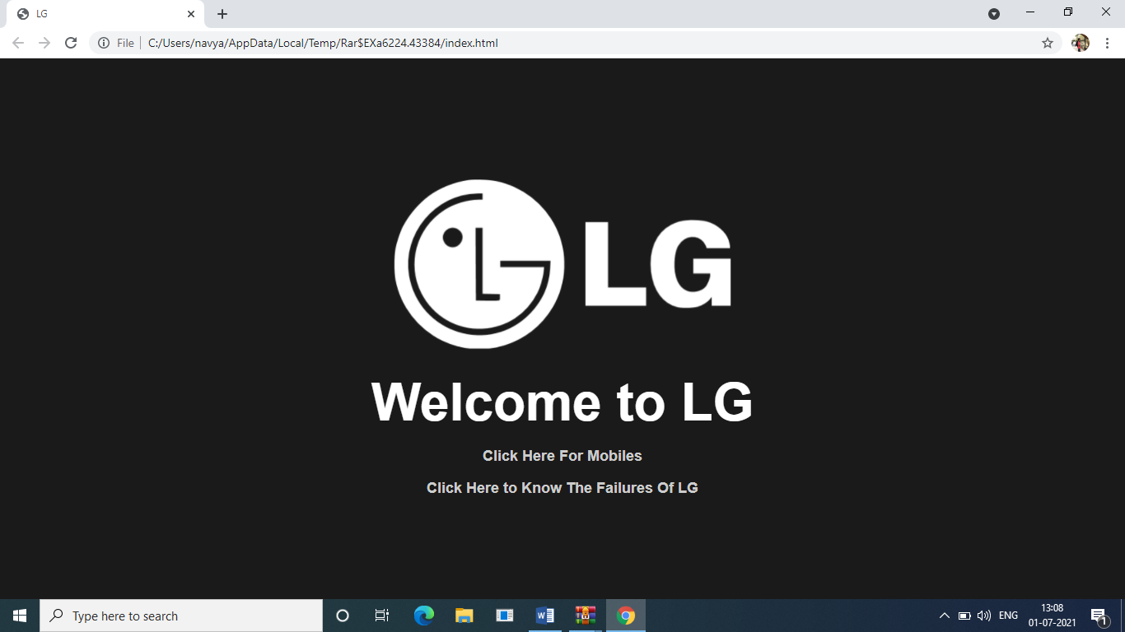

# 

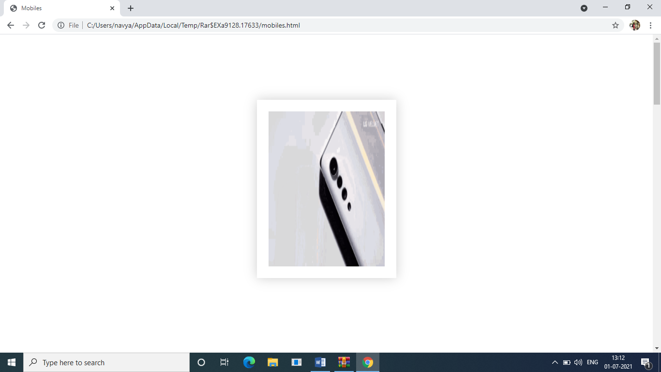

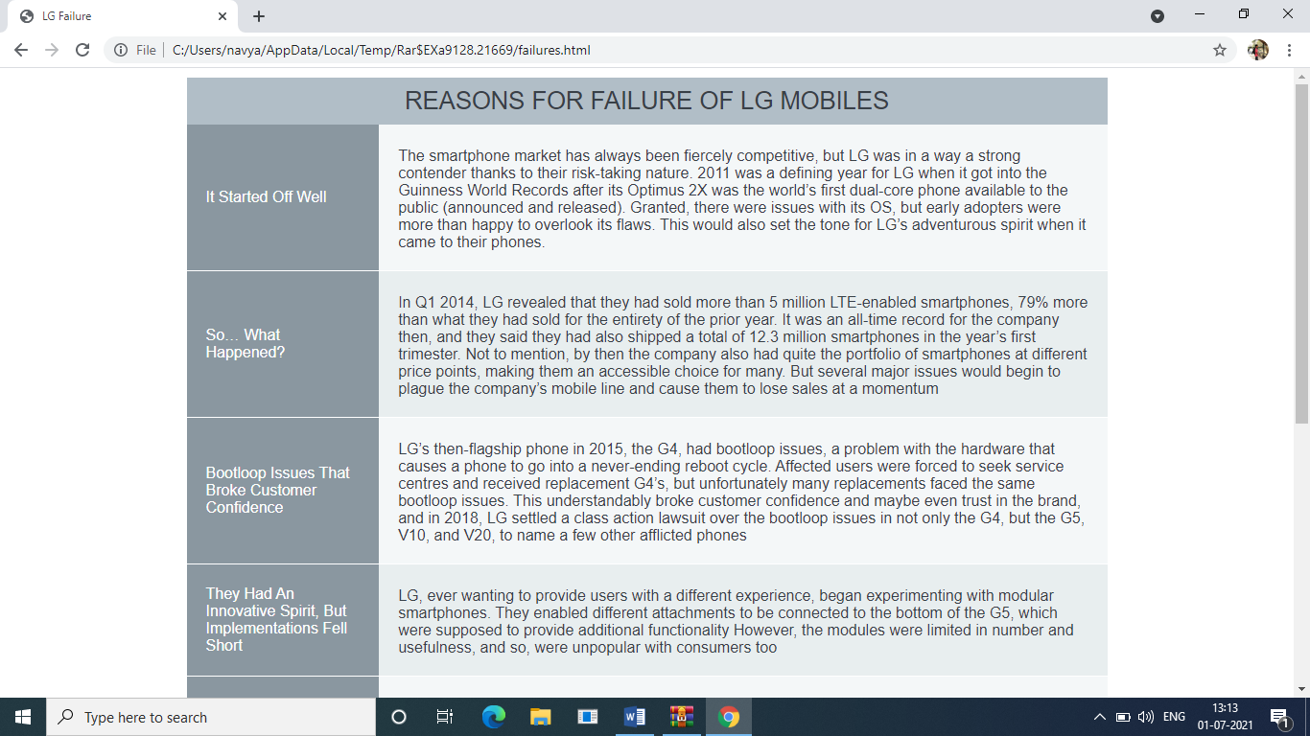

**BIBLIOGRAPHY**

1. References for HTML, CSS, and JavaScript in W3Schools - https://[www.w3schools.com](http://www.w3schools.com/)/
2. References for CSS and HTML – http://www.w3schools.com/html/html_css.asp
3. https://[www.geeksforgeeks.org](http://www.geeksforgeeks.org/)
4. https://freefrontend.com